Develop a Monitoring System

Brief
You are to design and build a monitoring system for your client who you will be identifying depending on your choice of system. These may include:
- Monitoring of a mailbox over time for an elderly person and alert the user when mail is present.
- Monitoring classroom temperatures and alert user when temperature below or above acceptable range
- Monitoring soil temperature and moisture over time and open/close a water valve.
- Monitoring wood moisture in home floor boards or firewood over time and alerting user when needed.
- Monitoring the temperature of a laptop and controlling and/or timing of a cooling fan.
Your design should have a control system that interacts with sensors for example the temperature sensor, moisture sensor and other input.
There must be additional features such as displays to show current status, indications for alarms, user calibration, min or max daily temperatures.
You are allowed to work together but each student must create and complete their own monitoring system. Theoretically, depending on the complexity of the system, you could build one system between two or three students but this must be negotiated with Mrs Dunn.

Project Requirements
During the development of your monitor system, you are required to
- Assess the client needs to identify, explain and justify components needed for your system.
- Explain and address all other relevant considerations that needs to be considered for your system, such as:
  - why software code needs to meet codes of practice
  - why the system needs to meet end-user specifications
  - why the system needs to comply with all relevant intellectual property.
  - Why the system has to comply to health and safety requirements
- Use appropriate project management tools and techniques to plan the development of your monitor system. Use key stages, task lists, milestones, file naming and version control systems and collaboration tools. Regularly manage this.
- Plan the monitor system outcome beforehand using block diagrams, flow charts and natural language. Use simulation programs (Yenka, Tinkercad Circuits etc), datasheets and calculations to ensure you meet the requirements
- Build the system in an iterative manner - design, build, trial and test, and evaluate as you go through the process.
- There will be formative assessment at each key milestone. It is your responsibility to ensure you are ready to submit your work at these milestones.
- Document the process and techniques used to set up and test the specified system in the form of annotated photographs, diagrams, short video clips, or code snippets that demonstrate understanding, skills and knowledge and explain decisions made by you
- Present your work to the client (teacher and others identified) at the key milestones. Selling yourself and your ideas is an important part of Electronics and Computer Engineering.

Project Planning
- Plan the process and your beforehand using block diagrams, flow charts and natural language.
- Use key stages or sprint with task lists (Acceptable Project Management tool), version control tools, simulation programs (Yenka, Tinkercad Circuits etc) and calculations to ensure you meet the requirements
- Seperate your project in at least 3-4 key stages or sprints
- Build the system in an iterative manner - design, build, trial and test, and evaluate as you go through the process. 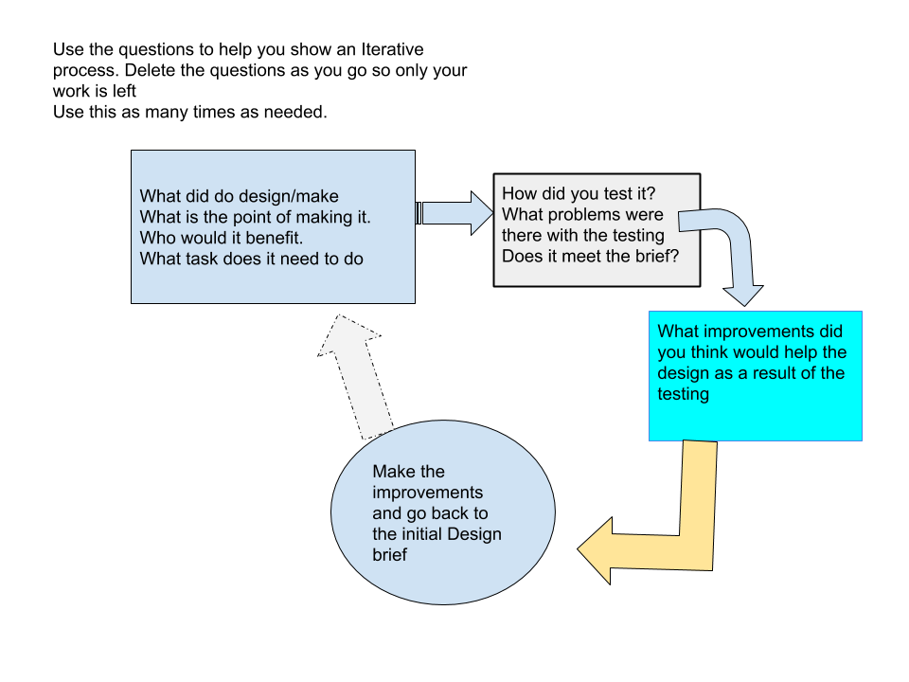
- There will be formative assessment at each key milestone. It is your responsibility to ensure you are ready to submit your work at these milestones. These assessments will require review of progress and planning of the next stages. The due date for the completion of the first key stage is Thursday 14 April.

Design and Planning Outcome
Construct your interfaces
This can be done using block diagrams, schematics and simulation programs. Construct functional models for all inputs and outputs. Divide your monitoring system into subsystems.
Construct electronic circuits and other hardware setups required.
Write, test, and debug software (See Appendix for an example) to control the subsystems and their interaction. Test all input and output interfaces separately. Make sure you use well-structured code, the outcome function as intended and is reliable.
Make sure that you:
- select the best type and value of component
- select the best arrangement of components
- modify hardware input and/or output parameters
- modify software parameters
- account for electronic noise and its filtering
- List all the tests you performed and any modification to hardware and software
Analyse and modify your initial designs until they are substantially improved and you are satisfied that they perform the functions required and meet specifications. Evidence is required that this was done in an iterative manner. You should have at least 3 -4 iteration of design, build, test and evaluate. One of these may be to create the PCB to improve the reliability of your system.

Documentation
As you develop, construct and test the subsystems, record the work you are doing using photos and notes. Use these records to write a report, which you will submit as evidence for the assessment of this standard.
Show in your report that you:
- used block diagrams and flowcharts to design your system and program
- used the electronic components provided to produce a sensor(s) that can interact with the environment
- used the output components to display, set alarm, open a valve etc
- write, test, and debug well-structured, clearly annotated, readily understandable software to effectively manage the interface between the microcontroller and the sensors and actuators it controls
- analyse, test, debug and modify the functional models’ sensor subsystems and output subsystems. This is to substantially improve the way the subsystems work/interact and the quality of the data delivered by the interface.
- Evaluated and justified the choice of components and systems used

Submission
Final submission due 4pm, 21 October 2022
All relevant documentation, your outcome and the presentations count towards your final grade. Presentations will be held throughout the assessment period in defined times. You should have at least three key milestones.
Complete the assignment checklists to ensure you have covered all the criteria in the assessments.
Hand in your monitor control system, your report and the assignment checklists.A reminder that the external CAT exam is the end of term 3 so you must ensure you have all the information for this.

Appendix A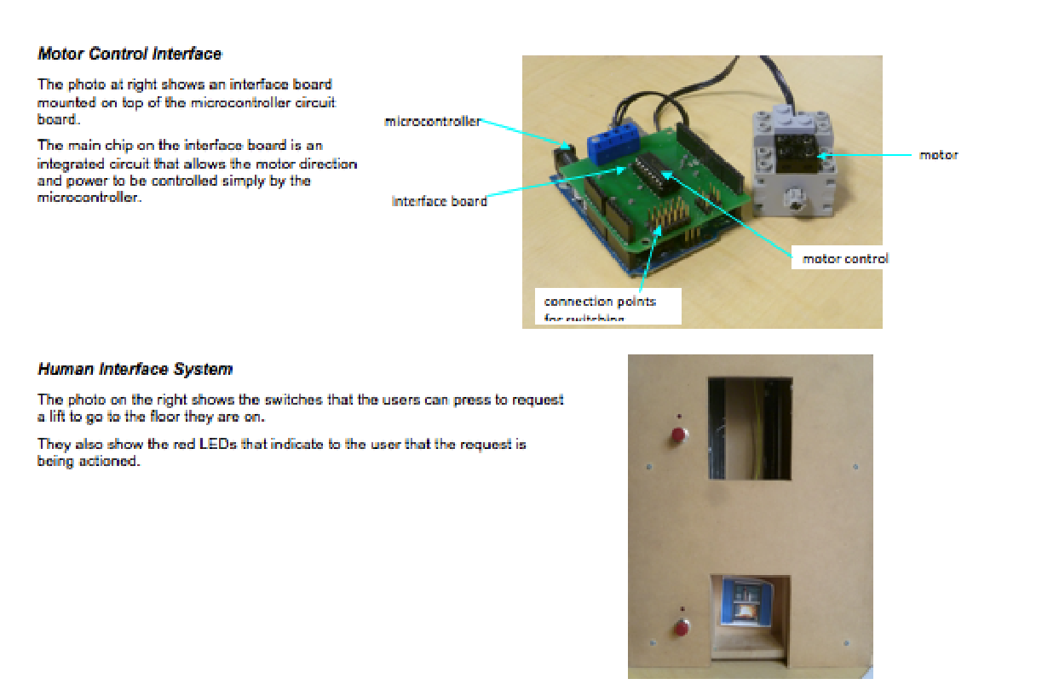

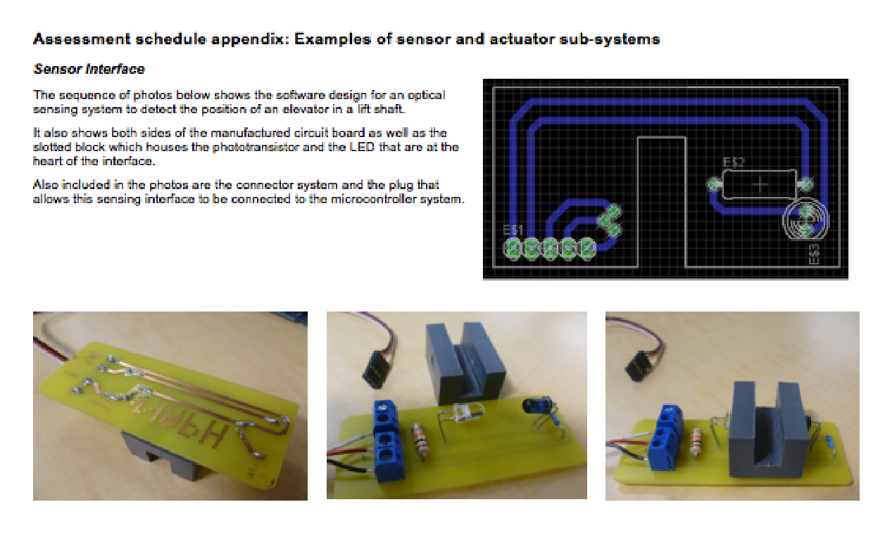

Appendix B: Code snippets
The code shown in this snippet is an example of the way software is used to manage the interface hardware.
In this case, the hardware side of the interface is an integrated circuit that is capable of controlling the direction and power delivered to a motor. The software side of the interface is the code that is used to manage the integrated circuit.
The snippet below is an example of this code:

