EV Data monitoring system:
Performance improvement for small electric vehicles.

Video of it working:  https://youtu.be/m-wmLEPRI7g | Github:  https://github.com/lukap123/Electronics2021

My interest in electric vehicles
My interest in electric vehicles stems from a competition by the name of Evolocity.
Evolocity is a competition for high school students designed to stimulate innovation and increase awareness of the advantages of EV’s. The competition involves high school teams designing, building and racing small electric vehicles such as karts, and bikes.

Classes:
Prior to this year, there have been 2 power classes:
- A standard class in which a team is supplied with a 350W Ebike conversion kit which includes everything a team would need for the electrics of their vehicle.
- An open class where the teams must supply their own motor, battery, controller and accessories. The maximum motor power is limited to 1000W.

These 2 power classes are then further split into the following 2 vehicle classes:
- Bikes, any vehicle with 2 wheels.
- Karts, any vehicle with 3 or more wheels.

This results in the following vehicle classes:
- Standard Bike
- Standard Kart
- Open Bike
- Open Kart

Events:
The events can be split into 4 categories. These are performance, innovation, show, and report.

Performance:
The performance events evaluate how well the vehicles physically perform by testing acceleration, deceleration, top speed, agility, and efficiency of the vehicles.
These factors are evaluated from how they perform in the following sub-events.
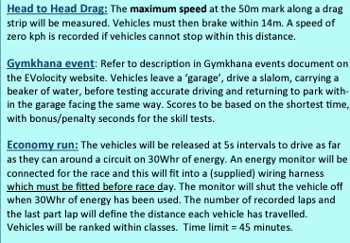

Innovation, Show, Report:
- The innovation category promotes the development and usage of new technologies.
- The show category promotes environmentally responsible design as well as professionalism of the finished vehicle.
- The report category encourages teams to go through a design process and document everything.
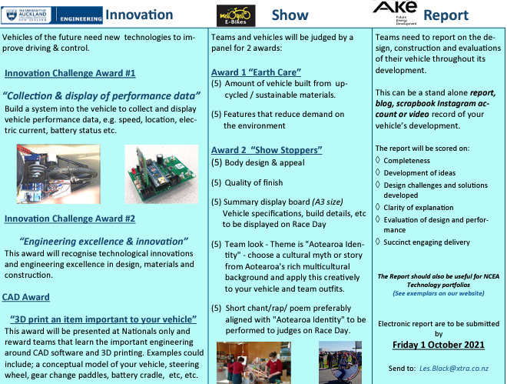

Innovation Category Marking Rubric:
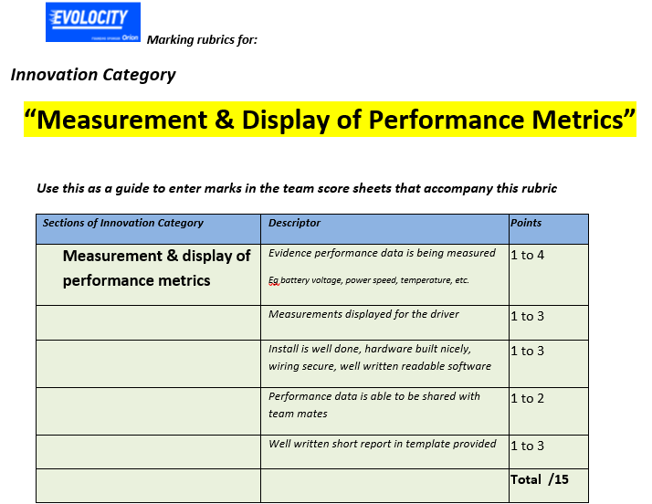

Previous Experience:
Over the past 3 years, with the help of a teammate, I have designed and built 3 vehicles. A standard class kart, an open class kart, and an open class bike. All 3 vehicles have done exceptionally well and won many awards and prizes especially in the performance categories. The 2020 event saw the introduction of a new top prize, an overall innovation trophy of which we were the inaugural winners.

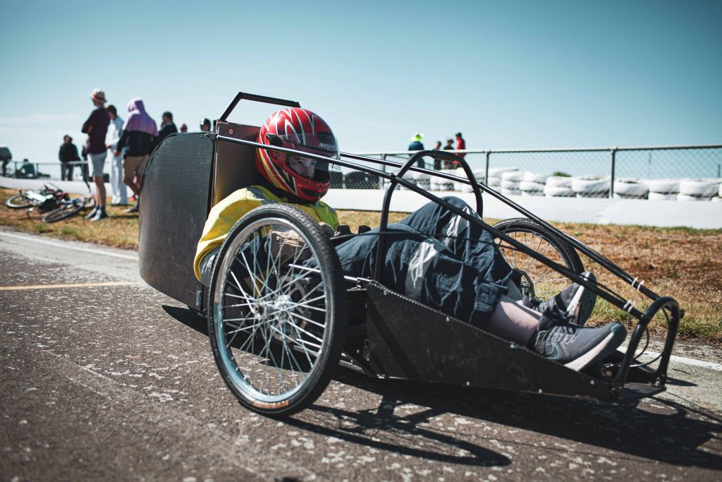
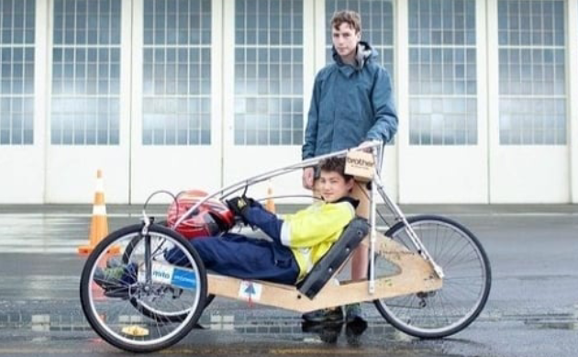
2018 Vehicle: 2019 Vehicle:

2020 Vehicle:
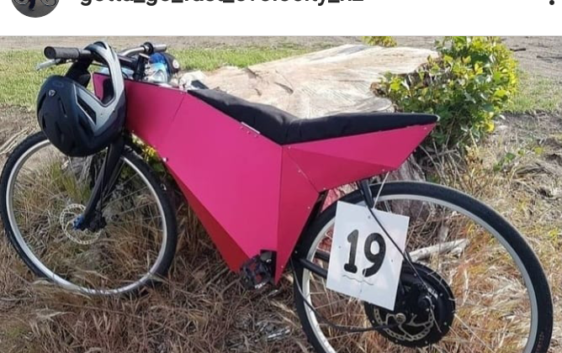
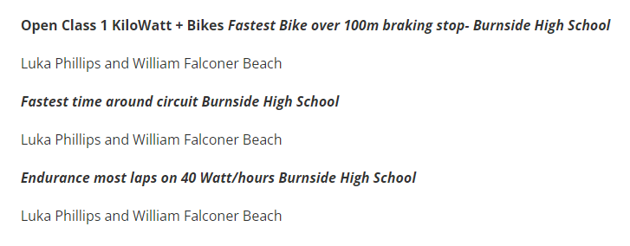
2020 Results:

2019 Design Recognition:
This is from the Evolocity website which recognised the quality of our design in 2019
https://evolocity.co.nz/wp-content/uploads/2020/04/EV-Build-3.pdf Page 9

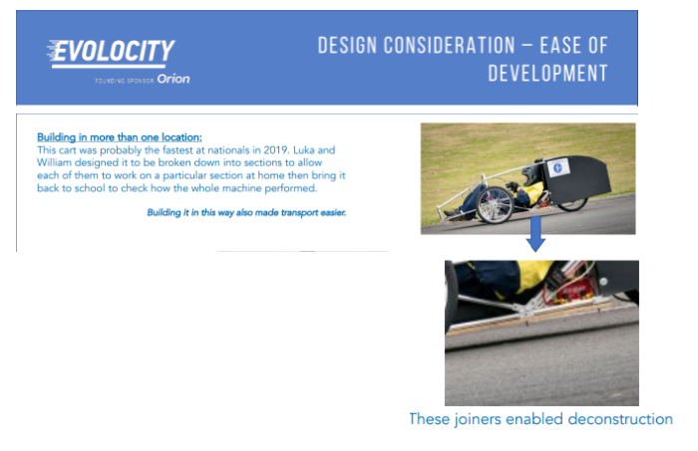

This table below shows the approximate cost of building a new vehicle from scratch, it shows that it is an expensive process. On top of this, a great amount of time and dedication is required, and a lot of costs such as consumables, electricity, and space in which to work are unaccounted for.

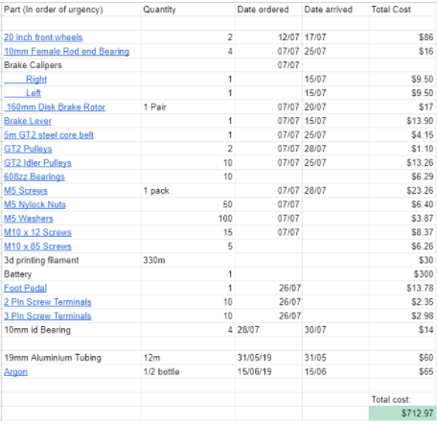

EVolocity 2021: A New Chapter
The Evolocity competition for 2021
EVolocity in partnership with Orion, University of Auckland, University of Canterbury, University of Waikato, Robinson Research Institute, Ara Institute of Canterbury and the Western Institute of Technology is proud to launch the school’s programme for the eighth year of competition. The programme now extends from Canterbury through to Nelson, Wellington, Wairarapa, Horowhenua, Manawatu, Whanganui, Taranaki, Waikato, Bay of Plenty and Auckland schools.

EVolocity Vision: “To establish a programme that enables participants to gain knowledge, skills and passion in the areas of design, engineering and programming that will prepare them for 21st century careers and empower them to create a more sustainable future.”

Objectives:
- To involve students in exciting electric vehicle building projects
- To grow the skills & confidence of students in ICT, Mechanical & Electrical engineering
- To grow leadership & teamwork amongst students engaging in EVolocity
- To promote educational pathways related to this growing industry sector
- To strengthen the links between students and tertiary education providers
- To foster positive attitudes & actions towards environmental sustainability

Competition Class:
As explained earlier, up until this year there have been just 4 vehicle classes. However, this is changing starting from this year with the addition of a new competition class. This new category involves teams building a go kart with a maximum power limit of 3000W with a maximum battery voltage of 48V. This is enforced by a power limiter which cuts the power when it is exceeded.
To go along with this new category comes a set of more stringent regulations designed to keep the event safe.
The aim of this new category is to start to bridge the void between a purely educational event where Evolocity is now, and a more performance based motorsport event which will better show the advantages of electric based vehicles as well as give more opportunities for innovation, which is at the core of Evolocity.

The new competition class competes in the Head to Head Drag, Gymkhana as well as the following:

There is also a custom controller category which awards the best overall performance by a team that has built their own controller.

As we have participated in EVolocity for the last 3 years, we have decided to push ourselves by entering in the open class competition. We know this will be challenging as it is an entirely new type of vehicle built to new regulations. In order to develop the cart it has been decided that on top of designing and building the base working cart, there should be a specific focus on a single aspect of the vehicle based on prior experience which could give a potential performance gain.

In order to work out what improvement would be focussed upon, it has been decided that a variety of idea’s formulated or trialled in previous years would be analysed and critiqued to find the area of focus that is most likely to be successful. It has also been decided that it would be beneficial if whatever improvement we come up with for this new class of vehicle can be replicated in the other classes in following years.

My project broken down into stages

What can be considered an improvement:
An improvement is a thing that makes something better. As my project will revolve around a performance improvement, I must make an outcome that makes an existing vehicle better by increasing the performance. I will know whether the performance of the vehicle has improved if one or more of these factors has improved.
- Efficiency - If the vehicle is more efficient then it will use less power to go a certain speed, it will also be able to go faster off the same amount of power. This will result in the battery lasting longer, a higher top speed, and better results in the economy run competition where the aim is to go the furthest distance off a set amount of energy..
- Acceleration - If the vehicle is able to accelerate faster, it will take less time to reach the top speed. This will allow the vehicle to do better in the street circuit where there are many sharp turns which require a lot of slowing down and speeding up, this is because the vehicle will be moving faster on average.
- Top Speed - If the vehicle is capable of moving faster, it will allow the vehicle to do better in the drag race where the result is determined by the top speed achieved by the vehicles.

In order to come up with potential solutions, I first researched which aspects of the vehicle affect efficiency, top speed and acceleration.
To do this, I researched what factors played a major part in determining efficiency, top speed, and acceleration in vehicles. I found that the main things that affect these factors are aerodynamics, vehicle weight, engine power, and gearing.

Aerodynamics:
Aerodynamics matters because it is the way air moves around objects. When air comes into contact with a moving object, it has to be moved out of the way and therefore it opposes the object's motion through the air. This is called aerodynamic drag, and it can be reduced by either decreasing the speed of the vehicle, or by changing the shape so that the air can be moved away better. An improvement to the aerodynamics would mean that the vehicle would experience less drag, allowing the vehicle to use less power to move at the same speed, or to go faster off the same power.

Vehicle weight, Engine power, and Gearing:
Vehicle weight matters because the formula linking force, mass, and acceleration is Force = Mass*Acceleration which can be rearranged to give Acceleration = Force/Mass. In this case the force is the torque at the wheels. This tells us that a lower mass will result in faster acceleration without having to use more power.
However, the same equation tells us that acceleration could also be increased by increasing the force which in this case is the torque at the wheels.
This could be done in 2 ways. The first way to improve acceleration would be to gear the motor down so that the wheels spin slower, but with more torque and therefore more force. While this would give quicker acceleration at first, the vehicle would have a limited top speed due to it being geared down. In order to mitigate this, a variable gearing system would have to be implemented which would have a gearing ratio that gives high torque during the acceleration, but could be varied in order to not limit the top speed.
The second way of increasing the torque would be to directly increase the torque generated by the motor. As the motor is standardised by the event organisers and cannot be changed, the only way to do this would be by increasing the electrical current delivered to the motor. This would make the motor output more torque and therefore make the vehicle accelerate faster.
This extra torque could also be utilised through gearing in order to also give the vehicle a higher top speed.

Investigation into possible opportunities:
From this information I came up with 6 solutions that could improve the performance of the existing vehicles.
Improvement of small electric vehicles

Mechanical

Electrical
Chassis
Gearing System
Aerodynamics
Motor Controller
Electronics monitoring
Intelligent vehicle control
An existing chassis could be made lighter by measuring stresses and adapting the design to better suit the known stresses.
A gearbox could be made to be fitted to existing vehicles, allowing for better acceleration, top speed, and efficiency
An aerodynamic fairing could be designed, tested and fitted to an existing vehicle allowing for greater efficiency.
A custom motor controller could be made which would give greater control of the motor control parameters.
An electronic module could be made that senses vehicle variable such as speed current voltage and temperature of parts.
An electronic module could be built that finds and controls the vehicle to operate at the optimum speed of the vehicle.
I will need to investigate these options further to determine what will best match my interests abilities, and give me an advantage in the entry for Evolocity This year.

Motor Controller
- Chassis
- Gearing
- Aerodynamics
- Electronics Monitoring
- Intelligent Vehicle Control

Motor Controller:
A motor controller is an electronic device that is connected in between a power source such as a battery and a motor. The purpose of a motor controller is to vary the power delivered to a motor by using either pulse width modulation (PWM) or a variable resistor.

How do motor controllers work?
Motor control using a variable resistor works by converting some of the energy outputted by the battery into heat, so that the motor does not get as much power. However, this method of motor control is rarely used because the heat generated makes it inefficient.

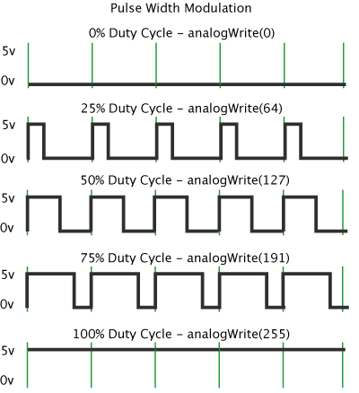
Motor control using PWM works by switching the power to the motor on and off many times a second, by varying the ratio of time that the motor is powered and not powered, the power delivered to the motor can be varied. For example, if the motor is switched on for 50 milliseconds, and switched off for 50 milliseconds, then it will only have half of the maximum power delivered to it and it will only spin half as quickly.

There are 2 commonly used motors which each require their own motor controller types. These are brushless motors and brushed motors. While brushed motors simply need a voltage connected across them with 2 wires, brushless motors need 3 wires with varying voltages. This is because the electromagnets in a motor must either repel or attract the permanent magnets, this polarity is controlled by the direction of the current flowing through the windings.

In a brushed motor, the brushes control the current flow passively, which means no control input is required to make the motor spin, therefore the motor only requires a voltage across it.

However in a brushless motor, there are no brushes to automatically control the current direction through the windings. This means that the polarity and timing must be controlled by a logic circuit and high speed switches. This improves the efficiency and lifespan of the motor by eliminating friction from the brushes, however it makes the control of the motor much more difficult as 3 separate control voltages must be generated compared to just one for a brushed motor.
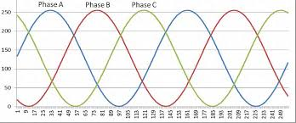

How would a custom motor controller improve performance?
A custom motor controller could be made to improve the performance by having better efficiency than the standard one. It could also be designed to deliver more power to the motor by not limiting the current.

Efficiency:
The main factor that determines efficiency in a motor controller is the amount of power that is turned into heat due to resistance in components. The main source of this resistance is the mosfets (A type of electronic switch).
For example, the mosfets used in the standard class motor controllers have a resistance of 2.5 milliohms. In order to calculate the loss at full power I can use an arrangement of ohm's law which states that Power = Resistance*Current^2. In order to solve this I need the current, which can be calculated using another arrangement of ohm’s law which states that Current = Power/Voltage. As the controller limits output power to 350W and the Voltage is 24V I can work out that the maximum Current is 14.6A. This means that the maximum power loss due to the mosfet in the standard controller is 0.5W. This means that even if a motor controller with zero resistance was created, the efficiency would only increase by 0.14%. While there may be a slightly higher efficiency gain in a higher current brushless motor controller (higher current so larger loss, current must flow through 2 mosfets in series rather than just one), it would still only be a few percent. This means that even the maximum efficiency gain possible is negligible and therefore the efficiency gain could not be considered a significant improvement.

Power Limit:
The standard class motor controller has a current limit in order to limit the motor power, however a custom built motor controller could be designed to have a higher current limit to provide more power to the motor.
As calculated before, the maximum current that the standard class motor controller allows is 14.6A, however the datasheet for the motor shows that the maximum continuously allowable current for the motor is 22.35A, allowing the motor to use 537W. If the motor controller was designed and built to withstand this current, then it would be possible to increase the power usage by 187W, which would be a 50% increase in power usage. This would translate to approximately 125W, or 44% extra when accounting for the decreased motor efficiency due to the higher current. This means that this solution would give a very significant improvement over the standard controller currently being used.

However, while this would be a good solution in the standard class where the motor is standardised and there is no power limit, it would not be as beneficial for the open class and competition class as there is a limit to the maximum power allowed.

How would it help?
A custom controller would help by increasing the maximum power provided to the motor. The result of this would be faster acceleration, as well as a higher top speed.

Is this solution feasible and practical?
I have tried to build both brushed and brushless motor controllers in the past, and due to the high peak currents and peak voltages, they are prone to fail and therefore require a lot of electrical protection, making them complicated to get right. The parts required for them such as mosfets and gate drivers also cost a lot which means that they are expensive to build and repair if they fail.
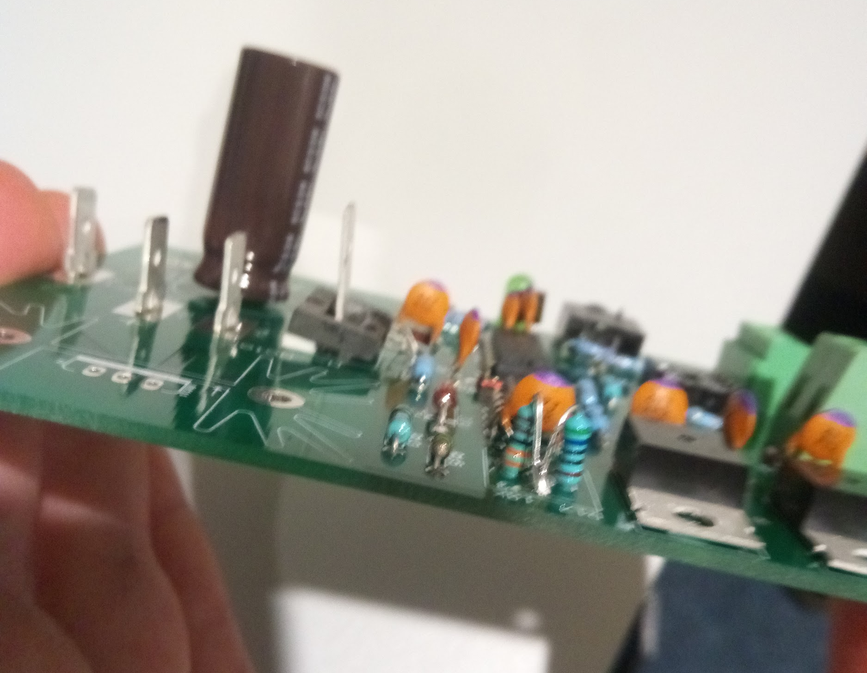
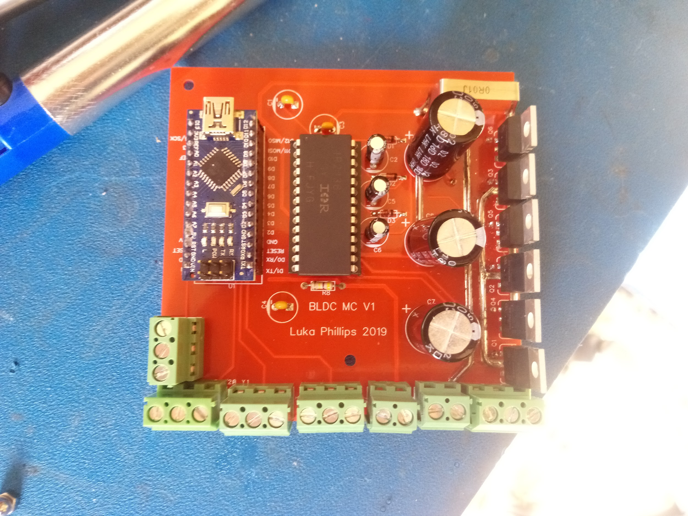
These are the 2 motor controllers that I have built in the past. The red one is a brushless motor controller and the green one is a brushed motor controller. I was not able to get the brushless motor controller to run as the mosfets and gate driver kept blowing up for an unknown reason which I could not figure out even after days of probing and testing.
I was able to get the simpler brushed motor controller to work somewhat reliably, however even that took a lot of spare parts, time and effort.
For this reason, I have decided that the limited benefit for non standard class vehicles combined with the risk of it not working properly or consistently as well as going over budget is too high, therefore I will not be pursuing this solution.

Chassis:
Stresses could be measured on an existing chassis using strain gauging. This better understanding of the stresses involved in the chassis could be used to do 2 things. The first of these would be to lighten an existing vehicle by removing material in low stress areas and adding material in high stress areas. The second thing that could be done would be to use this new information to build a brand new chassis for a competition class cart. This would improve the vehicle as it would be lighter, and stiffer allowing it to accelerate and corner faster.

Modifying an existing chassis has been decided to not be a viable solution for 2 reasons.

The first of these is because the time required to cut apart and rearrange parts of the chassis would be very long. I know that this is the case as I have done it in the past. The reason that this process takes so long is because sections of framing are difficult to remove when fully assembled, possibly requiring the removal of multiple components from the vehicle. The replacement part must also be cut very accurately so that it fits well and can be welded in well. Screws can not be used for parts that must be attached strongly, as the chassis are made of thin aluminium and the threads would rip out easily, therefore parts must be welded. Before welding, parts which may be affected by the heat must also be removed and any paint must be removed and the area cleaned. Paint and parts must also be reapplied after welding so that the vehicle still works and will be protected against corrosion.

The second reason is because cutting and rewelding the chassis would also decrease the strength of the existing chassis. This is due to the effect that heat has on aluminium, which is called the temper. Most aluminium that is readily available is tempered which means that it has been heated and quenched making it stronger. Welding causes it to lose some of this strength as the area that is being welded gets very hot and must cool slowly to prevent cracking of the weld. Welding new areas of the chassis would weaken more sections of the chassis, and welding areas that have been previously welded would cause those areas to become even weaker.

It has also been decided that stresses measured on existing vehicles would not be very useful in the design of a new chassis. This is because there are many major differences between existing vehicles and what is required for the new competition class chassis. The largest of these is that the competition class vehicle must have 4 wheels. All previously built carts have 3 wheels, so the stresses would be very different between the 2 and therefore the data would not be useful.

Gearing:
A gearbox could be made to be fitted to existing vehicles. The gearbox would allow a variety of gearing ratios which would allow the motor to work more effectively at a wide range of speeds. This would mean that the vehicle could accelerate faster, get to a higher top speed, and be more efficient at a wider range of speeds when compared to a drive chain where the motor is connected to the drive wheel through a fixed gearing ratio. Better acceleration, top speed, and efficiency would mean that this solution would help improve the vehicle in all 3 events.

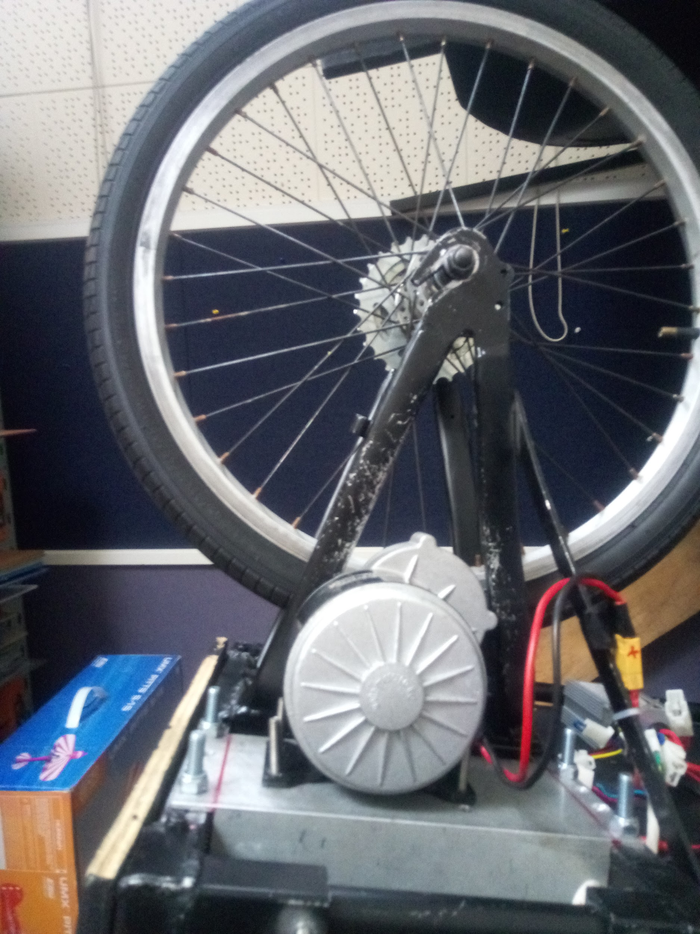
However after further research into what would be required for a gearbox I decided not to pursue this option as gearbox parts such as pulleys and gears are expensive. These parts are expensive as they are designed and made to be used in situations where they will need to operate for extended periods of time under heavy loads for many years without maintenance. This means that they are made with high precision and high quality materials and therefore they are expensive.
The space available for a gearbox is also very limited, as the gearbox must be mounted between the motor and the rear wheel. This space has been kept to a minimum in existing vehicles in order to save weight and increase maneuverability by making the wheelbase shorter.
In order to build a gearbox in this small space, the gearbox would have to be compact which would result in a more complex gearbox, and not many gears could be incorporated. The result of this would therefore be an expensive highly complex gearbox with limited effectiveness, therefore, I have decided that resources would not be well spent on such an outcome.

Aerodynamics:
An aerodynamic fairing could be designed and fitted to a vehicle. A fairing would lessen drag from the air by redirecting it off all the rough features of the vehicle to a smoother outer surface. This would allow the vehicle to be more efficient, and reach a higher top speed, helping it in competitions such as the drag race and economy run.
However I decided not to pursue the option of an aerodynamic fairing. I decided this as a fairing would be difficult to design to suit an existing vehicle,would not look good and would need a lot of support making it heavy. This is because the existing vehicles have not been designed with a fairing in mind and therefore lack the correct profile to reduce air resistance optimally. They also lack mounting points for a fairing. These mounting points would need to be added to the frame and would add significant weight and may also weaken the frame if the supports are welded on for the reasons covered in the discussion regarding chassis modification.
A fairing may also impair visibility or maneuverability of the driver in the vehicle, making it more difficult for the driver to get in and out of the vehicle or spot other vehicles on the track, making it a potential safety issue.
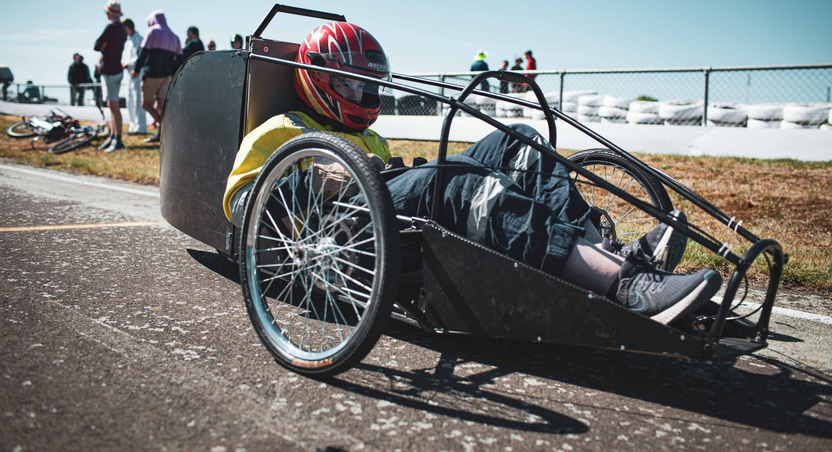
For example, shown above is a vehicle built and raced in 2019. While a rear fairing and some panels were able to be attached easily for the following year, other panels such as the side and top panels would be much more difficult as they would need to curve around the drivers arms or head and therefore couldn’t be mounted directly to points on the chassis. They would also need to be easily removable to allow the driver to get in and out of the vehicle, and also so that they could reach out of the vehicle. Because of this, I decided that it was not a practical solution.

Electronics Monitoring:
An electronic module could be made that senses vehicle variables such as speed, current, voltage, and temperature of parts. It would allow the driver to be able to see when the vehicle is running at peak efficiency as well as the current and power being used so that they could make sure that they are using the maximum power available to them without overloading anything. This would help the driver in 3 ways. The first is it would allow the driver to use more power, which means a higher top speed and faster acceleration for the reasons previously mentioned. The second is it would reduce the risk of any electronics parts blowing up, and the third is it would allow the driver to drive the vehicle more efficiently.
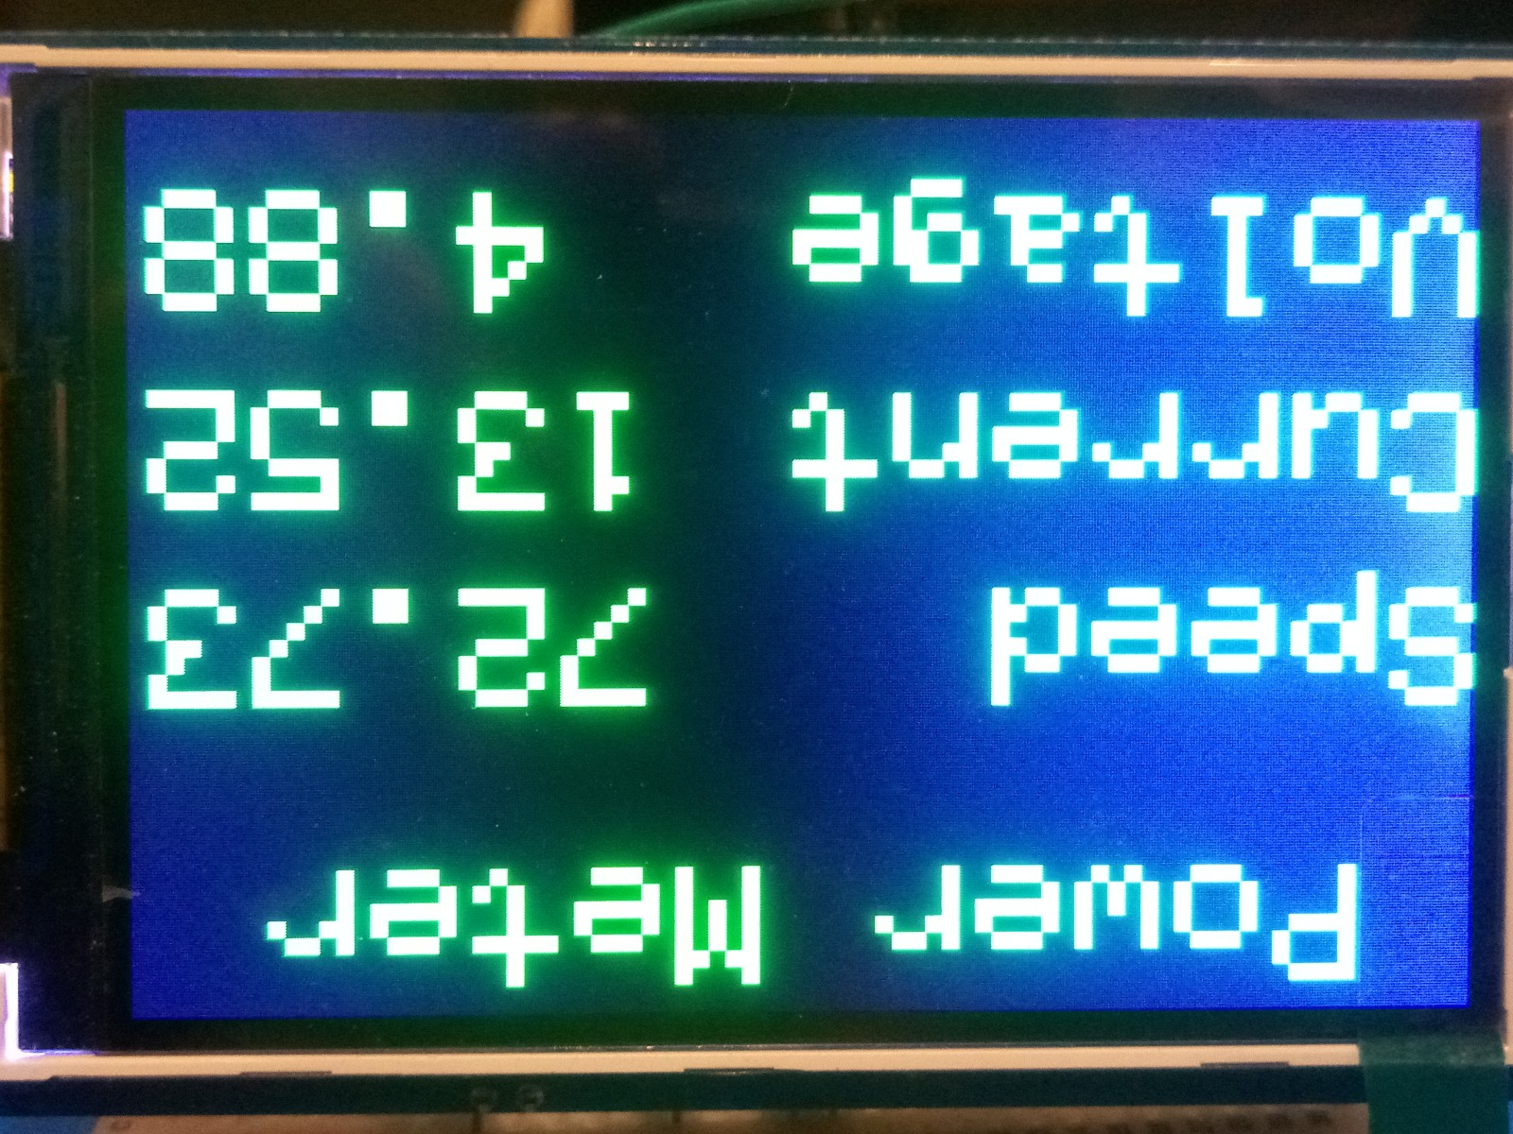
I attempted a similar project last year which involved measuring and displaying current, voltage, and speed. The project was overall successful, but there were many problems I encountered around the resolution and calibration of the sensors as well as the presentation of data on the display.

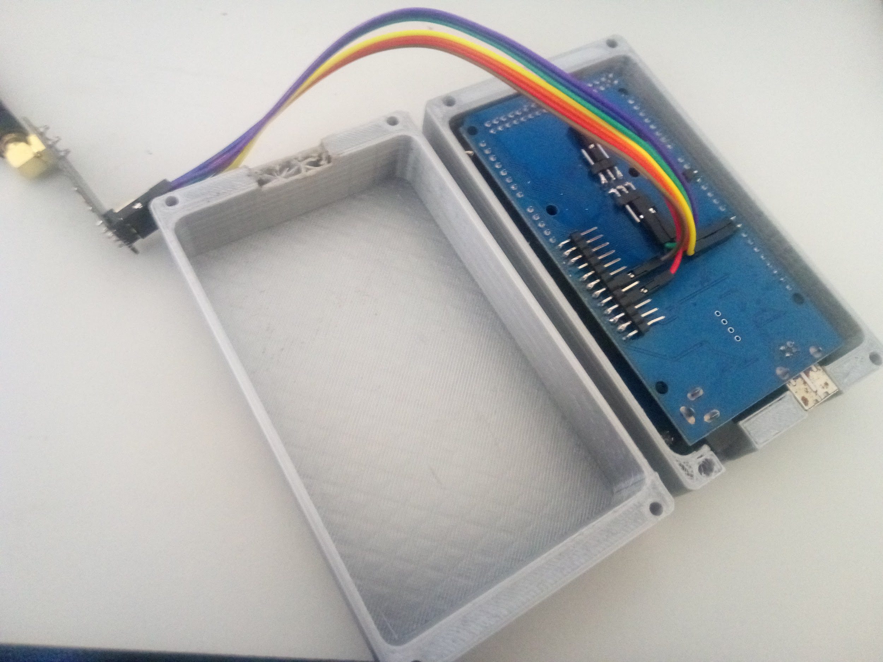
One example of this is the use of high current capable hall effect current sensors. These required a lot of calibration and messing around to get usable data from. This was due to the fact that they were designed for much higher currents than I was using them for.
Another example of a problem I encountered is the speed sensor, the way I implemented it in the code meant that it would sometimes interfere with other functions.

I have decided that I would like to pursue this solution as my outcome because it has the highest likelihood of success, and will likely provide a substantial improvement. I believe it has the highest chance of success because I have past experience with a similar project.

While the same could be said about the motor controller, I am unsure about the cause of the problems in the motor controller, whereas I am quite certain about the problems with my previous attempt at a similar monitoring system. Also unlike the motor controller, the monitoring system has much less interaction with the high current and high voltage. This will mean that it will have less parts which have to be designed for high current and voltage which will make the project cheaper and less likely to fail.

Intelligent Vehicle Control:
Intelligent vehicle control would be an extension to electronics monitoring where the data from the monitoring system is both displayed to the driver but also fed to a computer. This computer would be connected in between the throttle and motor controller but also to the monitoring system and would use algorithms, calculations, and pre-programmed functions to maximise performance. For example it could use PID control in order to automatically maximise efficiency without input from the driver, or it could have a launch control mode which sends predetermined control signals to the motor controller. On top of the ways that the previous solution would help make the vehicle better, this would improve on that by further improving efficiency and acceleration by controlling the power more precisely than could be done by the driver. The driver would also then not have to worry about power usage and could focus on driving in the optimal manner.

The intelligent vehicle control system requires data which would be collected and sorted by the monitoring system as it requires information such as current, voltage, speed and temperature in order to function effectively and these are all things that would be measured by the monitoring system

The need and opportunity that I will choose and investigate further

For this reason I have decided to pursue the solution of electronics monitoring while making sure to make the design easily adaptable to intelligent vehicle control, this is so that it can be implemented as a further upgrade easily. By developing a simpler solution which will still be effective, the chances of the outcome being delivered on time to a good standard will be increased.

Client:
The main stakeholder that the outcome is being built for is myself as I will be the one to build it, install it, and race with it. I am qualified to be the client as this is my 4th year competing and I have consistently had great success. I will be developing this in partnership with the developer of the cart frame, so I will also get feedback from them. But overall, I know what I am wanting from this project, and what needs to be done. I do need to start looking at existing solutions as there is no sense creating something less effective than what is already out there.

Research into existing products and projects:
I researched existing power meters on the market and existing related personal projects. The 2 solutions available on the market that were the closest to what I required were the Turnigy Power Analyzer and Bafang Ebike display. I first researched existing products as it would not make sense to create a solution to a problem that has already been solved. I also researched existing projects as I could learn from other people’s mistakes, but also the types of sensors they used and what they did to improve their projects.

Existing Product 1:

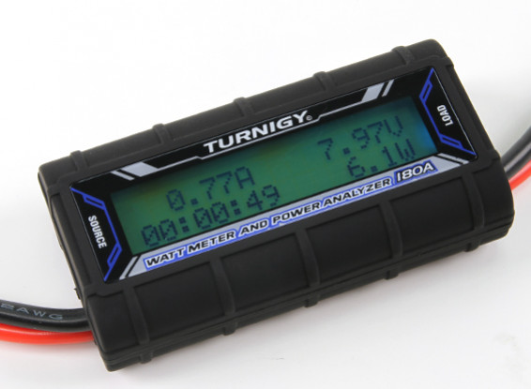
The Turnigy Power analyzer is a power meter designed to measure values in RC applications. As such it is able to measure:
0~180A - Resolution 0.01A
0~60V - Resolution 0.01V
0~10800W - Resolution 0.1W
0~99Ah - Resolution 0.001Ah
0~9999.9Wh - Resolution 0.1Wh
It displays this information on a 16X2 LCD display and it has a total size of 85*42*25mm.
This product is able to measure many things, and can do this with excellent accuracy. However it does not have any way of monitoring RPM or speed, which are crucial for the outcome to function well. This measurement will be crucial as I will require it to measure efficiency. Without it, I will only know the voltage and current being used which will be useless unless I know how fast the vehicle is going. Therefore this product is not suitable for my application.

Existing Product 2:

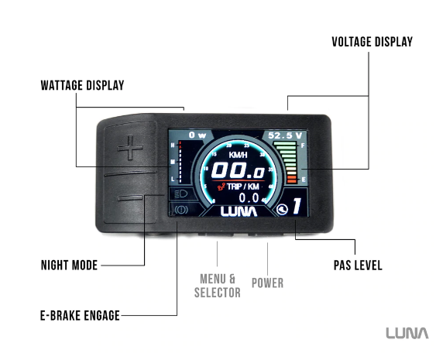
The Bafang Ebike display is a monitoring system designed for use with E-bikes, It is able to measure and display adequate data needed such as battery voltage, wattage, speed, and distance. However, it is designed to only function with certain motor drives and as such, uses a proprietary interface. While there is a chance that it is possible to reverse engineer the code used to encode the data into a data bus, it would be extremely difficult especially as the code is not open source. For this reason it is not an appropriate solution for my needs.

From this research I am able to conclude that there is no product available on the market that would fulfill my needs.
This means that my next step is to look into projects done by other people which could be directly used, modified, or partially used for my solution.

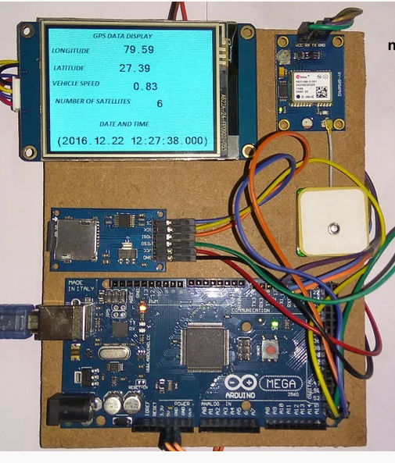
Existing Project 1:
During my research into existing projects, I found this GPS based Arduino digital dashboard. This project does however lack anything other than GPS functionality however it should not be difficult to incorporate other sensors to it as it is Arduino based. This would allow me to display GPS data as well as the other information such as current and voltage.
Another benefit of this design is the fact that it uses a Nextion display. The Nextion brand display is a display which has its own graphic driver built in. This means that a Graphical user interface can be programmed into the display through the use of a PC, and the arduino simply has to send data to the LCD through SPI. This means that the Arduino does not have to deal with the GUI, making the Arduino code easier to write, and making the Arduino run smoother. It will also mean I can have a more complex display with more animated parts such as dials.
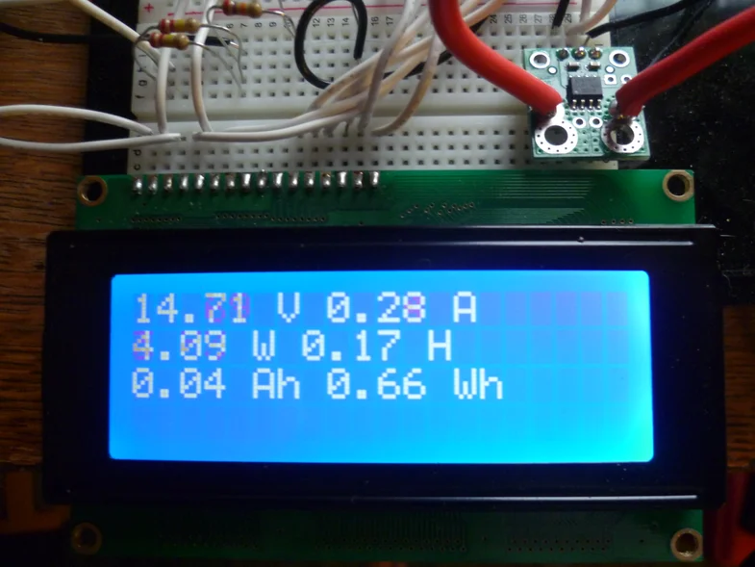
https://www.instructables.com/DIY-Amp-Hour-Meter-Arduino/
While unlikely, It is possible that this project does not do everything the author says it will do as it has not been tested by a 3rd party.

Existing Project 2:
Another existing project I found through my initial research is this Arduino based Amp/Volt/Wattmeter. This is also an Arduino based project which means easy modification, and as the name suggests it measures Current, Voltage, and Watts. These are 3 things that the first project lacks. However this project uses a 16X2 LCD which does not look as good as the other existing project.
https://www.instructables.com/VISUINO-NEXTION-GPS-DISPLAY-AND-SDCARD-LOGGER/
While unlikely, It is possible that this project does not do everything the author says it will do as it has not been tested by a 3rd party.

This initial research into existing products and projects has allowed me to see that there are no commercially available products available which suit my needs.
It has also allowed me to see that while there are no existing projects that fit my needs exactly, there are projects that have certain functions I require and it may be possible to merge them.
My past experience with a similar project will also allow me to avoid possible problems, saving time and enhancing the outcome.

Things I need to consider that will influence my outcome:

What are the Relevant Rules/Regulations:
As the solution would be used in Evolocity, it must therefore comply with their rules/regulations. To find out what these were, I went onto Evolocity’s website and found the design guidelines for the vehicles. From this I found the parts which were relevant to electrical systems.

- All components that require it must have adequate heat dissipation
- Wires and terminals on the vehicle must be neatly run, secured and unable to chafe, be protected from moving parts, and be rated correctly.

I then researched what I must do in order to comply with these requirements.
Heat dissipation is the removal of excess heat from an object, in the case of my project it would relate to electronic components such as resistors and transistors.
In order to dissipate heat from components that require it, a heatsink, airflow or a combination of the 2 can be used.
To help me comply with the regulation that states that wires and terminals are to be neatly run, secured, unable to chafe, protected from other parts, and rated correctly, I decided that the best way to do this would be to minimise the amount of wires and connectors used. To do this, I will likely use a custom pcb which eliminates many wires and connections. The wires will instead be copper tracks on the surface of the pcb which will make them far less likely to be damaged.

Health and Safety regulations:
Relevant Health and Safety regulations put forward by Evolocity have already been covered under Rules/Regulations. However while Evolocity does not specifically state any other health and safety regulations it is expected that common sense be used to mitigate health and safety risks. Possible health and safety risks are, wires shorting, as well as the driver coming into contact with live wires.

Wires shorting must be avoided as it could cause heating of certain components, to the point that they combust or cause their surroundings to combust starting a fire. Extra care must be taken around the battery wires as if these are shorted, the battery may catch fire which would be extremely dangerous especially in the case of lithium batteries which may be used in these vehicles.

Live wires contacting the driver or other personnel must also be avoided as it would cause electric shock to the person, while this is highly unlikely to be lethal to most people, older people or those with heart conditions may be at significant risk and all precautions should be taken to prevent unfortunate circumstances.

In order to mitigate health and safety risks to the driver, the electronics should not be damaged easily, or come into contact with potential hazards such as other vehicle components or the driver. The electronics should also be kept free of dust, water as well as moisture where possible.
In order to achieve this I will make sure that the electronics are enclosed in a watertight and dust tight enclosure. I will also make sure that there is no chance of accidental shortcuts by using insulating materials such as heat shrink on exposed metal parts.

What is the intended environment the outcome will operate in:
Another factor that will influence the outcome is the environment that the outcome will be used in. From previous experience I can say that the outcome will need to be able to be used in harsh sunlight, light rain, and in temperatures of between 10-40 degrees celsius. The outcome must therefore be designed to operate in high moisture conditions as well as operate throughout the entire temperature range accounting for self heating and cooling of components.

Budget:
The maximum budget will be set by external factors. In order to make sure that the outcome fits within the budget, I must make sure to use economical parts. One way to do this is to buy parts from overseas which will not be marked up as they would be in NZ. However in order to do this I would also need to order significantly in advance which will require accurate and advanced planning as the outcome will have to be completed before the day of the event.

Time constraints and the possibility of COVID:
The main time constraint will be getting the outcome finished before the day of the event. This also creates deadlines at which certain things will need to be completed or ordered. It will be important to set and follow these deadlines.
Another important thing to consider is the possibility of covid. The main impact this would have is the delivery of parts and lack of access to resources at school. This will mean that it will be important to get parts ordered as quickly as possible and work on the outcome from home so that not being able to access resources at school won’t be as much of a problem.

Problems identified from previous projects
As I have done a project similar to this every year for the last 5 years, it would be wise to review my prior work and see what information I can find that may help me move forward better. I think looking at this critically may give me some good insights.

After looking at a variety of possible solutions;

I have settled on an outcome which will measure many vehicle data points such as; speed, current, voltage, and temperature. These data points will then be displayed to the driver. The outcome will also be designed to be upgraded with functionality allowing it to use these data points and driver inputs to control the vehicle.

Identifying problems from previous years outcomes, and finding potential solutions:

While last year's outcome was overall successful, some aspects of it could be improved.These things were the current sensor, wiring, and display.
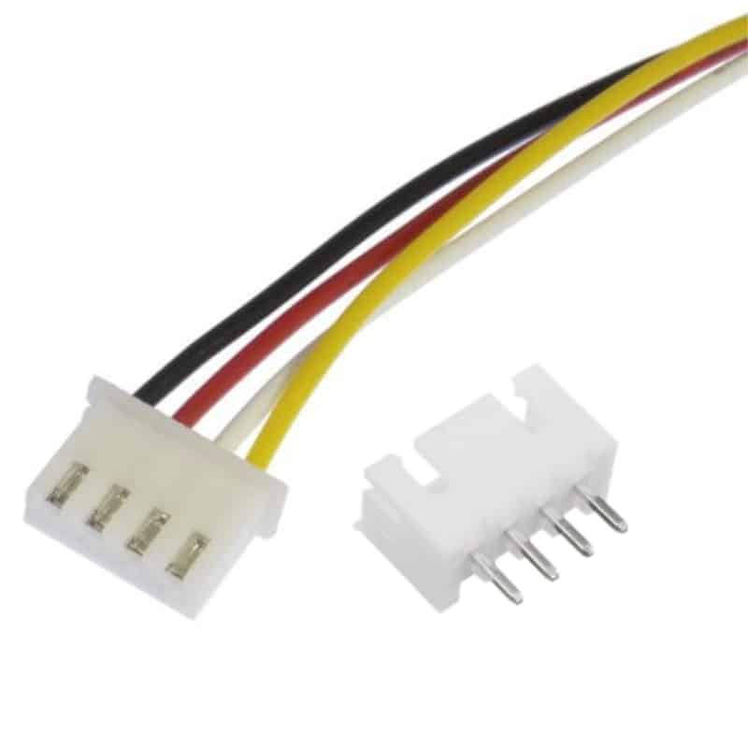
The current sensor I used last year was designed to be able to measure much higher currents than I required (200A). While this could be seen as an advantage for future improvements allowing it to be used with much more powerful systems it worked out to be a disadvantage for me because it meant that I had a limited resolution. This is because the resolution of the Arduino ADC is 10 bits therefore giving 1023 “steps” between 0V and 5V. This works out to roughly 5mV per step. As the current sensor I used outputted 10mV/A, it meant that I only had a resolution of 0.5A. This was a problem because it was only accurate to within half of an amp. In order to solve the problem of low accuracy, one solution I could use is an external ADC with a higher resolution. This would mean that I could detect smaller changes in current making the reading more accurate. Another solution would be to use a current sensor with a lower range such as a 100A sensor that would output 20mV/A rather than 10mV. This would still surpass my requirements and give me a resolution of 0.25A, which would be two times as better than what I had.

Last year's outcome used 2.54mm headers and dupont housings in order to make connections between the separate interfaces. One problem with this that I found was that they took up a lot of space and they kept coming loose. In order to solve these problems, I will use JST XH connectors in this year's outcome. These connectors are lower profile, and have a physical locking mechanism which stops them coming out on their own. Another solution would have been to glue the connector pairs together, however this would make them hard to remove and inconvenient to put back together.

Last year’s outcome used a 3.5” LCD display in order to display the data to the driver. The problem I had with this is that I had selected the cheapest display I could find which had very limited documentation and functionality. This made it difficult to get it to work and display what I wanted to, resulting in a very plain and simple display. One solution to this problem would be to spend more time fiddling around with the display to try and get a simple interface to look good. Another solution would be to use a more advanced display such as a Nextion display. Nextion displays are designed to be used as a human-machine interface. They have their own microprocessor which allows them to handle graphics, so that the Arduino has less work to do. However, this also means that they are expensive. A display comparable in size to the one used in last year's solution costs $37 USD which would be my entire proposed budget on the LCD alone. As such, I have decided to spend time making a simple interface look good on the existing display.

Additional risks in my project and possible ways to deal with them.

Time + Financial:
One risk I may encounter is running out of time. In order to mitigate this risk, I will need to make sure to work efficiently - especially in the design stage so that I will have time to order all the parts from overseas which will in turn mitigate the risk of running out of money. Another way in which this risk will be resolved is by having done projects before which has allowed me to build up experience, allowing me to complete tasks quicker and more efficiently. Having access to good tools through school and the University of Canterbury, as well as help from people at Evolocity and my teacher will help to further mitigate this risk.

Health + Safety:
Another risk I may encounter is health and safety. In order to mitigate this, I can use safety equipment such as safety glasses or a fume extractor where necessary. This is also mitigated by having proper training, access to good equipment and plenty of experience.

Scope Creep:
Another risk I may encounter is scope creep, where the outcome becomes more complicated slowly over time. In order to mitigate this, it is important that I have a clearly defined outcome.

My Main issue refined

My main issue was that I needed a way to improve the performance of small electric vehicles so that the Burnside High school Evolocity team could do better in a competition called Evolocity without having to build new vehicles which would require a lot of time and resources. I researched the main factors that decide how well the vehicles would do in the competition, and used this information to come up with many possible solutions. By eliminating the options which were too risky or impractical, I was left with the solution that I thought would be the best, which is a system that monitors and displays a variety of vehicle parametrics. This solution's strength is its increased likelihood of completion to a high standard, while remaining economical while its weakness is that it may not have as big a benefit as a custom motor controller. This solution is also applicable to a wide range of vehicles, making it cost effective.
This addresses my main issue, as this outcome will allow the driver to utilise more power, and drive more efficiently. Therefore allowing it to do better in the drag race, economy run, and street circuit.

Proposal:
I would like to produce an outcome which will enhance the performance of an existing small existing vehicle by increasing at least one of the following factors: top speed, efficiency, and acceleration of the vehicle.
The outcome will be intended for myself as well as other members of Burnside High School Evolocity. The outcome should be designed in a way that it can be replicated easily, quickly and cheaply (mass producible), so that future teams do not need to spend time designing something that has already been made.

The requirements of the device is that it measures and displays the following vehicle data:
Voltage, Electrical Current, Vehicle Speed, Power Usage, Efficiency, and Temperature.
The device should also have unused connectors which allow for future sensors or inputs to be implemented such as temperature sensors, throttle sensors, or hall effect sensors. The outcome should also use a display that can be easily read in the sun.

The specifications of this device are:

Current measurement between 1A and 50A accurate to within 0.2A
It must be able to do this so that it is capable of measuring current with enough accuracy where it is important. It will be extremely unlikely that the current drops below 1A during normal operation and therefore it is not useful to have accurate measurements under that. The upper limit has been set to 50A so that it could potentially be used with higher power motors. The accuracy has been chosen to be at a level which will not be too difficult to achieve but will still provide valuable and valid data.

Voltage measurement between 20V and 60V accurate to within 0.2V
It must be able to do this so that it is capable of measuring voltage with enough accuracy where it is important. The voltage will not drop under 20V during normal operation and therefore it is not useful to have accurate measurements under that. The upper limit has been set to 60V so that it can safely be used with 48V systems. The accuracy has been chosen to be at a level which will not be too difficult to achieve but will still provide valuable and valid data.

Speed measurement accuracy to within 0.5KM/H
I have chosen this value because the main point of this measurement will be to record the top speed of the vehicle. As this will likely be close to 50kmh for most vehicles, it equates to 1%, which is what I would like to limit my inaccuracy to.

Maximum dimensions 150*150*80mm
These values have been decided upon because the device may be installed in the steering wheel, in which case it would be difficult to fit anything larger than this as the steering wheel would then have to be made very big.

Brief 1
Client: Myself and my team (Gotta go fast)
Stakeholders: Evolocity, Les Black (Coordinator)

Overview
I would like to produce an outcome which will enhance the performance of an existing small existing vehicle by increasing at least one of the following factors: top speed, efficiency, and acceleration of the vehicle.

Specifications
Measures and displays the following vehicle data:
- Voltage, Electrical Current, Vehicle Speed, Power Usage.
- The device should also have unused connectors which allow for future sensors or inputs to be implemented such as temperature sensors, throttle sensors, or hall effect sensors.
- The outcome should also use a display that can be easily read in the sun.
- Materials used must be UV resistant
- Current measurement between 1A and 50A accurate to within 0.2A
- Voltage measurement between 20V and 60V accurate to within 0.2V
- Speed measurement accuracy to within 0.5KM/H
- Maximum dimensions 150*150*80mm

Key Factors
- Materials
- Functional/Fit For Purpose
- Durable

Constraints
- Time Management (including COVID)
- Hardware components

Requirements
In order to build it the resources that I will require are:
- PCB design software
- CAD software
- Laser cutting
- 3D printing
- A Custom PCB
- Arduino
- Various electrical components such as resistors, transistors.
- LCD display
- Various connectors, wires.
- Enclosure
- Fasteners

I will aim to produce the outcome for less than $50NZ/Unit material cost

Conceptual Development:
Once I knew what the requirements and specifications were, I could start to conceptualise the design of the project. To do this I came up with a block diagram of the project based on thinking and research so far.
Microcontroller
Voltage Sensor
Current Sensor
Speed Sensor
Throttle Input
Throttle Output
LCD Display
Extra Sensor(s)
Control Switches

Key Stages and Due dates:
In order to better manage parts of the outcome, I will be breaking it into more manageable chunks which I will call key stages.

- Key Stage 1: Current Sensor
- Key Stage 2: PCB Design
- Key Stage 3: Assembly
- Key Stage 4: Programming
Task | Due Date
Current Sensor  Evaluate last year's solution to figure what needs to be improved upon this year. Find another current sensing method based on this, and test it to verify whether it will work well. | 18/06
PCB Design + Purchasing  Decide on parts to be used in outcome, and design a PCB accordingly. Create BOM for purchasing of parts. | 09/07
PCB Assembly + Testing  Solder components to PCB, while testing parts of the circuit individually. Test the outcome in its entirety to ensure proper functioning of the outcome. | 13/08
Programming: Functional  Program the basic mathematical functions which will convert the sensor inputs into useful information. Write code which will display this information on the LCD initially in a simple manner. Then optimise it for the user, taking into account the driver's needs. | 20/08

From last year's solution I can be sure that the voltage sensor and speed sensor work as intended. What I can not be sure of is the new current sensor. Therefore my first task will be testing the new current sensing method to ensure that it meets the specifications.

Other things I have not included but may do are power usage calculations, throttle measurement and throttle output, however as these things are all software based, and are not absolutely critical, I will produce the physical outcome first so that I have a more stable platform to work with. These tasks could also be done by another team in following years as upgrades to the outcome using the same system.

In order to minimise the productivity loss over the term 2 holidays, I will need to order the pcb and components before the holidays, this will mean that I won’t be wasting time waiting for the components to arrive. In order to do this, I will need to find and test a new current sensing method, design a PCB, and produce a BOM ready for order before the 9th of July.

Key Stage 1: Current Sensor

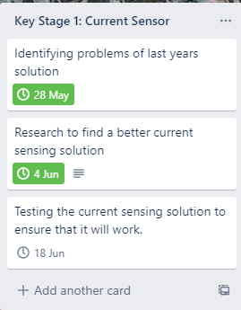
Research:
There are 2 widely used current sensing methods for DC current, these are hall effect and shunt resistor current sensors.

Hall effect Pros:

- High current sensing range. This is an advantage because it allows a small sensor to measure a large amount of current. This helps to keep the outcome compact.
- Electrical Isolation. This is an advantage as it means that the current sensor can be placed anywhere in the circuit, or even in another circuit, regardless of the voltage potential without the need for extra circuitry. This is an advantage because it means the current sensor could be moved between the high side and the low side of the circuit without having to make any other changes to the circuit.
- Non intrusive. can be placed over an existing wire. This is an advantage as it allows more flexibility as to where the sensor can be placed.

Hall effect Cons.
- High Cost. This is a disadvantage because it would increase the cost of the outcome.
- Measurement drifts, requiring compensation. This is a disadvantage because it would require frequent calibration to work accurately
- Measurement affected by external magnetic fields. This is a disadvantage because strong magnetic fields such as that from a motor would be able to mess with the current readings.

Shunt resistor Pros:
Low Cost
This is an advantage because it will decrease the total cost of the outcome, or allow for more money to be spent elsewhere.

Shunt resistor Cons:
- Power loss due to resistance. As the sensor will have more resistance than an equivalent hall effect based current sensor, the shunt resistor based current sensor will have a larger volt drop and therefore waste more power (V=IR), (P=IR). This heat will also have to be dealt with.

- Low output voltage requires amplification: This is a disadvantage because it means that extra circuitry is required to accurately interface with the sensor, increasing the complexity and cost of the outcome.

Last year's solution utilised a hall effect based current sensor. The main reason this was chosen was the isolation it would provide between the Arduino and the high voltage, high current circuit comprising of the battery, motor controller and motor. This meant that it did not matter whether the sensor was placed on the high or low side of the battery providing more flexibility. It also reduced the chance that the 2 circuits would “mix” , potentially causing damage to the sensitive low voltage electronics.

This year, I will use a shunt resistor based current sensing method. I have chosen to use this as flexibility is not a matter this year as it will be going on to a PCB and therefore won’t be able to be moved around anyway. I have also decided that the potential risk of the 2 circuits mixing is minimal and extremely unlikely, especially if everything is on a PCB where things will not move about.

As per the con’s, power loss can be kept to a minimum by using extremely low value resistors of under 1 milliohm. For example, A 0.5 milliohm resistor would only dissipate 5 watts at an extremely unlikely maximum current of 100A. Assuming that this is the worst case scenario and it occurs at 48V, the total power wasted by the sensor would be 0.1% of the total power. (P=I^2*R) (P=IV)

In a more reasonable scenario where efficiency would be the most important such as 12V 5A as seen in the economy run, the total power wasted by the resistor would be 0.0125W or 0.02% of the total power.
As such, the power loss through the use of this current sensing method would be negligible, and it is not an issue.

What may be an issue though is the extremely low voltage that this sensor would provide.
At 1A, the voltage drop over the resistor would be 0.5mv (V=IR). The resolution of the Arduino ADC is about 5mV per “step”. This would only provide me with a resolution of 10A (5mv/0.5mv), which would be insufficient to provide valuable data. A solution to this would be to use an operational amplifier in between the sensor and Arduino. If I used an op amp with a gain of 100, then the 0.5mV would become 50mV. This would give me a more than sufficient resolution of 0.1A (5mv/50mv). This would also mean that at the maximum current that needs to be measured of 100A, the op amp would output 5V which is perfect.

As such, a 0.5 milliohm resistor connected to an opamp with a 100x gain should be suitable for my requirements.

Testing:
I used tinkercad circuits to simulate the circuit. I decided to use tinkercad circuits as it was easily accessible, cheap and unlike other electronics simulation software allowed for emulation of code.

At first I made a simple circuit with a 0.5mohm resistor connected directly to the analog pins of the Arduino. It was unable to detect any current at 1A.

I increased the current to 5A, and the Arduino was able to detect that there was some current. This confirms what I thought would happen and tells me that an op amp will be required.
In order to calculate the value of resistors needed for the op amp to have a 100x gain in a non inverting op amp circuit, I used the formula, gain = 1+(R2/R1). I decided that the smallest value resistor would be 1kohm, this means that R1 = 1kohm. This gives me the formula 100 = 1+(R2/1000), which can be solved for R2. In order for a 100x gain, R2 must be 99kohm.

After adding an op amp with a 100x gain, I got a much higher value of 52 as expected. In order to convert this value to Current, I must divide it by 1023/100 as this maps the maximum analog value to the maximum current.
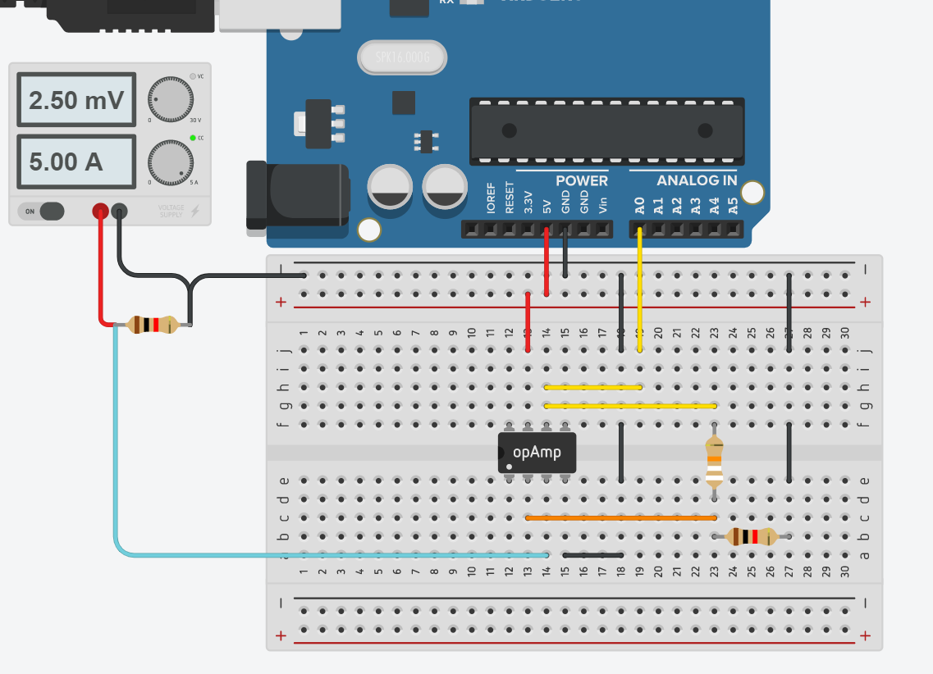

Doing this gave me the correct value of 5A. This matches the current supplied by the power supply showing that the circuit and code works as intended. However, the current measurement would not be shown with any decimal points. This was because the datatype of the “var” variable which stored the analog input was an integer which does not have any decimal values. I changed the datatype to a float which fixed the issue and displayed decimal values.

Discovering new problems
Doing so however, exposed a problem which was hidden before. This problem was that my current sense voltage when there was no current was GND voltage (0V), however, the op amp is unable to output lower than 20mv . Likewise, it is also unable to reach the full supply voltage of 5V. The result of this is that it was unable to measure anything less than around 4A.
In order to solve this problem, I decided to use an offset voltage and use an inverting op amp circuit so that the op amp would not need to reach full GND, therefore avoiding the error.

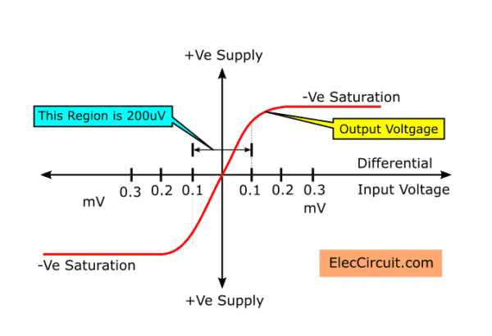
I decided to use a 0.5V offset voltage to ensure that I would be within the linear region of the op-amp (where the line is straight). However, as the op amp would still try to amplify the 50mV from the current sensor to 5V, I would lose some current sensing range as the op amp output voltage plus the offset voltage would be 5.5V, however the op amp could only supply 5V at best, therefore the upper 0.5V worth of range would be lost..

In order to solve this problem, I came up with 2 solutions. The first was to decrease the gain factor. If the gain factor was reduced from 100x to 80x, then 50mV would only be amplified to 4V. As 0.5V (offset voltage) + 4V=4.5V, this would maximise the resolution while ensuring that the voltage remained in the linear region.

The second solution that I came up with was to use a shunt resistor with a lower resistance. For example if a 0.3 mohm resistor was used instead of the 0.5 mohm, the amplified voltage with a 100x gain would be 3V. The gain factor could be increased slightly to get this closer to 4V in order to maximise the resolution.

After looking for appropriate resistors, I decided on the second solution as it appeared to be that 0.3 mohm resistors were more common than 0.5 mohm resistors.

In order to apply a voltage offset, I found that I would need to change the circuit from a non inverting amplifier circuit to an inverting differential amplifier. This works as an op amp only amplifies the voltage difference between its 2 input pins. This would mean that the opamp would output ~4.5V when there is no current, and approach 0V as the current increases.

The first step in my calculations is to figure out what gain factor I would like to have.
If the shunt resistor I use is 0.0003ohms, then at the maximum current of 100A, V=IR so there will be a volt drop of 0.03V. In order to amplify this to roughly 4V, I will require a gain of 4/0.03. In order to achieve this I used the formula gain=R2/R1 and decided to use a 40k resistor and a 300 ohm resistor. I decided on these values because they are neither too high, where very little current would flow, and are not too low where too much current may flow.

Once I knew the gain and the resistors I would use, I could then work out the bias voltage I would need to achieve. To do this I used the formula V(bias) = V(out) - Gain(V+ - V-)
Substituting the numbers gives me a bias voltage of 0.03375, which I decided to achieve using a 680 and 100k resistor. This was the circuit that concluded.
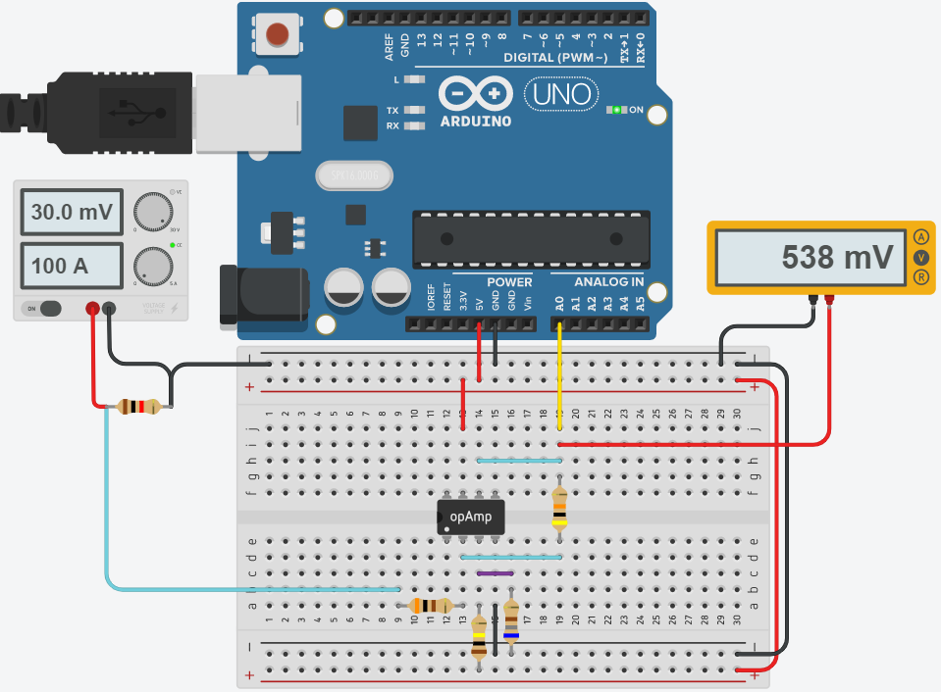

As it is an inverting amplifier, the output voltage is approximately 4.5V at 0A and approximately 0.5V at 100A. The small discrepancy between the exact 500mV I planned for and the 538mV as shown above would be caused by factors such as the 5V reference voltage not being exact, and the voltage divider not being the perfect ratio. However, this is expected and can easily be compensated for in the code.
In order to calibrate/compensate for the error, I first recorded the analog read value at 0V, and at 100A. This gave me 928, and 110 respectively. In order to convert the analog read values into the correct current, I first subtracted the value from 928, then multiplied it by 110/818.
This gave me some very good results, and it was able to measure a current of 1A, with 98% accuracy and 100A without observable inaccuracy.

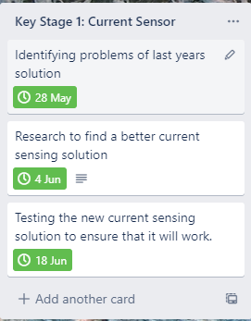
Conclusion:
As such, I have identified problems from last year's current sensing solution, researched the advantages and disadvantages of multiple sensing solutions and have tested the new solution through the use of simulation software to check that the new current sensing solution will work well. As such, I will be concluding key stage 1, and moving on to key stage 2.

This key stage was completed on time and to a high standard and therefore I have decided to make no changes to my plans for the following key stages.
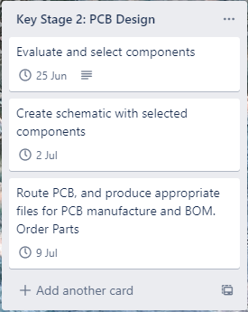

Key Stage 2: PCB Design

In this key stage I aim to go through the PCB design process to create a design that can be sent off to be manufactured. I also plan to create a BOM for purchasing of components to minimise the chance that a component is not ordered.

Component Selection:
These components have been selected for cost and availability, as well as other component specific reasons. I decided to use SMD components where possible for a few reasons. These are availability, size, and cost. SMD components are now far more common than through hole components. This means that I will have more component options by using SMD parts. SMD parts are also a lot smaller than their through hole counterparts, this allows the outcome to be made more compact. Furthermore, SMD assembly is cheaper than through hole assembly. This would be beneficial if the PCB assembly is outsourced. For these reasons, I will be using SMD components rather than throughhole components where it is feasible to.

Microcontroller | Arduino 2560 mini. I decided to use this microcontroller because it uses the same ic as is used on the Arduino mega. This will make it very easy to test certain aspects of the outcome on an Arduino board. It will work well for my project as it has sufficient analog and digital pins, as well as an spi interface which can be used for the LCD. In addition to this, there will be a lot of support available through the Arduino community.  I am using an Arduino board rather than putting the microcontroller directly on the PCB, as it eliminates a lot of small components that I would have to source and install myself.  https://www.aliexpress.com/item/32967417746.html
Display | As I desired a high resolution of 320x480 at 16 bits per pixel (rgb 565), it was clear that a high bit rate would be required to keep latency low which would allow for a higher refresh rate.  In order to achieve this, I looked into a variety of LCD’s with different communication protocols to determine which would be best. The first one I found was this one by Adafruit, which supports both SPI (serial peripheral interface) and 8 bit parallel.  https://www.adafruit.com/product/2050  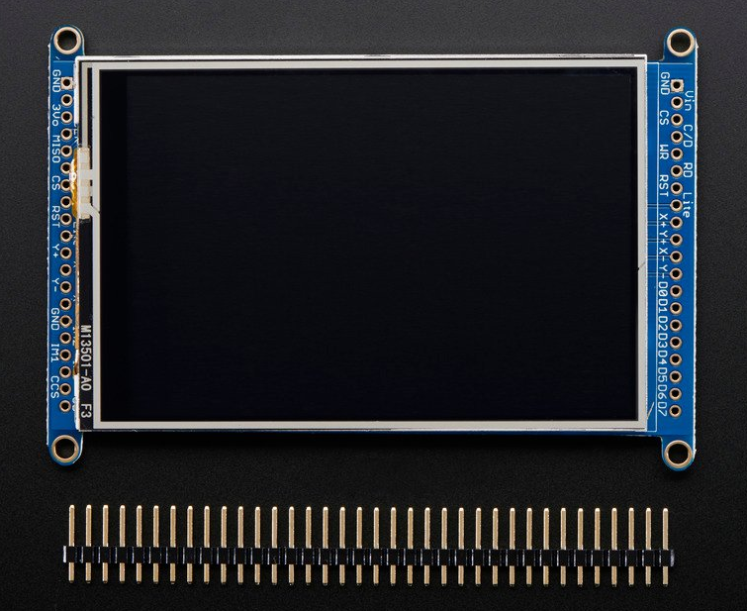  The SPI protocol has the advantage of requiring less pins, however takes more clock cycles to output all of the data as it can only output 1 bit at a time. In comparison, the 8 bit parallel sends 8 bits at the same time making it 8 times faster. Parallel protocols have a higher bitrate at the same signal frequency as they can output many signals at the same time, whereas a serial protocol has to output single bits one after the other.  I then found this Ili9486 320x480 3.5” LCD. Which allows for 16 bit parallel communication, this means that 16 bits of data can be sent in a single signal cycle, which should allow for a much higher bitrate than the serial port and 8 bit interface supplied on the Adafruit LCD, which should translate to lower latency and a higher maximum refresh rate.  This display is also compatible with a large amount of Arduino LCD libraries which should make it easy to use. It also has a connector on it which allows it to plug directly into an Arduino mega.  https://www.aliexpress.com/i/32609807497.html
Shunt resistor | I have chosen this resistor as it is the resistance that I require, and is also rated for 10W heat dissipation which means that it should stay fairly cool even under heavy loads. It is also made from a special alloy which has a stable resistance under temperature fluctuations.  https://lcsc.com/product-detail/Current-Sense-Resistors-Shunt-Resistors_Shenzhen-Yezhan-Elec-ASR-M-7-0-3F_C469443.html
Op-Amp | I have chosen this op amp as it is popular, which means there are many tutorials and schematics on how to use it. The design is also highly robust, and it will be easy to sort a replacement if needed.  https://lcsc.com/product-detail/General-Purpose-Amplifiers_ON-Semiconductor-ON-LM324DR2G_C63820.html
Resistors | I will be getting these values of resistors. The 40K, 300, 680, and 100K resistors will be used as part of the current sensing circuit. The 2K and 22K will be used in the voltage divider. They are SMD for ease of assembly and are +-1% tolerance to ensure accurate readings.  40K, 300, 680, 100k, 2K, 22K  40K ohm:  https://lcsc.com/product-detail/Chip-Resistor-Surface-Mount_HKR-Hong-Kong-Resistors-RCT0540K2FLF_C178188.html  300 ohm:  https://lcsc.com/product-detail/Chip-Resistor-Surface-Mount_300R-300R-1_C114529.html  680 ohm:  https://lcsc.com/product-detail/Chip-Resistor-Surface-Mount_Resistor-Today-AECR0805F680RK9_C328406.html  100k ohm:  https://lcsc.com/product-detail/Chip-Resistor-Surface-Mount_UNI-ROYAL-Uniroyal-Elec-0805W8F1003T5E_C149504.html  2K ohm:  https://lcsc.com/product-detail/Chip-Resistor-Surface-Mount_Walsin-Tech-Corp-WR08X2001FTL_C163983.html  22K ohm:  https://lcsc.com/product-detail/Chip-Resistor-Surface-Mount_RALEC-RTT052202FTP_C104107.html
Voltage regulator | I have decided on this switching voltage regulator. I have decided to use a switching regulator over a linear voltage regulator as a linear regulator would dissipate too much heat due to its inefficiency. This specific model has been selected as it allows up to 60V input, has a fixed 12V output, and can output up to 3 A. Furthermore, the datasheet is in english and easy to understand.  https://lcsc.com/product-detail/DC-DC-Converters_UMW-Youtai-Semiconductor-Co-Ltd-LM2596HVS-12_C347446.html  This switching module will also require the following components to function properly.  Inductor:  https://lcsc.com/product-detail/Power-Inductors_YJYCOIN-YSPI1050-680M_C497902.html  Capacitors:  https://lcsc.com/product-detail/Aluminum-Electrolytic-Capacitors-Leaded_AISHI-Aihua-Group-ERF1BM221G20OT_C106516.html  Diode:  https://lcsc.com/product-detail/Schottky-Barrier-Diodes-SBD_DIYI-Elec-Tech-S56_C129826.html

Schematic:
Now that all the components had been selected, I selected them from the pcb design library and placed them on the schematic grid.

At this point, I decided that I was going to split the electronics up in half, so that the majority of the electronics such as the Arduino and the LCD would be on one PCB, with the Current sensor on another PCB.
The reason I decided to do this is because the LCD would be mounted directly to the PCB. While it is possible to run wires to the LCD, the LCD has 34 pins of which around 20 are used. This would have meant that I would have had to make a custom cable which could have taken a lot of time to make as I would have had to make about 20 crimps on either end of the wires. As such, I decided that the better option would be to have the LCD directly mounted to the PCB. This also has the advantage of minimising possible interference with the video transmission between the Arduino and the LCD. As such, if I was to only use a single PCB, then the current sensor would have to be mounted near the steering wheel. This is a problem because the high current circuit involving the battery, motor controller, and motor may not necessarily be near to the steering wheel. As the shunt resistor must be in series with the high current circuit, this would result in high current wires having to be run from the battery, to the steering wheel, and to the motor controller, this would be a disadvantage because the high current wires are not cheap, are not very flexible, and it would also increase the conductive losses. On top of this, the high current flowing through the wires could cause interference to other electronic systems within the vehicle.

Components laid out:
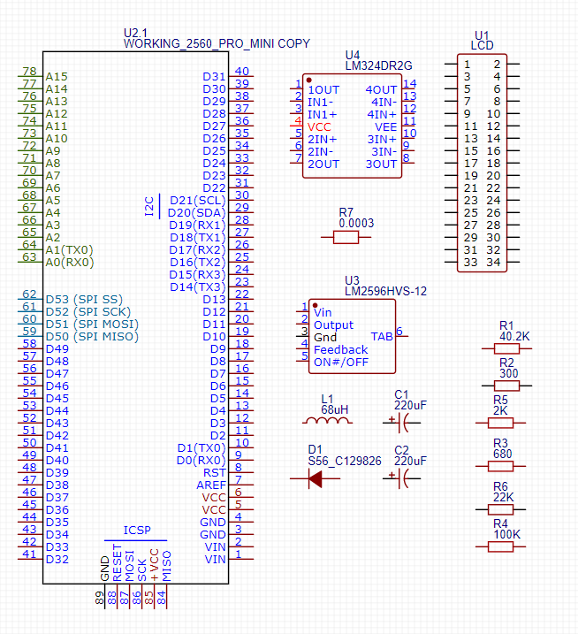

Once I had all the components selected and placed into the design environment, the next step was to tell the software how all the components should be connected.
During this process I added any necessary components as well as connectors. I also added extra connections to unused analog and digital pins in order to provide auxiliary connections. Furthermore I bought out some connections for interfaces such as rx/tx and I2c for future expansion. In order to keep the layout neat, I opted to use net tags which eliminated a lot of the traces between components. 3 LED’s were also added for fault diagnosis.

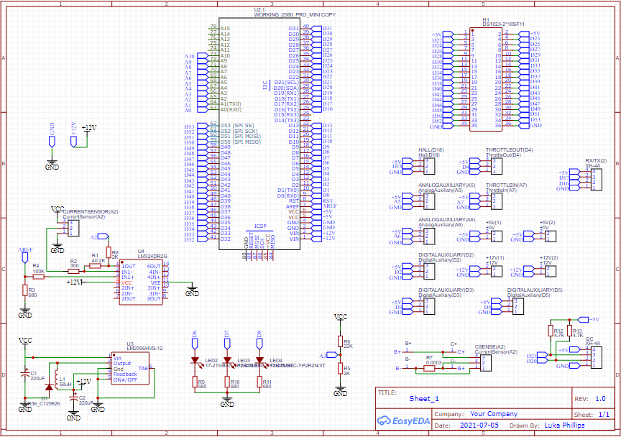
PCB Routing
I then used this in order to design the PCB. This was done by first arranging all the components into the board outline, and then routing the tracks and copper areas between the components until all the necessary connections had been made. The board was designed to be 2 layers, which means it has a copper layer on the top as well as the bottom. This was necessary to be able to route all the tracks neatly. In order to connect between the 2 layers, Via’s which are a small plated through hole have been used.
I decided to use a ground plane on both the top and bottom copper layers. A ground plane is a large copper area which connects all required things to ground. It is beneficial as it eliminates the need to route ground tracks, and it also helps to shield other tracks which decreases signal noise.
Special care was taken when routing the tracks near the shunt resistor. This is because the high current flow creates a magnetic field which can be induced in nearby tracks or wires resulting in a very small induced voltage. Another thing I had to be careful of was to make sure that the current carrying contacts did not have any current flowing through them as that would also change the measurement slightly. Even though these effects would only induce a very small voltage, likely a very small fraction of a mV, it was important that I did minimize them, as if I was to measure 1A, the measured voltage would only be 0.003mV and the noise could create a significant error in the reading. Therefore contacts were placed on the inside of the resistor, opposite to the current carrying side to ensure no current would flow through the sense wires. It also helped to reduce the amount of noise that the tracks could pick up.
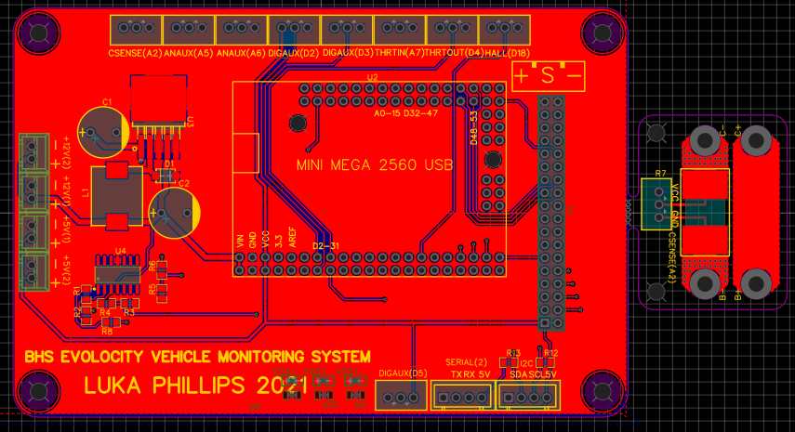

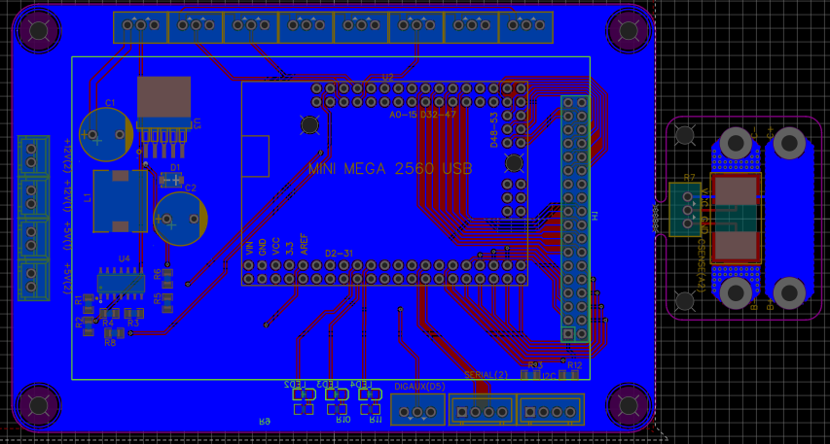
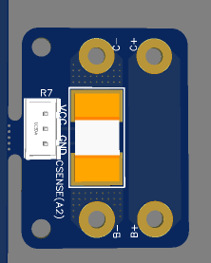
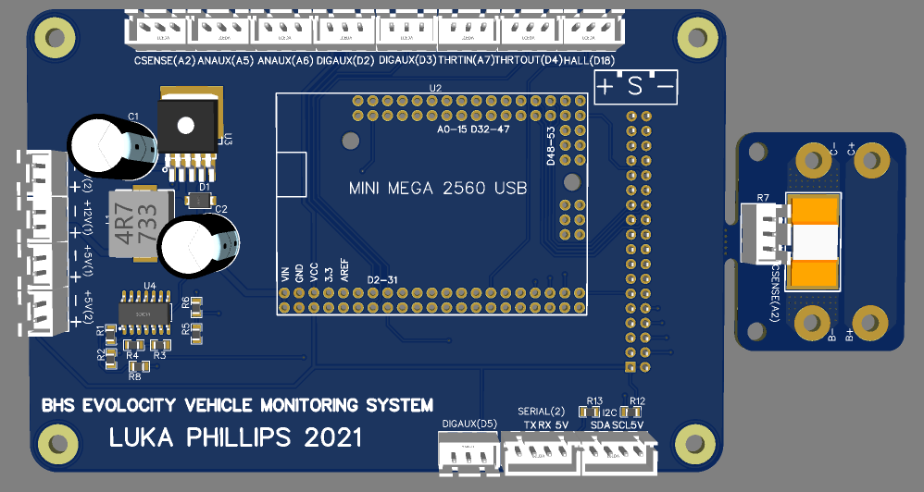
The PCB has been designed so that the Arduino and connectors plug into the back, with the LCD and signal LED’s on the front. This has been done to make the outcome smaller, as otherwise they would need to be placed next to each other which would use a lot of space.
The current sensor board has been designed to be able to snap off of the main PCB. This was done as a cost saving as it meant that I wouldn’t have to order 2 PCB’s but rather a single PCB with 2 designs. This break was done by placing many small holes along the edge of the larger board. This results in a section without as much material, which will break when enough force is applied.

Parts Ordering:
From the PCB design, I was able to directly submit an order through JLCPCB, which I had received good quality PCBs from before. This meant that I did not have to deal with gerber files and such with a 3rd party which could have resulted in compatibility issues.
I was also able to export a BOM from the PCB design, however it lacked some parts which hadn’t been included in the design such as the headers for the Arduino, so I found the parts from LCSC, added them to the BOM and ordered them.
The LCD and Arduino were not available from lcsc, so they had to be ordered from aliexpress

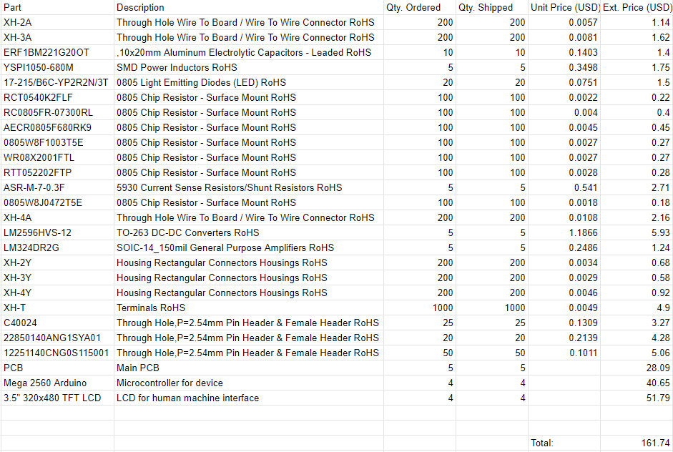
Costing with shipping included.
Product | Quantity | Cost (NZD)
Various electronics components | 1 | 116.98
PCB’s | 5 | 34.46
Arduino 2560 mini | 5 | 58.31
LCD | 5 | 74.29
 | Total cost | 284.04

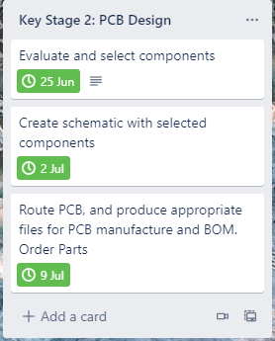
Key Stage 2 Reflection:
All processes went smoothly and parts were ordered during the 2 week term break. The electronic components and PCBs were received within the first week of the term. The LCD and Arduino have not arrived yet however this is not an issue as I have the same model of Arduino ordered earlier for personal use, as well as an LCD ordered for use last year. I will be able to test the outcome with these while I wait for more to arrive.

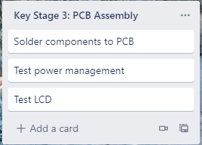
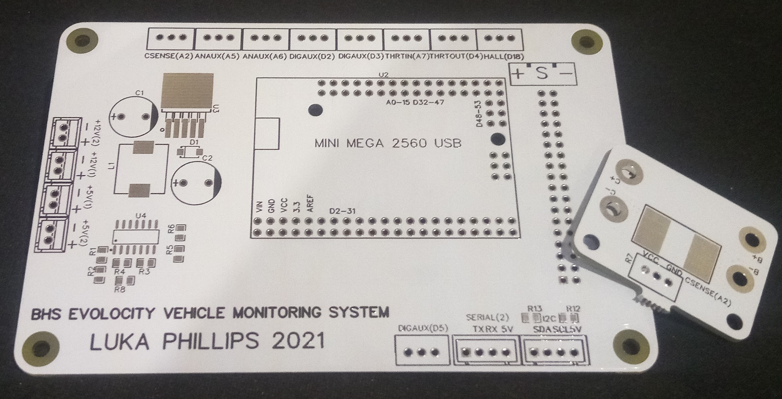
Key Stage 3: Assembly

PCB assembly
Before beginning the PCB assembly process, I checked that all necessary components had been ordered and received. During this check I realised that I had forgotten to order the diodes for the 12V buck circuit. I ordered some equivalent diodes from a local supplier and while waiting for them started work on the assembly of the rest of the parts.
I started off by soldering the surface mount components as they had the lowest profile. After all the surface mount components had been soldered, I soldered the through hole components. I used sockets to connect the Arduino and LCD so that they could be disconnected easily. Without the use of sockets, in the case that the Arduino or LCD failed, The whole device would become useless as it would be nearly impossible to desolder so many pins at the same time. It was also beneficial to troubleshoot as it allowed me to quickly identify if the problem was caused by the Arduino, LCD, or PCB.

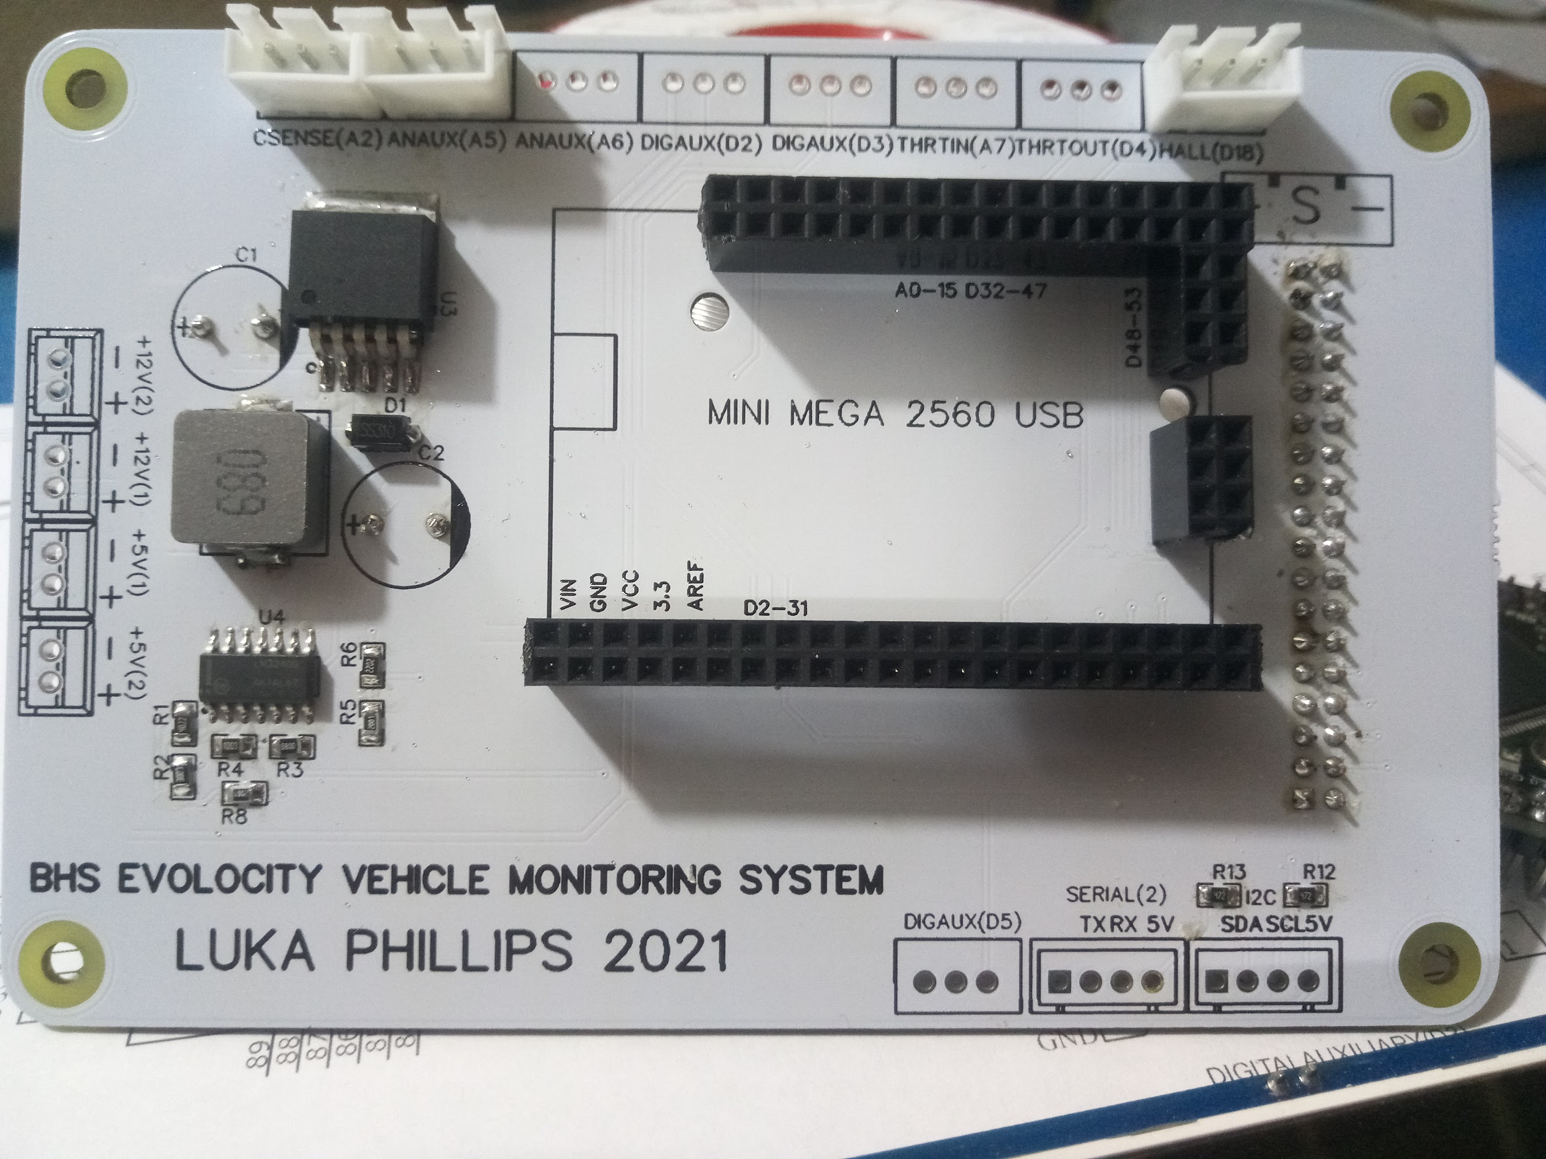
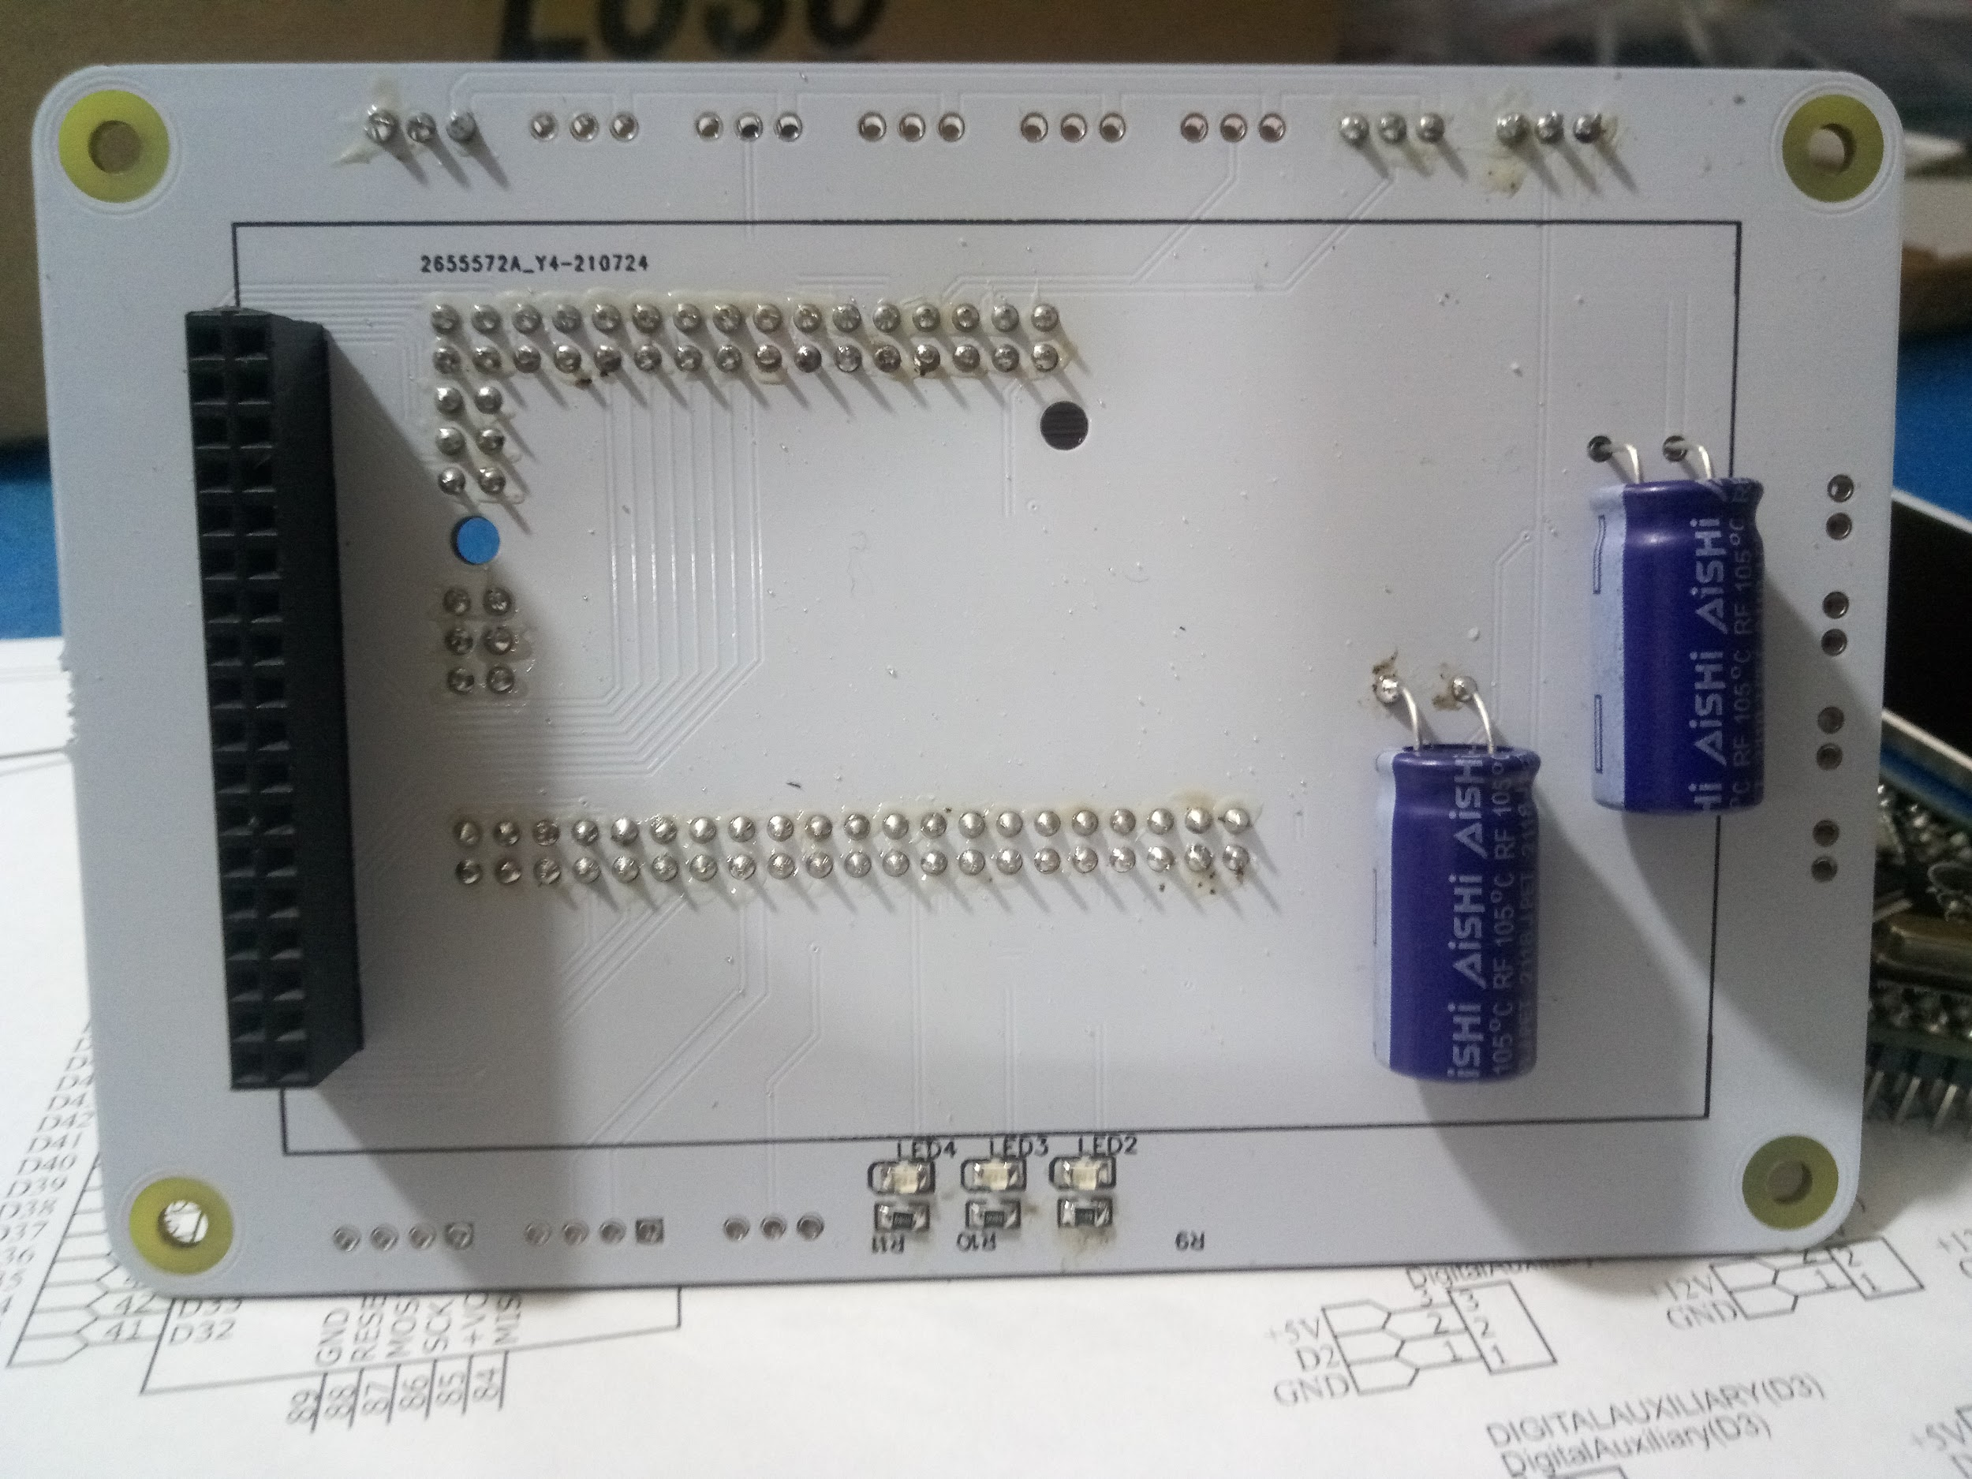
Power Management Testing:
Once the PCB was assembled the next step was to test the power management circuit to ensure that it was working correctly. In order to do this I used a variable power supply with the current limit set to 200ma. The purpose of the current limit was to protect the circuit in the case that a fault is present. A fault would likely cause a low resistance resulting in a high current flow. This would result in a component generating a lot of heat, eventually causing it to fail. However by limiting the current, the heating of components was also limited protecting them from overheating. In order to test the power management circuit, I set the power supply output voltage to 20V, and measured the output voltage of the voltage regulator with a multimeter. The voltage was 12V as expected and so I knew the power management circuit was working. I connected a power resistor across the 12V output to increase the output current and there was no change in the output voltage. This was as expected and from this I knew that the power management circuit was working properly.

LCD Testing
The next step was to test the LCD. In order to do this I used some example code and the TFT_HX8357 library which worked with the Arduino mega and the display that I was using. This worked straight away without any problem, and therefore I was sure that the section of the PCB responsible for the display was designed correctly.
The example code I used displayed an analog style meter and it was able to display the movement very smoothly. This was a massive improvement to the library I was using last year which only managed 2hz even with simple text, due to the long time it took to write the data to the screen.

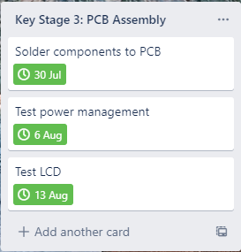
Key Stage 3 Reflection
Key stage 3 all went smoothly and according to plan. As such I decided that no changes would be required to the time frame moving forward.

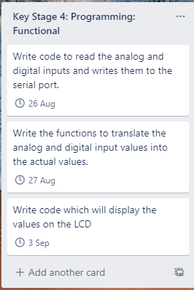
Key Stage 4: Programming:

Speedometer:
The first thing I did was to write the code for the speedometer function. The speedometer sensor consists of a magnet on the wheel, with a reed switch or hall effect device mounted close to the magnet so that the magnet causes the reed switch or hall effect to switch every rotation of the wheel.
I looked into existing code solutions, however they all used a timer interrupt to check the state of the wheel hundreds of times per second. I did not want to do it the same way as this method was unoptimised and wasteful of the Arduino’s resources. The constant interruptions may have also caused problems for writing data to the LCD, a problem that may have not been observed by the other solutions as they were using a much simpler 2x16 LCD. I instead chose to use a hardware pin change interrupt in order to detect each rotation of the wheel.
This was a much more elegant solution as the function responsible for acknowledging each wheel rotation would only be called in for each rotation of the wheel rather than 1000 times per second. As most mechanical switch contacts bounce, I implemented a debounce time so that switch bounce would not cause incorrect readings. The first iteration of the code was kept simple and only counted the number of times the switch was closed. However, this code had a major issue in that the speed wouldn’t go down to zero in the case that the wheel was to stop spinning as it was constantly waiting for the switch to close again.
In order to fix this, in the second iteration I implemented a timer interrupt which triggered once a second. This timer interrupt checked how many rotations had happened in the previous second, recorded it and reset the rotations in the last second to zero. This meant that I would now get an update of the average speed over the last second, and therefore solved the issue of the speed not going to zero. The speed could then be calculated by knowing the tyre circumference, number of rotations and time. I knew the number of rotations and time, however I did not know the tyre circumference and as such it was not implemented. Displaying the number of rotations rather than the speed also helped to make sure the code was working as intended.

I then combined this code with the example code which I used to test the LCD. Doing so allowed me to test that the speedometer function would not stop the LCD from working properly.
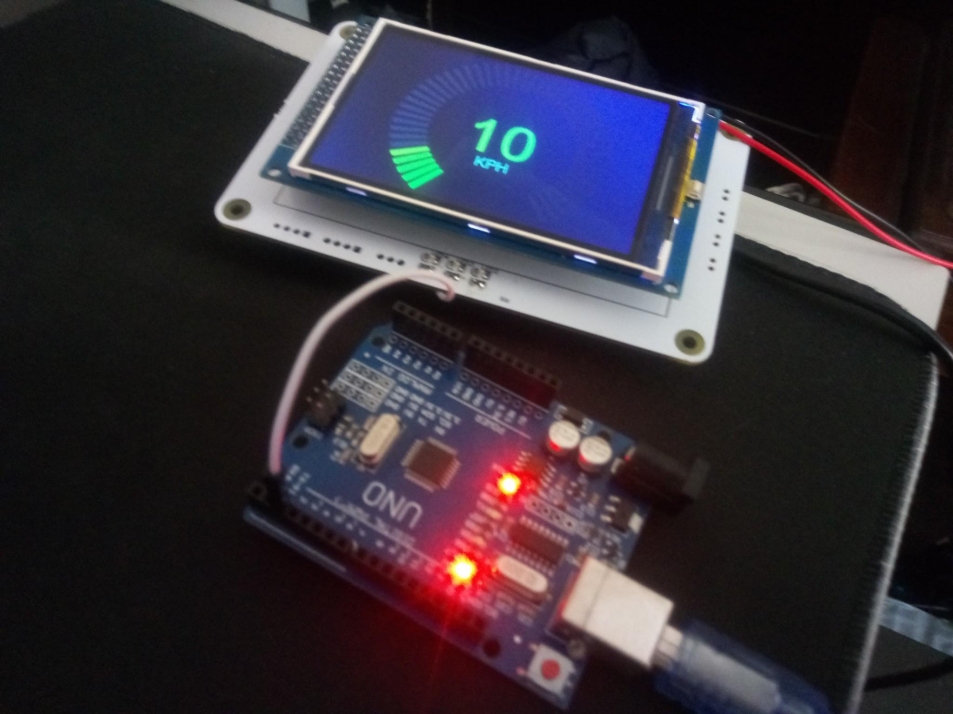
In order to test that it was working properly I connected the switch pin to another Arduino from which I replicated the sensor input by switching a digital pin periodically. This worked perfectly after fixing a few mistakes in the code, and the outcome was able to accurately tell the speed for anything at least 1 cycle per second, all the way up to 50 cycles per second at which point the limiting factor was the 20ms debounce time (1000/20=50) This could be increased by decreasing the debounce time, however it is not necessary as even with small go kart tyres with a circumference of roughly 1m, this would allow measurement for up to 50m/s or 180kmh which will not be achieved by the vehicles this outcome will be used on.
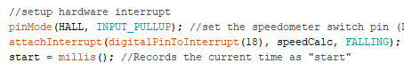
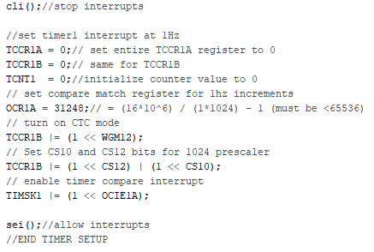
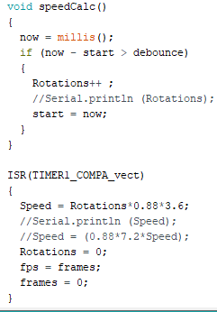

Voltage sensing:
Reading the ADC value at the Vsense analog pin and converting it to the actual voltage was quite easy. The main difficulty for this key stage was displaying said value to the LCD. For this, I wanted to experiment with text as it would allow me more freedom than just gauges. I first had a look at how the value within the dial had been printed, and for this they used a function from the TFT_HX8357 which was called “tft.drawCentreString”. As this command can only accept a string, and the datatype of the value was an int, they first converted the int to a string before printing. I didn’t like this approach and it didn’t suit my need for printing the voltage as the voltage value would have a decimal value meaning the data type wouldn’t be a float instead of an int. I was unable to get the code that converted the int to a string to convert a float to a string instead. I therefore looked at the documentation for the library and found the function “drawFloat” which was a much more elegant way of printing the voltage value. The second major problem I had was clearing the last printed value. The last printed value would not be cleared, and instead the new value would be printed on top of it creating a block of numbers on top of each other. In order to fix this problem, I wrote some code which recorded the last value and printed it in the colour of the background before the new value was displayed. This had the effect of clearing the screen. Finally, I wrote the equation to convert the ADC value to the actual voltage before it was divided by the voltage divider. I included a constant multiplier Vk, which I could change to calibrate the accuracy to account for inaccuracies in the resistor values. One problem I encountered was that the Arduino’s built-in analog reference voltage reference was not very accurate, and the reference voltage would change from 4.96V when powered from USB to 4.81V when powered from 12V. However, this reference voltage did appear to be stable and didn’t change so this should not compromise on the accuracy of measurements taken, as long as the device is calibrated correctly. This could be fixed by either using an external 5V precision voltage reference, or using the Arduino’s built in 2.56V reference with different resistors.
I calibrated the voltage sensing using a power supply which could output up to 30V, using a multimeter to measure the voltage accurately. I was unable to test the sensor fully as I did not have a power supply which could output 60V.
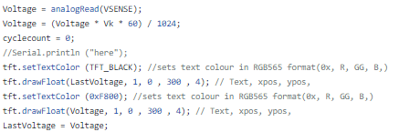

Current sensing:
The current sensing key stage was much like the voltage sensing stage in terms of programming, however there were a couple mistakes in the circuit design that had to be fixed.
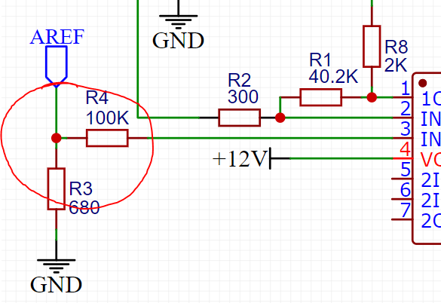
The first problem that I encountered was that I had not designed the voltage divider for the op-amp offset correctly. R4 should have been in series with R3 in between Aref and GND.
Another mistake I had made was to use the same ground for both the current sensing ground and power ground. As there was current flowing through the wire, this resulted in a volt drop making the voltage difference across the shunt resistor slightly larger than it actually was. I couldn’t compensate for this as the current flowing through the ground wire was not constant, so I had to run another wire between the board with the shunt resistor and the main board. I also decided to twist together the power wires to minimise any magnetic fields produced which may have induced noise into the current sense wires.
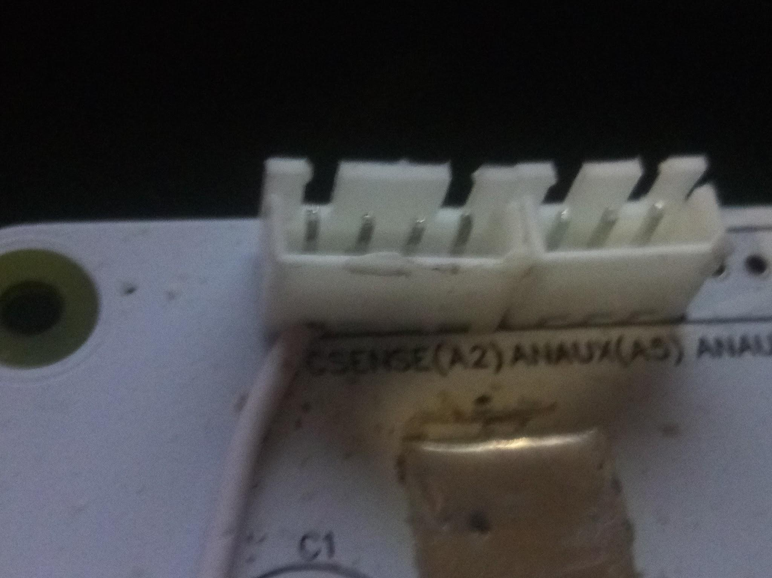
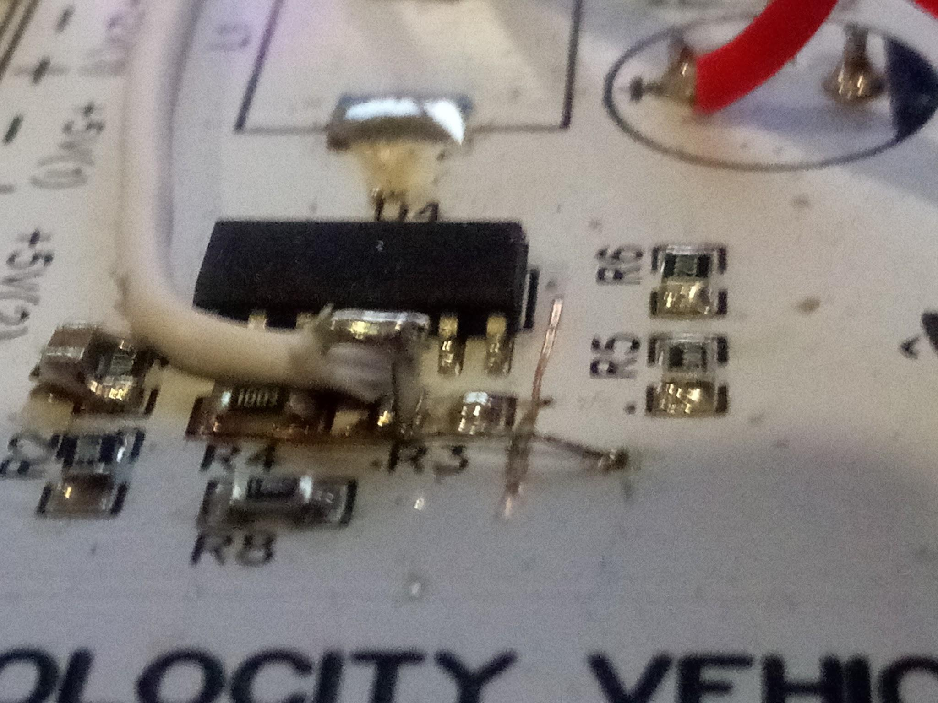

3 pin connector replaced with 4 pin to accommodate extra wire Repair job to fix design mistake.

After these fixes were done, I wrote some code to convert the analog input to the correct current. I did this using the following equation:
Current = (ZeroCurrent-Current)*(5/(137216*0.0003))*Ck;
Where “Current” is the analog input value of the current sense pin, “ZeroCurrent” is the analog input value of the current sense pin when there is no current, and Ck is a multiplier for calibration.
In order to print the value of the current to the LCD as a number, I did the same as I had done for the voltage display where I printed the value in a visible colour, before reprinting the value in the background colour in order to clear it.
I was unable to find any device which would allow me to test the sensor and code properly as doing so would have required the dissipation of a lot of power. The best I could do was a 50 ohm power resistor with the power supply set to 20V which would only draw 0.4A. I was unable to use a higher voltage and therefore more current as the resistor would have got too hot. However, it was able to accurately measure the 0.4A which was a good sign. I did try running a fairly large DC motor with a gearbox attached which drew around 1A, but due to the nature of brushed motors, the current was extremely erratic and I couldn’t tell whether the device was working as it should.
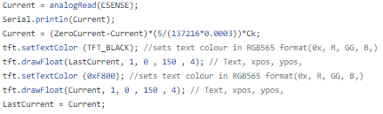
I also decided to add a function to see how frequently the screen was refreshing. I found that it was fairly stable at 6-8 frames per second, which was enough for everything to look smooth. This was done using the same timer interrupt as the speedometer which occurred every second.
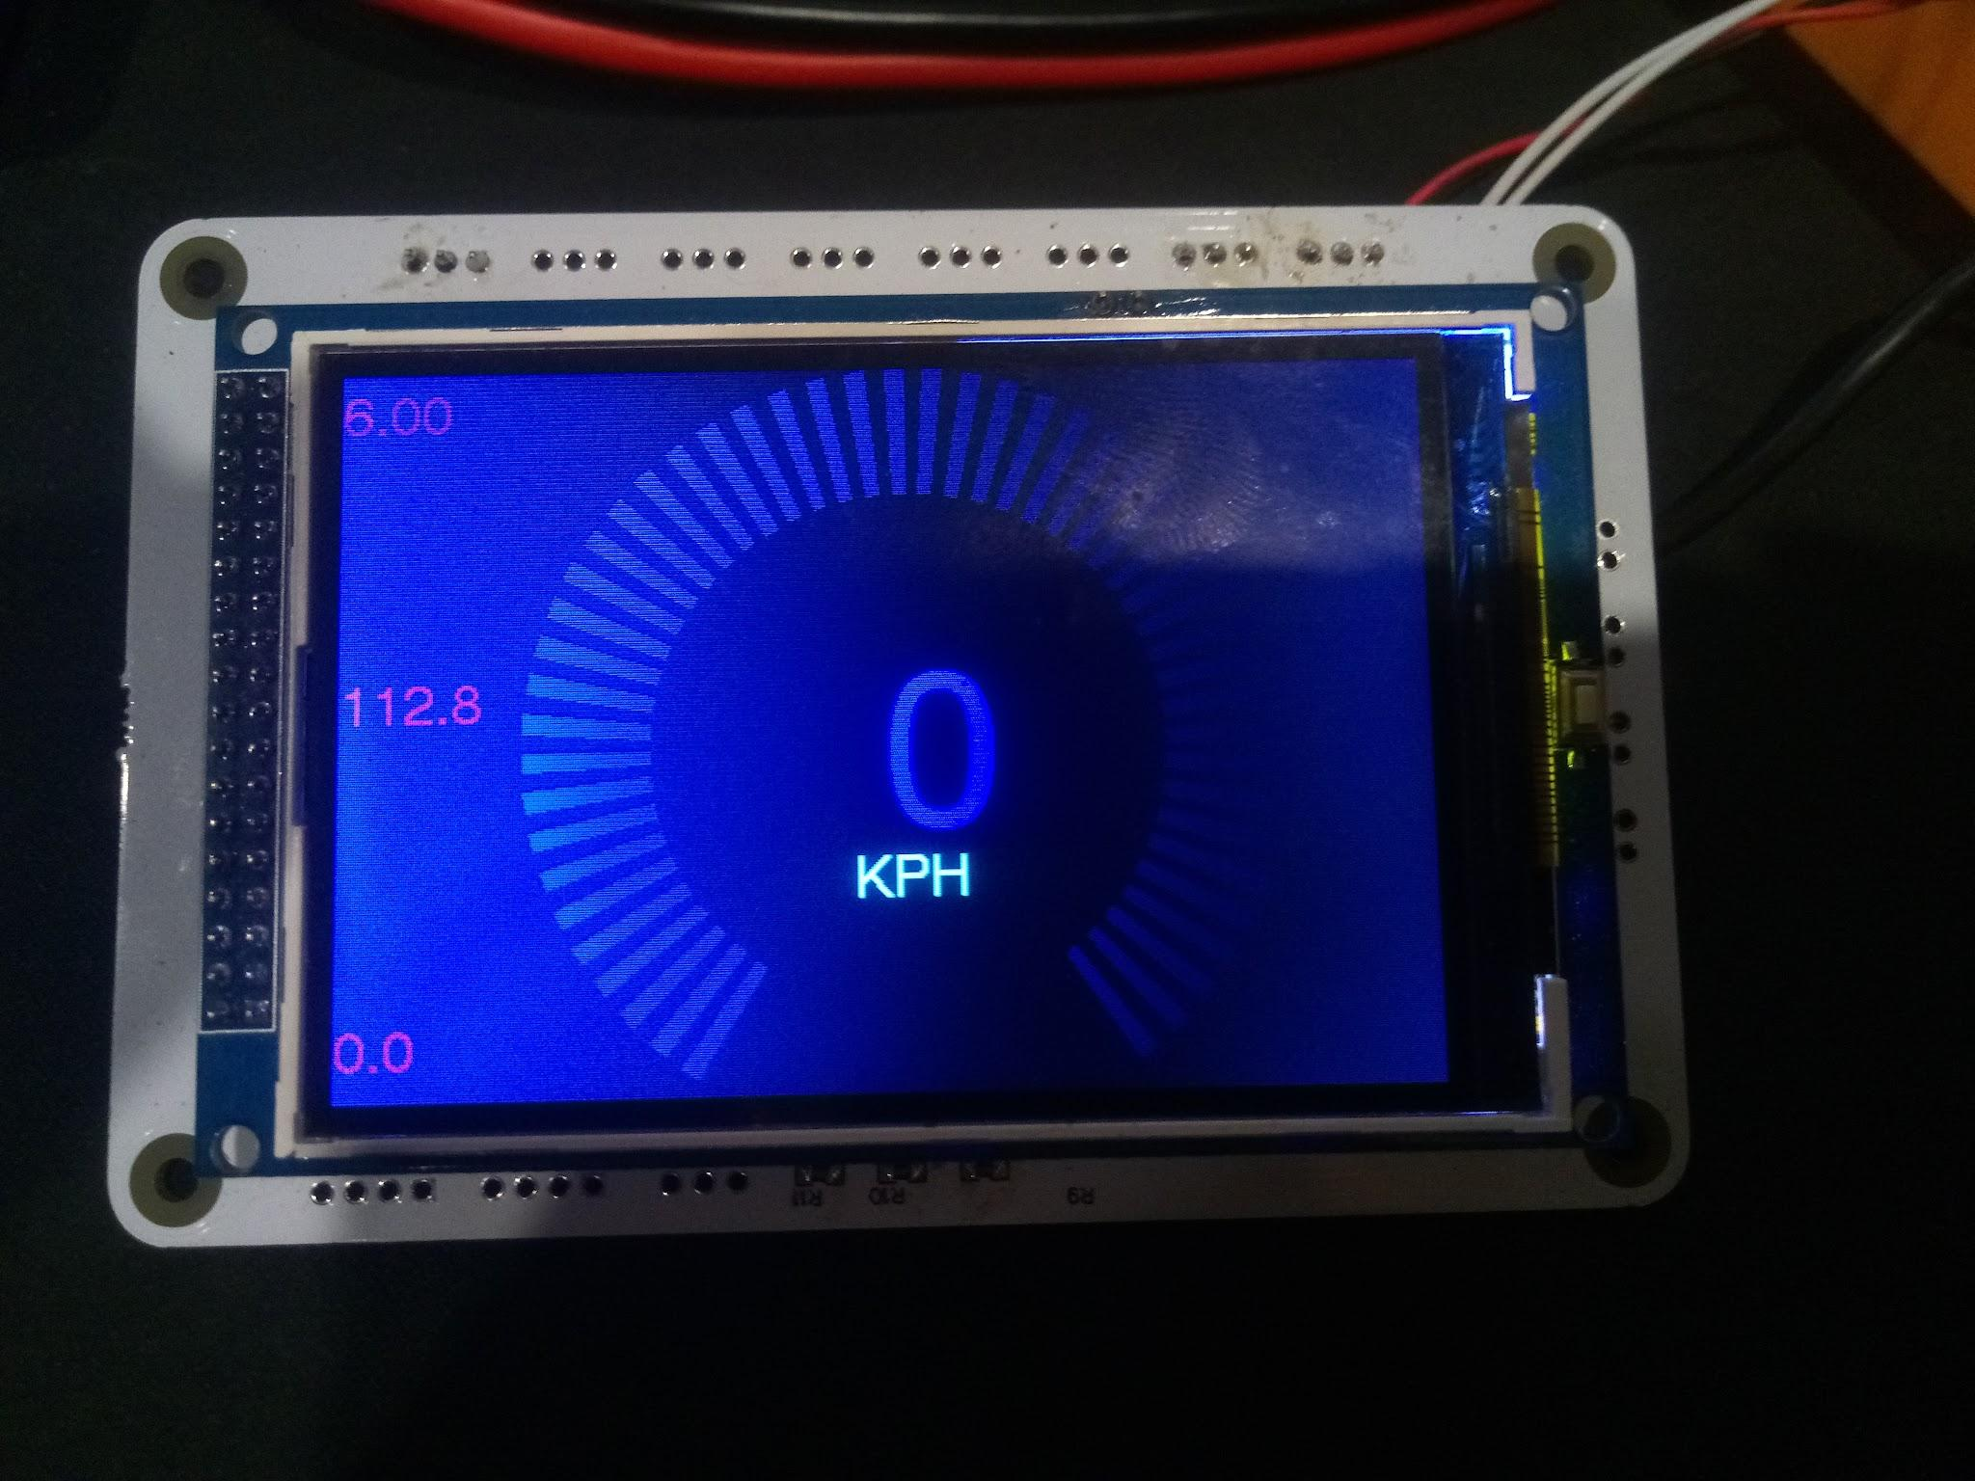
LCD screen with speed dial in centre, and FPS, current, and voltage down the left hand side. (Colours are much more vivid when viewed in person). This shows the LCD displaying all of the necessary raw data.

The next step was to design the interface to be optimised for the driver.

I noticed that while the gauge looked fancy, it took up a lot of precious space on the display and didn’t do very much functionally. At this point, I decided that I would try pursuing a simplified graphical style. To do this, I made a copy of the code and called it the simplified version. With this version, the guage was removed and the bare values were shown instead. I started by playing around with the position and size of the values to see what looked best. In doing this I realised that the numbers were quite hard to read in bright conditions such as sunlight. In order to fix this, I did some research into which colour is the most visible to the human eye in daylight. From this research, I was able to conclude that it is 555nm which sits right between green and yellow. I converted this to the RGB565 format used by the LCD which gave me the colour code 0xB7E0. This massively improved the readability of the screen and maintained readability even in sunlight.
In order to further improve the functionality of the display, I added more data points such as the maximum power, current, and minimum voltage.
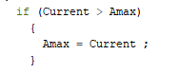
This was done by setting up a variable for the maximum value and checking each new value to see if it was larger or smaller than the previous value.

Another thing I did to improve functionality was to center the most important metrics and make them as large as possible so that they would be the easiest to read. This was the final result mounted in the steering wheel for initial testing.

Testing, feedback and fixes:
In order to verify that the outcome was fit for purpose and work out what changes were needed, the outcome was mounted and tested on the vehicle. All 3 measurements of the current, voltage, and speed worked, and they were found to be correct using a logging ammeter, multimeter, and GPS. However there were some pretty clear improvements that could be made.

During testing, it became very clear that the most important factor was the maximum current, as this was the instantaneous load the battery, controller, motor and any circuitry would have to handle when the motor was stalled such as during acceleration. I wanted to know this to a fair degree of certainty so that I could be sure that all the components were rated for it. This code was not good at measuring instantaneous maximums as it did not update the value very frequently, at around 10 HZ. This was mostly limited by the capability and frequency of the microprocessor to process and print the data to the LCD. In order to get around this and increase the polling rate of the current sensor, I set up the code so that the current sensor would be measured around 100 times for every refresh of the LCD. This massively improved the ability to measure sharp current peaks. In order to test this, I measured the maximum current under load and found that it was consistently getting between 105 A and 110 A. This was perfectly in line with the rated maximum of the motor controller which was 100A, the extra 5 A to 10 A could be explained by overshoot of the current limiting circuit in the motor controller.

Code used to limit LCD update rate, and increase current sensor sampling rate.
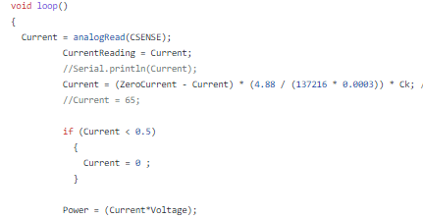
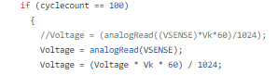

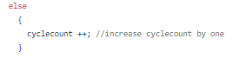

Another problem I had was that the current drawn by the motor changed rapidly which meant the current measurement would change frequently making it hard to get a good idea of the current. In order to fix this, I decided to implement an averaging algorithm which smoothed the current readings. This also had the effect of filtering out noise. The averaging filter worked by having a window of the last 10 values. The new value would be added and the oldest value removed so that the window of values always had the last 10 values. This prevented sudden changes in the current reading and made it much easier to keep track of.
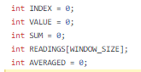
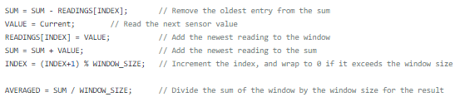

The final issue I had was that random numbers were being recorded as the maximum and minimum values for the readings when the device was powered up. I thought that this may have been caused by the analog to digital converter in the microcontroller not working properly while the microcontroller was still turning on, in order to fix this I wrote some code to void the first few readings taken before the ADC started working properly.
Initially I had it void the first 50 readings, but this did not work consistently so I increased it to 500. Doing this solved the problem and random values were no longer being recorded.
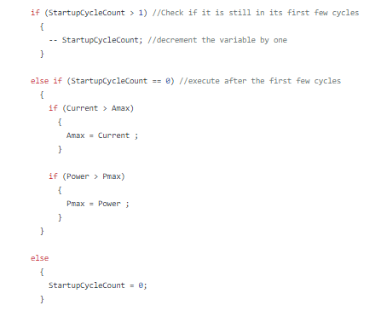

After all these fixes had been put in place, the outcome was tested again on the vehicle and no new problems were found. The visibility and arrangement of data on the screen also worked well.

Track Testing:
In order to make the race safer, the event organisers allowed us to do some test runs at the race track one week before the event. It was decided that the outcome would be tested here as it would push the device to the same limits it would be under on race day giving a definitive answer as to whether any changes need to be made or not
.
Unfortunately, due to the malfunctioning and badly designed power limiter we were supplied with before testing, the outcome I had built and the motor controller failed.

The cause of this issue was most likely due to the lack of a precharge resistor across the switching circuit of the power limiter, combined with the faulty power limiter repeatedly turning on and off.

The result of this was high voltage spikes being produced every time the power limiter turned on and off caused by the parasitic inductance of the wiring. This high voltage spike had enough energy to destroy the oxide layer of 8 of the 12 high voltage high current mosfets used in the motor controller, shorting the battery across them. It also managed to kill the voltage regulator which shorted the input to the output. This meant that the linear voltage regulator powering the microcontroller also failed, which resulted in the microcontroller being powered directly from the 48V battery instantly killing it.

This did not occur without the power limiter as the main kill switch has a precharge resistor across it which prevents exactly the voltage spikes that likely occurred. However, as the power limiter was connected after this switch and precharge resistor, the resistor was unable to do what it should have. This could not have been prevented by us as the regulations require the kill switch and thereby precharge resistor to be wired before the power limiter.

Simplified circuit diagram of Power Circuit

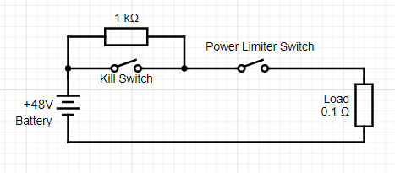

Circuit Diagram showing mosfet arrangement, and parasitic inductance.
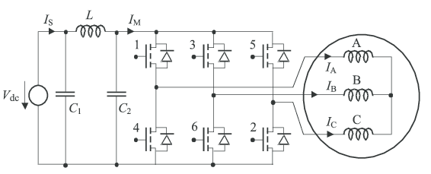

The LCD however still worked completely fine, which could be explained by it having its own on board voltage regulator which wasn’t under a high current load.
The opamp may have still been fine, but as I couldn’t guarantee that it would function properly I decided to write the entire board off and build up a new one.

As the process was the same as for the first one, building it up was even quicker and only took around an hour to get the new one up and going. If the outcome had been built on something such as a prototyping board, then it would have taken much longer and the dimensions wouldn’t be quite the same. Having the parts on hand was also extremely beneficial and meant that I didn't need to wait for replacement parts.

This ability to quickly replace the damaged board was an advantage of designing and planning for the board to be produced in mass, and it was a good demonstration of redundancy through replaceability. Having the new board up and running quickly meant that I didn’t have to worry about it and could instead focus on getting a new controller working.

Track Testing 2:
We were given a second chance to pre-race test the vehicle with the outcome on the track. However, to avoid any complications the power limiter was not used this time. This was unfortunate as it meant I couldn’t compare the power measured with my outcome to that measured by the power limiter. Regardless, the outcome worked flawlessly throughout the entire ~1 hour session. Reading the display was not a problem even with the sunlight and helmet.

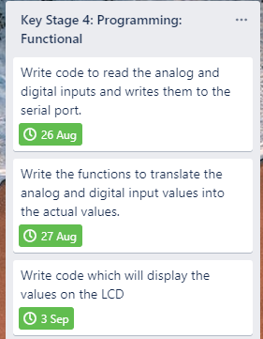
Key Stage Reflection:
The design mistakes cost me a decent amount of time which delayed the rest of the key stage, however I was able to recover from this and get all the data displayed on the screen in an easy to read manner. Implementing the fixes required after testing and feedback also went smoothly, and despite the original board being damaged through no fault of my own, I was able to quickly build up a replacement thanks to earlier planning, test it under race conditions, and fix it to the vehicle ready for race day.

Race Day:
The outcome worked perfectly all throughout race day with no problems whatsoever. This was a massive change from previous year’s designs which all stopped working on race day for one reason or another, usually due to loose wiring or connections.
The use of a custom PCB and latching connectors meant that the entire system was more robust and therefore less prone to failure. Another large contributor to this success was the large amount of testing that was made possible by having the outcome ready early. As the outcome had been tested many times and for many hours, I could be sure of its robustness which proved itself on the day.
The early testing also meant that the fault with the power limiter was identified and solved before race day.
While it was a shame that it took out the motor controller and the original board, the ease of construction and relatively low cost allowed the dead original board to be replaced quickly which demonstrated redundancy of the outcome.

Innovation Award:
The outcome won the innovation award for the collection and display of performance data.

Race Result:
The outcome was a great help and contributed to the win in the competition class race where the power limiter was used to limit power to 3000W. The outcome allowed the driver to monitor their power usage so that they were always at the limit of the maximum power, this in turn meant that the driver could maximise power usage without going over the limit which would result in the power being cut.

Final Evaluation

Comparison against brief:

Measures and displays the following vehicle data:
- Voltage, Electrical Current, Vehicle Speed, Power Usage.
All of these things were measured and displayed as demonstrated in the video.

- The device should also have unused connectors which allow for future sensors or inputs to be implemented such as temperature sensors, throttle sensors, or hall effect sensors.
This image of the finished board shows unpopulated spaces which can be populated with connectors and used.
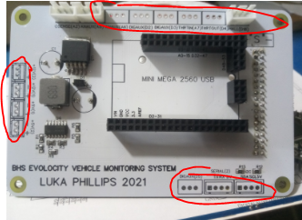
- The outcome should also use a display that can be easily read in the sun.
This has been achieved by using highly visible colours. The displayed values can be read even through a visor.

- Materials used must be UV resistant
The LCD is similar to that of a mobile phone which has no problem with similar amounts of UV during years of use. No degradation of the LCD was noticed during the testing process. The PCB and components themselves are enclosed so are not in any risk of UV exposure.

- Current measurement between 1A and 50A accurate to within 0.2A
The accuracy was tested and found to achieve the necessary accuracy by comparing the values against that of a commercial ammeter. The current range far surpassed the required amount and was able to achieve accurate readings between 0.5A and 110A.

- Voltage measurement between 20V and 60V accurate to within 0.2V
This was verified and found to be achieved with a multimeter.

- Speed measurement accuracy to within 0.5KM/H
This was verified and found to be achieved with a GPS speedo.

- Maximum dimensions 150*150*80mm
The dimensions of the PCB with parts soldered are 120*80*50. Therefore this has been achieved.

Summary:
The outcome that I developed was a small EV monitoring system that was designed to measure current, voltage and speed accurately.

This was achieved through thorough research, trialling of different methods in both hardware and software, as well as a repeatable method of production utilising a PCB.
The outcome has been developed with futureproofing in the form of expandability as a main goal to reduce E-waste and future costs.

The outcome was built to be reliable and robust through careful consideration of the construction method, component choices and software. Redundancy has also been considered by making the design quickly replaceable.

The constraints of covid and shipping times were planned and worked around to produce the final outcome on time. This allowed plenty of testing of the outcome to iron out bugs and verify the reliability and longevity of the design.

The final outcome was utilised in the event it was designed for, at which the outcome demonstrated that it was reliable and fit for purpose.

Finally, the winning of the innovation award and competition class award made certain the benefits of the monitoring system in the outcome of the competition.

Appendix:

Example Trello board:
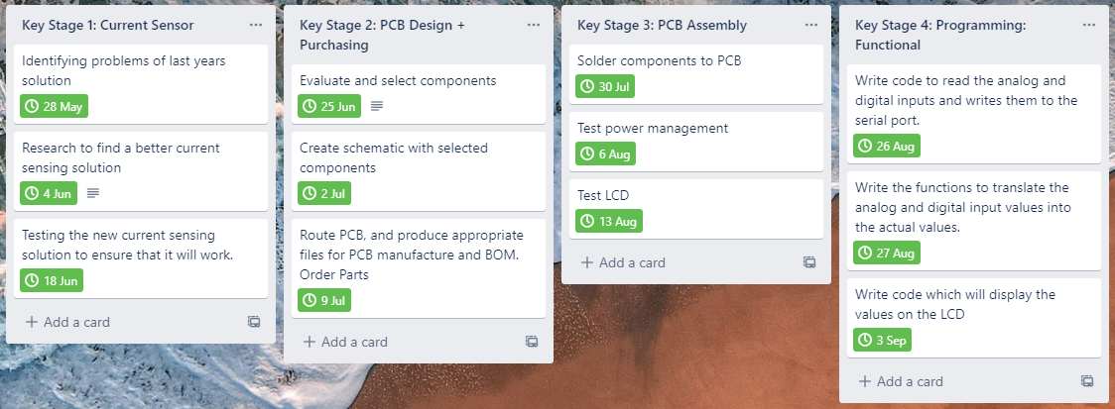

Bibliography
ClubTechnical. (2019, March 23). Top speed of a car. ClubTechnical. https://clubtechnical.com/top-speed-of-car
ClubTechnical is a regularly updated blog dedicated to mechanical engineering. As such its main purpose is to inform and educate. This site does not link to any other websites, and the only advertisements shown are ads run by google of which the authors have no control over. The information provided by this source would not favour any individual, organization, or company. Therefore I can say that the information is not biased.
To ensure the accuracy of the provided information, I cross referenced the information provided against the following sources and found that the information was consistent. This means that the information provided is highly likely to be accurate.
- https://www.newscientist.com/lastword/mg24232320-700-why-do-cars-have-speed-limits-is-it-physics-or-just-practicality/
- https://www.bryantmotors.com/car-buying-guide/basics-horsepower-torque.html

Environmental and Energy Study Institute (EESI). (n.d.). Vehicle Efficiency | EESI. EESI. Retrieved April 12, 2021, from https://www.eesi.org/topics/vehicle-efficiency/description
The Environmental and Energy Study Institute states that it is a non-profit organization dedicated to promoting sustainable societies. The main purpose of the source is to educate and persuade. This site does not link to any other sites, and does not have any advertisements. It also does not state any model of car or company which it could favour or oppose against. As such I can say that there are no biases which would skew the accuracy of the information provided.
Szymkowski, S. (2018, February 26). What’s the difference between horsepower and torque? Motor Authority. https://www.motorauthority.com/news/1115371_whats-the-difference-between-horsepower-and-torque
Motor Authority is a website which focuses on automotive product and industry news. The intended purpose of this text appears to be to inform and educate. Many of the articles that they do are car reviews which means that it may be possible for them to be biased towards certain companies. The specific article that I have chosen to describe the different effects of torque and horsepower does give specific car models, however, the provided information does not favour one vehicle over the other and gives accurate verifiable data. Therefore this source has very little bias, and the information is likely to be accurate.
Lucas, J. (2014, September 20). What Is Aerodynamics? Livescience.Com. https://www.livescience.com/47930-what-is-aerodynamics.html
Live science is a science news website that reports on stories in the area of science. The main purpose of this website is to educate and inform people about science. The information provided by this source states what aerodynamics is and what its effect is and would not be able to be altered in a way to favour any entity. The article also links to sources and additional information, ensuring that the information provided is likely to be accurate.
Cavallo, C. (n.d.). All About DC Motor Controllers - What They Are and How They Work. Thomasnet. Retrieved April 14, 2021, from https://www.thomasnet.com/articles/instruments-controls/dc-motor-controllers/
Thomasnet is a registry of American manufacturers. As such, some information provided by this site could be biased to influence purchasing decisions. However, this would not have influenced any of the information that I gathered off of this site as it would not be possible to skew it to favour anyone, due to the fact that it was purely factual. Therefore this information will not be biased and the information is accurate.
Maes, J. (2020, July 27). Does Welding Aluminum Weaken It? Make It From Metal. https://makeitfrommetal.com/does-welding-aluminum-weaken-it/
The purpose of this source is to educate people about metal working. The website does not show any ad’s nor does it recommend any particular product. As such, I can say that there are no biases which would affect the accuracy of the information provided.

HobbyKing. (n.d.). Turnigy 180A Watt Meter and Power Analyzer. Retrieved April 12, 2021, from https://hobbyking.com/en_us/turnigy-180a-watt-meter-and-power-analyzer.html?___store=en_us
The purpose of this site is to sell a product to a customer. As such, the information
provided will be biased in order to make the product look more attractive. However, as the supplier is reputable and well known, it is highly unlikely that any information would be totally incorrect.

Gesslein, K. (2018, December 2). 500c Bafang Display : The Mini-Me Of Ebike Displays. ElectricBike-Blog.Com. https://electricbike-blog.com/2018/11/30/500c-bafang-display-the-mini-me-of-ebike-displays/
This source is a 3rd party review of a product with the intent of informing a potential customer. However it is not clear how the reviewer got hold of the product whether they payed for it or whether they were sent it for free. Therefore it is possible that the review itself may be biased, however there is a very small likelihood that the measurable specifications are incorrect as the company is well known but also because they could be verified by a 3rd party.
Evolocity. (2021). Design Guidelines. https://evolocity.co.nz/wp-content/uploads/2021/03/2021-Design-Guidelines-WOF-3-Wheels.pdf
This source comes from the organisers of evolocity and its purpose is to educate competitors about the rules and regulations. It does not show any advertisements or specific products that would make it biased. I can be sure that it is accurate as it lists the rules and regulations of which they decide. Therefore it is a reliable source.

https://www.roboteq.com/applications/all-blogs/2-uncategorised/46-how-brushless-motors-work
This source comes from a manufacturer of electric motors. The purpose of this source is to educate people. It makes no mention of any of their products and therefore is unlikely to have any bias. It is also unlikely to have any inaccuracies as it is from a large company and such a mistake would cost them their reputability.

https://evolocity.co.nz/wp-content/uploads/2019/11/Motor-data.pdf
This source comes from the manufacturer of the motor and its purpose is to educate consumers about the properties of their product. This source has potential to be biased as the motor they tested could have been cherry picked in order to show the most attractive results. Therefore the accuracy has potential to differ from actual results however this will be minimal.

