Factory Robot
Relevant Document: Assessment instructions
This project is about designing and building an automated robot system for our client, who owns an online electronics business. It has become busy for them, so we have to create a system which allows robots to deliver packages around the factory warehouse.

Client Needs
- Robot needs to follow a line on the floor
- Robot needs to stop at a pickup station
- Robot needs to wait for a package to be added
- Robot needs to deliver the package to the correct station
- Robot needs to return to the pickup station
- Robot needs to indicate when it is ready for a package
- Robot needs to not crash into other robots

Relevant Implications
For this project, my user will want to have the robot in a factory setting, and will use it to carry packages with an automated process. The robot needs to be safe to work with, and programmable in order to set pick-up and drop-off points. Because of this, some important relevant implications are Health & Safety, Usability, and Functionality. I have addressed these below.

Health & Safety
This refers to the health and safety of people working around your product or using it. Designers should take into account any health & safety risks relating to your product, or if any particular health conditions will be affected by using or working around your product. For example, are there sharp edges, choking hazards, epilepsy triggers? Will there be health risks with prolonged use, such as fatigue or muscle problems? If not considered, this relevant implication could have legal consequences, or compromise the health of your users.

The Health and Safety At Work Act^{[1]} requires healthy and safe working conditions, to reduce hazards in the workplace. This relates to our factory setting, as the robot will be moving around the factory to receive and deliver packages. If there are to be people around the robot, for maintenance or other reasons, we need to make sure the robot will not cause any health and safety risks to the workers. This could mean making sure exposed circuitry is covered, minimizing sharp edges, and having an emergency ‘off’ button in case of malfunction.

Usability
This relevant implication refers to the ease of use for your client or targeted audience. It includes things like user interfaces and interactability - so that your users can actually make use of your product. This also means using existing and accepted conventions to make it easy to use and navigate.

For the robot, this means having an interactable robot - easy to program and input information/use the robot. It also means using conventions in the programming and hardware to make it understandable for yourself and any maintenance. For example, using black wires for ground, and red for positive. Having a designated ‘on/off’ button so that the user can turn the robot off when not in use - saving energy - or in the case of an emergency. Clear indicators to show users what is happening with the robot. Any maintenance work that needs to be done should be easily accessible, including changing batteries - clearly visible and not buried under wires.

Functionality
This implication refers to if the product works or not. All promised functions of your product should work as intended. If functionality is not addressed with a product, clients won’t be able to use it for the intended purpose.

For our robot, this means all the client needs must be addressed and working properly - tested so that this is ensured. For example, as the robot needs to follow a line on the floor, this must work fully - the robot must be able to detect a line and move according to it. It needs to complete its promised functions of delivering packages to stations. This will have to be built up and tested so that we can ensure the functionality of our robot. Otherwise, the point of the robot is null as the client won’t be able to use it.

Specifications
Here I have listed the specifications for my robot. In this section, all client needs will be addressed and translated into a measurable specification for my robot.
- The robot will be able to carry weights ranging from 10-100g and 8-20mm in diameter
  - To prove the concept, the robots will be given mock ‘packages’ of this weight and size range to test their functionality. My robot will need to be able to carry these weights.
- The robot will have sensors to detect when packages(weights) are placed on it
  - The robot should not move from the pickup station until it actually has a package, so it will need sensors to detect when a package is placed.
- The robot will have a green LED to indicate when it is ready for a package
  - The robot needs to indicate when it is ready for a package, LEDs are a good way to do this as they emit light. The green colour helps with the usability of the robot, as green usually indicates ‘go’.
- The robot will be able to detect and follow a line 25mm thick to navigate the factory and stations
  - The client wants an automatic system, so to navigate the factory the robot will need something to follow.
- The robot will have sensors to detect black lines 25mm thick on the ground
  - To prove the concept, we will have a ‘map’ for the robot to follow. The main line is approximately 25mm thick, so the robot will need to be able to detect this in order to navigate.
- The robot will store the line information for Stations A, B, & C to be able to stop at the correct station
  - To be able to stop at the correct station, the robot needs to be able to identify which station is which. Since the stations have unique line combinations, we can use these to distinguish between them.
- The robot will have sensors to detect the space around it and prevent collisions
  - The client does not want the robot to crash into other robots that may be on the track/working in the factory. Sensors will allow the robot to detect objects.
- The robot will stop when it detects objects within 100mm in front of it
  - This prevents any collisions between robots, as per the client’s request. This is also for the health and safety of the people around it.

Initial Design
Here I have included a block diagram of the different subsystems I will need for my robot. I have gone on to expand on the different main components I will need for each subsystem. I have included some components that I will most likely use, as well as some circuits or diagrams to help me understand these components.

Arduino
Line Following
Sensors
Collision Detection
Sensors
Movement
DC Motors
Package Handling
Sensors

Subsystems/Components

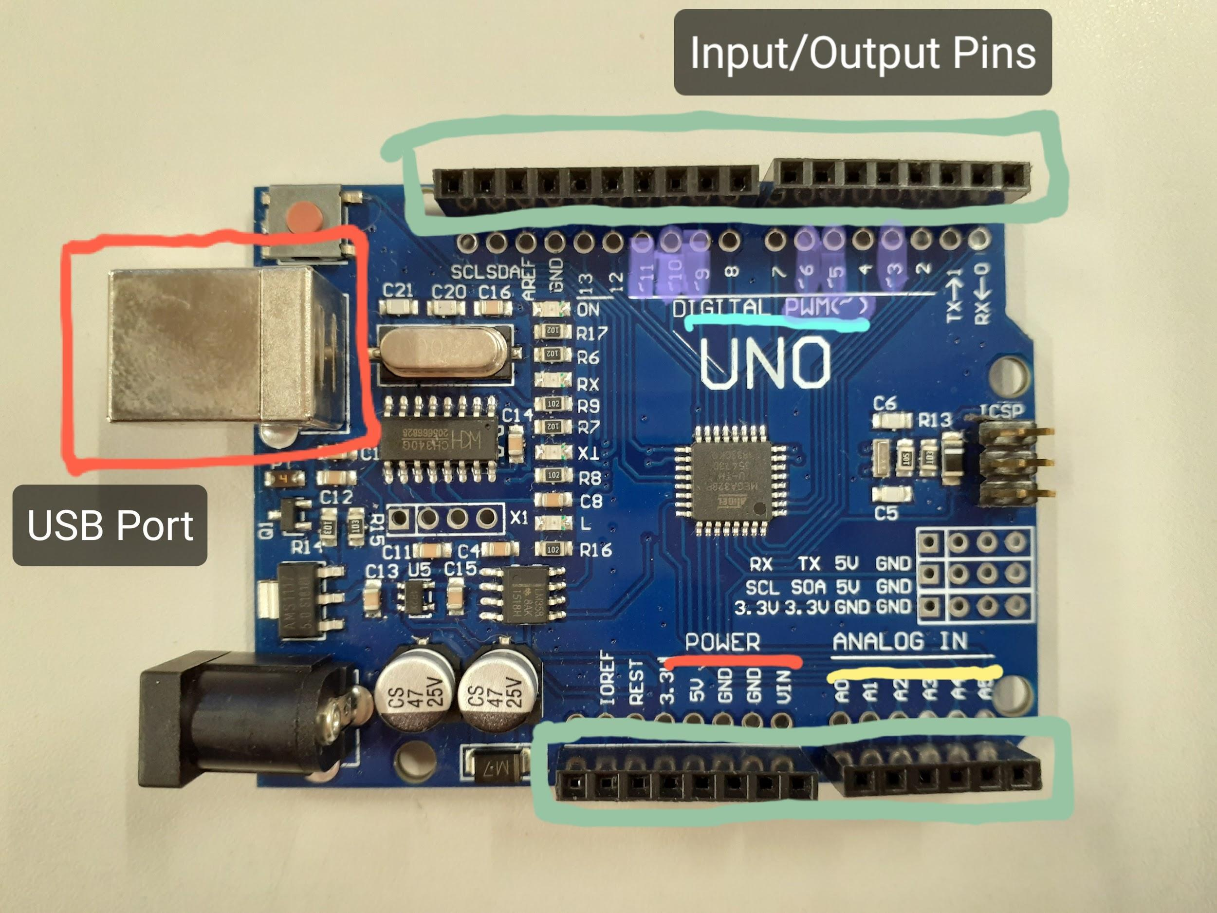
Arduino
Arduino Uno: Has a set of input/output pins running along the top and bottom. On one side, there are 5 analog inputs, as well as power connections - 3.3V, 5V, ground, etc. On the other, there are digital I/O pins, which can be programmed to be input or output. Some pins are PWM compatible, meaning they can simulate an analog output using Pulse Width Modulation. The arduino can read analog inputs as it has a built-in ADC. They are also compatible with ‘shields’ that can be stacked to allow for more inputs/outputs. There is a USB port to connect for power, and a built-in debug LED.^{[6]}
The Arduino can be connected to a computer through a USB cable, which allows you to upload programming into the Arduino. Wires can be inserted into the pins, which you can then connect to other components, like the motor controller so that the Arduino can send them instructions.

Movement

DC Motors
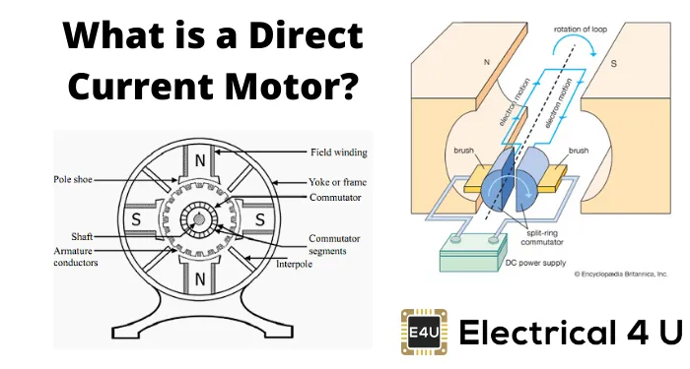
Direct Current motors are electric machines that convert direct current into mechanical energy.^{[3]} The electrical energy from the circuit charges a rod conductor, which then interacts with a magnetic field.
When a current-carrying conductor touches a magnetic field, it moves, so when the electrical field of the conductor touches the magnetic field, a mechanical force is produced. The DC motor uses this principle - motoring action - to turn the rod(shaft) and its chassis/connected components.^{[4]}

H-Bridge
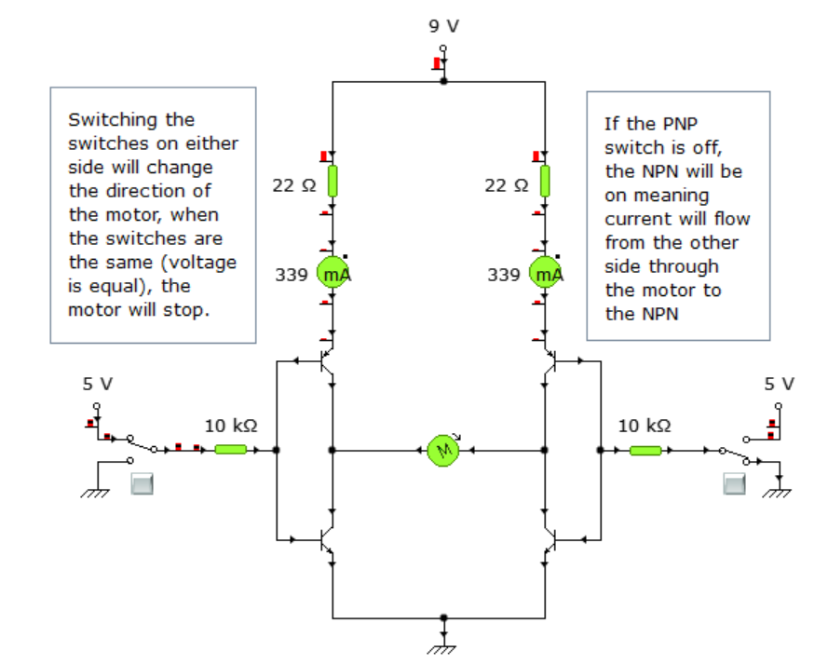
H-bridges can control the speed and direction of a DC motor.
The transistors in this circuit control the path the current takes to the ground. The switches allow the user to change the direction of the current flow and therefore change the direction of the motor’s rotation.

Motor Controller
We will use a motor controller for our robot to control the speed and direction of our motors, and therefore the wheels connected to it. It can connect to the Arduino, meaning we can easily program how we want the motors to go, making sure they are going the right direction and speed for the situation.

Using a motor controller will allow us to run the DC motors for the wheels through the Arduino - it acts as an intermediary between the motors and the Arduino, as it allows for enough current to be delivered to the motors. Arduino ports or other microcontrollers usually provide around 100mA of current while DC motors require a higher current - which is why we use this motor controller.^{[12]}
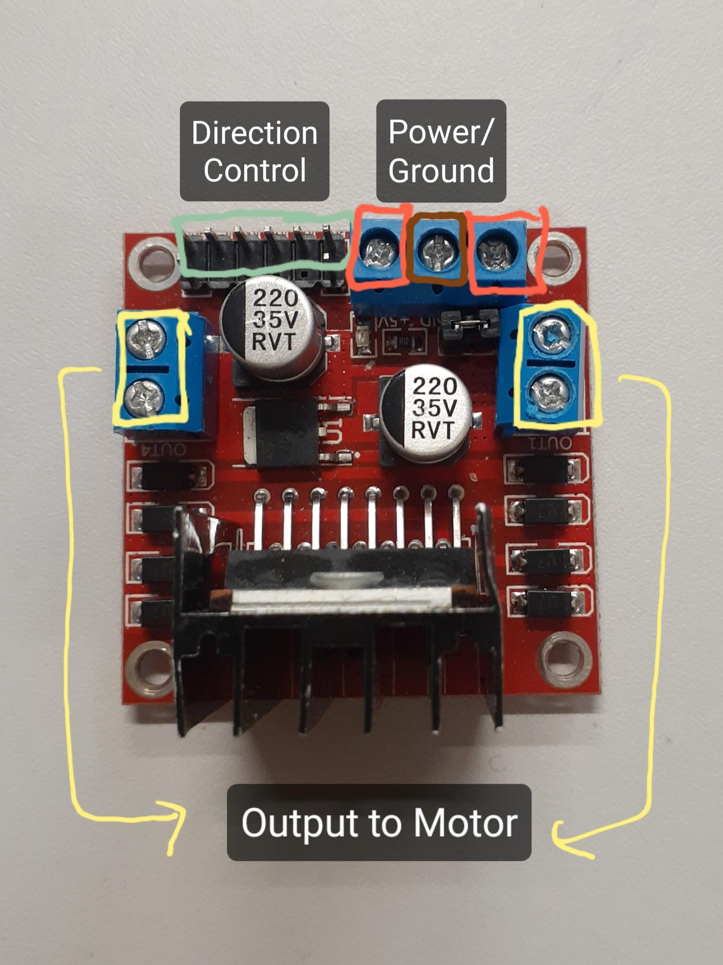
Motor Controller L298: This has 6 inputs, 3 to control each motor with - meaning we will use this for the two larger wheels. The outer pins control the speed of the motors, using Pulse Width Modulation voltages from the Arduino, and the inside pins control direction. Can take up to 12V, and if using 12V, it takes 7V to run, and directs the remaining 5V to an output that you can run the Arduino from.^{[5]} The terminals on each side connect to motors A&B to provide power and determine direction.

Line Following
RGB Colour Sensor: Colour sensors are photo-electric sensors that emit light from a transmitter, then detect the light reflected back from the object with a receiver. This allows it to read what colour that object is.
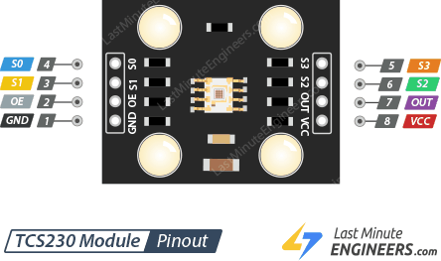
This pinout shows the pins on the module, and what to connect them to. Pin 1 goes to ground, and Pin 8 connects to a power supply of 2.7V to 5.5V.
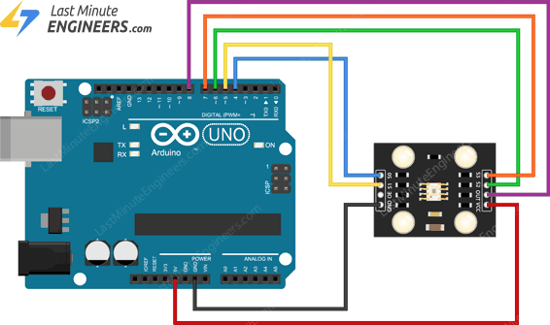
This diagram shows the colour sensor connected to an Arduino, where it can run safely off the 5V power supply.
Pins S1-4 determine the frequency scale and colour array = calibrating and programming.^{[7]}

Process
Here are my key stages for the development of this project.

 | Key stage Name | Description | Due date
1 | Movement | The purpose of this key stage is to demonstrate the robot moving forward, backward, left and right. | 17 May 2022
2 | Package Handling | The purpose of this key stage is to detect packages on the robot and indicate whether it is ready for one. | 27 May 2022
3 | Collision Detection | The purpose of this key stage is to demonstrate the robot detecting surrounding objects and avoiding them. | 6 June 2022
4 | Line Following | The purpose of this key stage is to demonstrate the robot following a line. | 27 June 2022
5 | Testing | The purpose of this key stage is to demonstrate the robot completing all key functions. As well as polishing up any functions and adding the aesthetics. | 1 July 2022
 | Submission | Submit all documents and robot | 4pm, Monday, 4 July 2022

Key stage 1: Movement
In this key stage, I will build the basis of my robot, adding wheels so it can move forwards, backwards, left and right. It will be programmable, and I will test that it can be controlled to move in all directions as well as at different speeds.

Task list
Task | Description | Due date
Draw Circuit DiagramCompleted | Notate all components and connections | 28 May
Build the robot baseCompleted | Attach the DC motors to the chassis, attach the wheels. Attach Arduino and Motor controller | 28 May
Attach wiringCompleted | Use colour codes to keep it coordinated. Use conventions - black=ground, red=positive | 28 May
ProgrammingCompleted | Program a sketch in Arduino. Make sure wiring is attached to the correct pins and program direction/speed of motors. | 13 May
Test  Completed | Ensure the robot can move consistently in the direction it is programmed. Take video proof. | 17 May
Complete full movement | Can control movement forwards, backwards, left, and right. | 17 May 2022

,Design
Below I have added some more detailed component/system information not included in the initial design but relevant to this stage. I have included a circuit diagram for the motor controller wiring. Any individual photos of components used will be added in the construction stage.

Wiring diagram

Motor Controller
Arduino
DC Motor
DC Motor
Battery Connector
VIN
GND
GND
12V/9V
5V

5V
(for testing)

PWM
PWM stands for Pulse Width Modulation, and is a way to simulate an analog output from a digital device. The Arduino can only output a HIGH or LOW voltage from its pins, however some pins are capable of PWM, which can create a string of pulses, where the voltage alternates between HIGH and LOW. Graphed, this creates a square waveform that shows the ratio between the amount of time the voltage is HIGH(the pulses), and the amount of time the voltage is LOW. This is called the duty cycle.

If the voltage is high 50% of the time, and the pulses look like this;
then it is a 50% duty cycle. This means that the average voltage would be 50% of the HIGH voltage. For an Arduino with a HIGH of 5V and LOW of 0V, this would be around 2.5V. Using this, the duty cycle can be changed to 25%, 10%, 75%, and this would allow for a variable output voltage, allowing for circuits that dim lights or change speeds of motors.⁽⁴⁾

On time = Voltage high, Off time = Voltage low. Period length = On time + Off time.
Frequency is the speed of the pulses. For the Arduino Uno, the pins that are compatible with PWM will have a frequency of around 490Hz with the exception of 5 and 6, which have a frequency of around 980Hz.⁽⁵⁾

In the Arduino, the function analogWrite(pin, value) can be used to output a PWM signal from the PWM compatible pin named. The value is a number proportional to the duty cycle of the signal, from 0 to 255.⁽³⁾

Construction
Here, I have added photos of all the main components used in this stage. Some are close ups of the specific parts of the robot (showing how we attached them). I have not added images of the specific wires, screws, or tools used. Some images are alongside the instructions of how we constructed the robot.
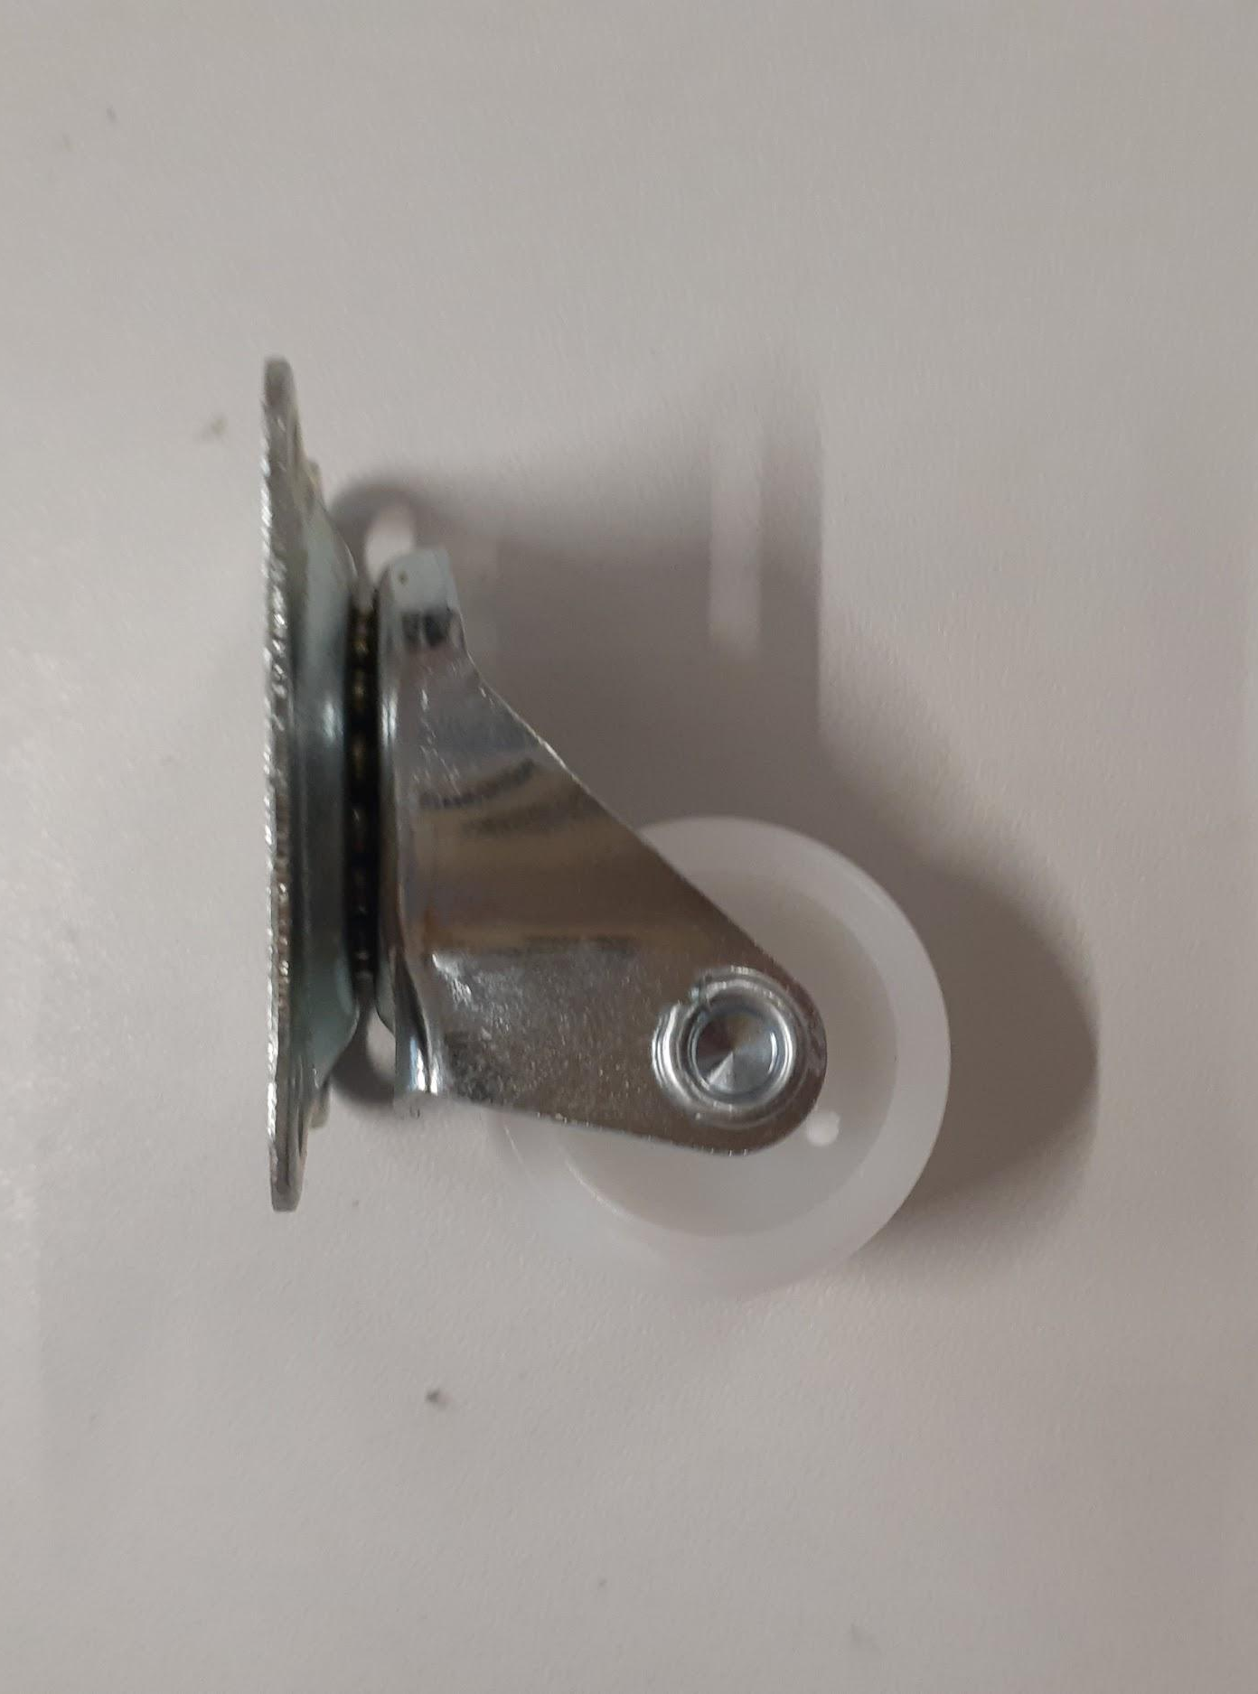
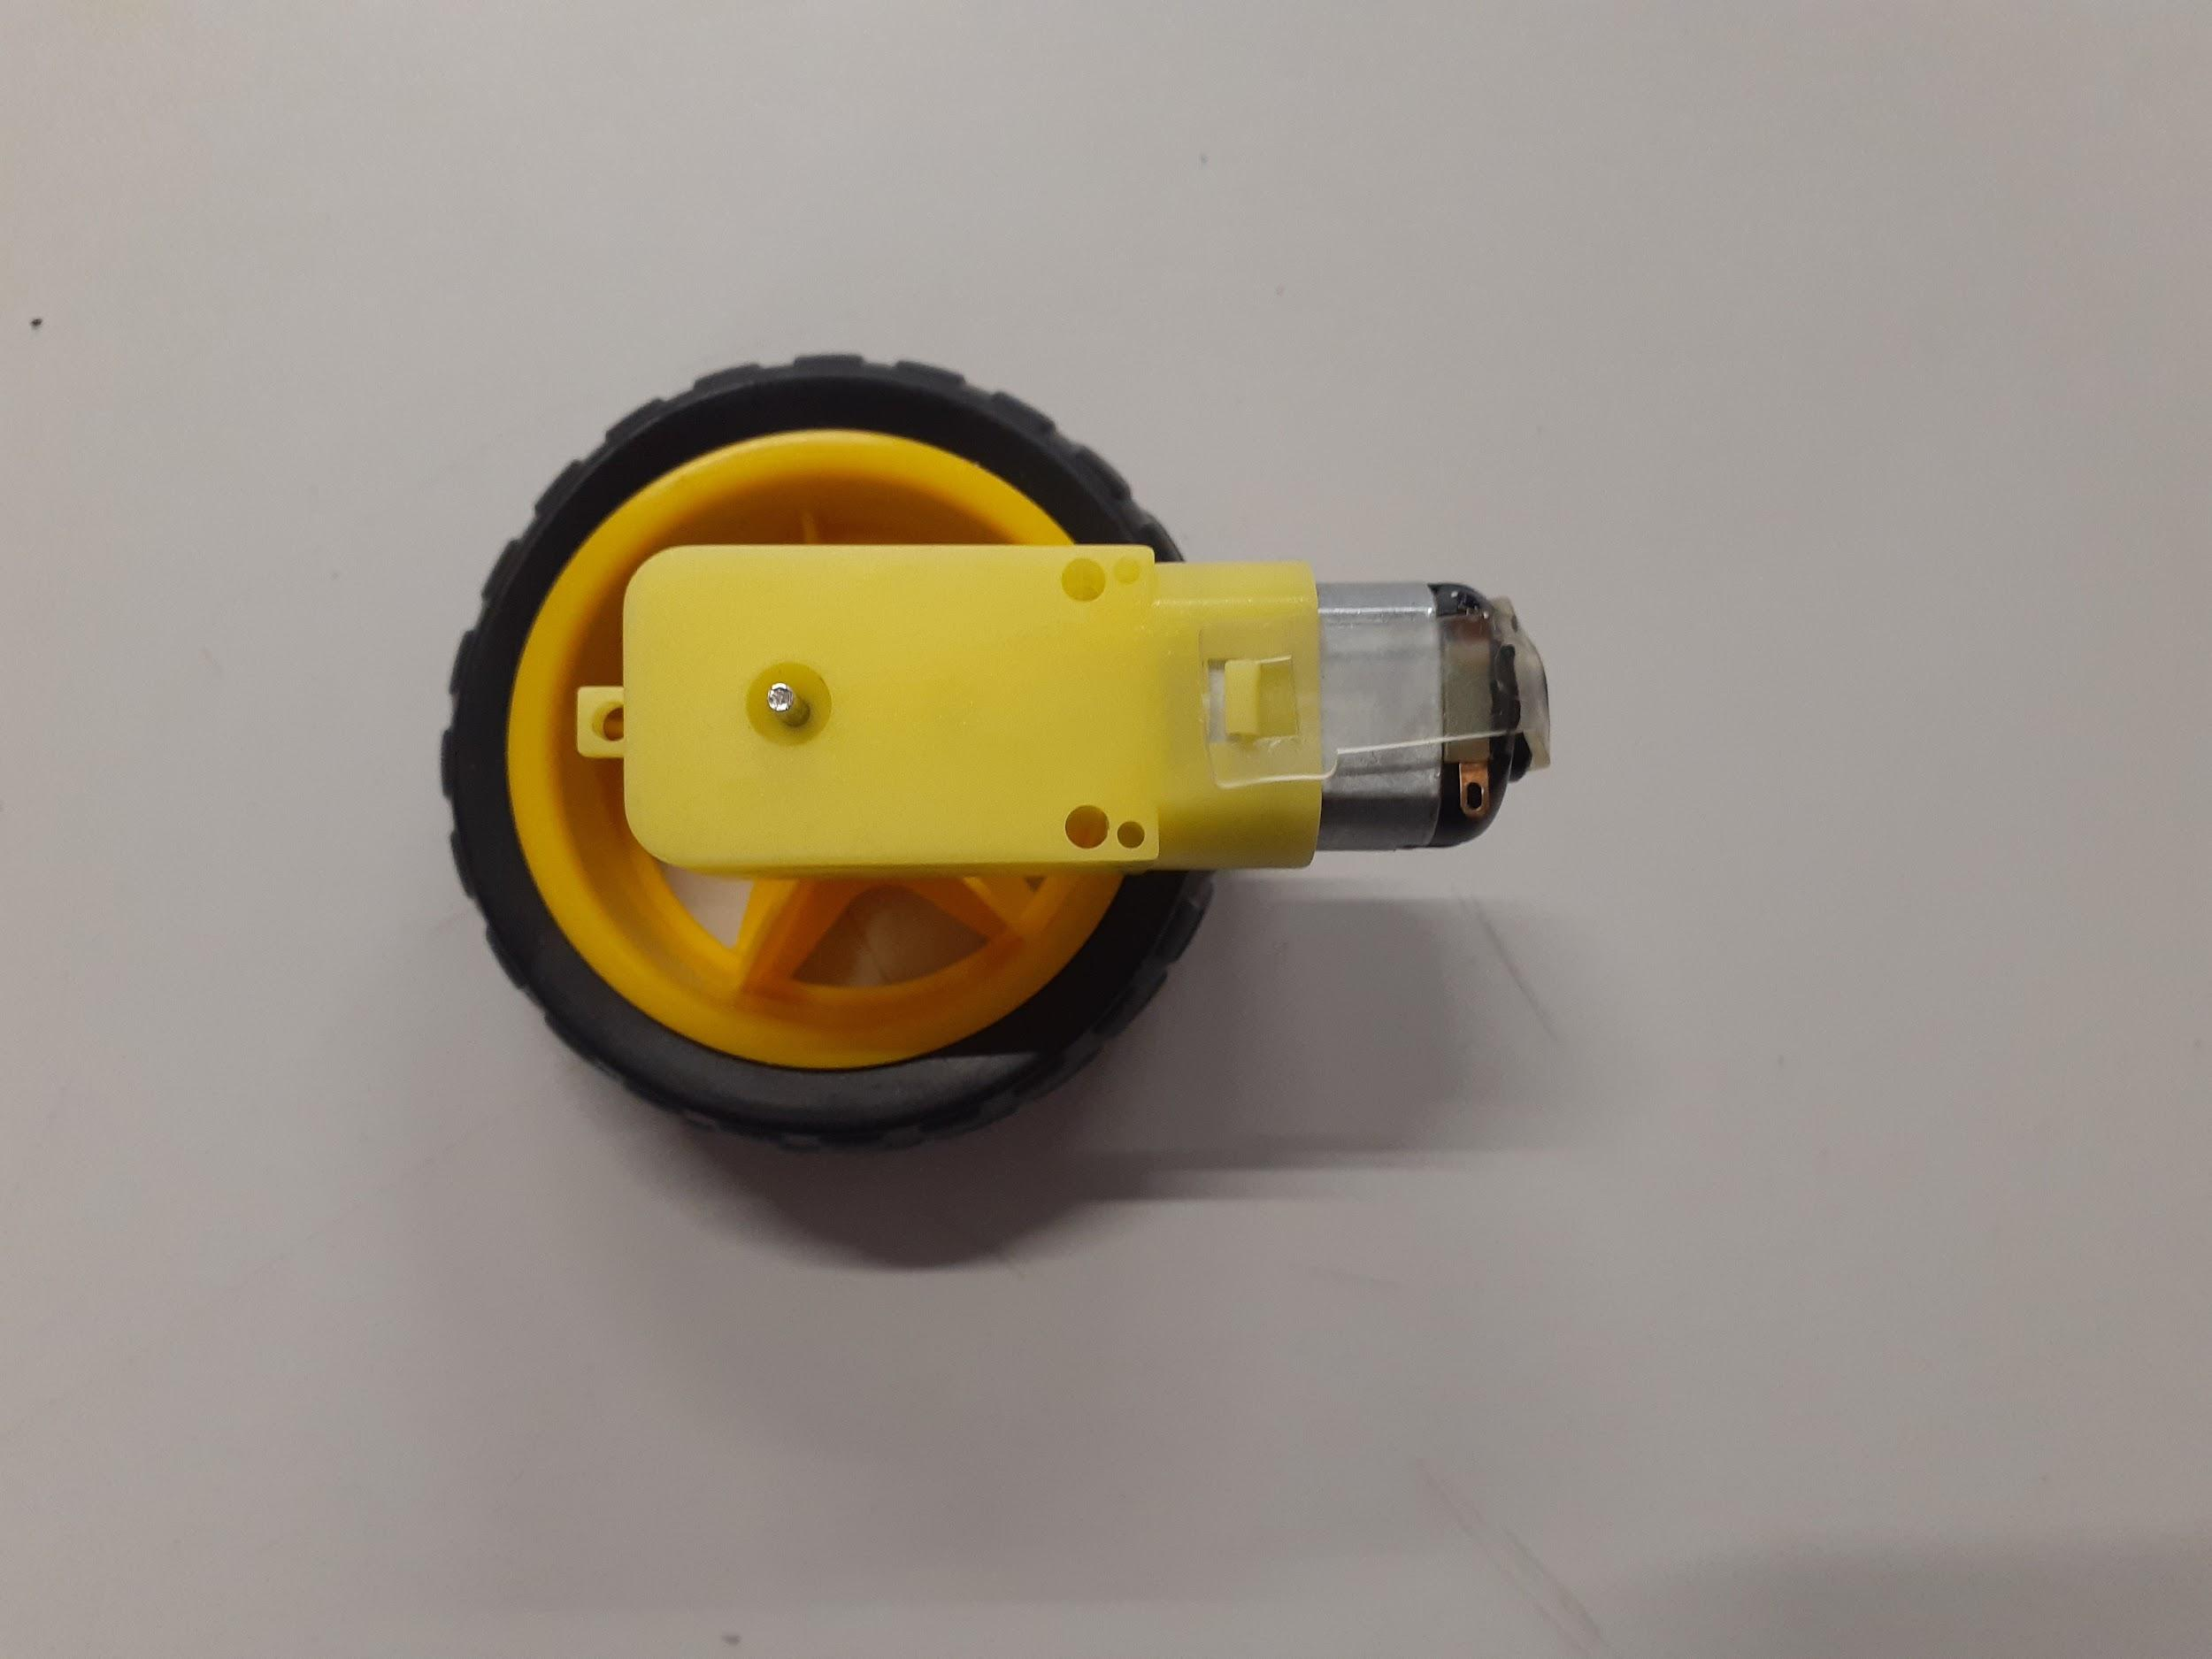
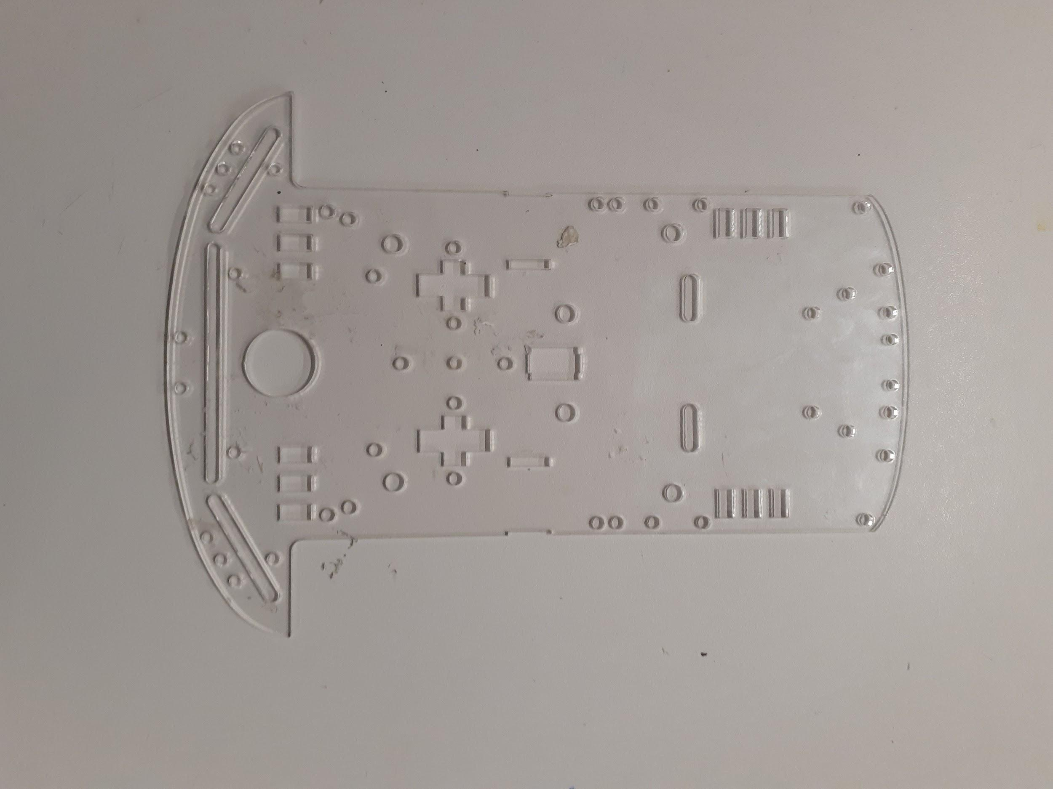
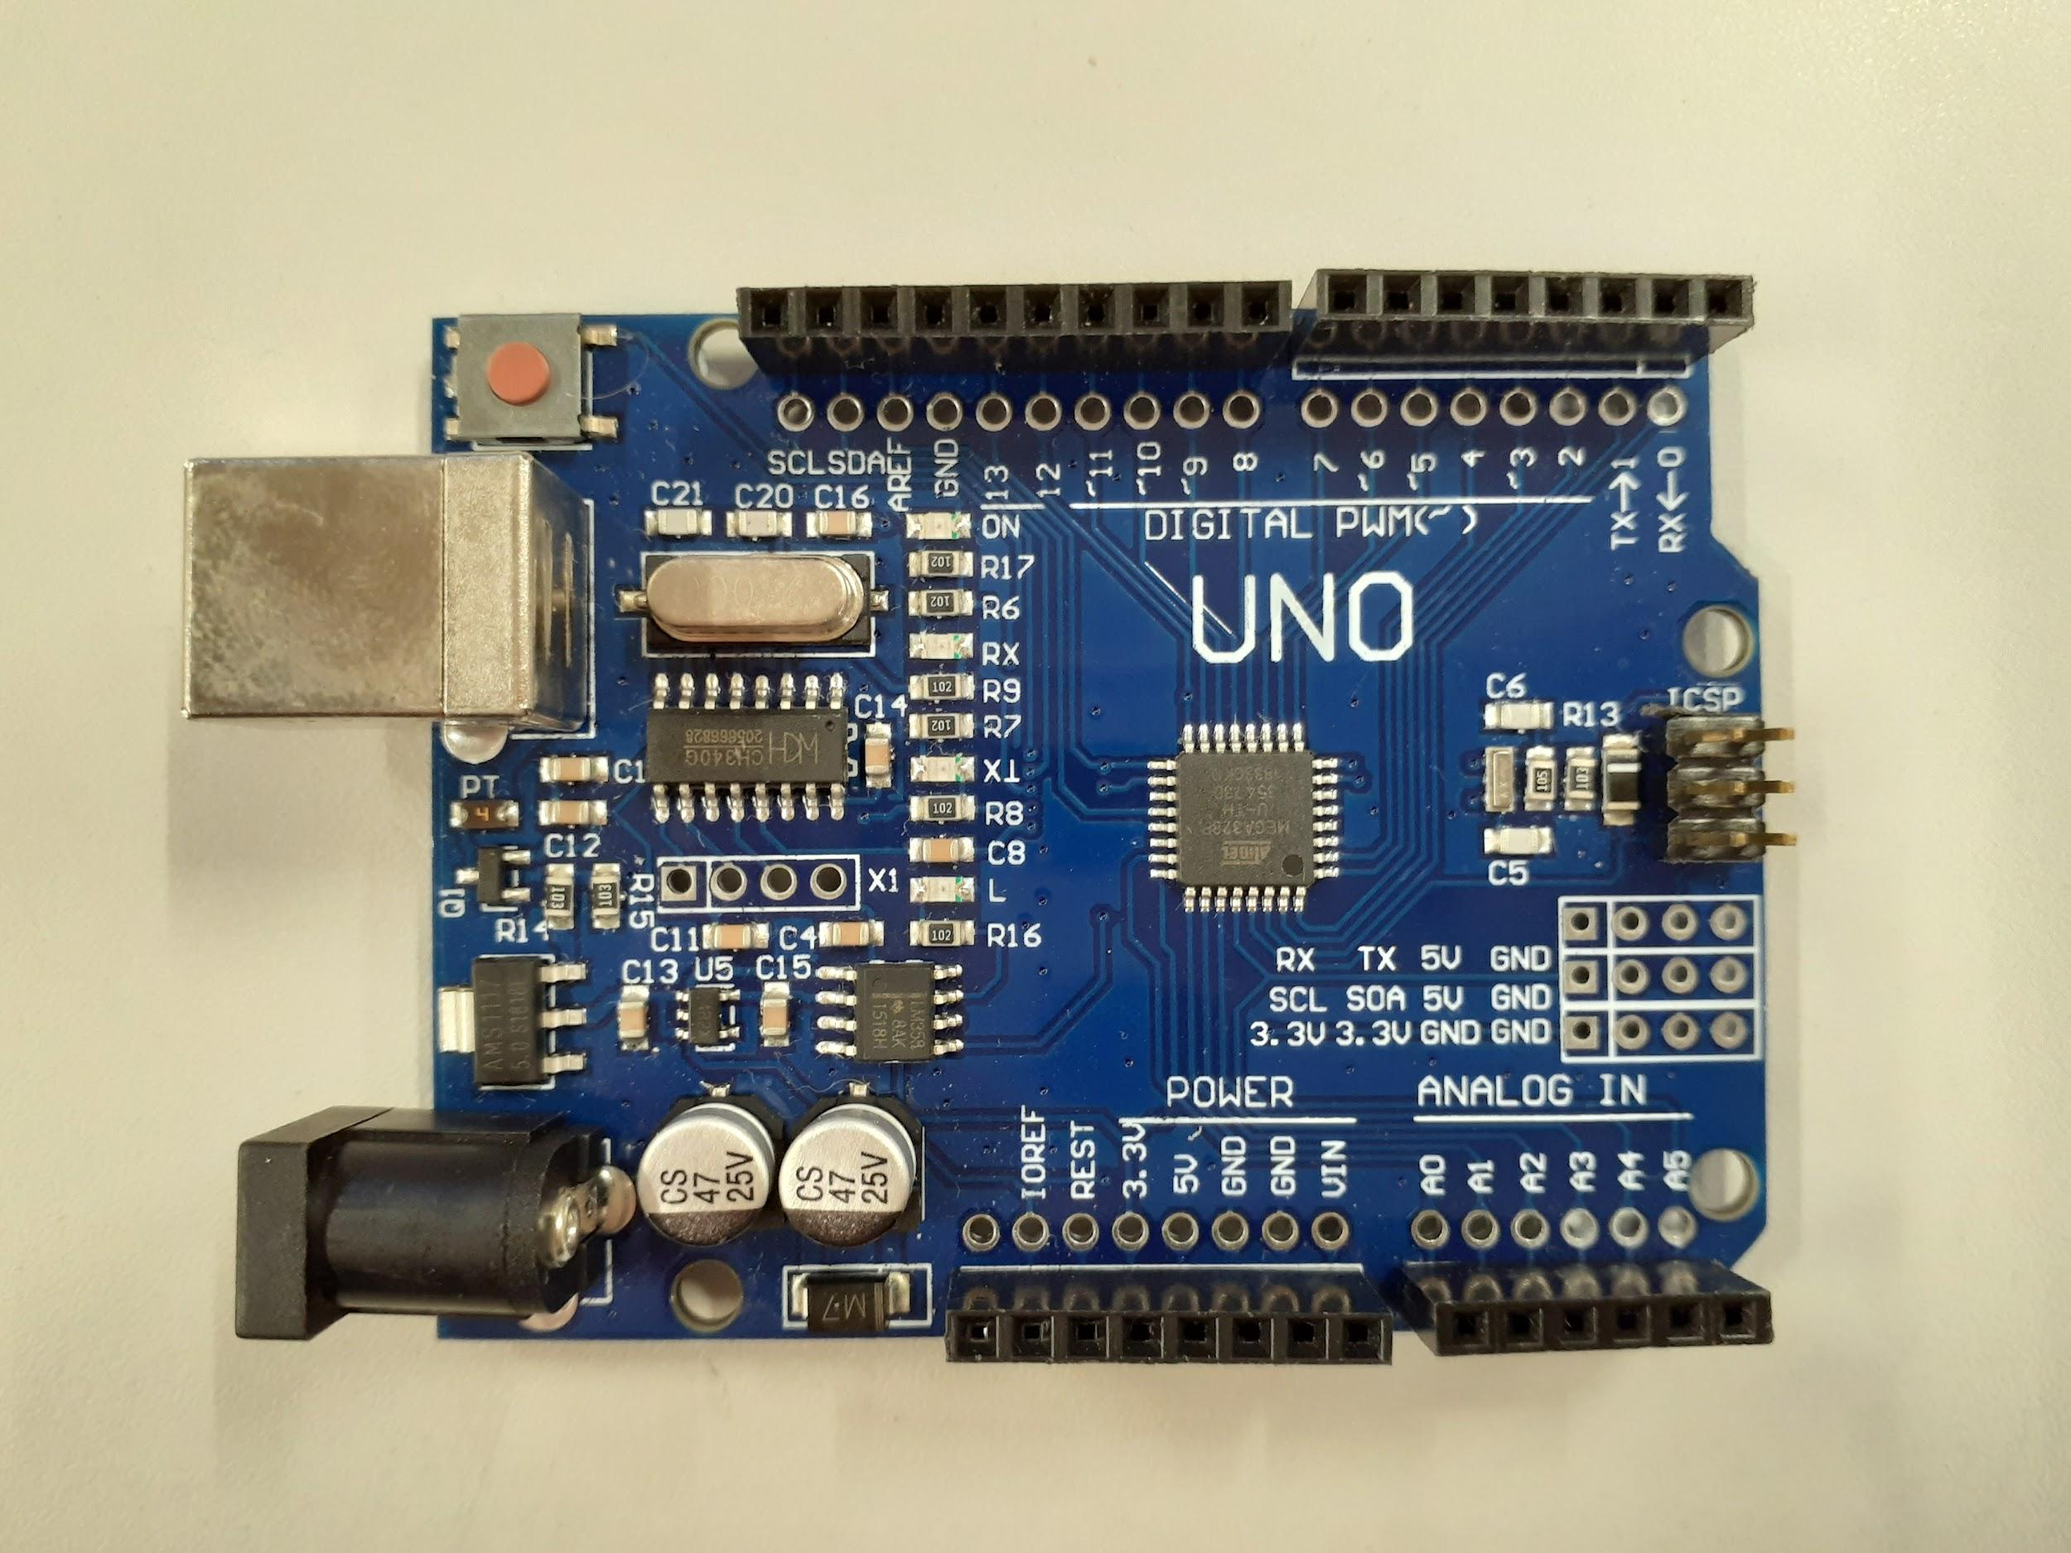
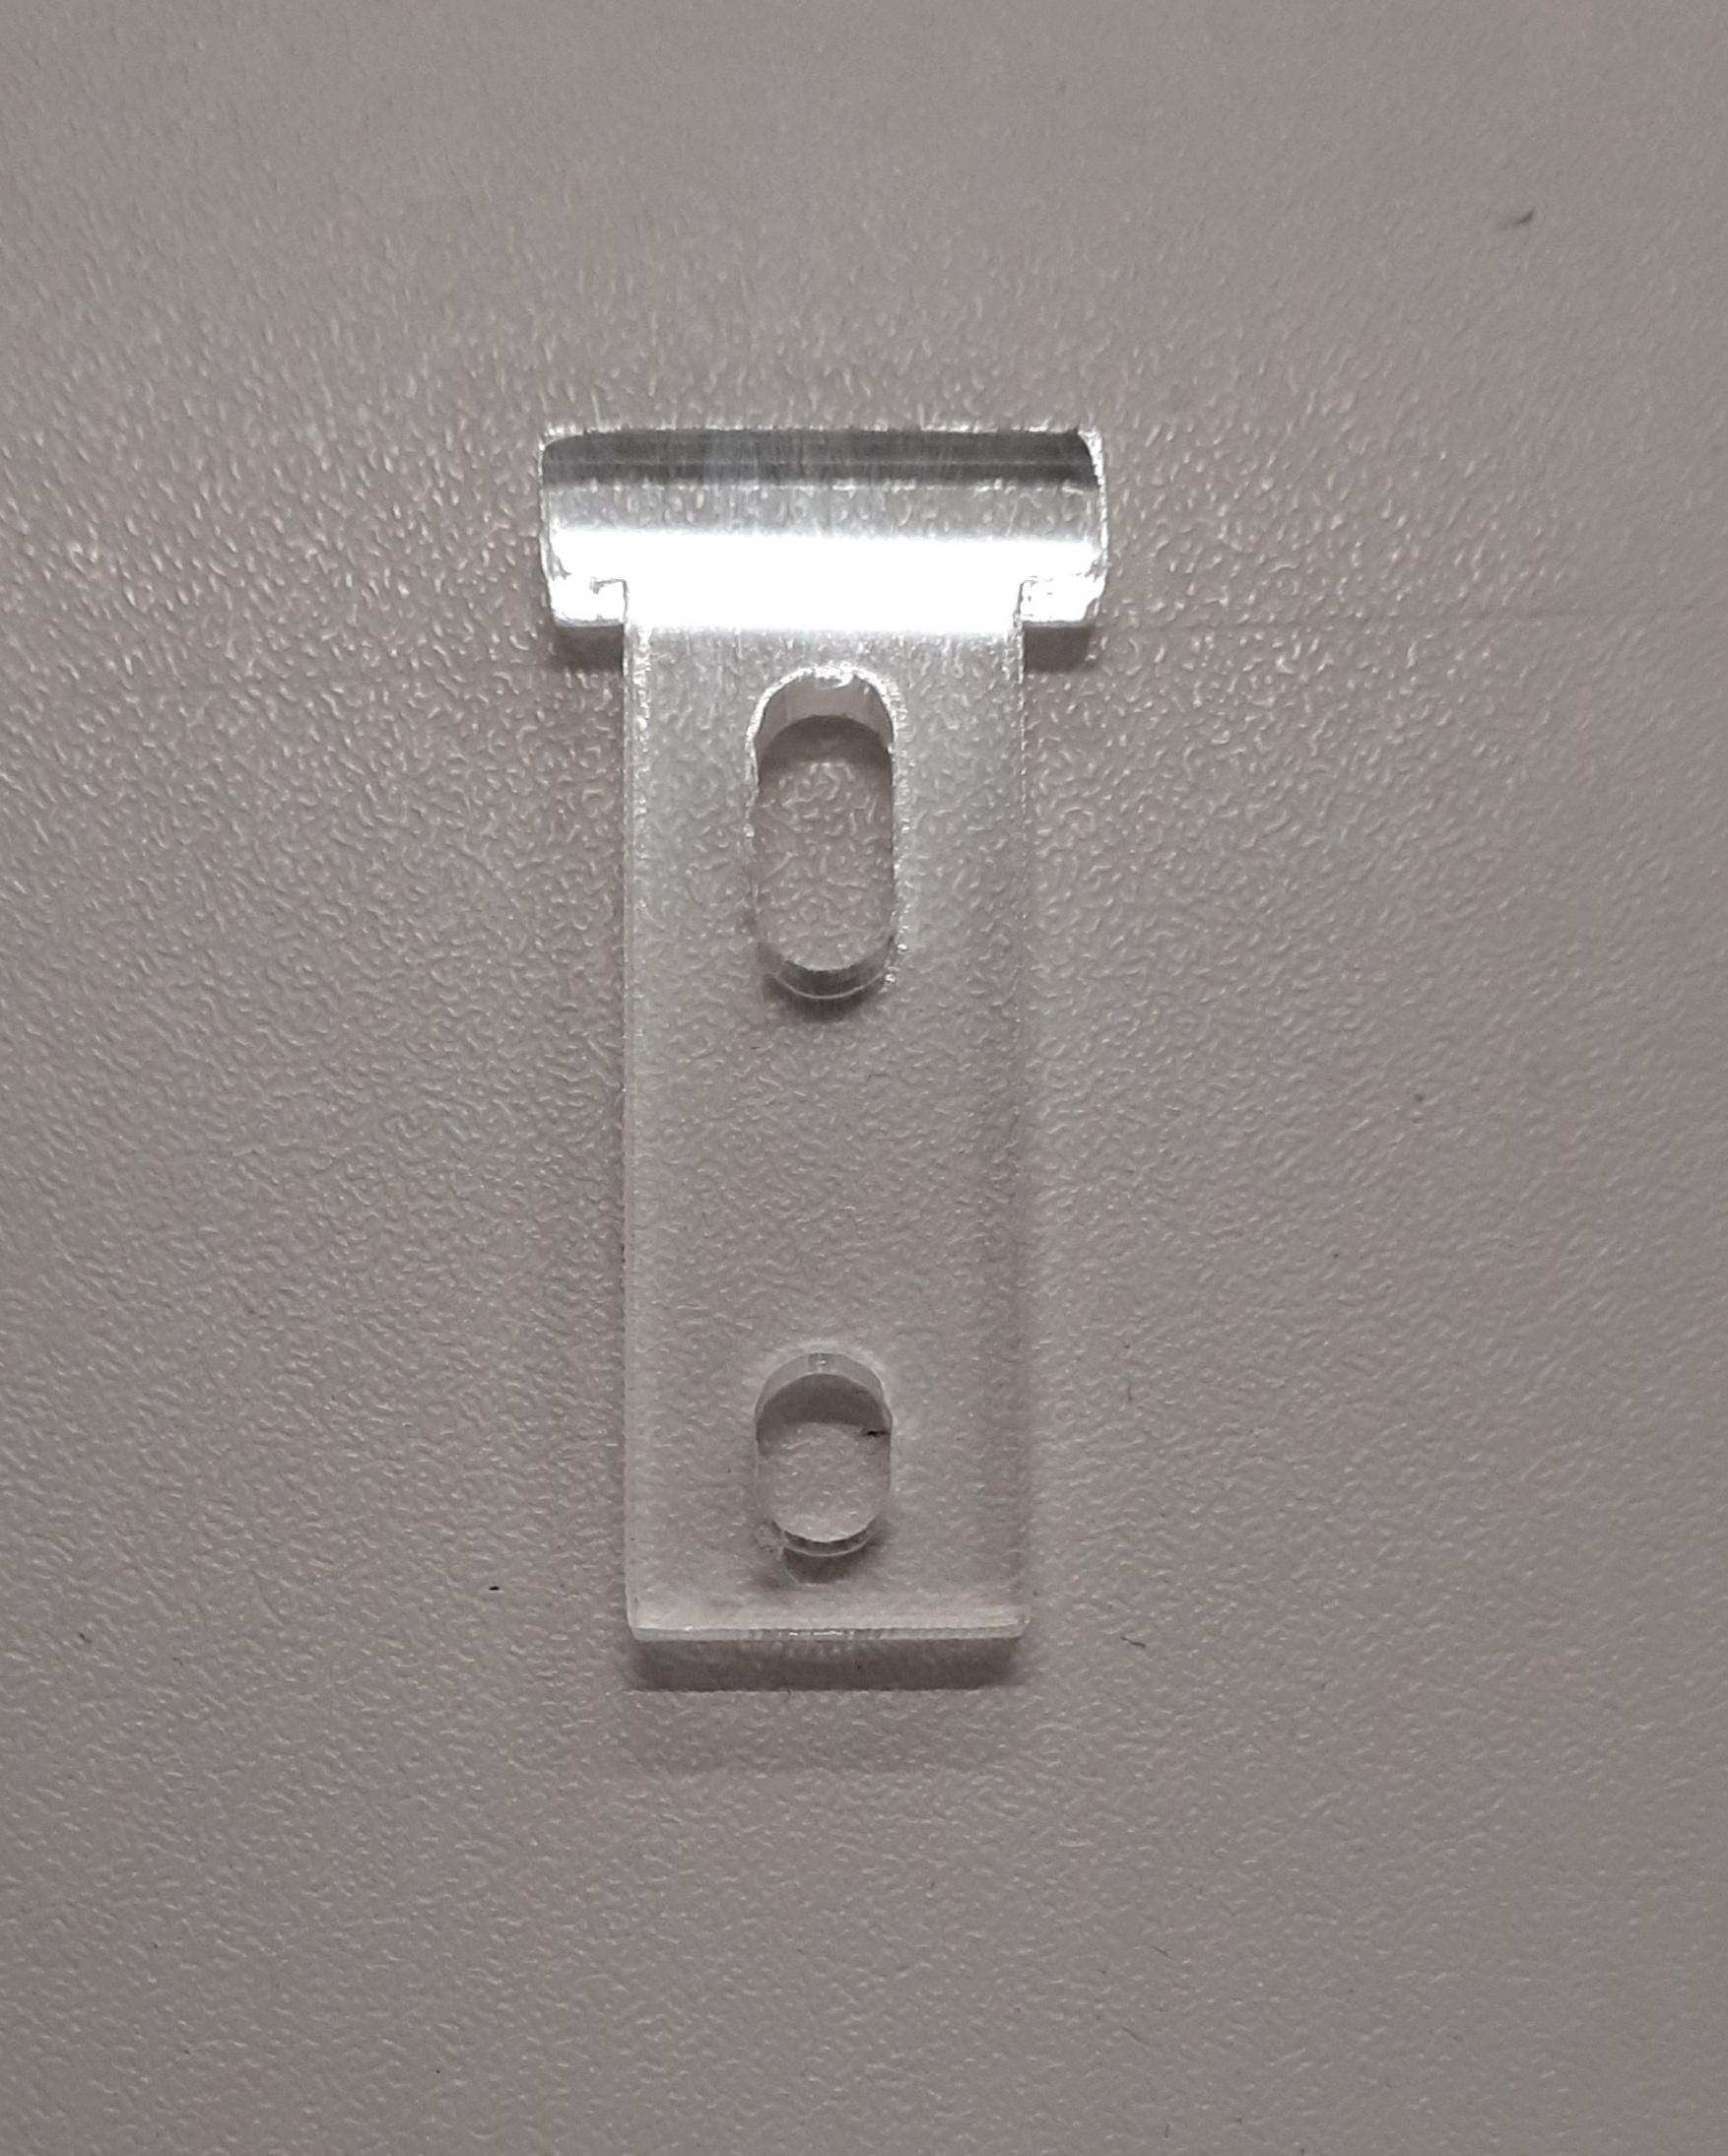
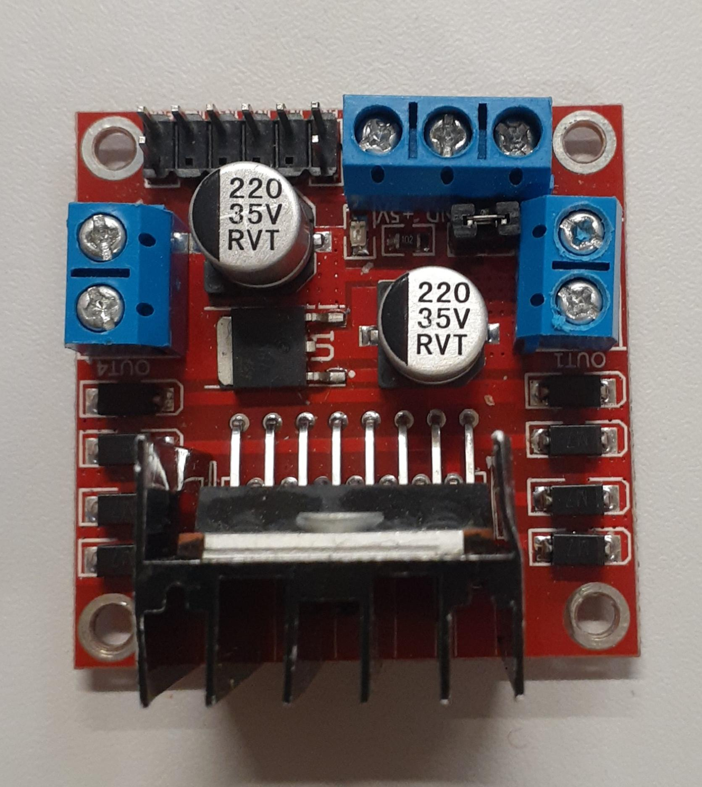
Above, from left to right; Chassis, support strut, Swivel wheel, DC motor w/ wheel attached.
Left; Arduino Uno, Motor Controller L290

Method
- Attaching the DC motors to the chassis. We used the smaller laser cut ‘struts’ to create a support on either side of the motor. We then inserted a screw through the struts and the motor, attached a nut on the end, and tightened with a 5*75 screwdriver.
- Attaching wheels to motors. These click into the rotating shaft in the motors. There were a few different treads of wheels, but fortunately these wheels are easy to change if need be.
- Attaching the swivel wheel to the chassis. We used what I believe are rod connectors, which were small bars with threading on the inside so that we could offset the swivel wheel from the chassis. We then screwed the wheel to the connector, and the connector to the chassis.
- Soldering wires to motors. We detached the heads of the motors from the casing, and soldered wires to the copper loops on the sides. We used clippers to cut the correct length of wire, and wire strippers to expose the wire from the casing before attaching them. We used a heat gun to secure heat-shrink around the soldering to protect the wire. We reattached the motor heads.
- Attaching Motor Controller. We used some padded double sided tape to attach the motor controller to the chassis.
- Connecting motors to the controller. The wires that were soldered on earlier, we fed through the holes in the chassis, and screwed the ends into both outputs for either motor using a 3*75 screwdriver.
- Attaching the Arduino to the chassis. Again, we used padded double sided tape to secure the Arduino to the base.

Wiring (refer to circuit diagram above)
- Attaching 9V Battery connector. The positive line connected to the 12V terminal on the motor controller, and the negative line connected to ground.
- Power to Arduino. A red wire was connected to the 5V terminal of the motor controller and ran into the VIN pin on the arduino. A black wire was connected to the GND terminal alongside the battery pack wire, and ran into the GND pin on the Arduino.
- Direction/Speed controls to Arduino pins. We ran wires from the 6 control pins on the motor controller to appropriate ones on the Arduino. The outer ones for speed control were connected to pins with PWM compatibility.
  - We first connected each motor separately to the 5V output on the Arduino to test if the motors worked, before connecting all the pins.

More Photos of Construction Stage
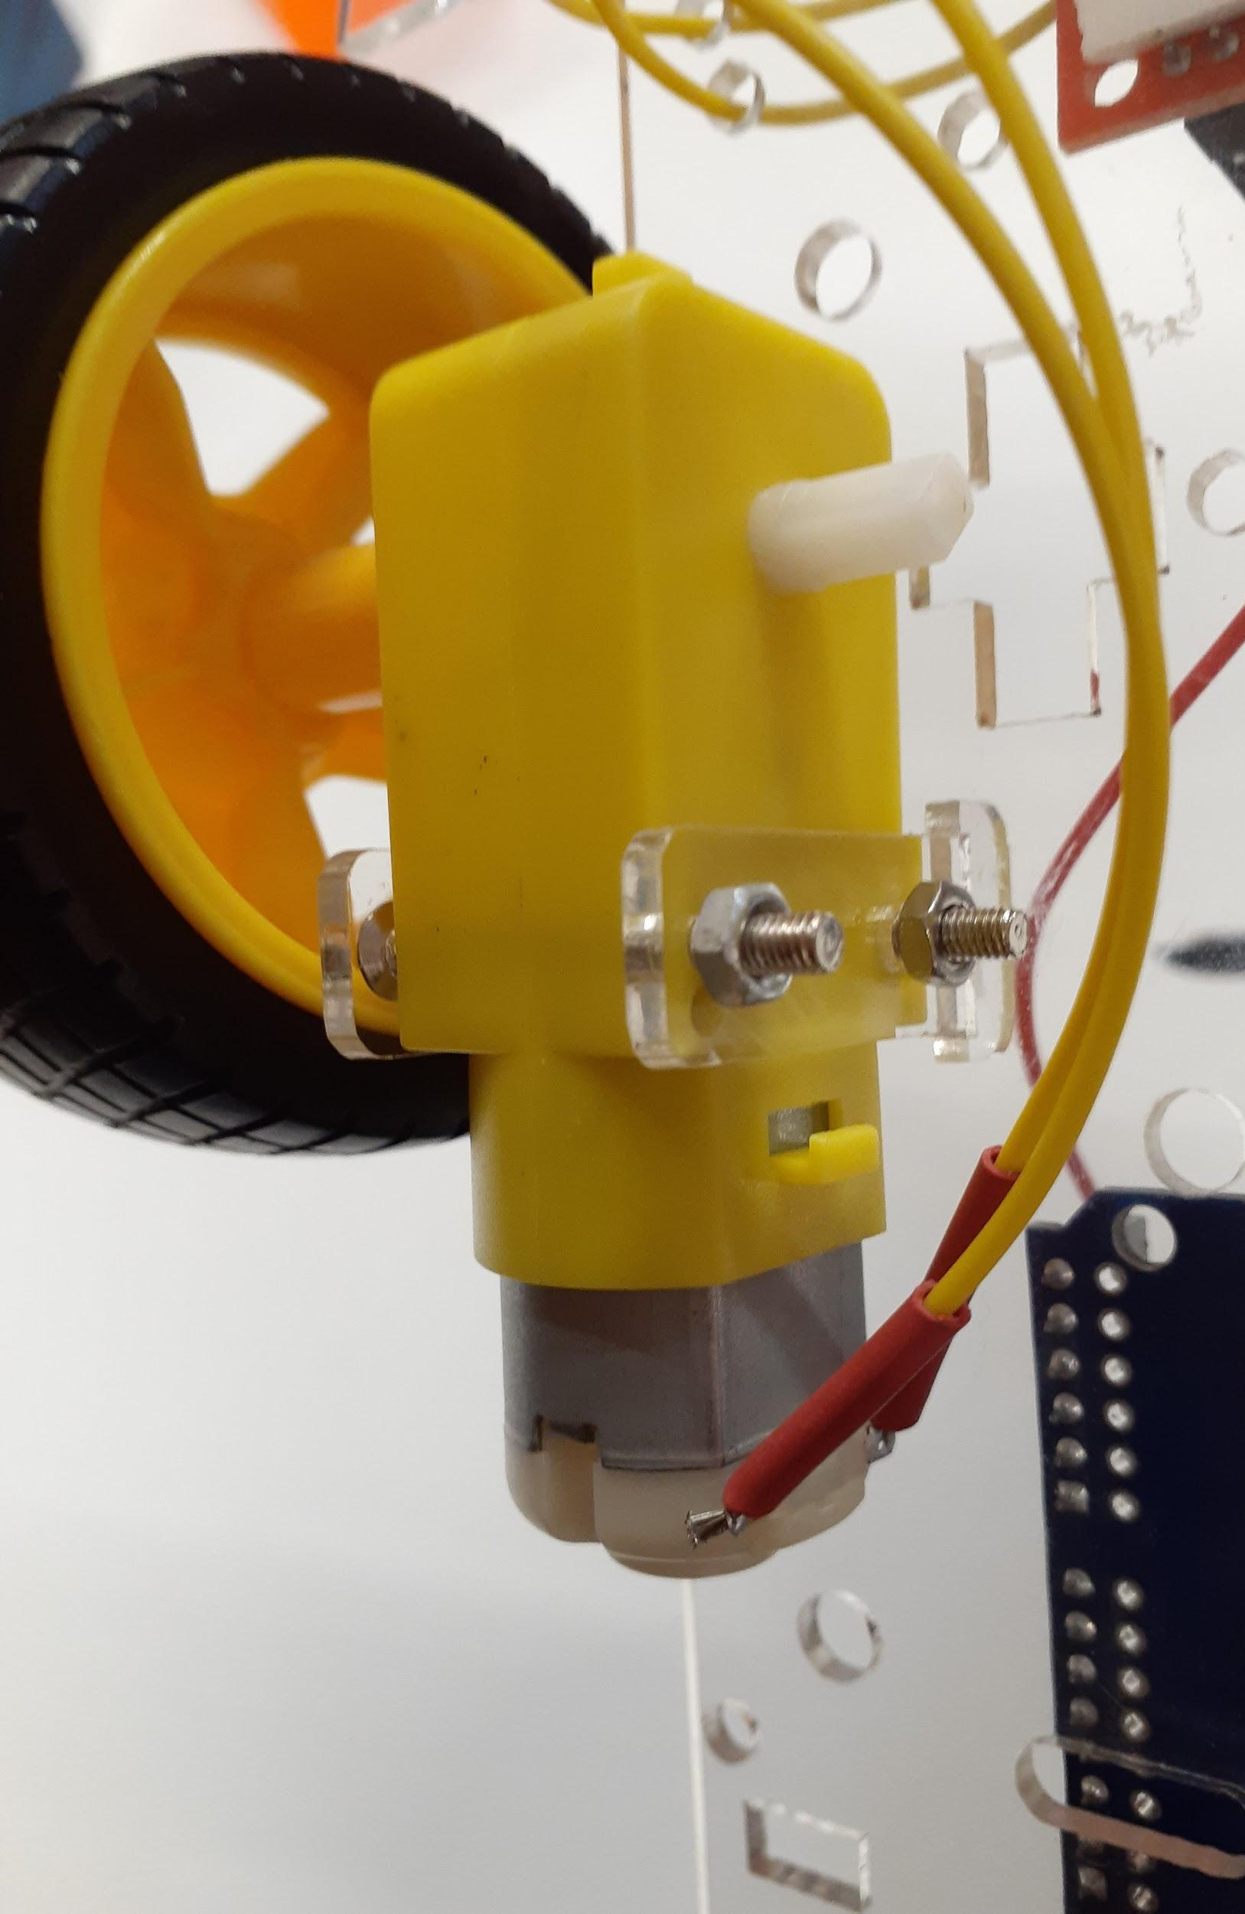
Steps 1, 2, 4; Step 3; Step 6;
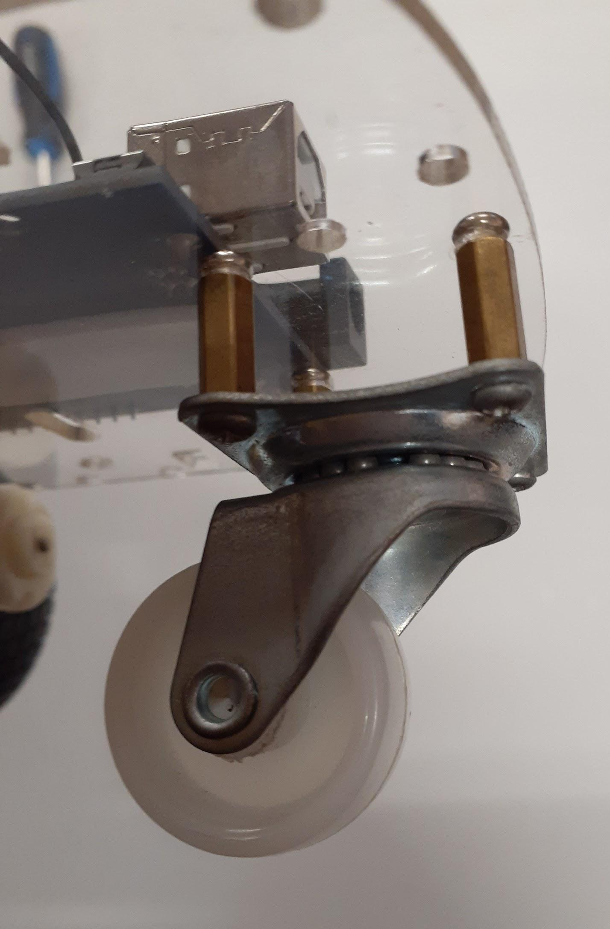

Step 10;
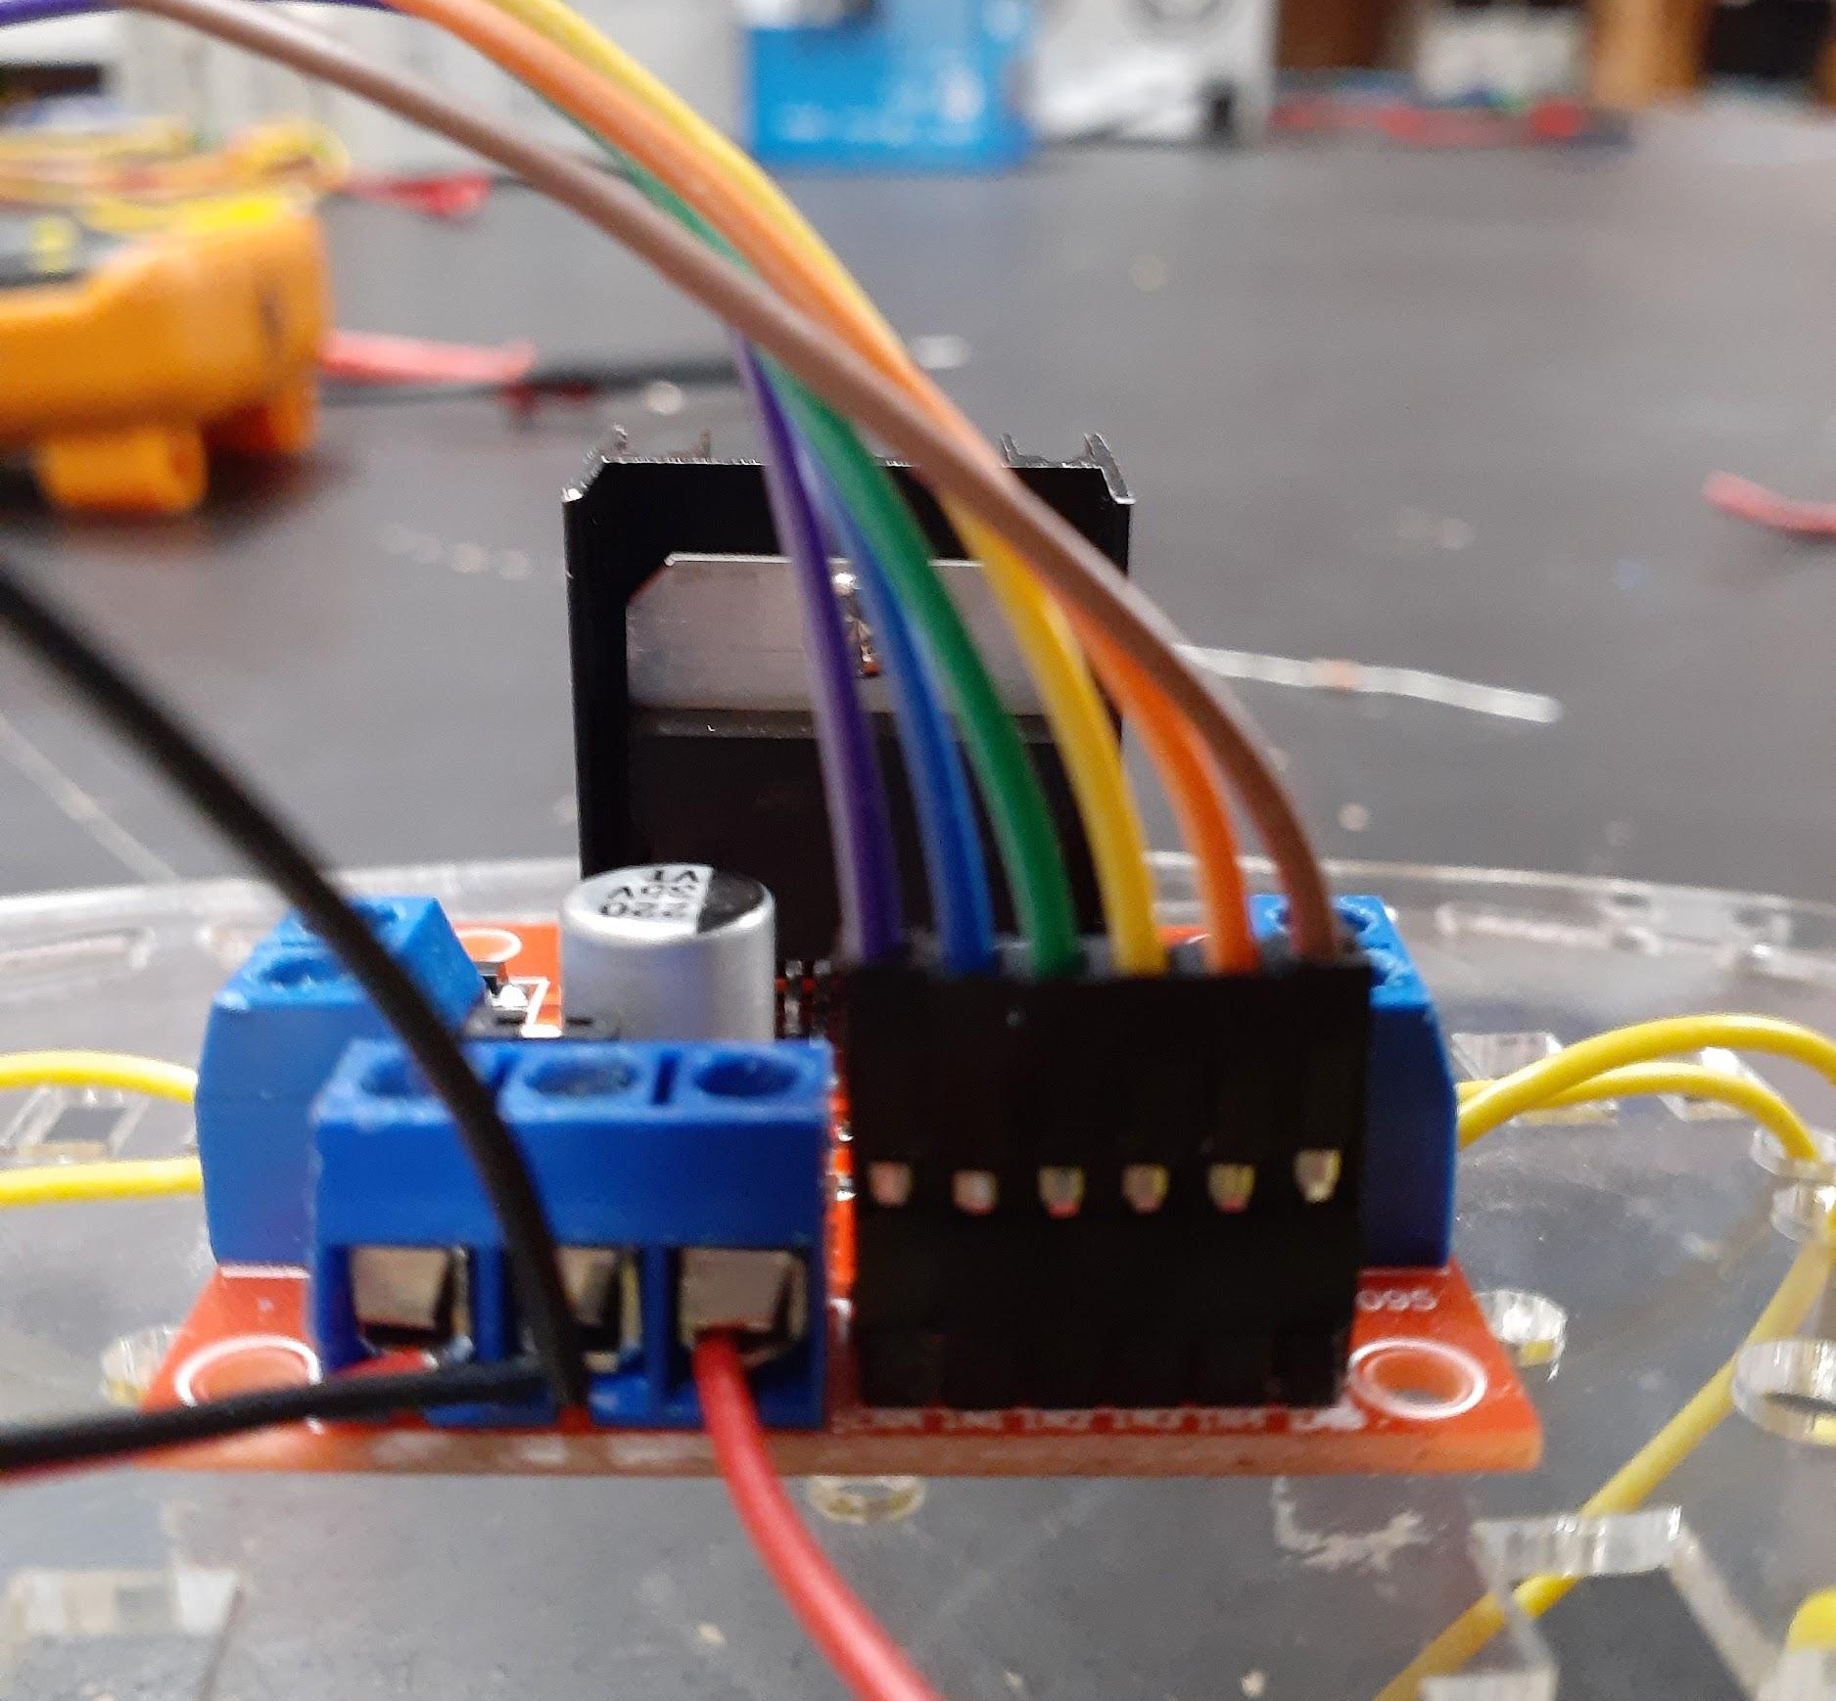
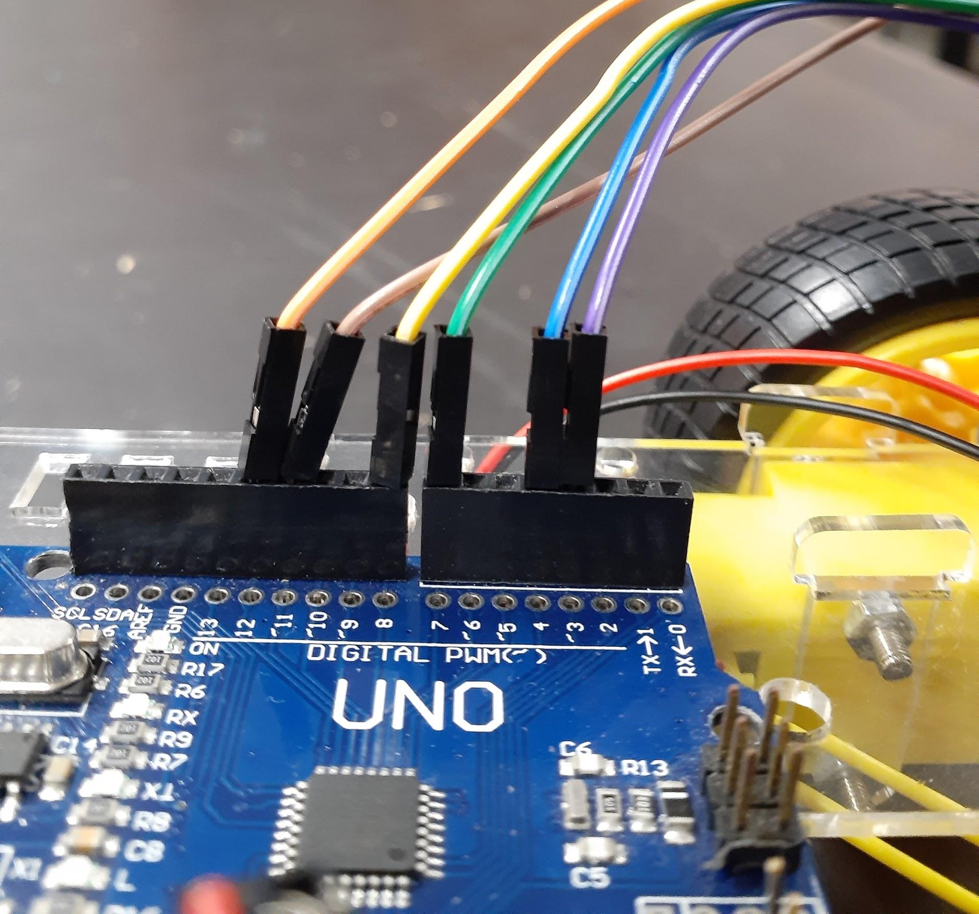
Here you can see the wires going from the motor controller to the Arduino. From left to right on MC; ENA, IN1, IN2, IN3, IN4, ENB. These respectively went to Arduino pins 3, 4, 7, 8, 12, 11.

Step 10a;
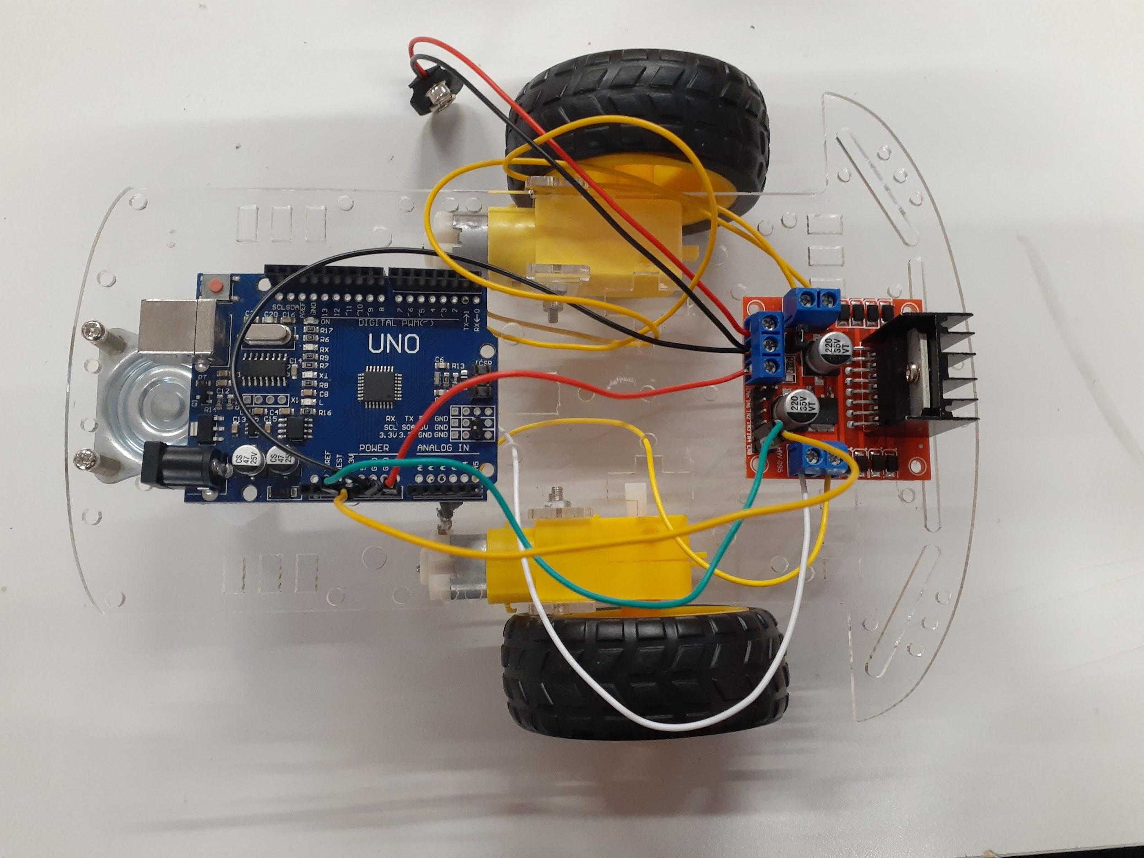
Here you can see my robot as it was - to test if the motors would turn, therefore turning the wheel. Without programming, I could only connect one directional pin and the speed pin of one of the motors to the 5V output from the Arduino. We connected one motor at a time to ensure they both worked. This robot does not look like my final version, as I had to change wires and motors several times after this photo was taken.

Program and Test
As mentioned above, before assigning Arduino pins to each direction/speed pins on the motor controller, we first tested each motor by running its speed and one directional pin into the 5V on the Arduino. This allowed us to check if the motors were connected properly to the motor controller first, checking if both the DC motors and the motor controller worked the way it should. After this, I then connected all 6 Inputs to the motor controller to the Output pins on the Arduino, so I could program them in an Arduino Sketch.

Arduino Sketch Program
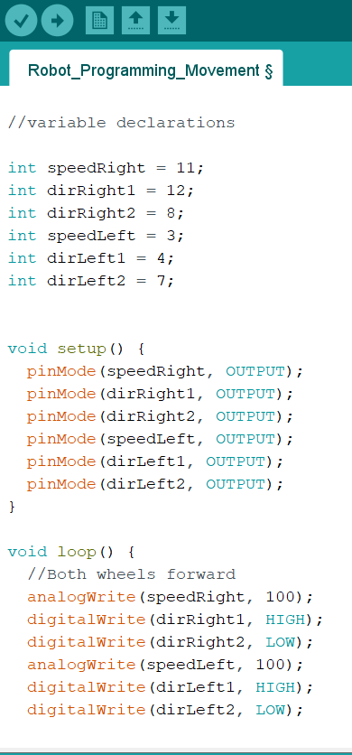
Here you can see my coding for the robot to move forwards. I first declared all Arduino pins and named them by what they did.
In the setup, I set all the pins connected to the motor controller as OUTPUT, as they will only need to send information/instructions, not receive them.
I then could start programming what I wanted the motors to do. I used analogWrite to allow the PWM to moderate speed, and here I have set the speed of the motors to 100 for easy testing. I used digitalWrite to change the direction of the motors. One of them is forwards, and another is backwards. These can be set to HIGH or LOW depending on which direction you want the robot to go. At the start, I tested one motor at a time by commenting out half the code so that I could ensure both wheels went backwards and forwards.

I then added the different settings of the motor pins to change the direction of the motors/wheels. We manually tested each of these, uploading the sketch to the Arduino via a USB cable.
To test and power the robot, we used a 9V PP3 battery that would snap into the battery connector.

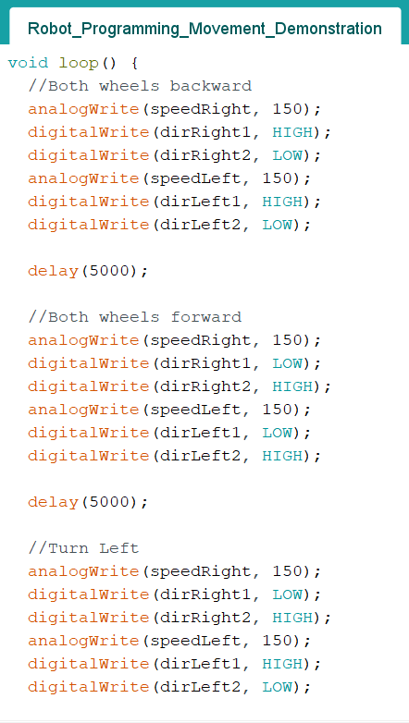
For the purposes of the demonstration, I added a delay between each ‘block’ of code using delay(5000) so that the Arduino would run each setting of the wheels one after another in a loop.
Below a video is linked with the delay shortened to 2500 so you can see the robot moving in all directions.

Final Robot for Movement
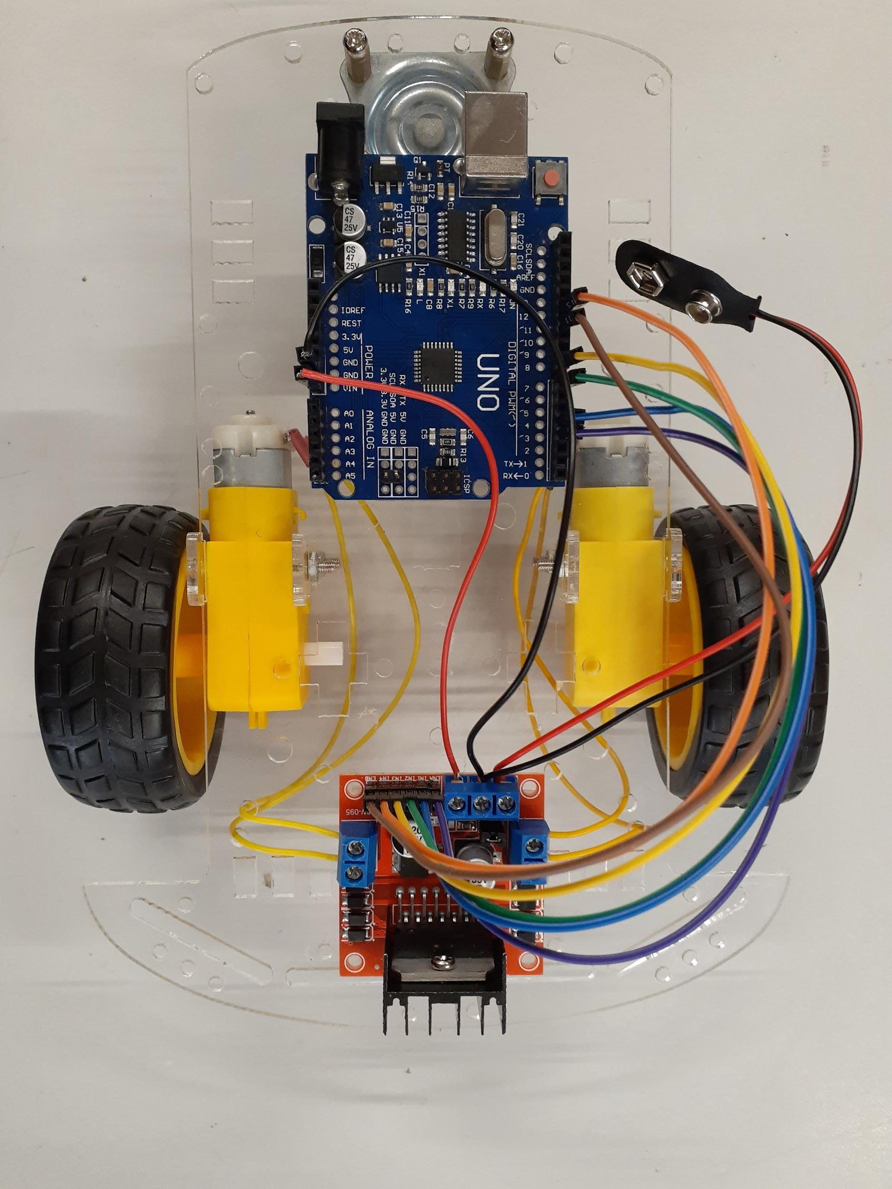

Video of Robot - Movement Stage
Linked here: Ysabella_Movement.mp4 (Sound off please!)

Key stage 1 Task Reflection
Task | Original Due Date | Reflections/Issues/Timing etc
Draw Circuit Diagram | 28 May | I based my circuit diagram off of the one drawn by Mrs Dunn on our ‘build day’. As I wasn’t present at that time, I took a photo and ended up drawing my personal circuit diagram much later, as I just used the original diagram to build my robot.
Build the robot base | 28 May | This was completed within 1-2 hours, and was easy while working alongside classmates who were able to help me with any materials or how components went together. There were some tools I hadn’t yet used, like the wire stripper/builder, and the heat gun - but they were relatively simple, and I was able to use these.
Attach wiring | 28 May | This was completed within the same day as the base building task, as we wired the robot straight afterwards. I managed to get this done up to the motor testing set-up on this particular day, and had them working. The wiring to the Arduino was done the following week, but as it only involved 6 wires that went straight from the motor controller to the Arduino, it wasn’t very complicated. The new thing for this task was learning to make male ends for wires to connect the motor controller to the Arduino.
Programming | 13 May | This stage was relatively straightforward, as it was much like the programming we have done before. As it didn’t require any physical work/components, it was calmer than previous stages, and easy to test with a USB cable. I did switch some pin variables around to make my wiring and coding neater, it was the quickest way to ensure my wheels would go the right way around.
Test | 17 May | At one point, one of my motors became unusable - the copper plates connected to the wiring had snapped off. I replaced the head of the motor to save myself from having to re-attach the full motor and support struts. Unfortunately, the motors ended up with different speeds. If I had kept this, I would have to program very specific speeds for each motor - and different numbers too. I found out that this was because some motors had a different default speed potential. There were apparently fast and slow ones. I replaced the motor heads a few more times, but they still were not even - my program set both their speeds to 100, but one wheel would turn faster than the other. Eventually, I decided to replace the whole motor, repeating steps 1-2 with a matching pair.  I completed my demonstration on May 16, which went well.
Complete full movement | 17 May 2022 | As I was filling in gaps in my documentation, I did wish I had specific photos for some of my stages, like the construction stage. I was rushed on the day that we built up our robots, and therefore did not stop to take developmental photos. The video linked above was also quite messy, and I will endeavour to take clearer photos/videos to make my documentation easier in the future.  I completed this overall key stage later than projected. The date of completion was pushed back to May 20, which is 3 days later than originally planned.

Key stage 1 Overall Reflection
Overall, I feel I have made good progress on my robot. I now have a physical prototype to hold and work on, which helps with visualising the next steps of my project. In general, I have noticed that some parts of the robot are prone to breaking, whether due to delicate components or issues in the initial construction. I mentioned above how I had to rewire the motors several times, and I also had to replace/repair some wires. After shortening some wires however, I feel my robot is neater which will be helpful for future development. A negative is the back and forth of changing code and testing the robot, which is necessary but takes up a lot of time. My computer also wouldn’t upload my sketch, so I had to do it off another computer. This made editing my code and keeping everything updated take longer than it should have. A positive is that again, I now can see my robot and know what I have to work with. I have also become more confident in my practical skills like soldering, and making the correct wires to use on my robot.

Something I have noticed is that it is very hard to connect a battery to my robot for testing, as it turns on as soon as the battery comes into contact with the connector. A way to remedy this would be to add a switch, so that I can have everything connected before I start running the program. 9V PP3 batteries also go flat rather quickly, and are hard to attach. I may look into alternative power sources/connections like a battery housing that would make changing batteries easier. I also want to add functions to my programming so that it is easier to ‘tell’ the robot what to do/which way to go, as my current code is lengthy and takes more time to change/update.

This key stage was completed on the 20th of May, which is 3 days later than the intended due date. Personally, my demonstration of movement was completed on time, but I had to complete small repairs and update my documentation, which delayed my starting of the next stage. Because our teacher (Mrs Dunn) was away during the start of the term and only returned halfway through week 2, I was not able to demonstrate earlier - which could have allowed me to make adjustments and complete this key stage earlier.

Because my Movement key stage was completed late, I may have to change the due date of the next stage to allow myself enough time to complete Package Handling. This would in turn push the Collision Detection stage back. As I have allowed more time for the Line Following stage, I do not believe that I will have to push that one back.

Updated Process table
 | Key stage Name | Description | Due date
1 | Movement | The purpose of this key stage is to demonstrate the robot moving forward, backward, left and right. | 17 May 2022  Actual Completion: 20 May 2022
2 | Package Handling | The purpose of this key stage is to detect packages on the robot and indicate whether it is ready for one. | 27 May 2022  31 May 2022
3 | Collision Detection | The purpose of this key stage is to demonstrate the robot detecting surrounding objects and avoiding them. | 6 June 2022  9 June 2022
4 | Line Following | The purpose of this key stage is to demonstrate the robot following a line. | 27 June 2022
5 | Testing | The purpose of this key stage is to demonstrate the robot completing all key functions. As well as polishing up any functions and adding the aesthetics. | 1 July 2022
 | Submission | Submit all documents and robot | 4pm, Monday, 4 July 2022

Key stage 2: Package Handling
In this key stage I want to develop a package handling system for my robot. This will include a housing to place the package in and a system to detect and signify when the robot is ready for a package. I will program and test this so that it can detect when there is a package and start moving.

Task list
Task | Description | Due date
Draw Block Diagram | I will draw a block diagram to show how my components interact with each other and the previous subsystems. | 24 May
Design Housing | Sketch housing ideas with specific measurements and material options. | 24 May
Develop Housing | Construct housing and attach to robot. | 27 May
Wiring | Attach wiring and detection system using colour conventions. | 27 May
Programming | Write code for Arduino to detect packages and start movement. | 31 May
Test | Ensure robot can detect and carry packages while moving. | 31 May
Demonstration | Show proof of package handling. | 31 May

Design

Block Diagrams
Here is my block diagram for the relevant subsystems for this key stage.

Arduino
(Programming)
Package Detection System
Package Housing
(Physical/Aesthetic)
Movement
The package housing and the package detection system are from the same subsystem, but only the detection system is connected to the Arduino. The Arduino then feeds into the movement subsystem.

Possible Detection Systems
- Limit Switch
  - Digital Input
Limit switches are electromechanical devices operated by a physical force applied to it by an object. Because of this, they are often used to detect the presence or absence of an object. They are available in a few different switch configurations - Normally Open, Normally Closed, or one of each. Limit switches operate using an actuator connected to an electrical switch. When an object comes into contact with the actuator, the switch operates causing an electrical circuit to connect or break (depending on the switch configuration.^{[8]} This would work with the robot by detecting when a package is placed on the switch.

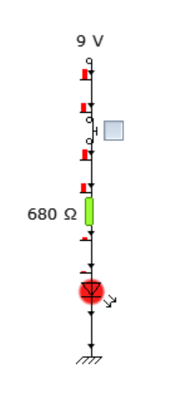
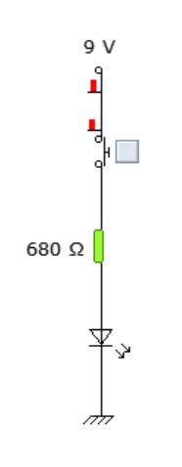
Here you can see I’ve used a ‘push-to-make’ switch to simulate a limit switch in the Usually Open configuration as it comes into contact with an object (when button is pressed). When the switch is pressed, the circuit is completed and the LED lights up.

For our robot, this circuit wouldn’t work, as the limit switch will be an input into the Arduino and the LED will be an output from the Arduino. The programming for the Arduino will tell the LED to turn on or off, not a direct circuit.

This limit switch with a roller is the one I would use, as it is what I have access to at school.
It has a ‘C’ pin, which will go to ground, and 2 other pins, a normally open and a normally closed switch, one of which will go into an Arduino pin to be programmed with.

- LDR (I didn’t choose this option)
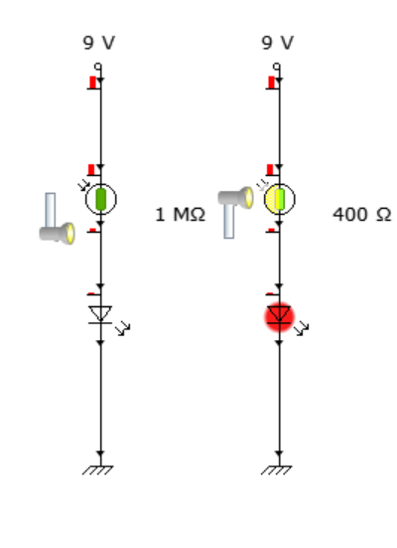
  - Analog Input
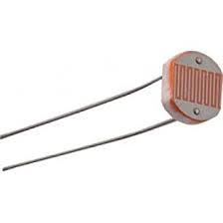
Light dependent resistors vary in resistance depending on how much light is reaching the face of the LDR. The more light there is, the lower the resistance, and vice versa. A light-dependent resistor could be used to detect when a package is placed, as when a package is placed on top of it, the light will not be able to reach it, and we can read this using the analog input on an Arduino.

Here you can see an LDR, and to the right is an example of how LDR values change depending on the light value.

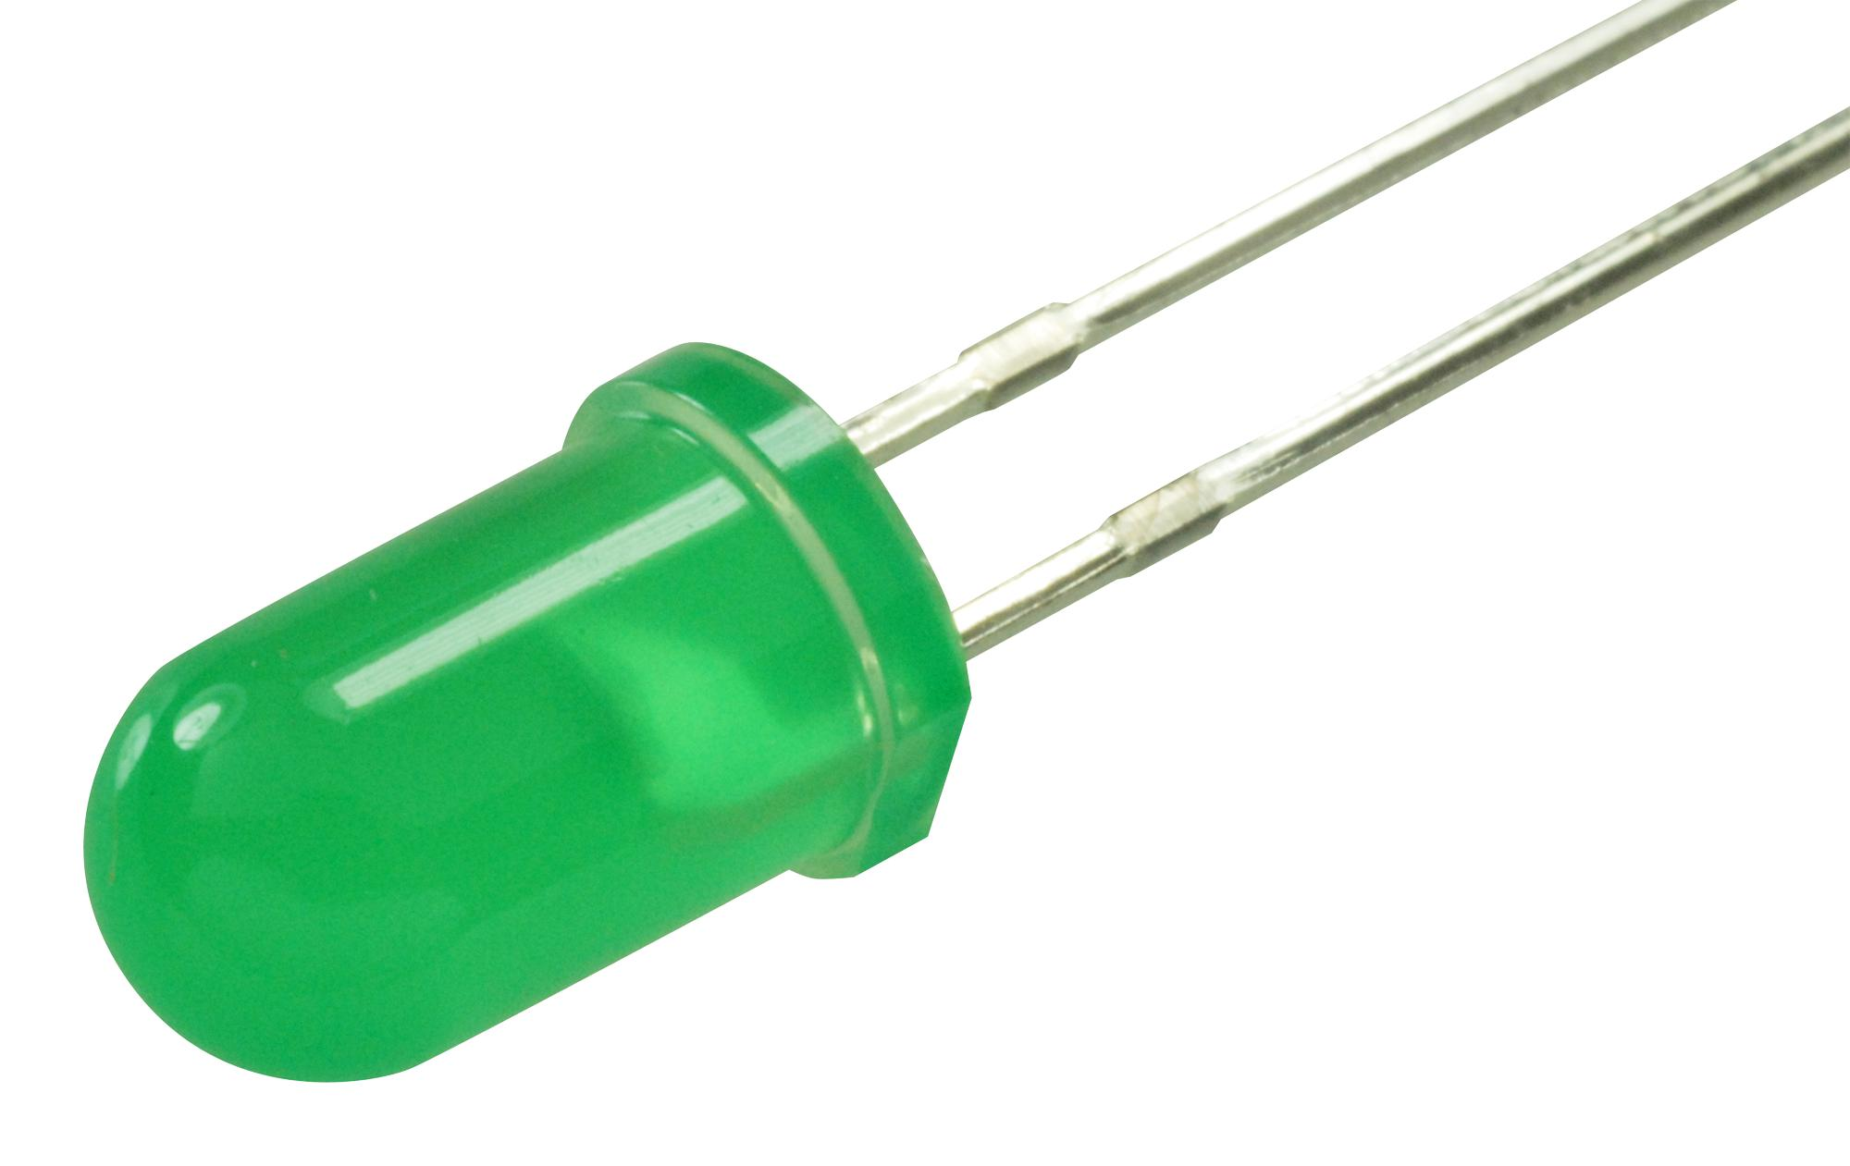
LED
I will also be using an LED to indicate whether the robot is ready for a package. This will connect to the Arduino, and uses a digital output to turn it on or off. I will also need a resistor as the Arduino will provide 5V but my LED should only have 10-30mA of charge flowing through it. A 680Ω resistor should

Wiring Diagram

GND

5V

Motor Controller
Arduino
DC Motor
DC Motor
Battery Connector
VIN
5V

Digital Output
Limit Switch
Digital Input
LED

Here is my wiring diagram for package handling. I have shaded out the components from the previous keystage, as they currently do not affect the package handling system. You can see I’ve added the limit switch and an LED, connected to ground and 5V or a digital input.

Package Housing
As the weights for simulating packages are quite small, we will have to make a housing for them so that they can be placed securely and be detected reliably. I have decided to go with a circular base shape for my housing, so that the ‘packages’ fit snugly inside. I took measurements with a caliper to ensure that my design was accurate, and sketched out a design. I also traced out the chassis of my robot to scale in case I needed to place any attachments. Pictures below.
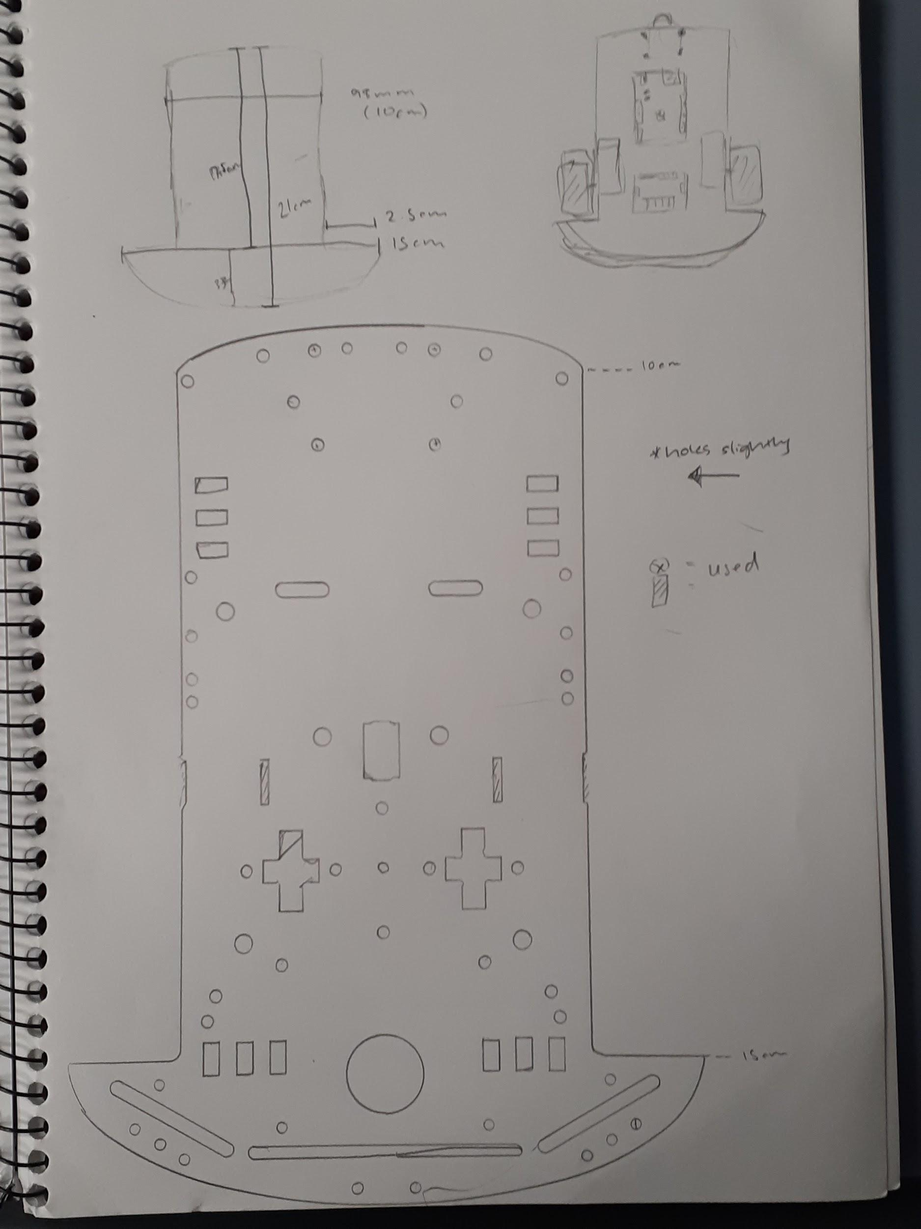
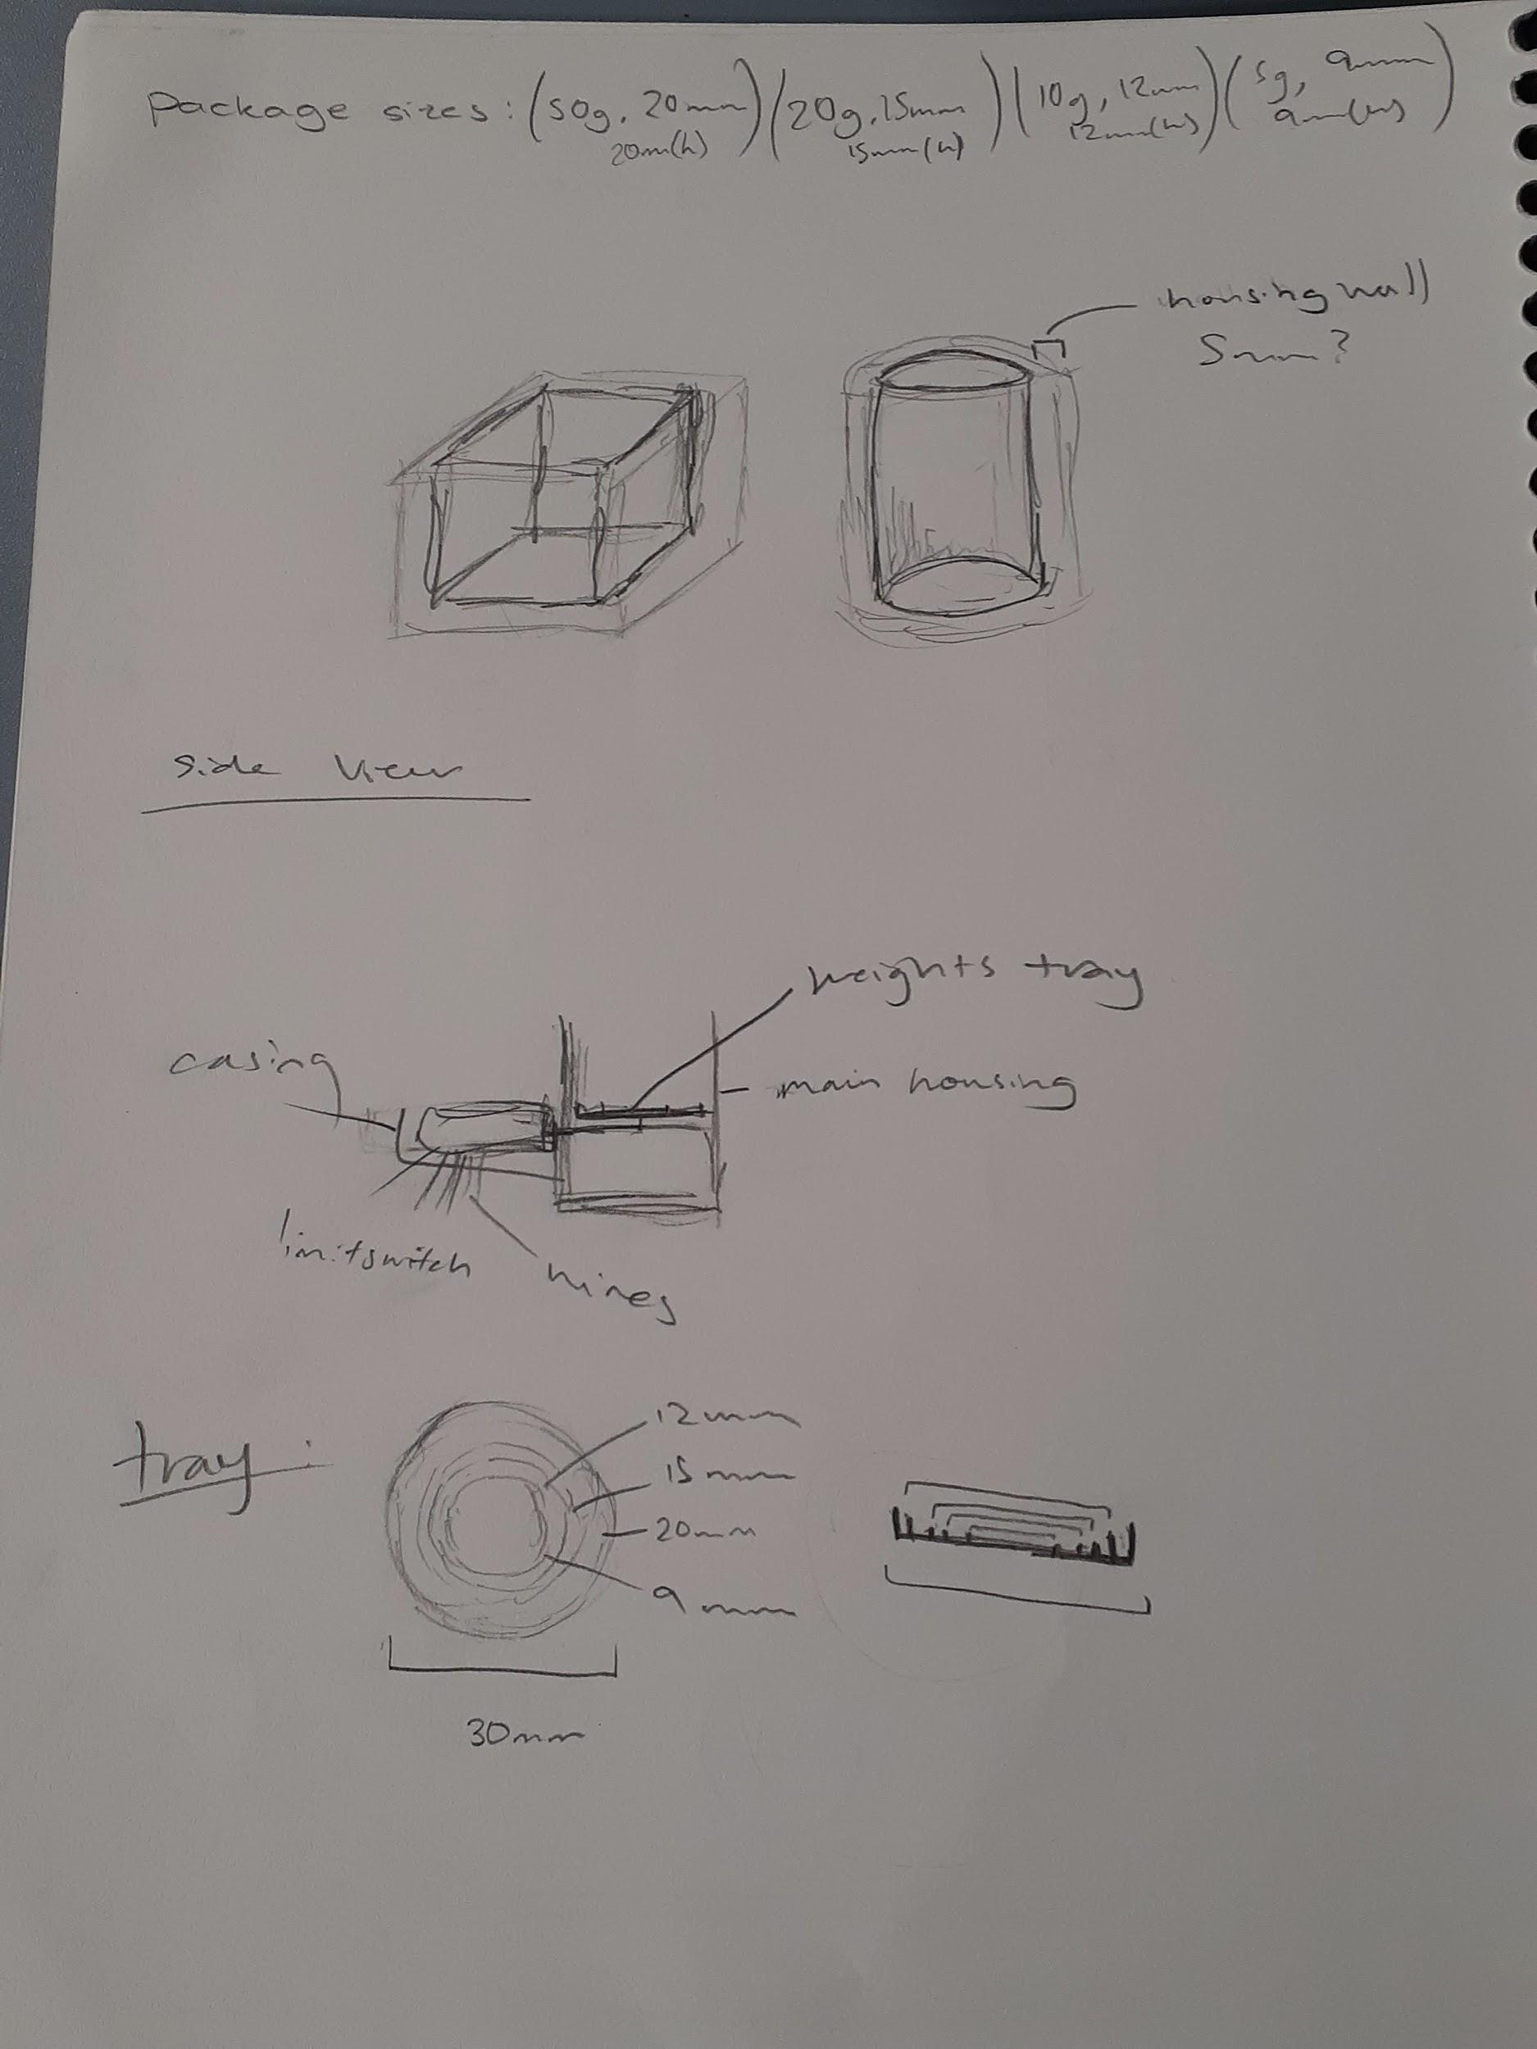

Construction

Package Housing
Here is my modelling in Fusion 360 for my package housing.
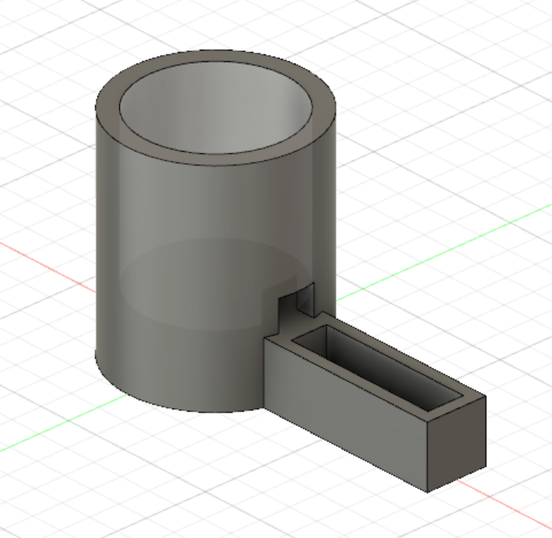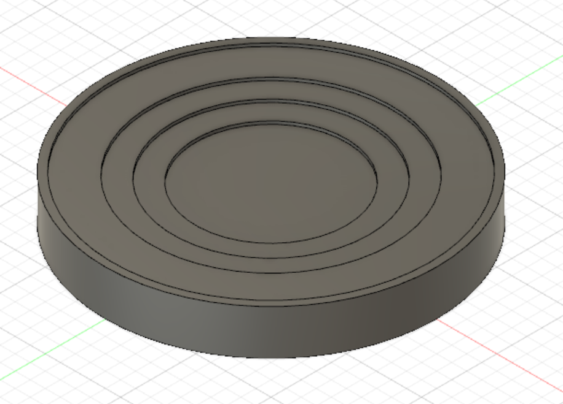
I realised that my slot for the limit switch was not wide enough, so I went back to widen it, along with making the window for the lever taller. I then reprinted it.
I also added a small platform for the weights, with very slight indents for the different sizes of weights, and this would fit inside the ‘chimney’ of the housing.

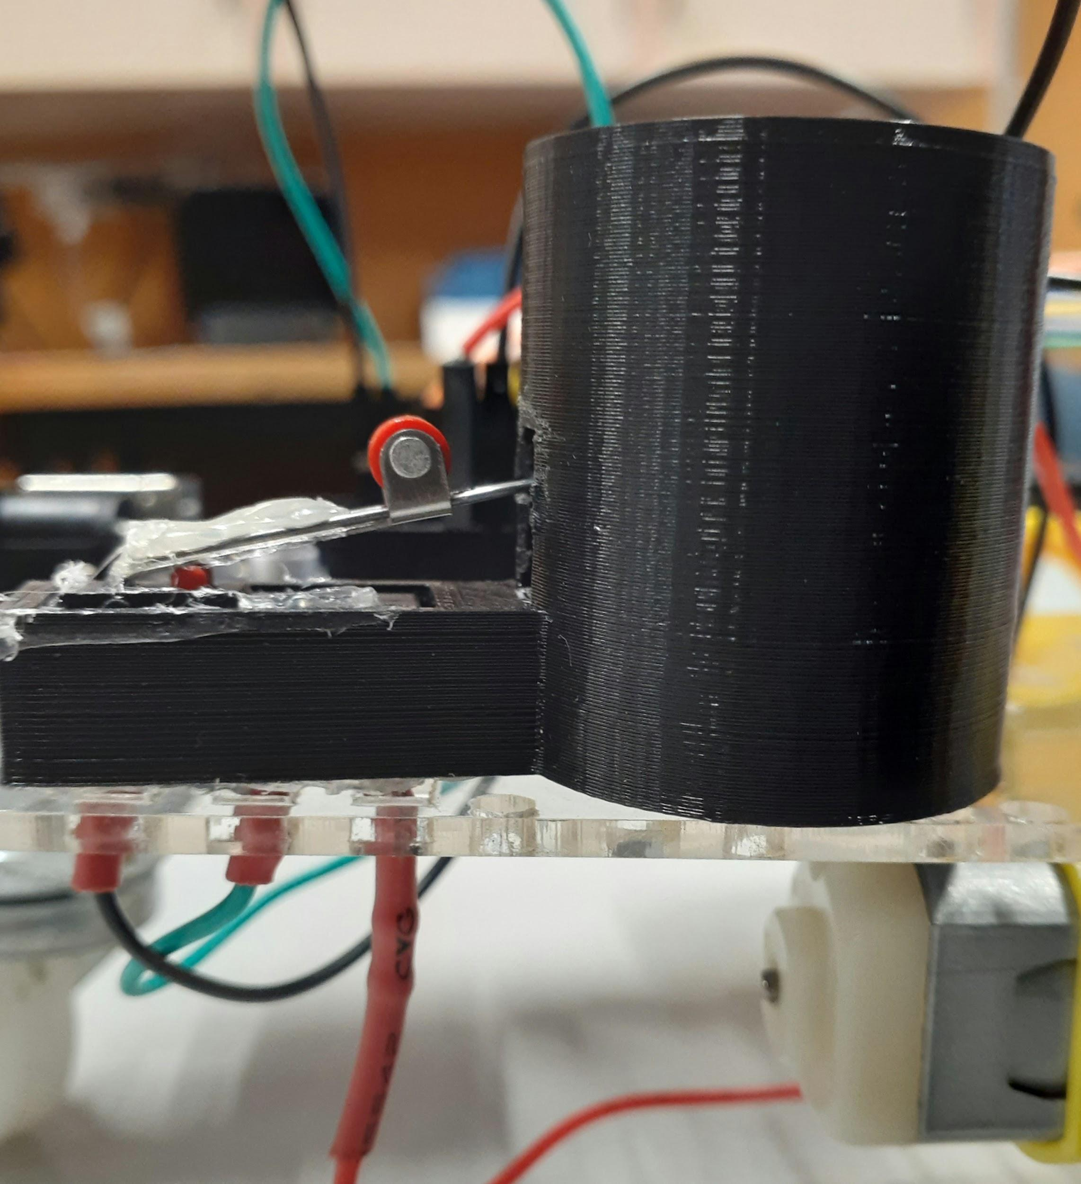
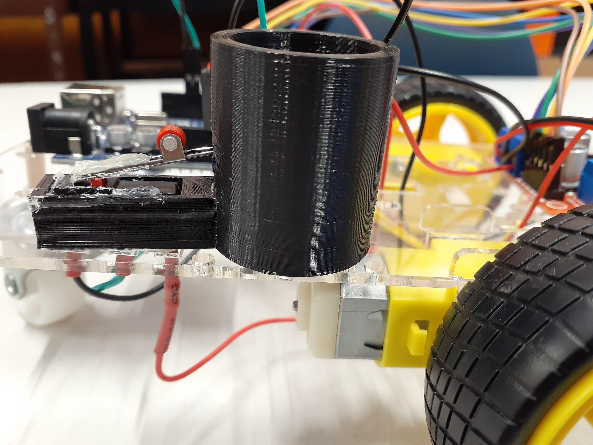
I used hot glue to attach the limit switch to the package housing, and used a hair pin to connect this to the small platform for the weights.

Wiring
I soldered wires to the pins of the limit switch, using standard colour conventions to signify ground(black) and others. I later realised during programming that I didn’t need to use all of the pins, so I have an extra unneeded wire. It isn’t currently in the way, and could be useful if I need to change how the package detection works.

I also soldered wires to a green LED, which I will use to signify when the robot is ready for a package. I used a 680Ω resistor, and used heat shrink to protect any uncovered wires. I used a wire crimping tool to construct the correct pins for connecting to the Arduino.

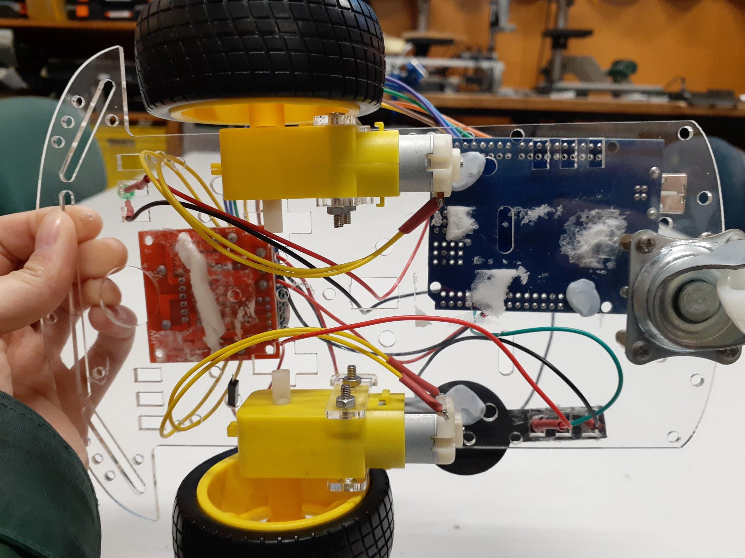
The underneath of my robot is a little crowded with wires currently, which may affect its movement. I will have to add a task for cleaning it up in a future keystage.

Program and Test

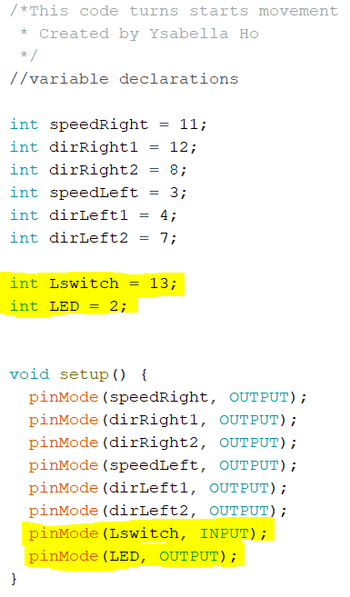
Arduino Sketch
Here is my programming for package handling. It was straightforward as I only had to use digital inputs and outputs for this keystage. A change from the movement coding is that I have added functions for all movement; backwards, forwards, left/right, and stop. I did this using void function (int, speed) which I could then call in the void loop using function(speed).

I ended up downloading the ezButton library (which is used to debounce switches) as I had a problem when testing where the motors wouldn’t start/move smoothly when the limit switch was pressed down. Ater attaching the limit switch properly with hot glue, there was no stuttering effect so the ezButton was actually not needed. Moving forward, I will use the coding without the ezButton, as it would be simpler.
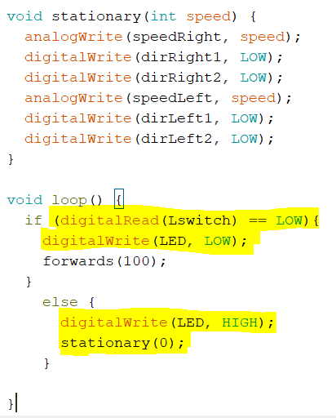
The relevant and new parts have been highlighted in these images. I added a function for ‘stationary’ to make it easier to stop the robot. The other functions were coded much the same way, using a different function name.

In the loop, I added an if/else statement to read the limit switch, and if it was pressed, the robot would move and the LED would be off. Otherwise (ie. no package) the robot would stop and the LED would turn on (indicating the robot is ready for a package).

The reason it reads when LOW as opposed to HIGH is because I believe I used the wrong wire - there was a ‘normally closed’ and a ‘normally open’ terminal. The code still works like this, but perhaps I should have added comments to make it clearer.

Video of Package Handling: here

Key stage 2 Reflection
Task | Original Due Date | Reflections/Issues/Timing etc
Draw Block Diagram | 24 May | This was completed easily, and was a visual way to put together how my subsystems would flow into one another.
Design Housing | 24 May | This took a bit longer, as I had decided to use a limit switch instead of an LDR, as it had a digital input. This added some aspects to the design that I needed to address.
Develop Housing | 27 May | This part wasn’t too difficult, but I had to go through a few iterations to make my final housing.
Wiring | 27 May | This part was a little more confusing at the start, and I soldered on an unneeded wire, but eventually got it correct. Quite behind in timing at this point, but it needed to be done properly.
Programming | 31 May | This part was completed alongside the wiring, due to my confusion at the start, but once I figured out which terminals went into which Arduino pins, it was very simple to code.
Test | 31 May | Without the package tray (before hot glueing) my robot would stutter, and wouldn’t run smoothly, but it worked afterwards.
Demonstration | 31 May | This part went smoothly, although very late.

Key stage 2 Overall Reflection
I am very behind my original schedule, but my package housing and handling system works reliably, and I am proud of using a different method than everybody else - it challenged me to actually design and code everything myself. Of course, now I pay the price of being very behind. My plan to remedy this is to finish distance sensing quickly, as the code should be quite simple, and it compounds into package handling. After that, I will move quickly onto line sensing. I will have to make use of any time possible, coming into the electronics lab during study and lunches.

As for my physical robot, some wires are too long, making it difficult to follow them. I will have to clean this up at some point to keep my robot clean and safely functioning. I also need to secure my components onto the chassis. I am utilizing a lot of the pins on my Arduino, so I also will have to solder some wires together in the future. I have not yet added a switch, or a designated spot for a battery. I have been using the power supplies while testing for this keystage.
Overall, my robot has become a little untidy in terms of wires, but I understand my programming fully as well as my next steps.

Updated Process table
 | Key stage Name | Description | Due date
1 | Movement | The purpose of this key stage is to demonstrate the robot moving forward, backward, left and right. | 17 May 2022  Actual Completion: 20 May 2022
2 | Package Handling | The purpose of this key stage is to detect packages on the robot and indicate whether it is ready for one. | 27 May 2022  31 May 2022  Actual Completion: 20 June 2022
3 | Collision Detection | The purpose of this key stage is to demonstrate the robot detecting surrounding objects and avoiding them. | 6 June 2022  9 June 2022  24 June 2022
4 | Line Following | The purpose of this key stage is to demonstrate the robot following a line. | 27 June 2022  30 June
5 | Testing | The purpose of this key stage is to demonstrate the robot completing all key functions. As well as polishing up any functions and adding the aesthetics. | 1 July 2022  4 July 2022
 | Submission | Submit all documents and robot | 4pm, Monday, 4 July 2022

Key stage 3: Collision Detection
In this key stage I want to develop a distance sensing system for my robot, where it will stop if it detects objects within a short distance in front of it. This will stop it from crashing into other robots on the track, and also act as a safety measure.

Task list
Task | Description | Due date
Draw block diagram | Construct a diagram to show how components work with previous subsystems and each other. | 21 June
Design ‘housing’ for distance sensor. | The ultrasonic distance sensor will need a bracket to hold it in place. | 22 June
Wiring | Connect the component to the Arduino. If possible, tidy the wires. | 22 June
Programming | Write a sketch for distance sensing. | 22 June
Test | Troubleshoot and test with previous subsystems(movement/package handling). | 23 June
Demonstration | Show that the collision detection works along with the package handling system. | 23 June

Design

Block Diagram
This is my block diagram to help visualise the system interactions for this keystage.
The distance sensor will be an input to the Arduino, much like the package detection system, which is why I have put them together.
The Arduino will read both of these, and will only start movement if both conditions are satisfied (there is enough distance in front of the robot, and it has a package).

Arduino
(Programming)
Package Detection System
Distance Sensor
Movement

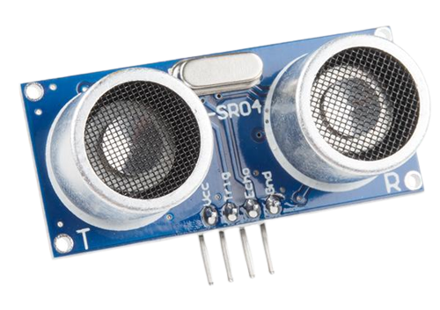
Distance Sensor - Ultrasonic
I will be using the Ultrasonic Sensor HC-SR04 to measure the distance from the front of my robot to any nearby objects.
This sensor works by emitting an ultrasonic wave of 40kHz, which travels through the air and will bounce back to the sensor if it collides with any objects.
The sensor then receives this wave and using the speed of sound, you can calculate the distance between the object and the robot. The sensor runs on a 5V power supply, which can be provided by the Arduino, and the other terminals can be connected to ground and the digital I/O pins also on the Arduino.

The sensor has 4 pins, VCC, TRIG, ECHO, and GND. The trigger pin is for emitting the ultrasonic wave, and the echo pin is for receiving it. Here is a diagram of the HC-SR04, and one of how it works.^{[9]}
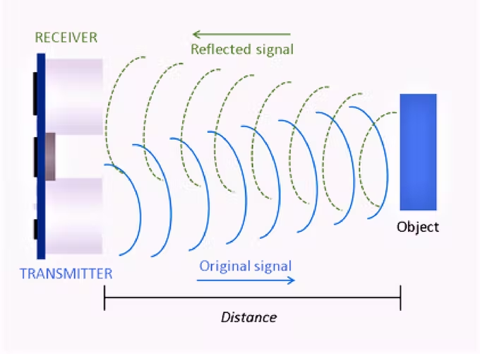
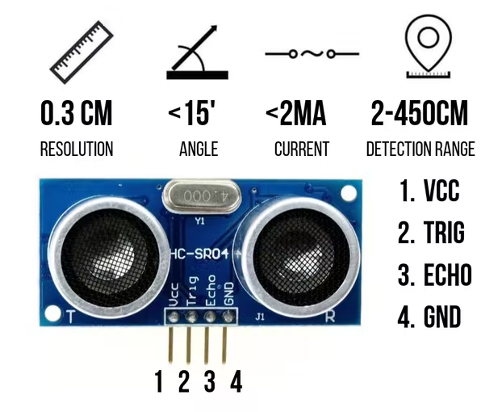

Wiring Diagram

Digital Output

Digital Input

5V

GND

Arduino
VIN
Limit Switch
LED
Ultrasonic Sensor

ECHO
TRIG

GND

VCC
Here is my wiring diagram for the components in this keystage. There is only the ultrasonic sensor that needs wiring, and it has 4 pins. VCC and GND are just power supply and ground, and the trigger and echo pins can go into the digital I/O pins.

Again I have shaded the previous components.

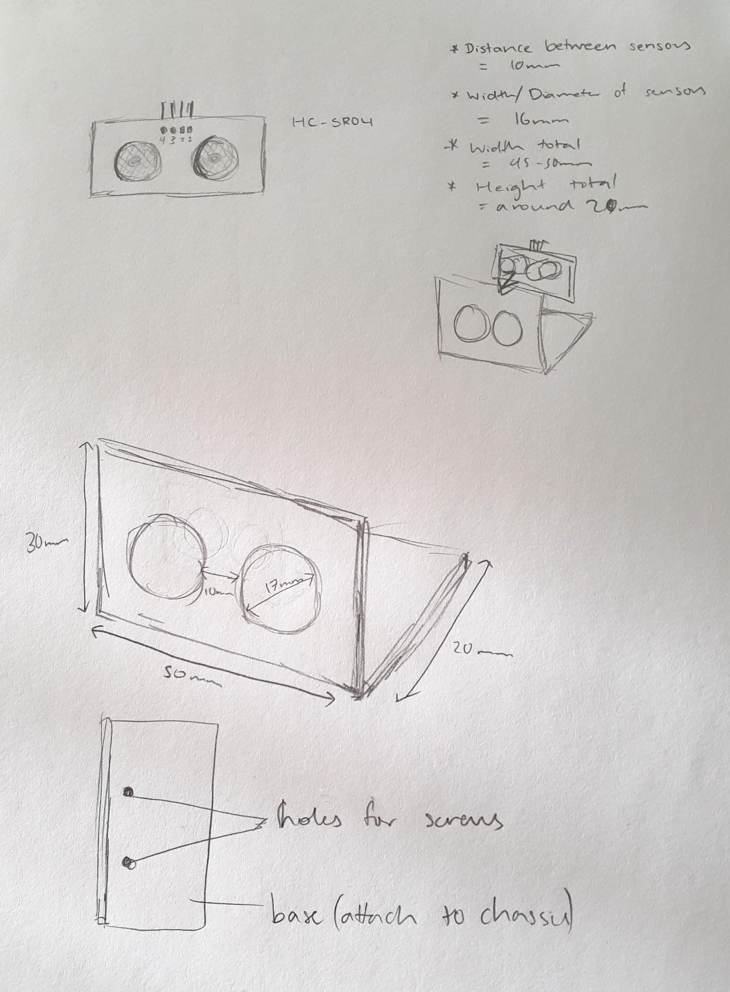
Sensor Housing
Here is a sketch of the small ‘housing’ I will make for the sensor. It has a hinge/bracket sort of shape, which will allow it to be attached to the chassis using screws or adhesive, and the HC-SR04 can slot into the front face. I plan to model this in Fusion360 and 3D print it.

I took measurements using a caliper to ensure they were as accurate as possible, and included them in the sketch.

Construction

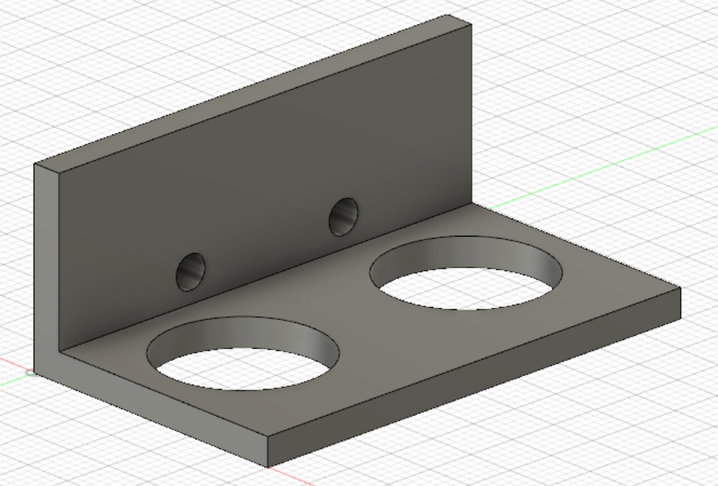
Sensor Housing
Here is my sensor housing in Fusion 360. I based this on the sketches above, and kept it as simple as possible.

I had to approximate some things, like the centre of the holes, but the distances between them were fixed.

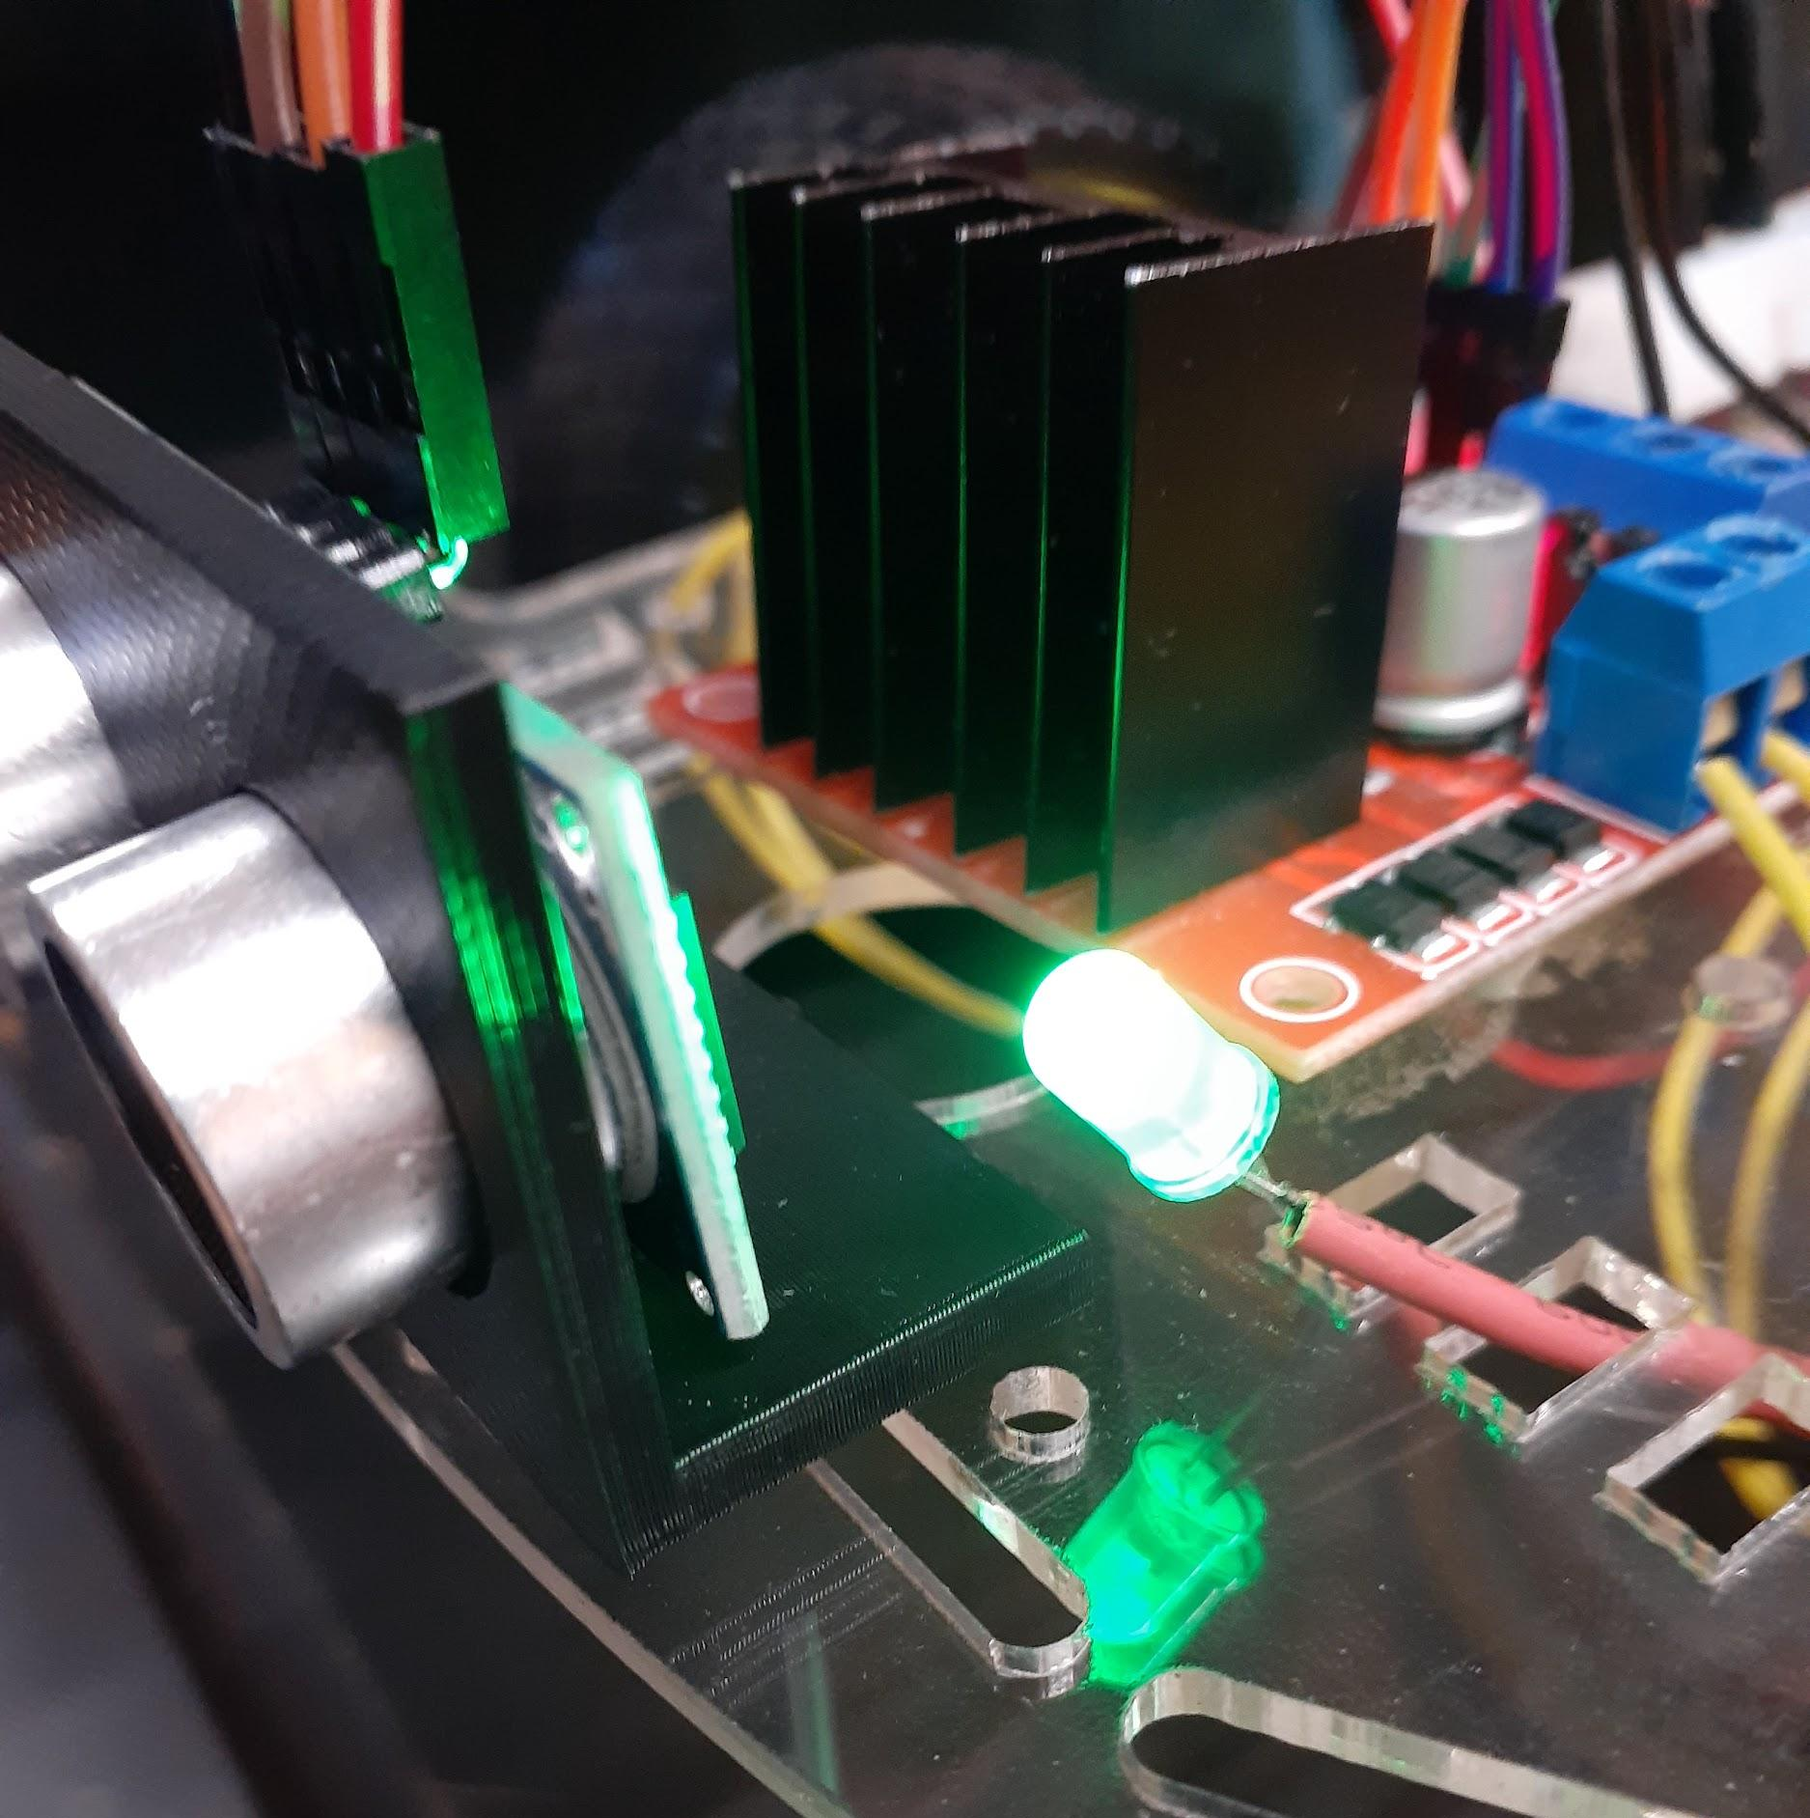
Physical Attachment
Here you can see I’ve attached the ultrasonic sensor to the front of my robot using the bracket shaped housing. I 3D printed the housing, and used double-sided tape to attach it to the chassis, as it turned out that the holes for the screws were in the wrong place. Luckily, the base worked well as a surface to adhere the entire thing to my robot.
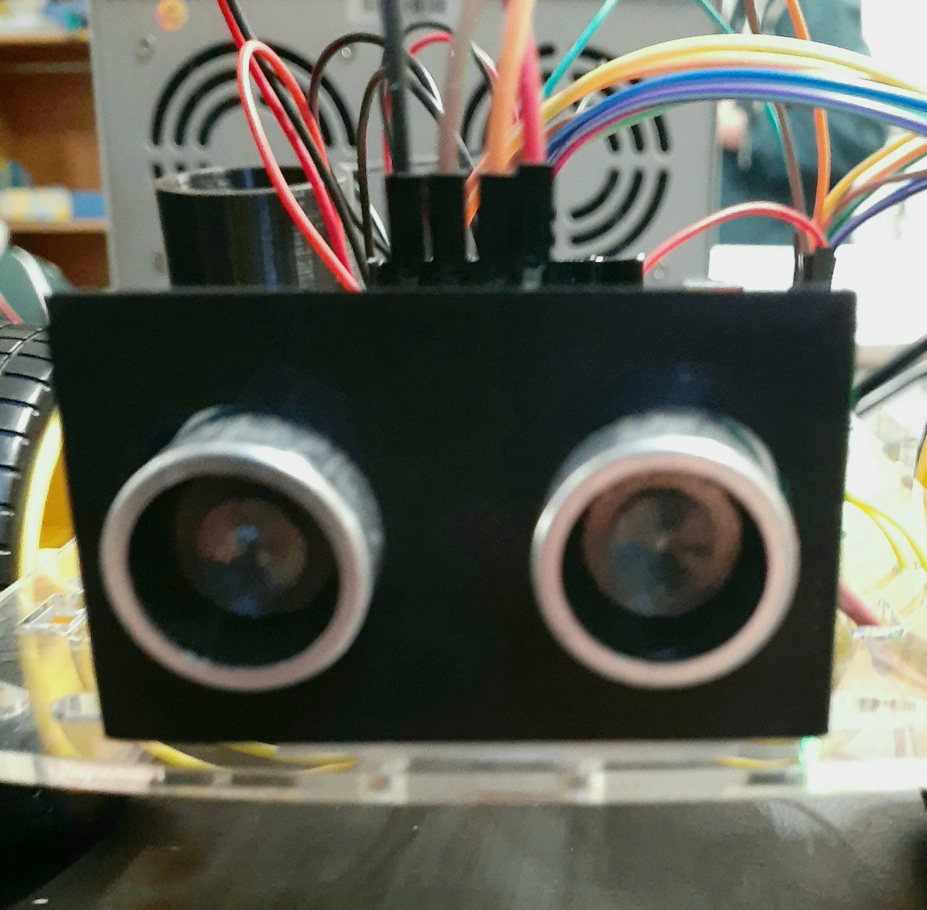
The sensor slotted in correctly to the front of the bracket, and you can see where the sensor is relative to my motor controller and LED there.

Here is the front view of the ultrasonic sensor and its housing. As you can see, the sensor terminals fit inside the holes so that they can be extended out the front of the robot. This allows for a more accurate and undisturbed measurement of the distance in front of the robot.

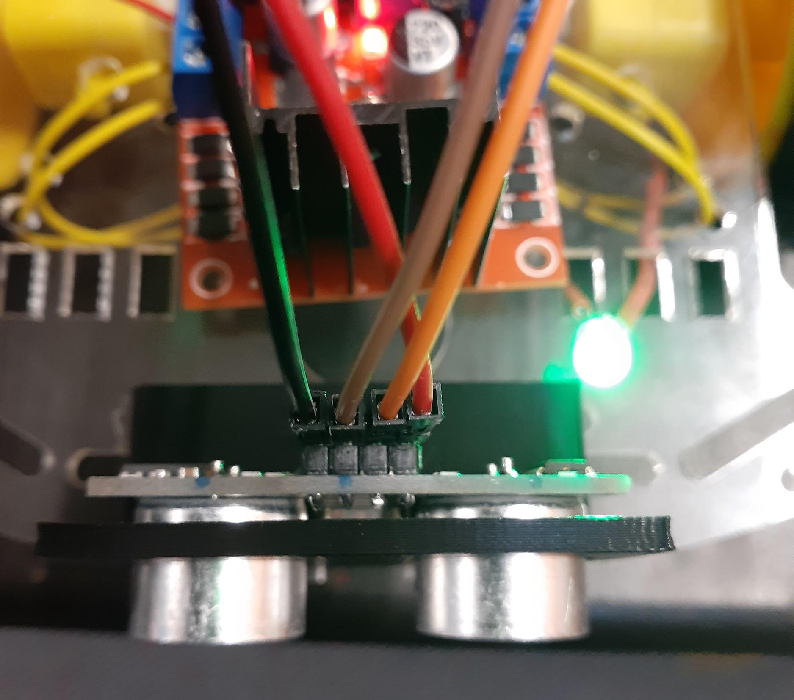
Wiring
Here you can see I have connected jumper wires to the 4 pins of the ultrasonic sensor. These are female to male, so that I can connect the pins to the Arduino. From left to right, they are; ground, echo, trigger, and vcc. I have used colour convention codes (black for ground, etc.) to make it easy to determine which wire goes where.

It is difficult to see in this image(left), but I have placed the ECHO wire (brown) into pin 5 and the TRIG wire (orange) into pin 6 of the digital I/O pins on the Arduino.

Below you can see I have added a small breadboard with the negative and positive power lines. I have moved my ground and 5V power supply to this board, as I am running out of pins on my Arduino for individual components.
Later on, I will solder wires together so that there is no need for this breadboard. Temporarily, it helps with organizing my wires, and once I know exactly where everything will go, I can group wires and twist them together to occupy less ground/5V pins.

Program and Test

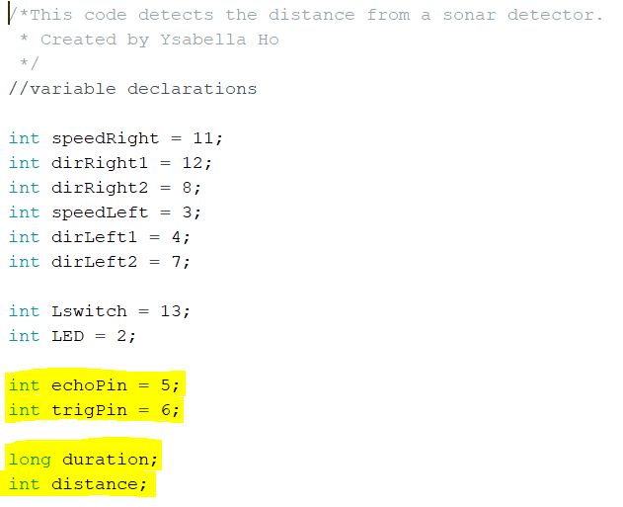
Arduino Sketch
I first wrote a separate code to test the actual distance sensing and calculations before combining it with the package handling and movement.
Highlighted are my new variable declarations, with the pins for the echo and trigger, as well as variables for the length of time the ultrasound takes to bounce back, and a distance that will be calculated.
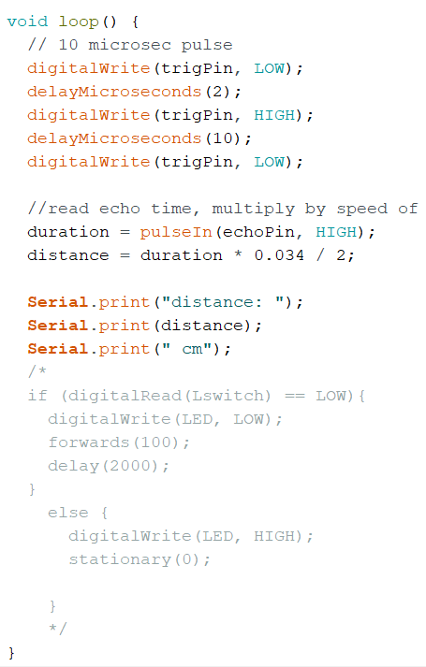
Here is the loop that the Arduino will run. I have commented out the previous coding for package handling.
This code tells the trigger pin to send out an ultrasound for 10 microseconds, then stops it again. The LOW setting at the beginning is to ensure the pulse is reset every loop.
Then, the echo pin reads how long it has taken for the wave to bounce back to the sensor. This is taken using the pulseIn function which reads when the echo pin changes from HIGH to LOW. This duration is then multiplied by the speed of sound, then divided by 2 to account for the fact that the sound wave has to go there and back.
I used the Serial Monitor to test whether this system was working.

Combining with Package Handling
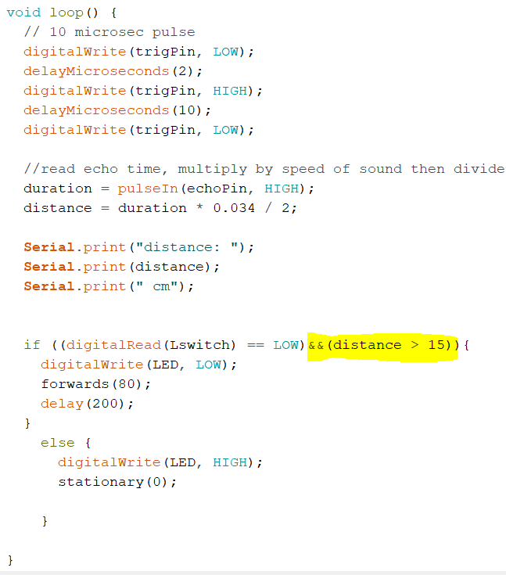
Here is my sketch that combines the distance sensing with the other subsystems - actually telling the robot to do something. The loop is much the same as above, but I have added to the if statement.

The code now reads “if the limit switch is down, and the distance in front is greater than 15, do things”

I have made the speed lower, and the distance for clearance 15cm instead of 10cm to allow more time for the robot to react and stop. This also allows me to add a delay, which will hopefully help with lowering battery consumption.

Video of Collision Detection: here

Key stage 3 Reflection
Task | Original Due Date | Reflections/Issues/Timing etc
Draw block diagram | 21 June | This was done pretty easily, as it was similar to the last keystage, only working with package handling as well.
Design ‘housing’ for distance sensor. | 22 June | This was also quite simple, as I didn’t need a large or complicated design. Some parts of the 3D modelling were a little frustrating, but I used sketch dimensions.
Wiring | 22 June | This was straightforward, as all 4 pins have a use.
Programming | 22 June | This was rather simple, just some maths - there was a different form of variable though (long).
Test | 23 June | The distance sensor worked right away, and after slotting it into the housing it worked fine.
Demonstration | 23 June | This part went well, and on time!

Key stage 3 Overall Reflection
Overall, for this key stage I am very happy with my progress - it was the most straightforward and smooth process compared to the previous stages. This may be because there was only one component I had to work with this time. I am happy that the code works, and I am glad I took the time to understand it properly and not just copy & paste it into my sketch.

Although I have freed up space for more ground and power connections using the breadboard, I will eventually have to clean that up - perhaps by using a veroboard or soldering some wires together. I have also not yet added an on/off switch to my robot, nor a more secure battery connection location. However, I have now acquired some new batteries, which will have good charge - in the next key stage(or in the final one) I hope to remedy some of the above issues and make my robot a bit more usable. I won’t have much time for the next key stage, but I plan to make good use of whatever time I do have, and I am getting better at keeping to my task management schedule. I will not need to change my main process table.

Updated Process table
 | Key stage Name | Description | Due date
1 | Movement | The purpose of this key stage is to demonstrate the robot moving forward, backward, left and right. | 17 May 2022  Actual Completion: 20 May 2022
2 | Package Handling | The purpose of this key stage is to detect packages on the robot and indicate whether it is ready for one. | 27 May 2022  31 May 2022  Actual Completion: 20 June 2022
3 | Collision Detection | The purpose of this key stage is to demonstrate the robot detecting surrounding objects and avoiding them. | 6 June 2022  9 June 2022  24 June 2022
4 | Line Following | The purpose of this key stage is to demonstrate the robot following a line. | 27 June 2022  30 June
5 | Testing | The purpose of this key stage is to demonstrate the robot completing all key functions. As well as polishing up any functions and adding the aesthetics. | 1 July 2022  4 July 2022
 | Submission | Submit all documents and robot | 4pm, Monday, 4 July 2022

Key stage 4: Line Following
In this key stage, I want to construct a system for my robot that will allow it to move following a line, and stop at the stations.

Task list
Task | Description | Due date
Draw block diagram | Draw a diagram to show how subsystems interact with each other. | 27 June
Design any housings | Any supports that are needed, where any components will be attached to the main robot. | 27 June
Wiring | Connect components to Arduino. | 27 June
Programming | Code sketch for line following. | 29 June
Test | Make sure the system consistently works. | 30 June
Demonstration | Show that the robot can follow a line. | 30 June

Design

Block Diagram
Here is my block diagram to show how the subsystems work together.

Arduino
(Programming)
Package Detection System & Collision Detection
Infrared
Sensor
Movement

Again, the IR sensor is an input to the Arduino, along with the previous systems it also determines whether the Arduino should tell the robot to begin movement. It is the final subsystem that I am adding to the robot, or at least the final one that ties into the ‘input’ systems.

Infrared Sensor
For my line following, I will use infrared sensors, which will detect the amount of light reflected off the underneath surface - showing whether it is white or black.^{[11]}
There are a few types of infrared sensors, some with 4 pins and some with 3 pins - different sensors can return either digital or analog inputs. There is always a VCC and GND pin, as well as an OUT pin, where an analog (or digital) value can be read.^{[10]} I will hopefully use an analog value to accommodate for slight variations in lighting on the map we will be using for demonstration. The OUT pin can be connected to the Analog Input on an Arduino, where it can then be used in a sketch code.

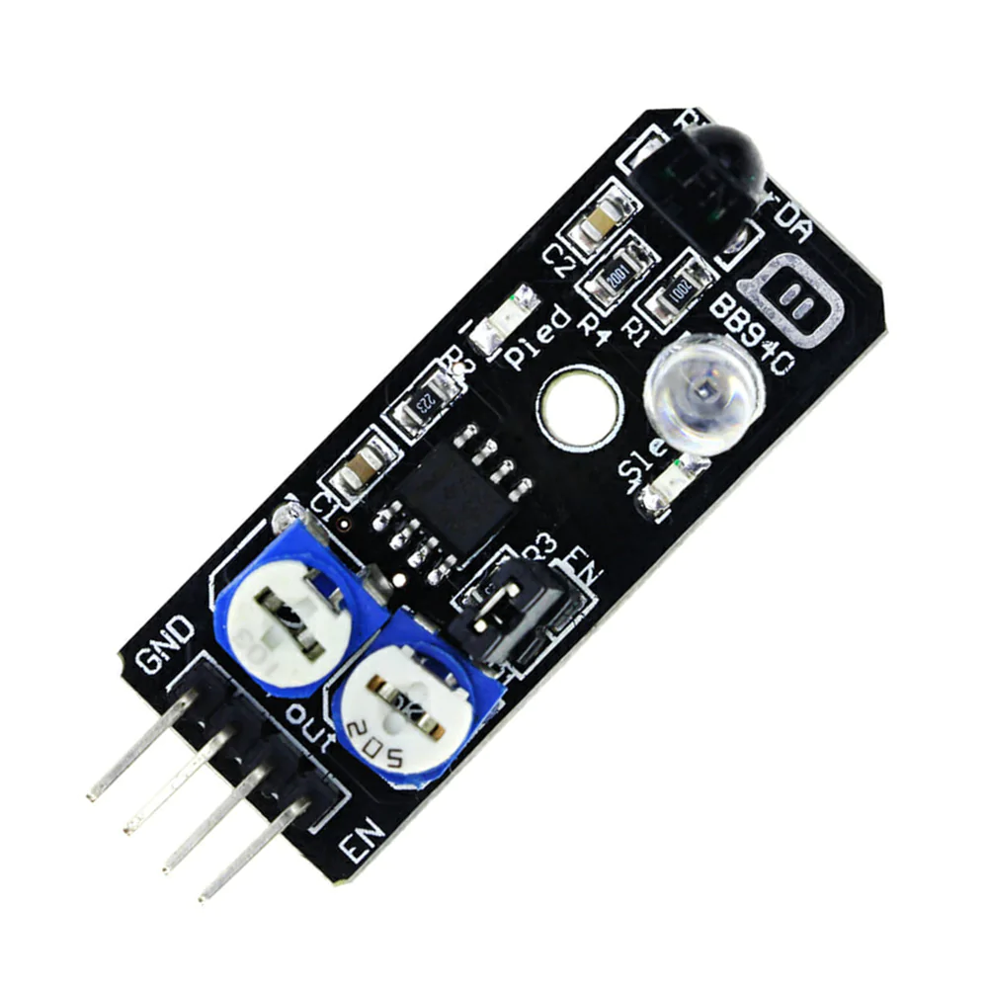
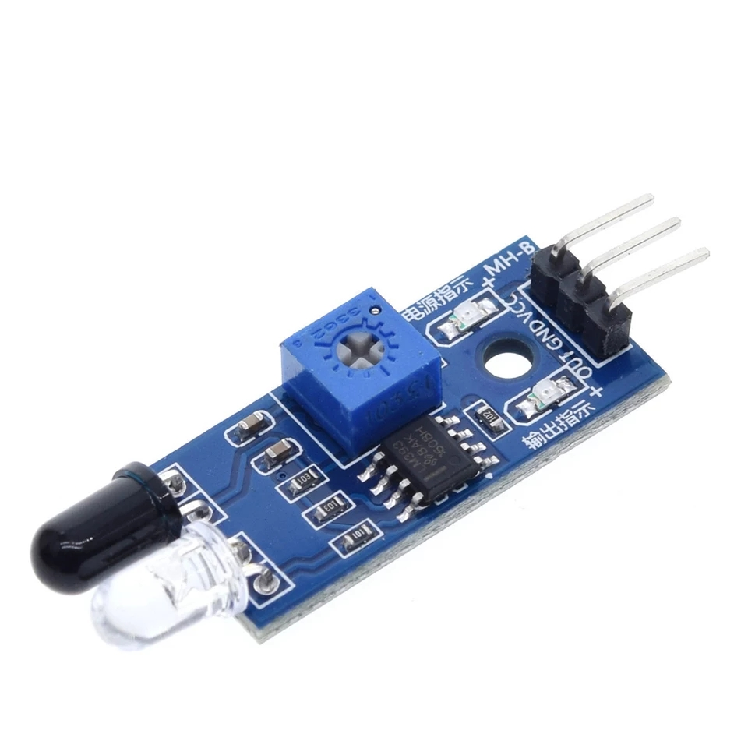
Here are some examples of the IR sensors - 3 pin and 4 pin.

The transmitter emits an infrared ray, and the receiver reads how much light is reflected back. If most light is reflected back, the surface is white. Vice versa for black.

For my robot, I will use a line sensor on each side, and program the robot to move when the surface reflected is white. That way, if one side shows black, the robot will turn, and if both are black, the robot will stop.

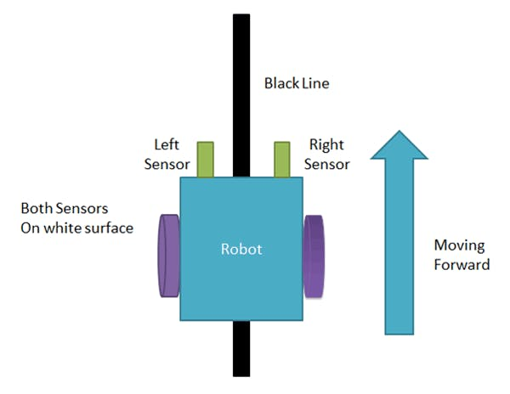
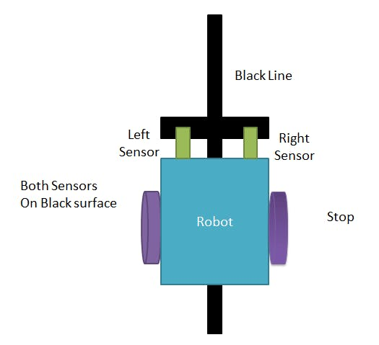
Previously, I have mentioned using an RGB colour sensor, but I thought this grayscale/infrared may be simpler, after receiving some feedback. It is also the sensor most available to me.
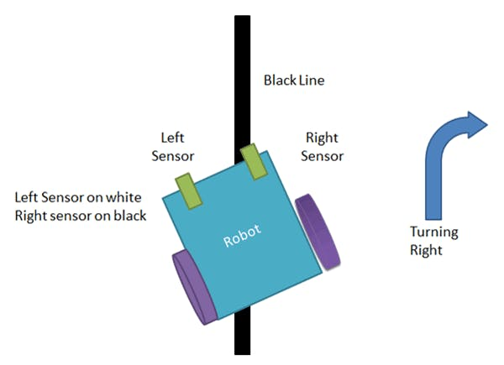
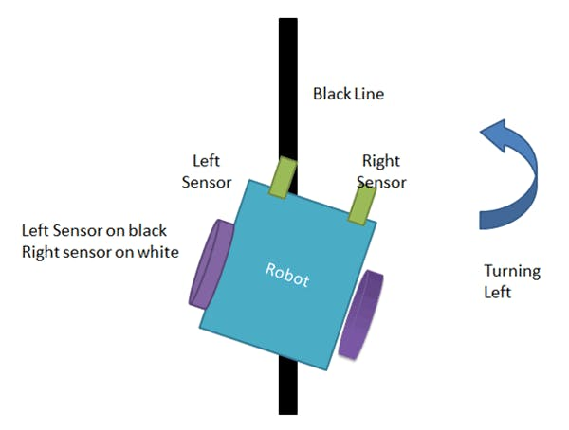

Images here are from Arduino Project Hub

Wiring Diagram
I’ve shaded out the previous system and shortened the wires so it is easier to see what the new components are doing.

Analog Input

5V

VCC

Digital Output

Digital Input
Arduino
Ultrasonic Sensor

ECHO
TRIG

GND
Breadboard

-+
GND
IR Sensor
IR Sensor

The two infrared sensors are connected to 5V and ground via a breadboard strip that I added in the previous key stage so that I had more 5V and common ground pins to connect to. Their AO (analog output) pins are connected to the Arduinos’ analog input pins, and I don’t need to use the digital output pins.

Construction

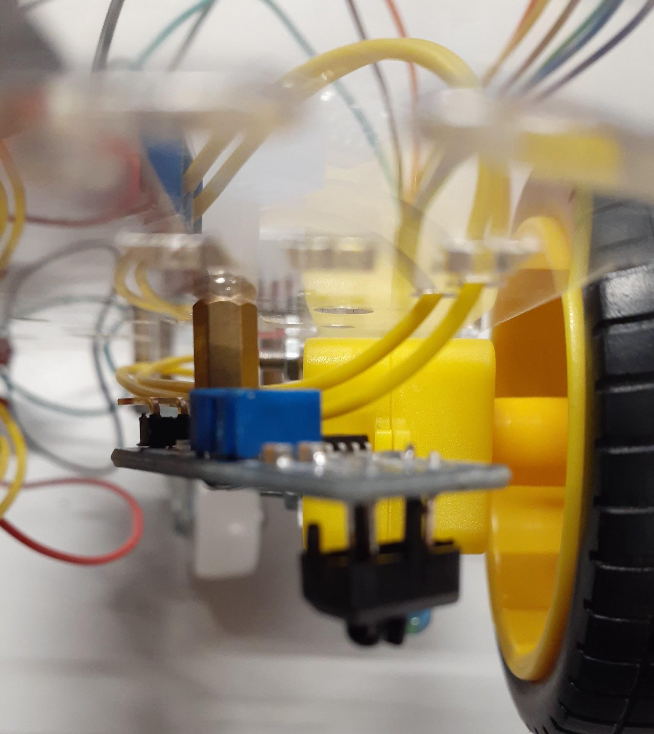
Attaching IR Sensors
Here you can see I have attached my chosen infrared sensors to the underside of my chassis. I used a free space on either side of my motor controller in order to secure them using rod connectors and screws. The rod connectors (small gold bars) helped to achieve the right distance between the IR sensor and the ground so that the values returned were consistent - this helped a lot when programming. I had to ‘swivel’ the sensors a bit so they were angled outwards, to allow for space for the wiring. This maneuverability ended up being very helpful when adjusting the sensors so that they were on either side of the line but able to detect the stations.
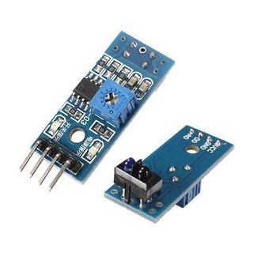
To the right is another image of my physical construction, and also a clearer image of the IR sensor module I used (TCRT5000).

Wiring
Following the circuit diagram, I simply connected some male to female jumper wires to the allocated pins. I tried to make some female terminals using the wire crimping tool, but they were loose and would slide off. I used new ones instead.
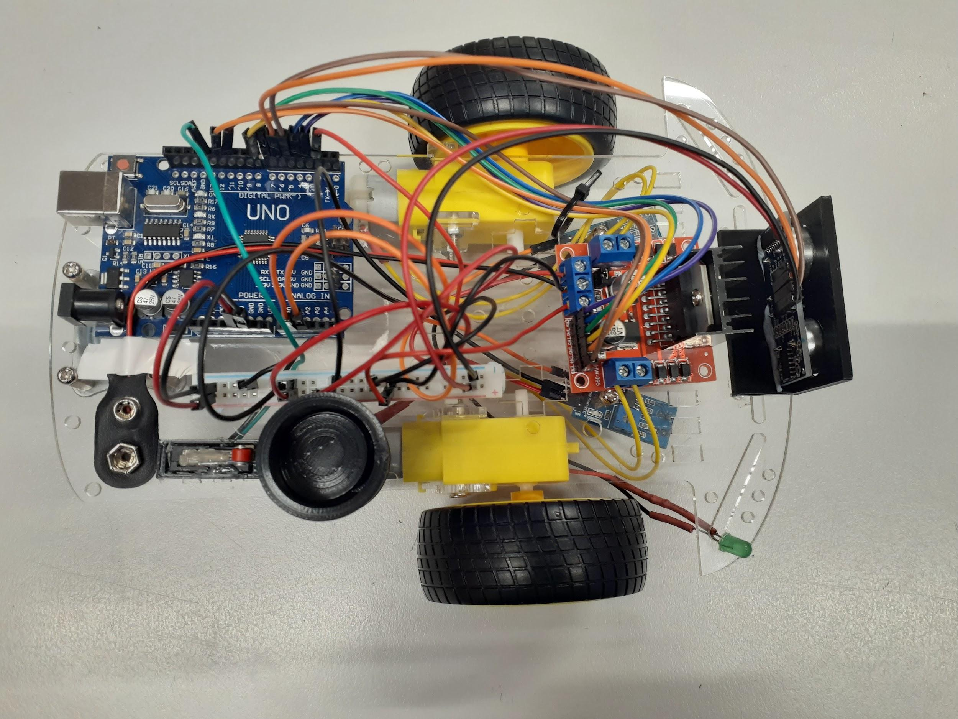
I connected the 5V and GND to the breadboard strip, and the analog output to the Arduino analog inputs. During this, I also used a cable/zip tie to secure my motor controller wires together and out of the way. This made it easier to follow my overall wiring. It was messier than I was hoping, but was the best I could do with the spaces I had left to thread my wires through.

Program and Test

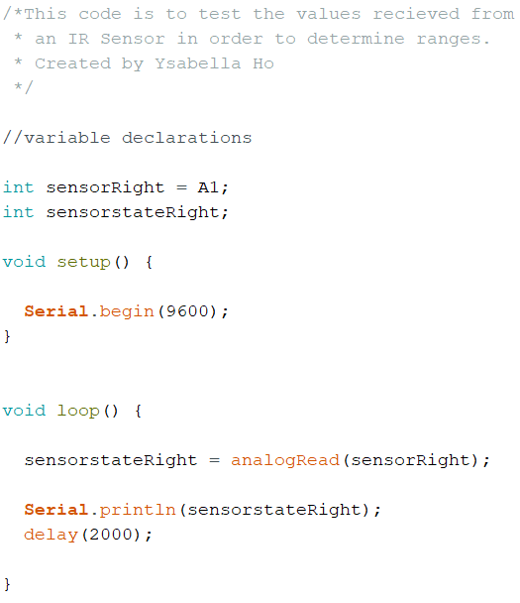
Testing for IR Sensor
To find out what range I should use for my statements in the void loop eventually, I first used a sketch with only the Infrared Sensor, and the Serial Monitor. I then used this to test what values were read off the IR sensor when placed above the black and white of the map we will be using.

I repeated this test with both sensors, using the code to the left and swapping out the variables for the left IR sensor.

Sensor | Result
Right | White = 37-43, Black = 600-700
Left | White = 39-40, Black = 600-700

Note; sometimes (on the stations) the black lines return values of 300-400.

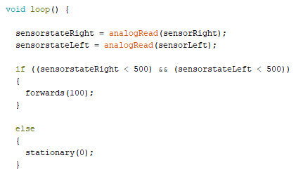
Line Following
I then coded a sketch to make it go forwards if both sensors picked up white, meaning it was on either side of the black line.

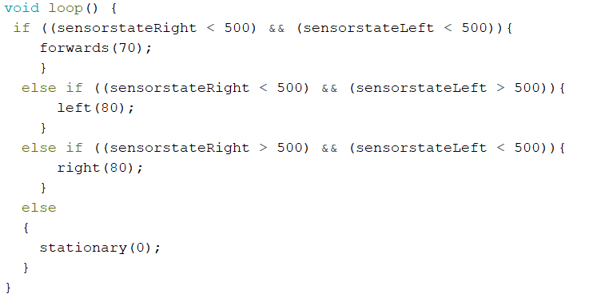
After this worked, I wanted to add turning functions to make it stay on the line and turn corners instead of just stopping. For this I used else if functions, as using only if would bypass the functions and it wouldn’t work.

From there it was a matter of adjusting the speed of my motors so that the robot wouldn’t skip the lines. I eventually got it to go around the factory rather smoothly, with a speed of 70. I noticed that if I set it too low - 50 - the PWM simulated voltage wasn’t enough to move the motors.

My robot would stop at Station A consistently but not the others. I am content with that, and now I want to combine it with package handling and collision detection so that the robot will stop/start at appropriate times.

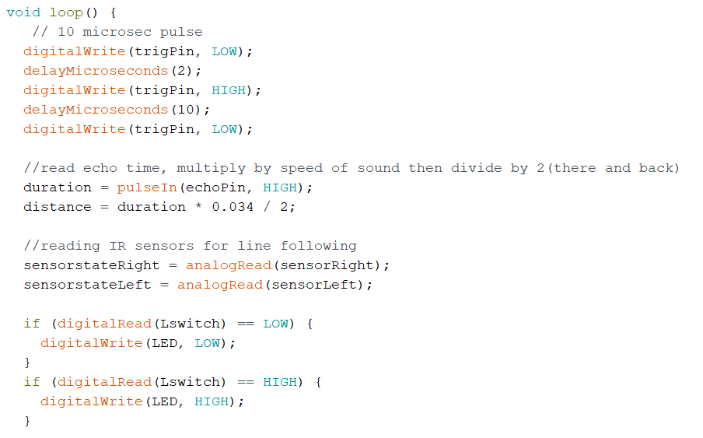
Combining with Previous Subsystems
To combine the line following with the previous subsystems, I simply added the code that needed looping - the distance sensor and the limit switch code - and then added multiple && statements to my if/else statement.

This code works perfectly fine, but I decided to try and improve how I had combined the subsystems so that my robot worked better in the context of the client's needs. Unfortunately, I ran out of time for this and my code didn’t end up working. I did realise I could take the distance sensing out of the very long if statement, and put it in a separate if/else statement that would stop movement if there was any object too close.

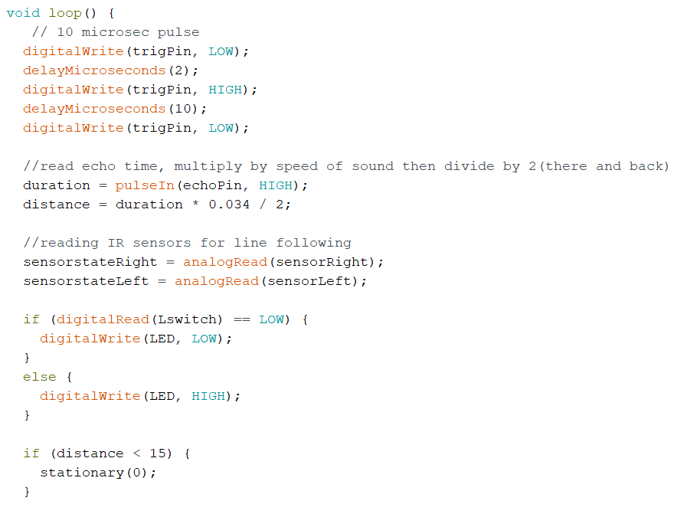
Trying to put code into context
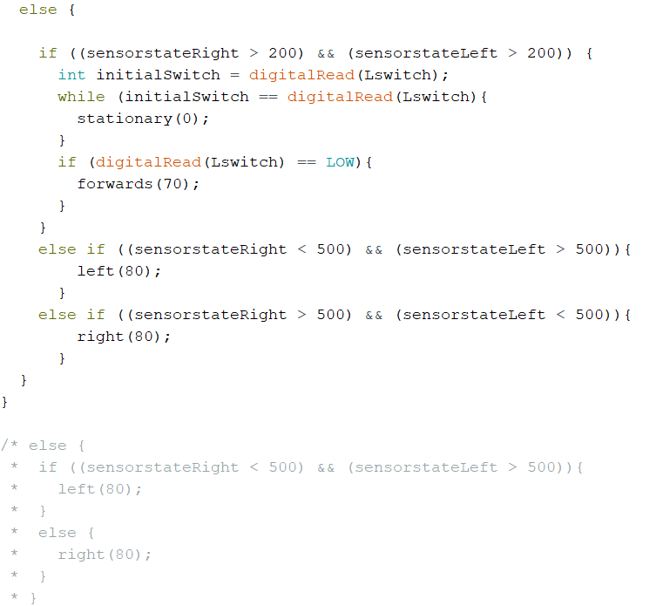
Here is my sketch that I was working on to improve the functionality of my robot. I ran out of time to continue working on it, and so I reverted to the previous code that worked.
One thing I could have taken away from this code was the distance sensor or collision detection if/else loop at the beginning. I could have coded it so that if the distance was less than 15cm, the robot would stop, and then put the rest of my code in the ‘else’ portion. I didn’t end up doing this.

After I reverted to my original combined code, I realised my testing with weights was not going well. I used a multimeter to test the continuity of my IR wires, then the voltage of my batteries.
Turns out my battery was no longer giving 9 volts, and that was why my robot wasn’t running smoothly. I swapped to a new battery and then had to lower the speed of my movement functions because of the higher voltage. I eventually got the robot to run smoothly with the combined subsystems, and the only thing changed in my code was the speed inputted into the function (I put it down to 60).

Final Code
Here is my final code that I uploaded into the Arduino on my robot.
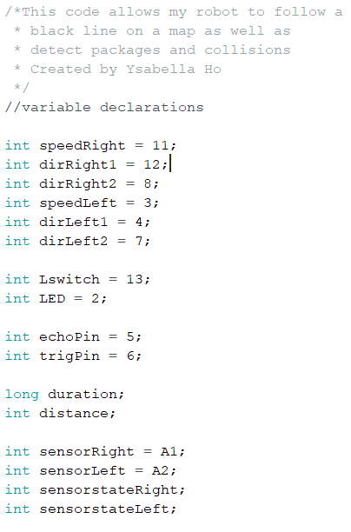
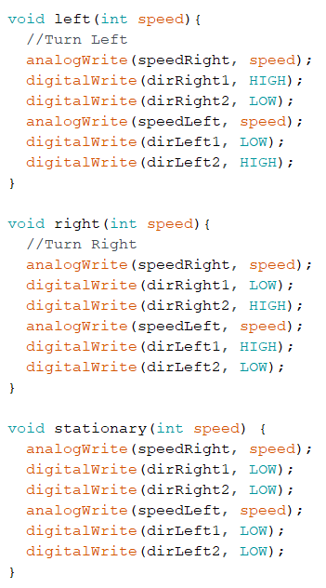
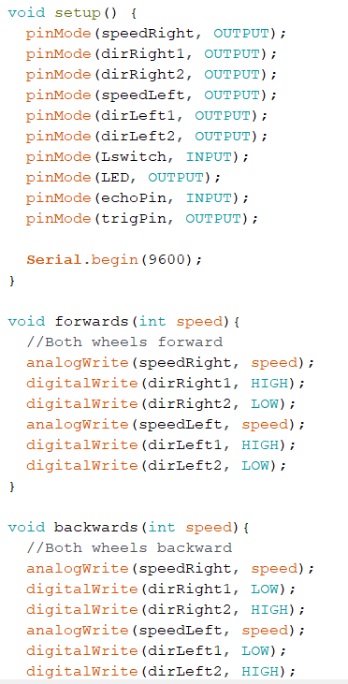
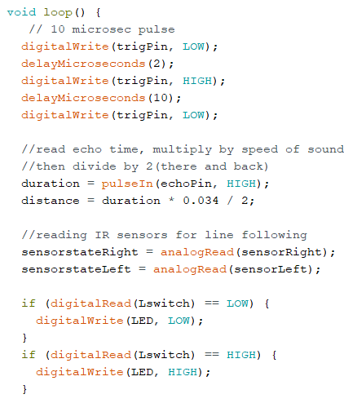

Video for Line Following: here

Key stage 4 Reflection
Task | Original Due Date | Reflections/Issues/Timing etc
Draw block diagram | 27 June | This was the standard - simple, but helped to visualise how the subsystems would interact. Especially important for this final subsystem.
Design any housings | 27 June | I didn’t actually have to design my own housings this time, which was a time saver. I was able to connect the components by themselves with some screws and rod connectors.
Wiring | 27 June | I tried to tidy up my wires, and I succeeded somewhat by tying the ones related to the motor controller down - this was the bulk of them before. I had to bring all the IR sensor wires up through the larger hole in the middle, so they look quite messy. If I had more time I might’ve tried to organize some more.
Programming | 29 June | This was simple at the start, and it was easy to get the line following to work on its own. When combining the subsystems, I regret that my trial of more advanced coding didn’t work out, but otherwise the code works.
Test | 30 June | This was full of ups & downs. Next time, I need to test my power supply more often so that I don’t have to wonder what’s broken.
Demonstration | 30 June | This went well in the end. The robot followed a line smoothly, and stopped when at a station, when the package was removed, or when there was something in front of it.

Key stage 4 Overall Reflection
I feel good about my robot - it can follow a line well, and the package handling and collision detection all still work. I do regret that I wasn’t able to get my extra code I was working on to function properly, but I am happy with my final code. I previously said I was going to tidy up my wires, and make a more permanent common 5V and ground with a veroboard or soldering the wires, but I ran out of time for this.

I would put these simple fix-up tasks in the final key stage, but I find myself out of time to complete it. This is due to a number of reasons, including my poor time management during the first few key stages. It is also due to hybrid learning at school - there was a lot of time lost physically working on code or in the electronics lab as students were cycled on and off school grounds to relieve the pressure of not having enough staff. This is ultimately due to COVID, which has been present throughout this project, and stalled many things. Earlier there was also an evacuation of the school due to a fire, which also took away more work time. I believe I tried to make up for this by coming to school during study periods (Wednesday mornings) and once on my scheduled home learning day. Of course, there are a number of things I didn’t get to finish but I am overall happy with what I have achieved during this time.

Updated Process table
 | Key stage Name | Description | Due date
1 | Movement | The purpose of this key stage is to demonstrate the robot moving forward, backward, left and right. | 17 May 2022  Actual Completion: 20 May 2022
2 | Package Handling | The purpose of this key stage is to detect packages on the robot and indicate whether it is ready for one. | 27 May 2022  31 May 2022  Actual Completion: 20 June 2022
3 | Collision Detection | The purpose of this key stage is to demonstrate the robot detecting surrounding objects and avoiding them. | 6 June 2022  9 June 2022  24 June 2022
4 | Line Following | The purpose of this key stage is to demonstrate the robot following a line. | 27 June 2022  30 June 2022
5 | Testing | The purpose of this key stage is to demonstrate the robot completing all key functions. As well as polishing up any functions and adding the aesthetics. | 1 July 2022  4 July 2022
 | Submission | Submit all documents and robot | 4pm, Monday, 4 July 2022

Final Evaluation
Overall, this project has taught me a lot about electronics and programming; but also time management and the merits of proper research and planning. I am very grateful for my teacher, Mrs Dunn, and my classmates for helping me when needed.

I think my greatest challenge was during my second key stage; Package Handling. I had to push back the rest of my production nearly a month because I had stalled on this key stage. It was probably because I really wanted to use a limit switch while most people were using an LDR, and I didn’t really know how to use it. During this time period, there were also a lot of other projects or tests or fire evacuations - that maybe pushed this project back on my priorities list. If I did this project again, I’d make sure to allocate the right time frame for each key stage, do enough research to make sure it was accurate, and stick to this plan.

The thing I am most proud of, is that I managed to finish these systems in the end, and caught up to my very adjusted production schedule. Unfortunately, I did not complete the final keystage, as I talked about above - but I finished the subsystems and key stages I most needed.

Regarding the relevant implications, I tried to keep my robot tidy for health & safety, and for sustainability I tried to reuse wires or make my own. Sometimes, new materials were needed to ensure the functionality of the robot, but many components were reused from previous projects. My robot functions as intended, and I believe it is usable enough to understand and test.

I received some feedback from peers about my robot. A classmate who doesn’t take electronics mentioned audiovisuals - perhaps music is a bit much but I would be interested in seeing how audio could fit in with the robot. Perhaps relating to usability, to make it clear what the robot was doing. There was mention of some more aesthetically based structure, which I agree with - if I were to continue with this project, I might’ve printed/cut my own chassis or structure.

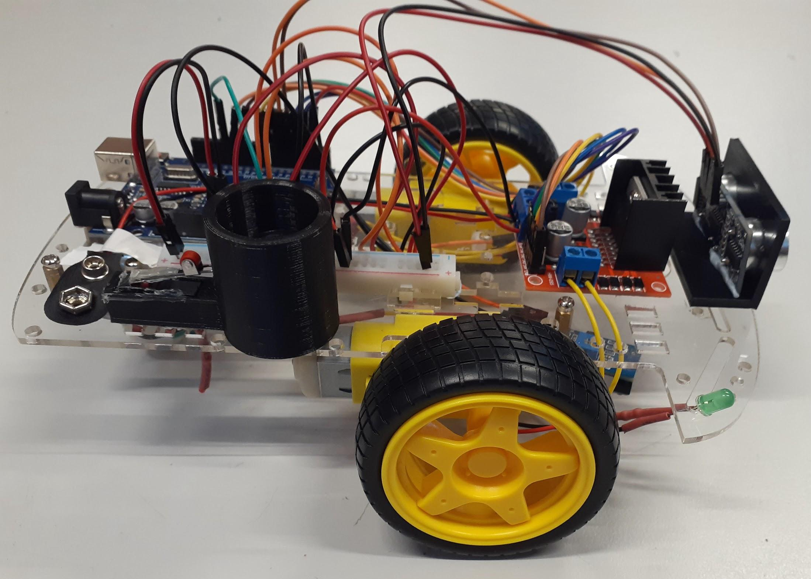
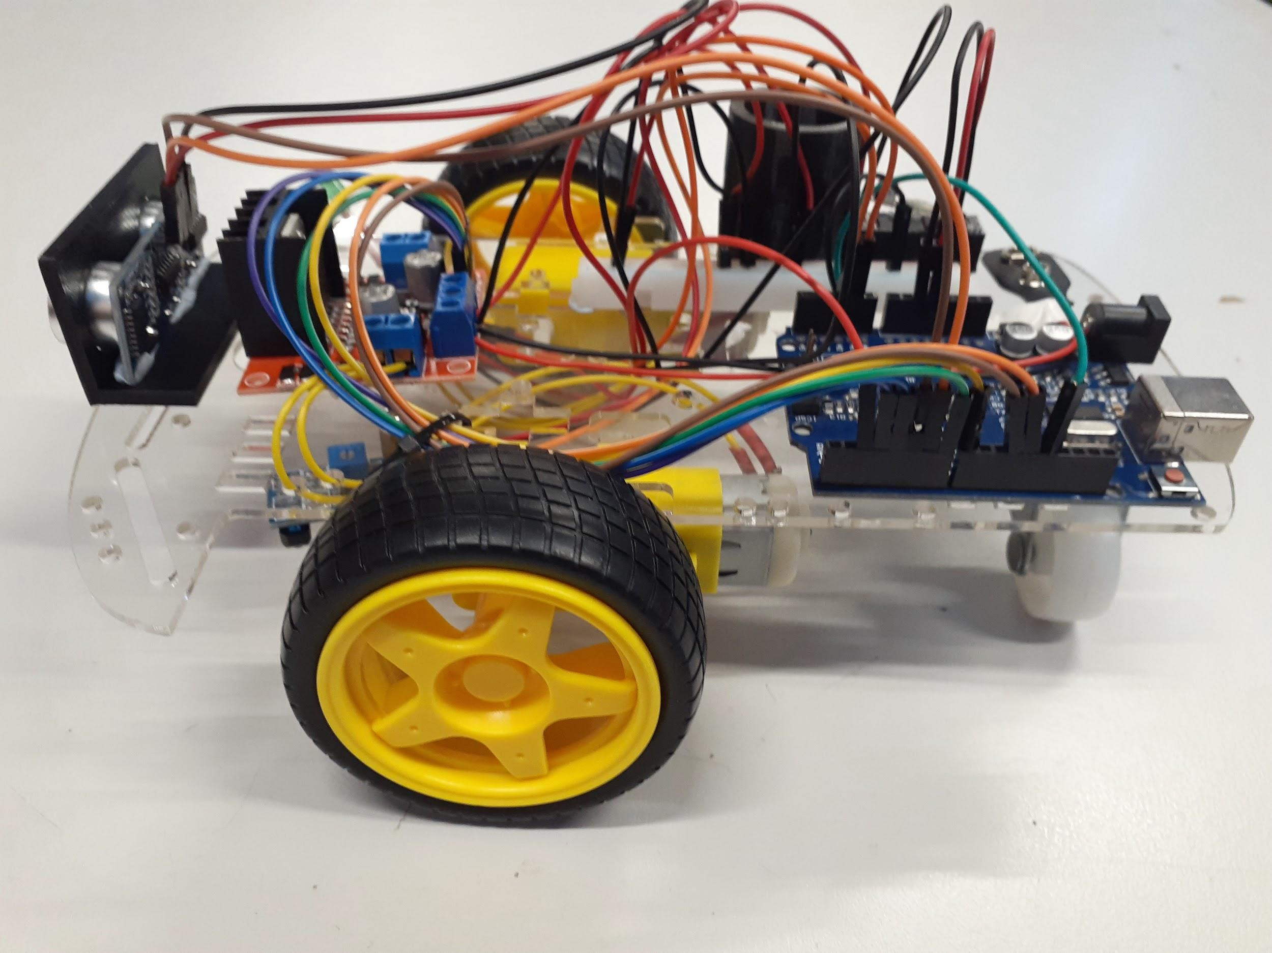
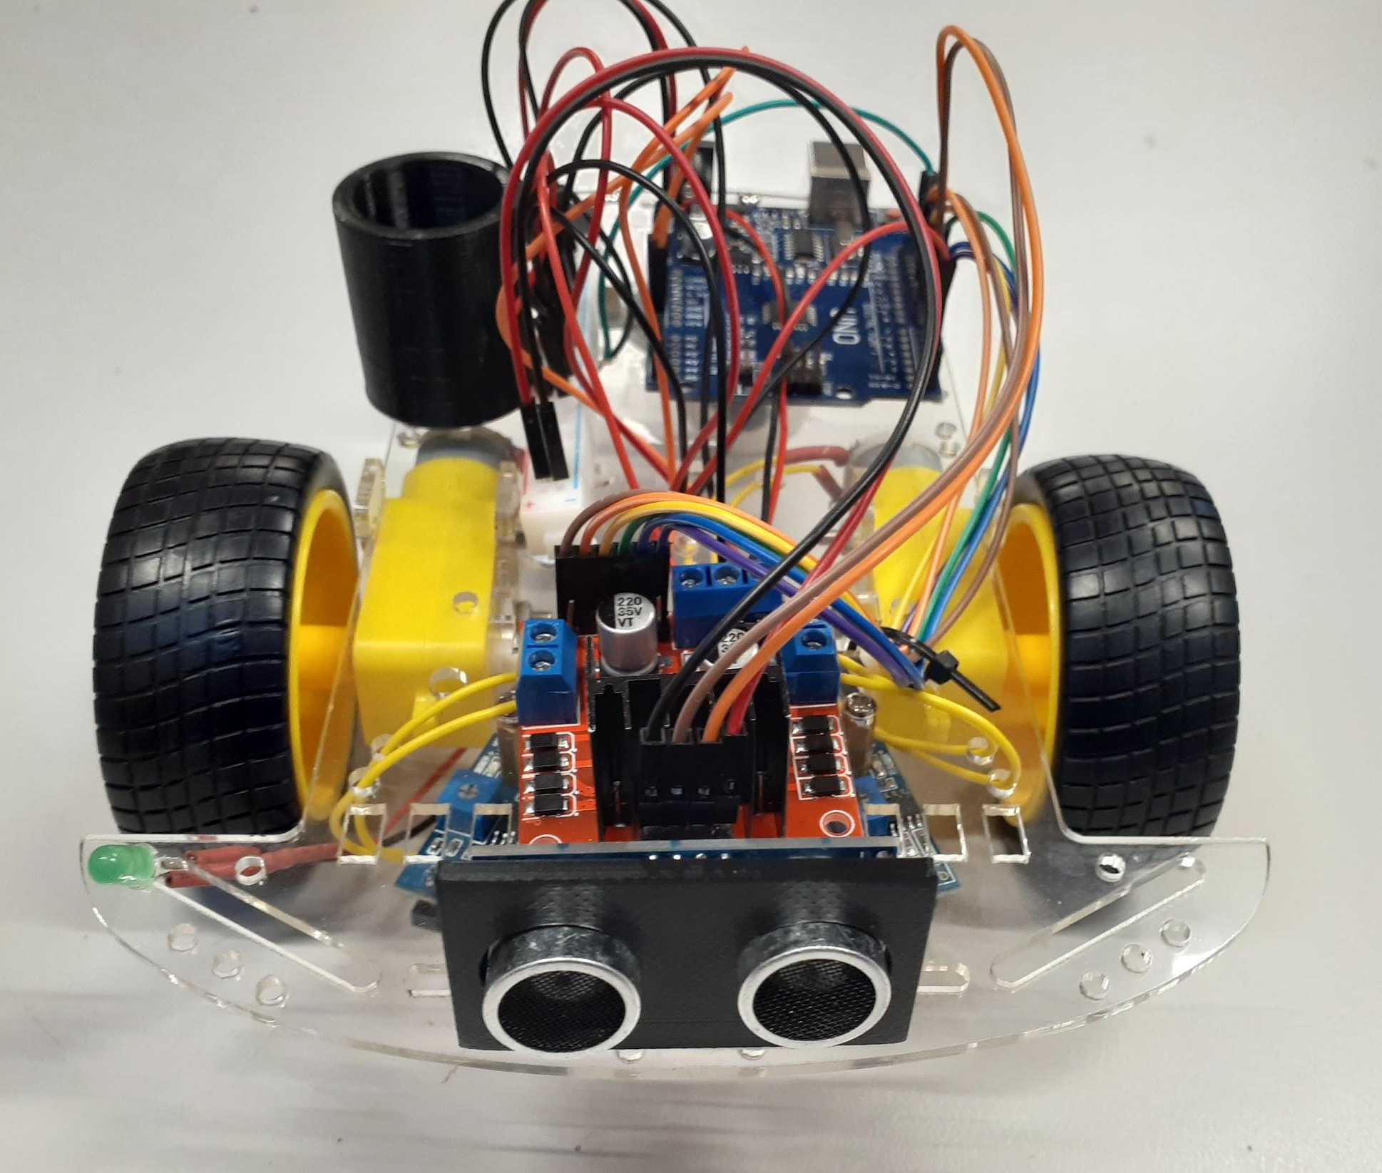
Many people said I should name my robot, so thank you Elizabeth, for teaching me more about electronics and creating a project.

By Ysabella Ho

References
- Employment NZ. (n.d.). Health and safety at work. Employment New Zealand. Retrieved April 13, 2022, from https://www.employment.govt.nz/workplace-policies/health-and-safety-at-work/#scrollto-health-and-safety-duties
- Digital Govt NZ. (2021, January 15). Privacy and personal information. New Zealand Digital Government. Retrieved April 13, 2022, from https://www.digital.govt.nz/standards-and-guidance/governance/managing-online-channels/security-and-privacy-for-websites/foundations/privacy-and-personal-information/
- BYJU. (2021, March 22). General Data Protection Regulation(GDPR) Guidelines BYJU’S. BYJUS. Retrieved March 11, 2022, from https://byjus.com/physics/dc-motor/
- Electrical 4U. (2020, November 30). DC Motor or Direct Current Motor: What is it? (Diagram Included). Retrieved March 11, 2022, from https://www.electrical4u.com/dc-motor-or-direct-current-motor/
- LessonStudio. (2014, December 8). HOW TO: control DC Motors with Arduino + L298N [Video]. YouTube. https://www.youtube.com/watch?v=kv-9mxVaVzE&t=27s
- Make Use Of, [MUO]. (2014, March 12). Thinking About Getting an Arduino? Watch This [Video]. YouTube. https://www.youtube.com/watch?v=5F054MNB1QI
- Engineers, L. M. (2021, December 7). Interfacing TCS230/TCS3200 Color Sensor with Arduino. Last Minute Engineers. Retrieved May 15, 2022, from https://lastminuteengineers.com/tcs230-tcs3200-color-sensor-arduino-tutorial/
- Mortenson, T. (2022, February 22). Limit Switches Explained - Working Principles & Types | RealPars. PLC Programming Courses for Beginners | RealPars. Retrieved May 25, 2022, from https://realpars.com/limit-switch/
- Jabbaar, A. A. (2019, September 17). Ultrasonic Sensor HC-SR04 with Arduino Tutorial. Arduino Project Hub. Retrieved June 26, 2022, from https://create.arduino.cc/projecthub/abdularbi17/ultrasonic-sensor-hc-sr04-with-arduino-tutorial-327ff6
- Hobby, S. (2022, June 16). IR infrared sensor with Arduino – How does work IR infrared sensor. SriTu Hobby. Retrieved June 26, 2022, from https://srituhobby.com/ir-infrared-sensor-with-arduino-how-does-work-ir-infrared-sensor/
- RoboCircuits. (2018, June 5). Line Follower Robot Arduino. Arduino Project Hub. Retrieved June 26, 2022, from https://create.arduino.cc/projecthub/robocircuits/line-follower-robot-arduino-299bae
- Benson, C. (2018, September 17). CLF-1000. RobotShop. Retrieved July 4, 2022, from https://www.robotshop.com/community/tutorials/show/basics-what-is-a-motor-controller

