Digital Technologies
Year 11 Electronics Assessment
Achievement Standard 91881
DT1.5 - Develop an electronics outcome (6 credits)
Achieved | Merit | Excellence
Develop an electronics outcome | Develop an informed electronics outcome | Develop a refined electronics outcome
Achievement Standard 91884
DT1.8 - Use basic iterative processes to develop a digital outcome
(6 credits)
Achieved | Merit | Excellence
Use basic iterative processes to develop a digital outcome | Use basic iterative processes to develop an informed digital outcome | Use basic iterative processes to develop a refined digital outcome

You may work on this assessment in your own time, but you are reminded that it must be your own work. You are expected to do most work in class. All students must sign the Student Authenticity at the back of the booklet.
The electronics and computer room will be available in the afternoon and lunchtimes for you to use. There will be due dates along the way that must be met.

This assessment is due 4pm on Monday, 4 July 2022.

Context
You are to design and build an automated robot system for your client who owns an online electronics business. Lately it has become very busy so they need a robot that can automatically navigate the warehouse floor to pick up and deliver the parcels at the correct station. For the purpose of proving the concept you need to be able to follow a line, stop at a pickup station, wait for the package to be added on your robot and continue to the delivery station (where the package will be removed) and your robot should return to the pickup station. An empty robot should have an indicator to show it is empty. For example, a green LED to show that it is ready for a load.
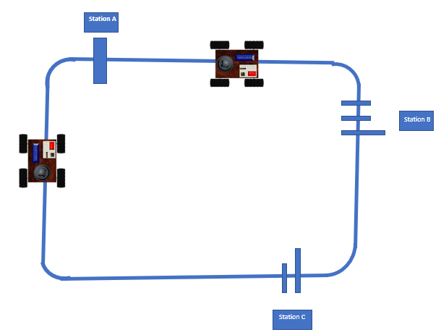
To prove the concept the package will be a variety of weights ranging from 10 to 100g and 8 to 20mm diameter.
There may be more than one robot on the circuit, and you must ensure your robot does not crash into the one in front. There will be multiple stations and you must program your robot to stop at the appropriate one.

Project Requirements
You will be assessed on how well you manage this project and all technical aspects of the outcome.
During the development of your robot system, you are required to
- Assess the client needs to identify, explain and justify components and systems needed for your system.
- You must identify the relevant implications, say what it means and what this might mean for your outcome. For example, you could:
  - Describe what ethics is. Describe the ethical issues that relate to your outcome. What might you need to include in your outcome to ensure this is addressed?
  - Describe what aesthetics is. Describe the aesthetic elements that relate to your outcome. What might you need to include in your outcome to ensure this is addressed?
  - Describe what usability and functionality are. What does this mean in relation to your outcome? What might you need to include in your outcome to ensure this is addressed?
You will need to consider addressing these implications during the design, development and testing of your outcome.
- Finalise your specifications and make sure the teacher agrees to it. There should be at least four subsystems: Movement, package handling, collision detection and line following. You will be given a recycled Arduino robot kit and use other parts from the Electronics room or create them using 3D printers, laser cutter or other.
- After the hardware has been selected:
  - Plan the process and the robot development beforehand using block diagrams, flow charts and natural language. Use task lists (Could use Trello or similar), simulation programs (Yenka, Tinkercad Circuits etc) and calculations to ensure you meet the requirements
  - As part of developing your outcome you will need to describe the interfaces and functions of the components of the systems used, explain the behaviour and function of the electronics outcome and justify your choice of the components and systems you have used. Some of these will be done during key stages. Examples of concepts that you can refer to when demonstrating this requirement are:
- a circuit as a complete path
- voltage as an energy path
- current as rate of flow of charge
- distribution of voltage and current through a circuit (series and parallel circuits)
- conduction (limited to the macroscopic behaviour of conductors, insulators, and semiconductors)
- circuit subsystems
- symbolic conventions and schematics (Yenka and Tinkercad Circuit simulations output accepted)
- hardware (for example components and combinations of components)
- embedded systems as software subject to hardware constraints.
  - When your project is signed off to commence, you shouldn’t have to do any more work on the initial planning.
- You will build the robot system in an iterative manner - design, build, trial and test, and evaluate as you go through the key stages. 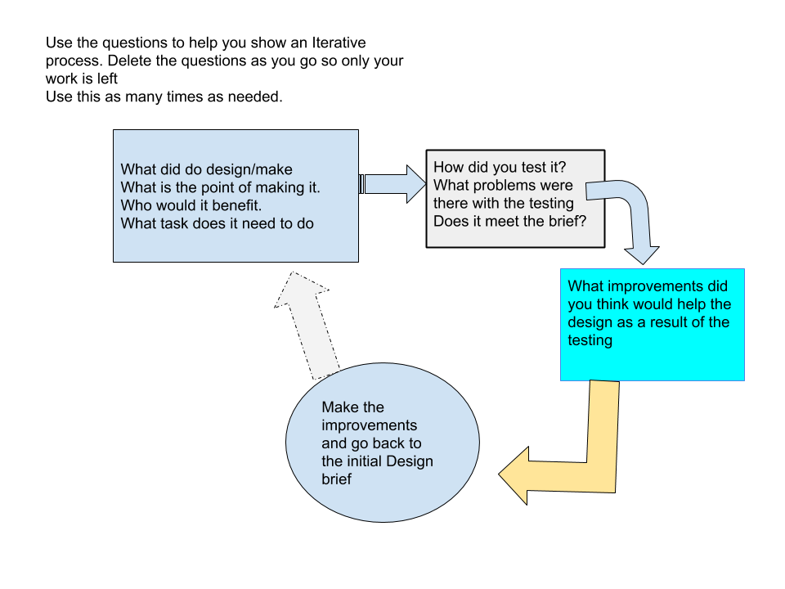
  - There will be formative assessment at each key milestone. It is your responsibility to ensure you are ready to submit your work at these milestones. These assessments will require review of progress and planning of the next stages.
  - Attach inputs or outputs to the microcontroller and modify embedded programs that test each microcontroller input and output separately to ensure they function as expected.
  - Integrate embedded software programs to develop the robot subsystems to meet specifications. Only combine subsystems programs after they have been successfully tested separately.
  - The embedded software program needs to be well structured, readily understandable, and clearly annotated. The program may be based upon commonly available program stubs, sketches, examples etc., but needs to be modified appropriately to meet the context. This means your program should:
    - be clearly set out and correctly indented
    - include comments that explain exactly what the program is doing at each step
    - use labels so that it is easy to read and understand the program.
- You must:
  - choose appropriate component types and values for the robotic vehicle
  - modify, test and debug a functional model of the robotic vehicle
  - use data sheets or calculations to assist in choosing appropriate component types and values for the robot
  - write well-structured, clearly annotated, and readily understandable software.

As you complete the task, gather evidence to include in a portfolio. This will be handed in with your completed robotic vehicle.

Documentation
As you perform the task, make notes and gather evidence for inclusion in your portfolio. For example:
- Show your use of appropriate resources and techniques used in developing your robot.
- Document the testing and iterative improvement you have made to your robot throughout the development and testing process. For example:
  - trialling and selecting the best type and value of components
  - trialling and selecting the best arrangement of components
  - adjusting hardware input and/or output parameters
  - adjusting software parameters
  - using a multimeter to measure and report voltage and/or current levels at indicated points.
- Include diagrams, annotated photographs, written descriptions or video evidence to show your understanding of the interfaces and functions of the components you have selected for your system. This evidence should explain the behaviour and function of the outcome and show reasons (justify) for your choice of components and systems. For example:
    - explain your choice of basic components to build your circuit, for example resistor to limit current and/or transistor to amplify current
    - explain any calculations and/or research, for example manufacturer data sheets, that you used to determine the best components for your circuit
    - describe how your circuit behaves in terms of the basic concepts, for example, a voltage divider, or the effect of a low battery
    - explain the operation, function, and calculation of the electronic components you used in your circuit.
- Show evidence of your iterative testing procedures. This would generally include evidence of improvement through repeated cycles of trialling and debugging
- Undertake testing procedures to debug and diagnose the electronic system to ensure fitness for purpose. Examples may include:
    - trialling and improving sub circuits and components
    - trialling and improving embedded software for functionality and usability
    - trialling and improving circuit layout
    - trialling and improving circuit design and function
    - trialling and improving the reliability of the circuit
- Provide evidence of how you addressed the relevant implications that you identified and described in the process of developing the outcome. For example:
    - How have you addressed ethical or intellectual property issues?
    - How have you ensured that your outcome is usable and functional for your end users?
- In your portfolio, you must include:
    - circuit diagrams
    - layouts
    - embedded software programs for each step of the task.
    - evidence of iterative improvement of the outcome.
- You may also want to include:
    - annotated diagrams and photographs, or videos
    - journal entries with tables that describe your trialling and testing of circuits
    - your responses to teacher questions
    - interview notes from a scheduled teacher consultation.
    - a short video showing the electronics outcome working

All relevant documentation and your robot count towards your final grade. You should have at least three key milestones.
Name: ____________________ Mark:____________________
Achievement Standard Digital Technologies AS91881:
Develop an electronics outcome
Achievement | Achievement with Merit | Achievement with Excellence
Develop an electronics outcome | Develop an informed electronics outcome | Develop a refined electronics outcome

Indicators |  | Comments
Using appropriate resources and techniques when developing a functional combination of hardware and software that performs to specifications  Evidence will be through log book, videos, photos and observations.  Use the concepts of complete circuits, ground loops, circuits diagrams, programming apps, soldering, 3D modelling, 3D printing, laser cutting, multimeters, iterative testing of components and systems. Robot should be able to stop when another in front of it and continue when it is out of the way. The robot must also be able to react when the package have been added to the robot..2 inputs and 2 outputs | A
Modifying and debugging embedded software  Examples:  The student used examples of code for each individual component like moving a DC motor control speed, reading a light sensor, reading a distance sensor, control an LED etc. Then they start modifying the code… changing the distance sensor code to stop when something front or go slower…  Testing continuously as they modify the code | A
Undertaking testing procedures to debug and diagnose the electronic system  Student demonstrates that they know how to modify system, debug and change code and test robot - mainly observation in class and videos for evidence | A
Describing the interfaces and functions of components and systems used  The student described the analog and digital inputs and outputs on the Arduino and the function of each component for example .. The LED is used as an indicator to show the package has been delivered | A
Describing relevant implications  Students identify at least two implications such as end user and function and describe them. Why are they relevant? | A
Modifying, debugging and commenting software so that the program is logical and readily understandable  Clear evidence of the modification process and reasons why they changed things, easy to understand what has been done. Code must include line following | M
Undertaking testing procedures to debug and diagnose the electronic system to improve the reliability  The robot consistently follows the line and is able to stop at the station. Robot is able to stop when an object is in front of it. | M
Explaining the behaviour and function of the electronics outcome  For example: The student shows evidence of using manufacturing and component manuals rather than depending on peers to help them. The student is able to explain why they use a specific component not just because it is the only one available | M
Addressing relevant implications.  For example: The student describes the functional implications and considers the client’s needs.  For example: Using a distance sensor to ensure the robot does not bump into another robot on front | M
Undertaking testing procedures to debug and diagnose the electronic system to ensure it is fit for purpose  Testing individual components and systems for example line following, demonstrating effective stopping at specific station .Result of testing compared to specifications | E
Iterative improvement throughout the development and testing process  Modify robot throughout development to make it better. For example, student use the encoder system because the movement wasn’t reliable. Modify position of line sensor to make line following more consistent etc | E
Justifying the choice of components and systems used in the development of the electronics outcome  The student has justified components and software based on customer needs. For example, the distance sensor was a better choice than switches because…. The DC motors are a good option because the continuous rotation servos | E
Further Comments:

Name: ____________________ Mark:____________________
Achievement Standard Digital Technologies AS91884:
Use basic iterative processes to develop a digital outcome
Achievement | Achievement with Merit | Achievement with Excellence
Use basic iterative processes to develop a digital outcome. | Use basic iterative processes to develop an informed digital outcome | Use basic iterative processes to develop a refined digital outcome

Indicators |  | Comments
Planning a digital outcome to address a problem, need, opportunity, or interest  For example, using natural language or pseudo code to describe the code or algorithm. Use sketches, wireframes or mock-ups to plan the outcome | A
Managing the development by decomposing the digital outcome into smaller components  For example chassis, motor system, distance sensing system, package sensing system etc | A
Trialling components of the outcome in an iterative manner  Try components separate and evaluate if they are appropriate, develop the robot system iteratively (not all at once). This should be evident through your key stages | A
Testing that the digital outcome functions as intended  Test in situ | A
Describing relevant implications.  Example: Usability, functionality | A
Using information from testing and trialling to improve the outcome  Students needs to provide evidence of testing and changes made | M
Trialling multiple components and/or techniques and selecting the most suitable.  Example: Different techniques for line following, heights etc | M
Addressing relevant implications | M
Applying information from the planning, testing and trialling of components to develop a high-quality outcome  Provide evidence in the form of log books, videos, images, teacher/ client observations etc | E
Further Comments:

Final grades will be decided using professional judgement based on a holistic examination of the evidence provided against the criteria in the Achievement Standard.

ASSESSMENT POLICY DOCUMENT
Student Information
Guidelines for Achievement and Unit Standard Assessment in the
Digital Technologies Department at Burnside High School.
Achievement and Unit Standards Assessments will follow these guidelines for 2021. It is your responsibility to ensure you understand this Assessment Policy.
All Assessment opportunities will follow this procedure in 2021:
- Work must be submitted as instructed by your teacher.
- Work must be submitted by 4pm on Monday, 20 September 2021.
- If work is not submitted, it will be immediately recorded as Not Achieved and a letter sent home.
- There will be no negotiation on submission dates. Any changes will need to be organised through the Assessment coordinators office.
There will be no re-submissions other than for very minor verbal clarifications.
Any student who does not meet the minimum expected standard cannot achieve these Standards.
Students will continue to have the opportunity to check work with the teacher in class as they progress through the stages in the assessment. It is your responsibility to get your work checked.
A minimum standard is expected for a student to qualify for a resubmission opportunity.
Minimum Standard Criteria
- Each assessment will outline what is required. If by completion you have not met the standard you will Not Achieve. Resubmission is for minor clarification only, not an opportunity to re-attempt the standard.
- It is your responsibility to ensure you understand the minimum standard criteria.
Exemptions
Any student who does not submit the Assessment must comply with Burnside High School's current school policy, all correspondence must go through the Assessment Coordinator’s office.

Year 11 Electronics
Standard: AS 91881

Level: 1 - 6 credits

Assessment: Develop an electronics outcome

Standard: AS 91884

Level: 1 - 6 credits

Assessment: Use basic iterative processes to develop a digital outcome.

Authenticity Statement
Students will continue to have the opportunity to check work with the teacher in class as they progress through the stages in the project. It is your responsibility to get your work checked.

I, _________________________________________________________ (student name),
(please print)

declare that work submitted, except where clearly acknowledged, is entirely my own.

Signed: ____________________________________ (student signature)

Date: ______________________________ Student number: __________

This assessment will not have the results entered unless this coversheet is both attached and signed for authenticity and for acceptance of the grade awarded.
AS91881
DT1.5 grade:

AS91884
DT1.8 grade:

Student signature: _____________________________

Date: ___________________________

