Factory Robot

This project is about making a robot to do simple tasks for a client. I will make the robot and code it’s needs. This involves 4 key stages; Movement, Package Handling, Distance Sensing and Line Following.
Key Stage 1 is movement, to do this I will need to screw the motors into the base board, add the arduino and it’s wires, code it and test it. I will know I have completed this key stage when it is able to move forward, backwards, and do a 360 degree turn.
Key Stage 2 is package handling, This involves designing a housing for an LDR that is coded to turn on/off a red and green LED depending on the light resistance. This will also have to trigger the motors to start turning, making the robot move forward once a package has been placed onto the robot.
Key Stage 3 is distance sensing, for this key stage I will have to add the distance sensor to a practical place on the board and wire it to the arduino. Code will also be a big factor in this key stage because it can determine how far the robot will stop in front of an object. I will know I have completed this key stage when it is able to work alongside the package handling, and movement code. This means that everything will have to work together to make the robot work. Once a package has been added on, the robot must sigan in the form of changing the light to red, and move off. If the robot comes close to a wall or an object in front of it it will stop at a safe distance.
The final key stage is key stage 4, Line following. Line following will guide the robot to its destination. This will involve adding the line following sensor to the bottom of the base, wiring it up to the arduino and coding it into the other code, i will know that I have successfully completed this key stage when I add a package on to of the robot, and it is place on top of a line, it will move off at a safe speed, following the line around the corners and stops when it comes to a obstible,
Relevant Document: Assessment instructions:

Client Needs

The client needs me to design a robot system for his online electronics business. It is very busy at the moment so they need a robot to go around the warehouse floor and pick up/deliver parcels. The robot will need to follow a line and go to different stations. An empty robot should have an indicator light up to show it is empty eg. A green light meaning empty.

Relevant Implications
For relevant implications I will describe 3 things that this project needs, expand on it and show why it’s needed.
- Useability, Usability is a relevant implication because it is the base to every project. If the robot dosen’t work at all then there is no robot at all. The product needs to be usable and has the right design to be used, this is so that it is able to be coded and built around the client needs.. I will do this by making it be able to move, and have good build quality so that it doesn't break easily and is easy to use
- Functionality, Functionality is a relevant implication because it makes the project have a purpose. Without functionality, the robot might be fully built, but does not function properly, causing the robot to not work at all. This product needs to be able to function properly and perform its tasks consistently and correctly, there isn’t much room for error, I will do this by making sure I program the robot correctly. Making sure that there is no minor errors that will break the robot further down the line
- Health and safety Health and safety is a relevant implication because in every work environment that this will be used in it has to follow their regulations, and the surrounding environments restrictions and regulations, The way this relevant implication is going to be used in this project by adding a distance sensor that forces the robot to stop as if it gets 10cm in front of the sensor.
Specifications
These are some specific things that the robot will need to function and fulfill the clients needs and wants.

- Must follow a solid black 5mm wide line line that is placed in front of the robot and carry out it’s job along the line -Functionality
- Must be able to carry weights ranging from 10-100 grams and 8 - 20 mm in diameter - functionality
- Must be able to move forward and backwards at multiple speeds in order to fulfill the clients needs with completing the task with accuracy. - functionality
- Must be able to turn 360 degrees so that it can fulfill the clients needs with moving around a an area. - usability
- Must have an LED that can be programmed to turn on when certain things happen like a delivery being complete or another action is finished to notify the client - Usability
- Must be able to stop and start efficiently while not breaking its self, Strong build, tightened screws and no steps skipped - Reliability
- Must have a anti collision system that will stop the robot colliding with other object 10 cm in front of it - Reliability
- Must be stable so that the customers products don’t break - reliability

Initial Design
This is a block diagram showing the things that are connected to the arduino and the battery. I will attach these to the arduino and battery to make a functioning robot, I will also add code, and make it rigid and robust so that it doesn't break and is reliable for the customers needs. The block diagram shows all the components I will need to complete the project.
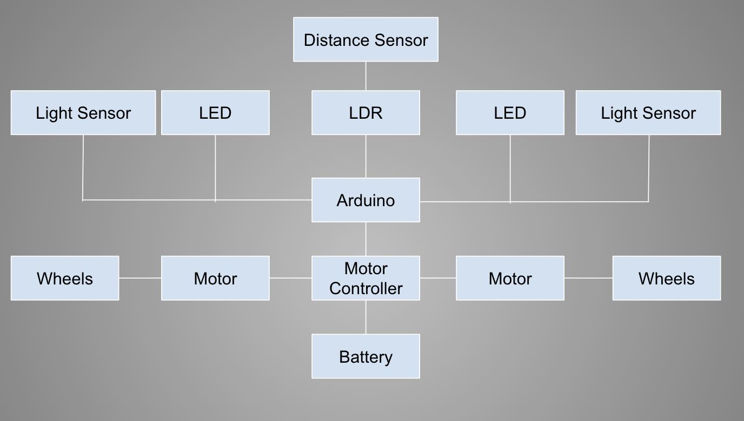

In the end the robot will be able to fill out the client's needs and be reliable. I want it to also look good with good cable management so that if this prototype has any issues, it is easily interchangeable with other components.

Process
These are the processes of what I will need to complete to ensure the completion this project. I will know I have completed the project successfully when I have a robot that moves, senses a package on top, follows lines and stops when an obstruction object is placed in front of it.
 | Key stage Name | Description | Due date
1 | Movement | The purpose of this key stage is to demonstrate the robot moving forward, backward, left and right. | 17 May 2022
2 | Packaging | The purpose of this key stage is to give the robot a purpose and a reason to function. this key stage I will be adding the housing for the weights and the LED for the customer to know when it has a package. | 27 May 2022
3 | Line following | The purpose of this key stage is to make the robot follow a line that is put infront of it, making it so that it can carry out multiple tasks along the line. Not going off corse. | June 10 2022
4 | Sensors/Loading zone | The propose of thi key stage is to demonstrate the robot not crashing into anything and get sensors working so that it can go into a loading zone | June 30 2022
 | Submission | Submit all documents and robot | 4pm, Monday, 4 July 2022

Key stage 1: Movement
In this key stage of building the robot, I will add wheels so that it is able to be programmed. This should be able to do basic movement turning forward and backwards. This will be shown by your robot going in all the directions it needs to, putting it’s code to the test. This will be very useful because once we have build the whole robot and we find out it didn’t work it would not be good, but if we go in stages it makes it a lot more manageable and makes sure that no component is broken or damaged.

Task list

Task | Description | Due date
Assemble the motors | Add the 2 motors onto the base board | May 5, 2022
Assemle the arduino boards | Screw the arduinos onto the main board | May 10, 2022
Add the wires | Adding the wires connecting both of | may 11 2022
Program the robot | Profam all of the simple things so that it can prove that it can move forward, backwards and turn around | May 19, 2022

Design
In the design process of key stage 1 I am going to be adding both motors, attaching the arduino board, motor controller and wheels. This will include a ircuit diagram, interface description and definition of all the components used
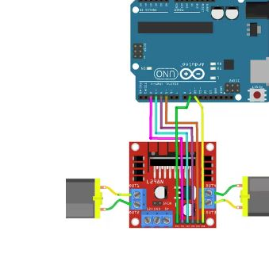
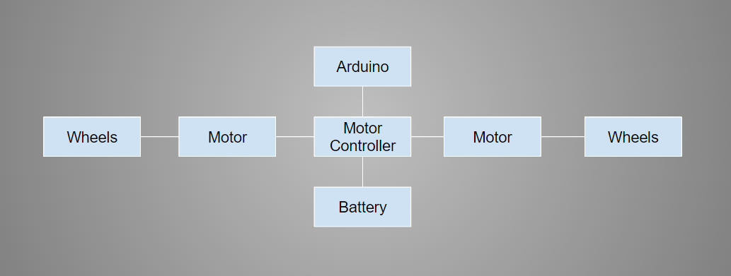
This diagram shows how the wheels and motors are attached to the motor controller, how the motor controller is attached to the arduino and how it is being powered by the battery.

Components Used

Arduino
The arduino is an easy to use piece of hardware that is able to take inputs and make outputs. This can be used to make a lot of electrical projects like laser tag, robots, lights, and many other things.

Digital Outputs
A digital output lets you control a voltage with a computer. If the computer tells the output to be high, the output will produce a high voltage if it is set to low and it will send out a low voltage.
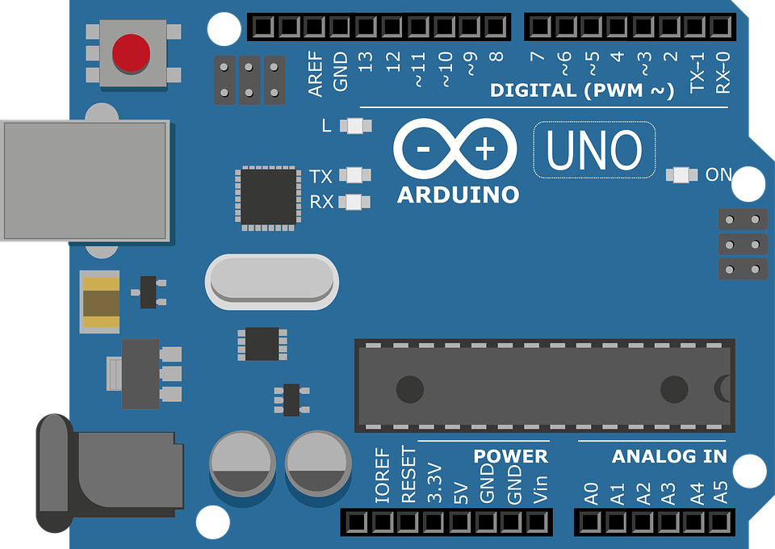This is an image of an arduino digital output would be used through a motor controller, the motor controller connects to the arduino through a pin which in my robot i used pin 3 and pin 11 which is located at the top of the arduino board as well shown in line 4 and 5 of the code.
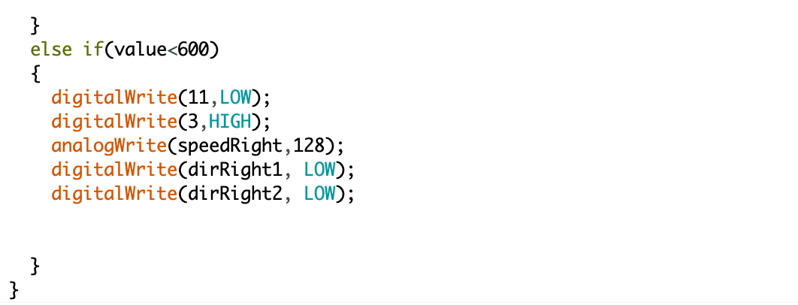
This piece of code shows the digital output being controlled by the
analogWrite(speedRight, 128);
line of the code, This is instructing the right motor to go at a speed (128 in this case). This code is changing the voltage going into the motor affecting the speed.

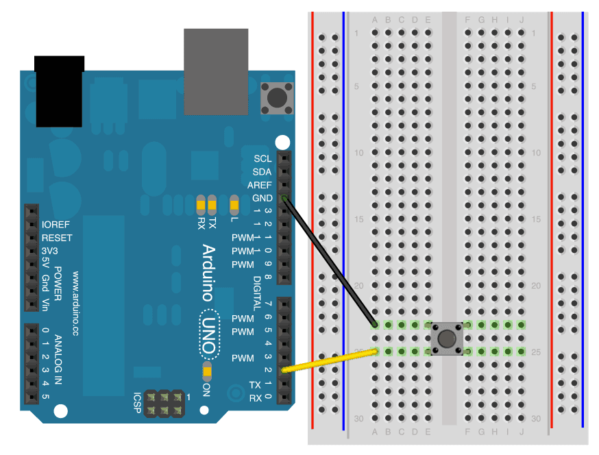
Digital Input
This is used in the form of birary (1 or 0) Ether on or off. You can see this in effect with Switches, Circuit breakers, Lights, Pushbuttons, Horns.
This diagram shows that a pushbutton is going to be either on or off, if it’s on it will let the current through, powering whatever is following it in the circuit and holding up the current until it is being pushed. The black cable goes into the GROUND pin and the yellow caple goes into PIN SlOT 2, these connect to the breadboard and goes through to the pushbutton (also shown in the diagram below, pointed out with arrows)

Analog output
PWM (Pulse Width Modulation): PWM’s use is getting analog results with digital means. We use digital control to create a clear straight/square wave, a signal switched on and off.

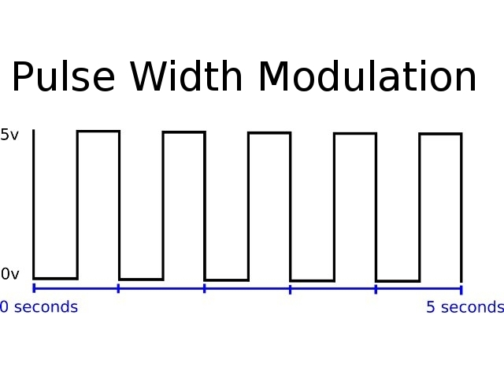

In this image it shows PWM in action, The Voltage is going from On to OFF (Hight to Low) . This gets outputted through the pin slots with lines in front of them shown in image below indicating power can flow through, this is how it is used to turn LED’s On.

DC Motor
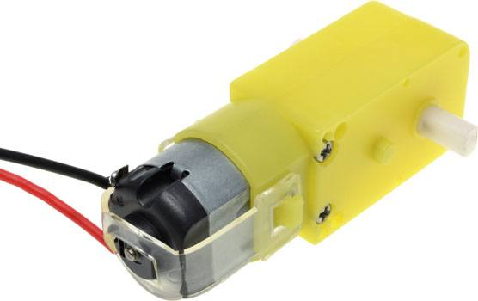
A dc motor is a component that is controlled by voltage, the higher the voltage the faster the motor rotates, the DC motor can be controlled by how many volts is out into it, the lower the voltage the lower the speed. To set the speed, the code will need to be added into the arduino but because the arduino does not put out enough voltage to power the motor, I used a motor controller

In this image it shows a DC motor, with two wires connecting to the head of the motor, this is where it connects to the motor controller to get power and give it the ability to be controlled by code. The far left white rod is a rotating device that wheels can be added onto to make the wheels rotate at a controlled and certain speed

Motor Controller
The main purpose of a motor controller is to control the motors, the motor controller is need when a motor is needed in the project, this is because the arduino does not put out enough vintage to power the motors at a controlled, consistent and fast enough speed.

In this image it shows the motor controller, the blue double screwed ports ether end of the motor controller. These control the motor, with each wire that comes off the motor gets put under the screw and is held. The 3 blue ports control the power, ground and connection to arduino.
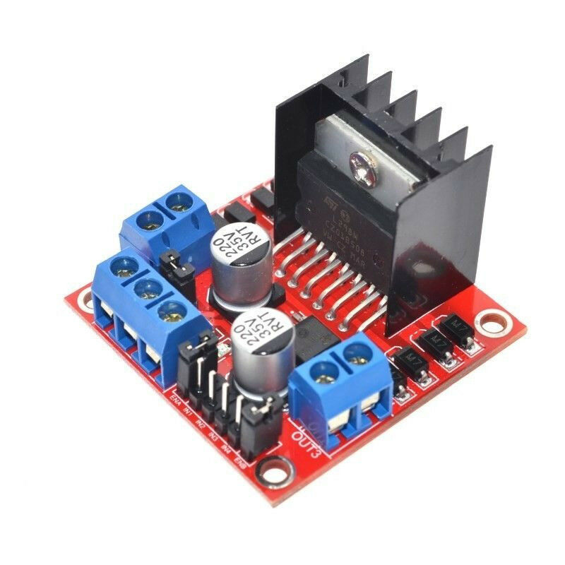

This pins circled in the diagram below where the 5 pins that connect to the 5 pins circled in the motor controller diagram above.

Wheels
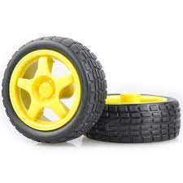
A wheel is a component that is intended to rotate on an axle bearing. The wheel is one of the key components to the whole robot moving. It’s soul purpose is to just rotate freely with whatever it is attached to. In this project it is attached to the motor.

In this image it shows what the wheels look like, they get attached from the middle into the dc motor. These have no electrical component attached until it is attached onto the motor.

The wheels connect onto the motor that spins, the part that is circled in the image above is where the wheels connect to the motor.

Battery
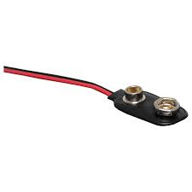
A battery is a source of electric power, consisting of one or more electrochemical cells with external connections for powering electrical devices. When a battery is supplying power, its positive terminal is the cathode and its negative terminal is the anode. Batteries are used in everyday life like toys, phones, computers and much more.
In these photos it shows what the battery connects to (left) And shows the battery with the ports at the top where the current comes out of. The way it connects to the arduino is as shown in the image, the red and white wires lead onto the board, The red wire is connected to V5 (5 volt) pinslot, bringing power to the arduino. The black cable is connected to the GND (ground) pinslot.
The battery connects to the motor controller by the two pins circled, the positive(red) connects to the left of the two, and the negative(black) connects to the right one of the two.

Construction
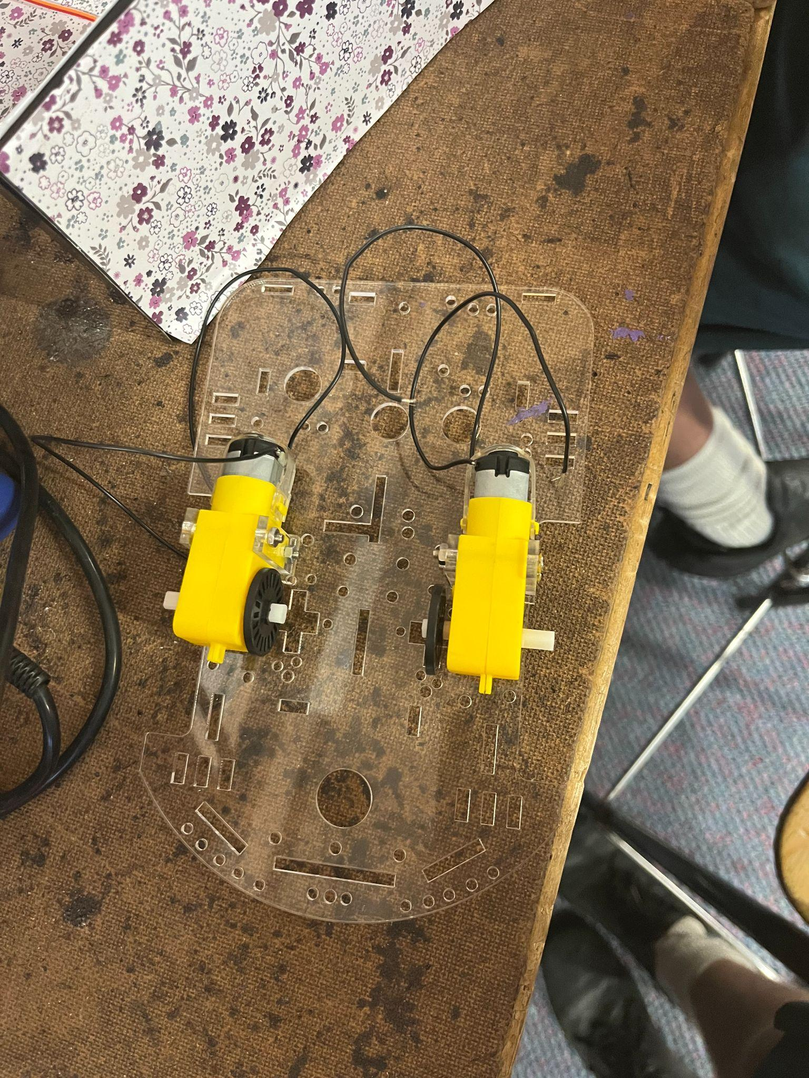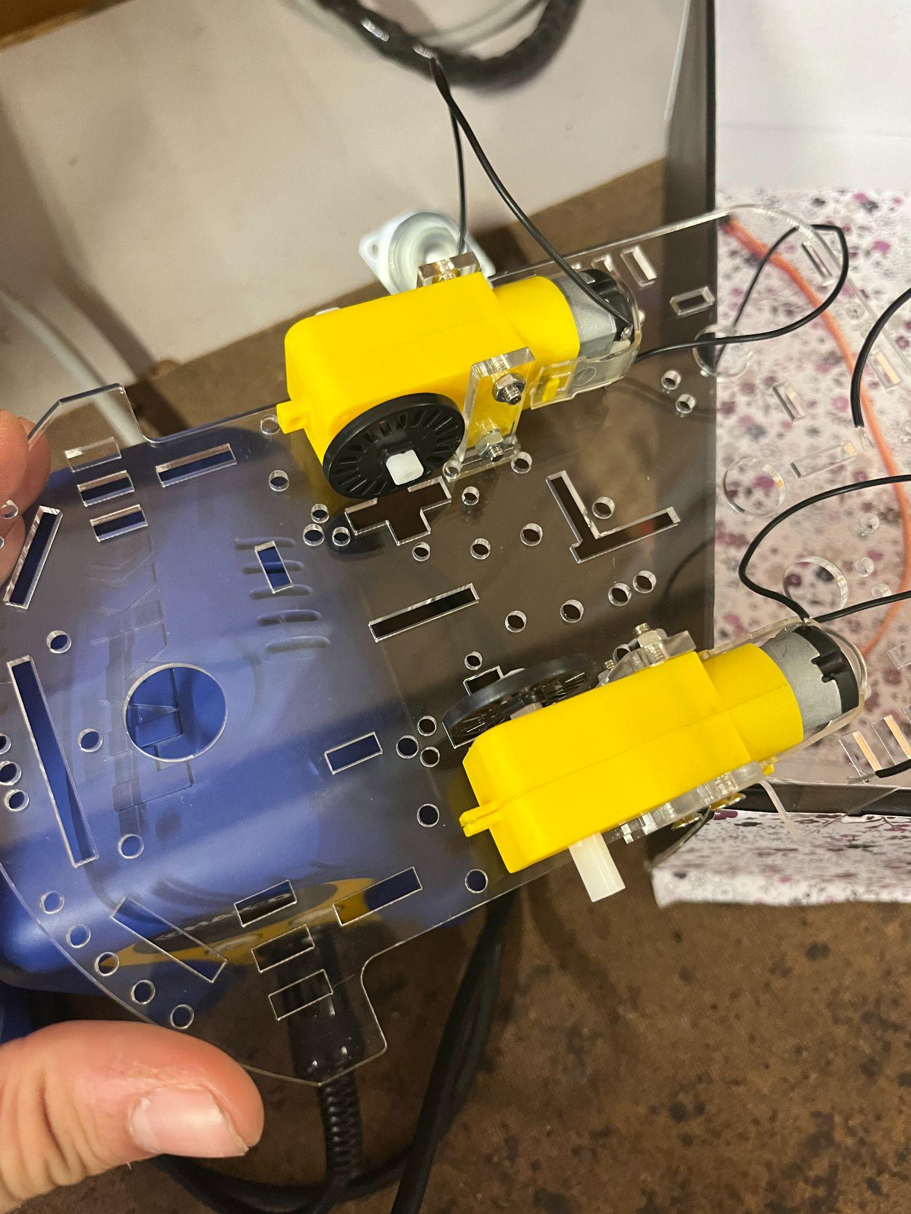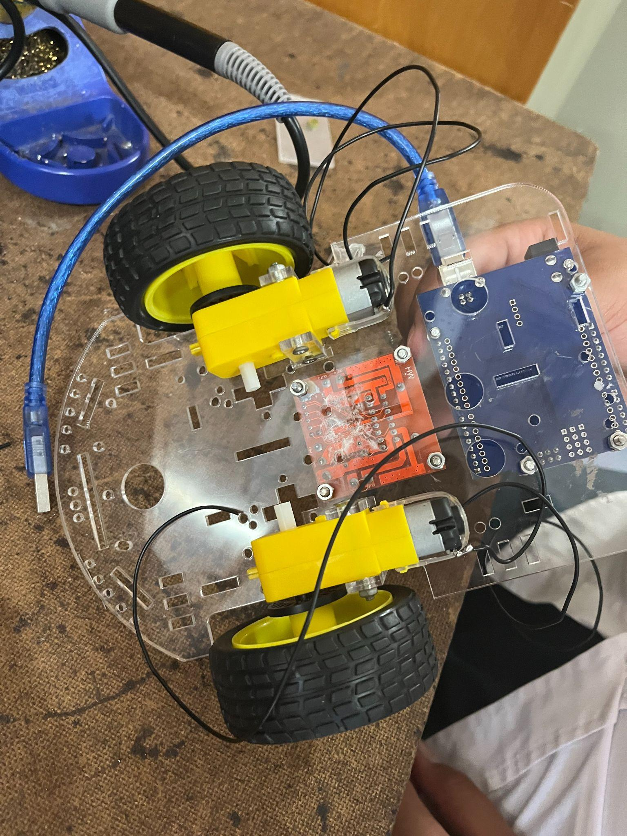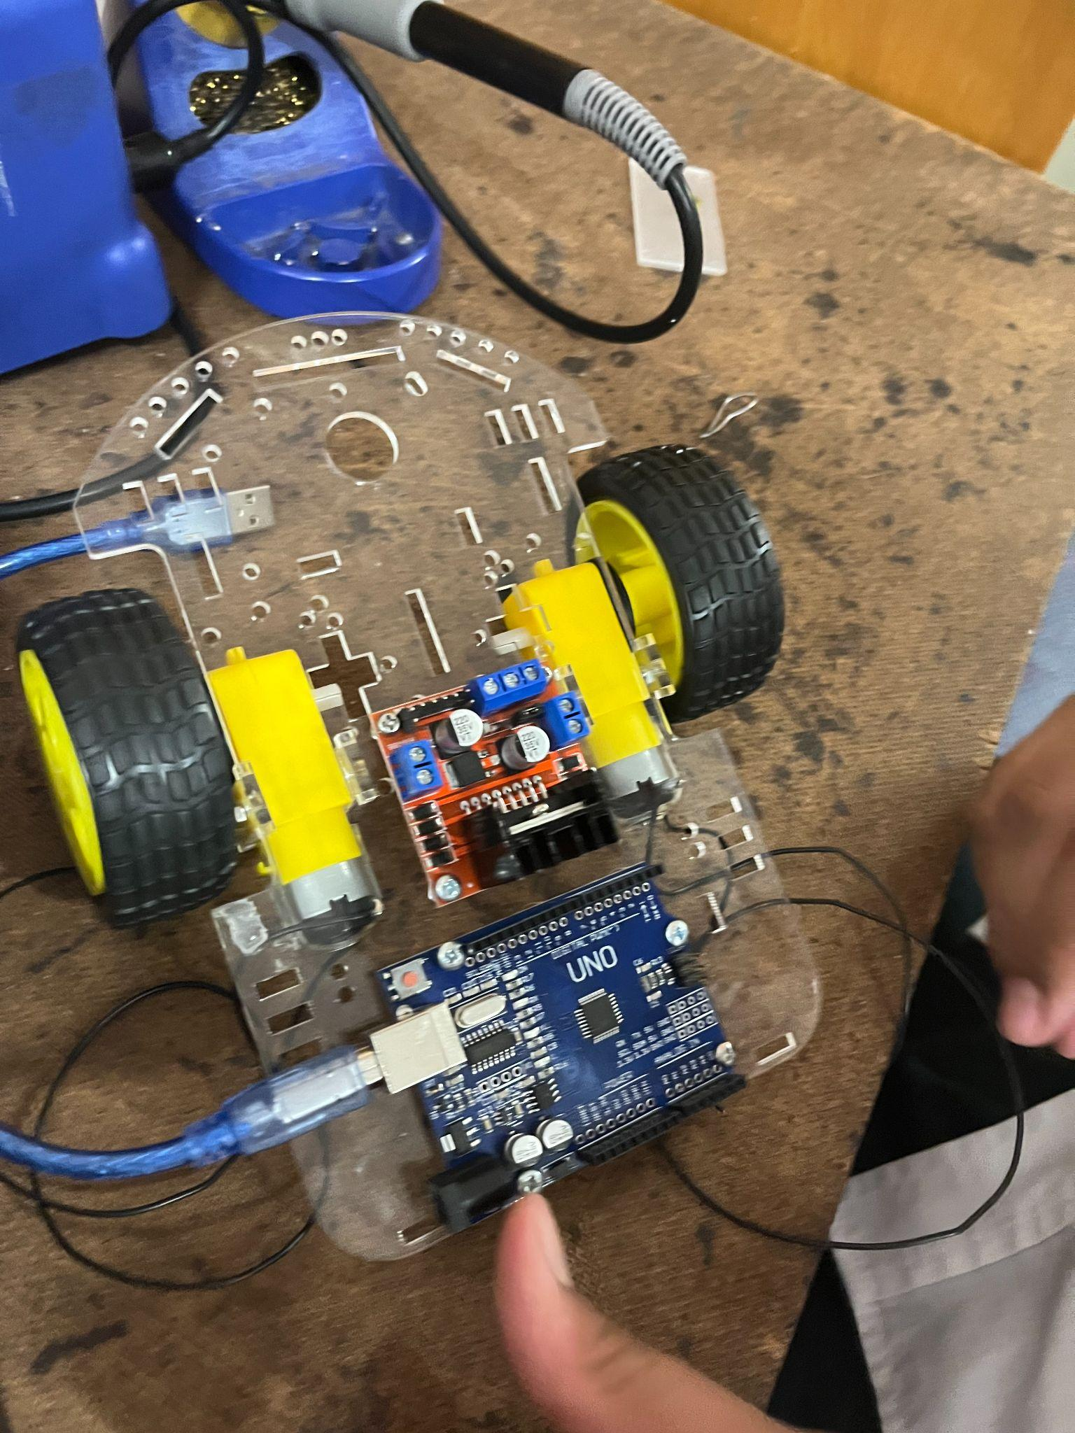
1 2 3 4

In photo 1,
this was the very first item that was added to my robot, this included screwing the motors onto the base board.

In photo 2.
I added the cables and prepared them to be soldered onto the arduino.
In photo 3
I screwed the boards onto the base board, and attached the wires to the motor controller.
In photo 4, I finished everything up, adding the wheels and making sure nothing was shorting or making a problem

Movement Code
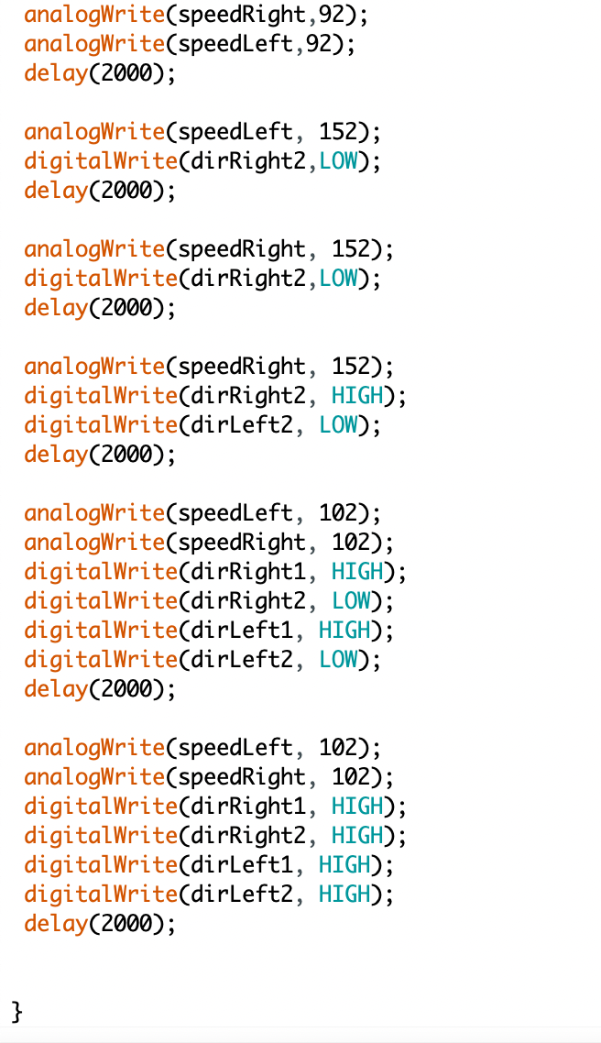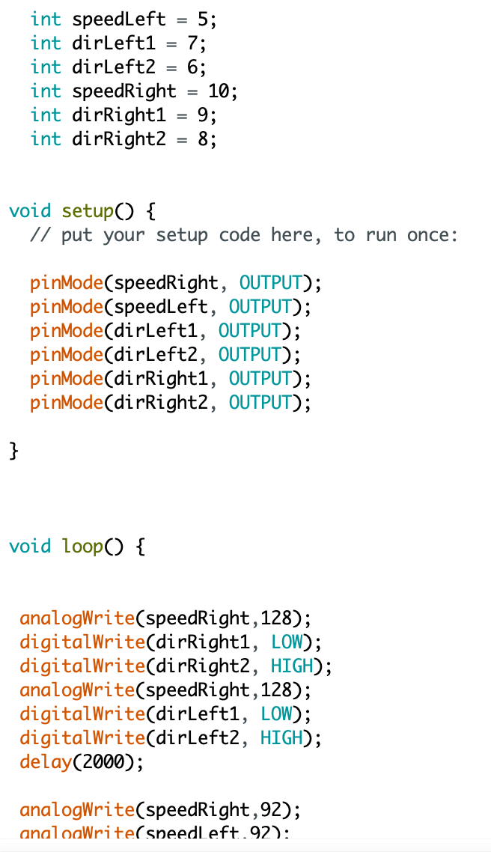

I screwed the motors in and tested if they worked by making a simple code that made them move, nothing that was too intricate or complicated, just to check that the basics were working. While testing the motor it also shows that all the other components are working as well. The only problem was the wheeles where hitting the main base of the robot, but i tightened up the screws and then it was fixed.

Key stage 1 Task Reflection
This is the task sheet of key stage 1, I complete all of the tasks ontime.

Task | Original Due Date | Reflections/Issues/Timing etc
assemble the motors | May 5 2022 | This was very easy to carry out, I had a small issue with the motor wobbling around but I fixed that once I figured out that the screw wasn’t tight enough.
Arduino boards | May 10 2022 | I did this quite easily, I had an issue with the board not lining up with holes but I just found 2 that lined up and screwed them in, Making sure it was very secure and it was.
Add the wires | May 11 2022 | This went very smoothly and had no issues with the wires not working or anything like that. They all went in fine and worked how they should.
Programming the robot | may 19 2022 | This was the hardest part of Key Stage 1. I have had lots of issues with the code not working, having minor issues with the pin slots and having the variables set.

Key stage 1 Overall Reflection

This key stage was good and everything went to plant time wise. I believe that I am still perfectly on track with my original times/deadlines. I had a few small issues with the motor and the programming but none of my components broke or weren't working. One of the positives of this is that nothing broke and everything worked on the first try (apart from the programming) . One of the negatives is that the programming took a bit too long and I still don’t understand all of it. The motors were a bit wobbly and loose for a few days but that fixed once I tried making it tighter so that it didn’t slip down. I didn’t change the date for anything, next time I might make the assembly part a bit shorter and the coding part a bit longer, meaning I get more time on the important parts because the assembly is fairly straightforward and easy.

Key stage 2: Package Handling
This key stage is all about package handling, in this key stage I will have to add an LDR, two LED’s, One red one Green, Design the housing of the package holder and program the LDR to switch the green light off and turn the red LED on + move the wheels forward, all at once. I will know I have completed this key stage when the robot moves off once the package is added on and the light’s change from green to red.

Task | Description | Due date
Weight Sensor | I will add a weight sensor so that it can receive information and know when something of weight is put onto the machine | 2nd june=
LED | I will add an LED onto the robot so that it can let the client know when something of weight is put down on the robot | 3rd june
Case Design | I will design a Case to the robot. adding all visual features | 8 june
Programming | I will program these steps in with the initial movement making it show a light when a weight is placed on. | 10 june
Test | I will test everything, checking all parts and fixing any issues or problems with the robot or code. | 13 june

Design
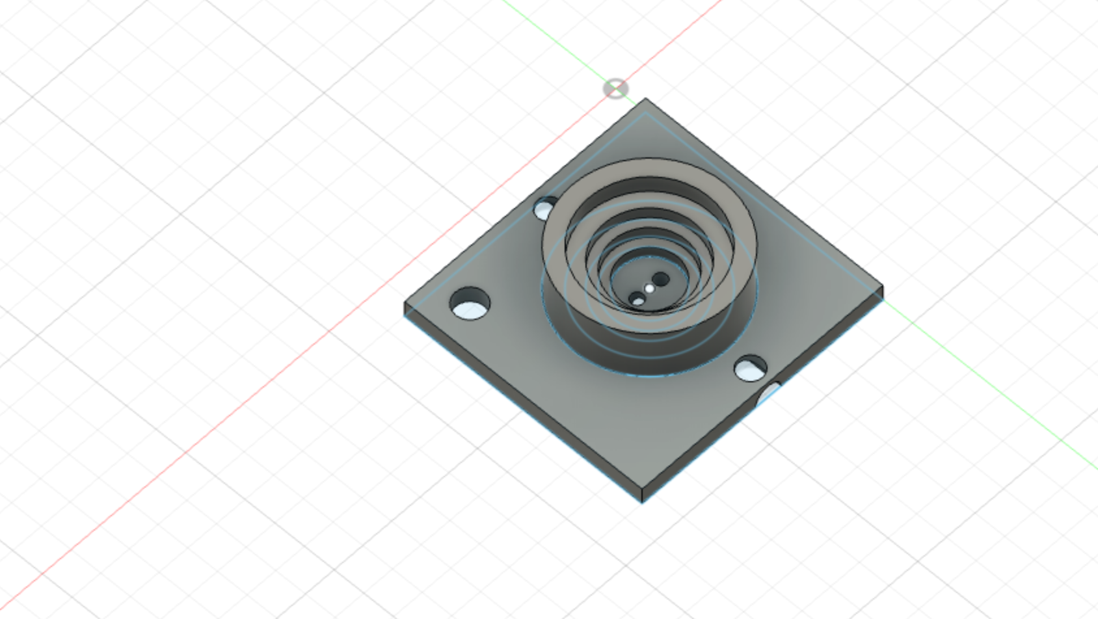
In the design phase of this key stage I am going to design the housing and show a circuit diagram, this shows how it is panned to be made and any issues that might arise.
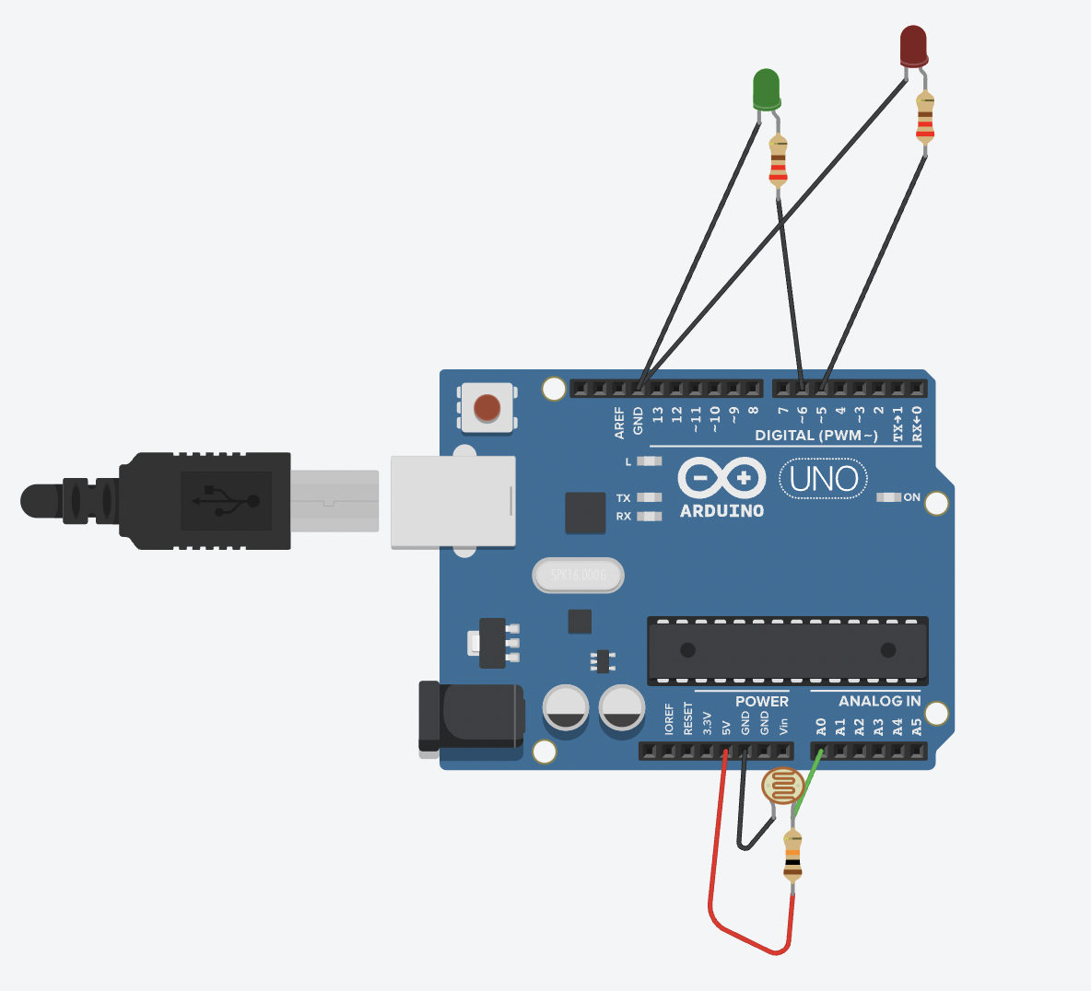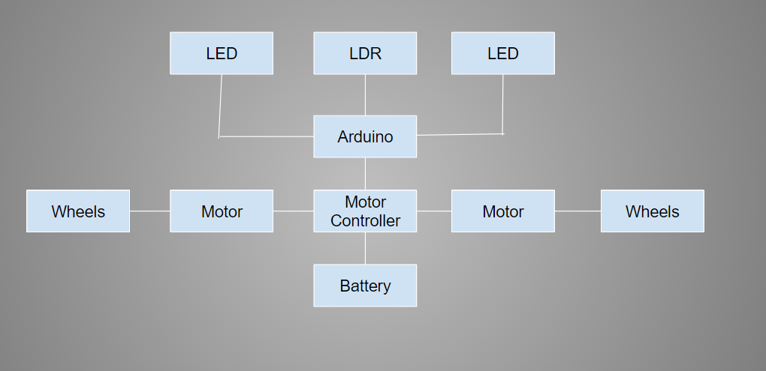
This is the circuit laid out in tinkercad and fusion, I went with this design for the 3d printing because it is functions in every way it should, it has a section underneath for the wires to go, a hole to screw it onto my chassis. The circuit is for the wires going through the printed packaging, one LED fo each symmetrical hole to show ON and OFF
Component Description
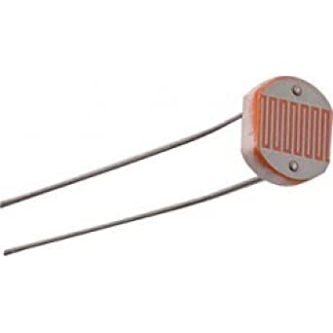
LDR: The LDR is a Light Dependent Resistor, The LDR has a resistance that changes when light is presented intensely on the LDR, meaning that it is able to be coded depending on the amount of light hitting the LDR(LED’s, Motors)
In this picture it shows and LDR, the two prongs at the bottom are what connects to the arduino/circuit. The top head section is what receives the light.

The LDR connect to the arduino through pin slot A0 because it is an analog input.
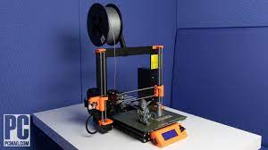
3d printer: *although it’s not a component I thought it as important to add* The 3d printer is used to print out and object that can be made in Fusion 360 or other 3d modeling programs, the 3d printer is used by adding layers of melted plastic that set as soon as they are placed onto the plate, meaning that it builds up layers overtime.
This is a 3d printer, it takes the material from the role, and feeds it into the head of the printer, the head of the printer is extremely hot and melts the material so that it can be maneuvered into different shapes and sizes.

LED
The arrow is pointing to the pin slots (6,5), these two pins are digital outputs because the LED’s that are connected only need to be ON or OFF. The resistors are there to stop the

Construction.
Some of the issues that I need to be aware of is that it needs to have a place for the wires to go so it doesn't break the wires and wear them out and it also has to be able to see light, this design shows the sectioned out part underneath. Shown in the photos. It also has to have 2 holes for the ldr wires to go underneath. I also added a circle to screw the board down and make it robust and secure. I added all these things by using press/pull on fusion 360 after creating a sketch in the shape I want to extrude. All of this is to make the LDR Fit better in the robot and it will be
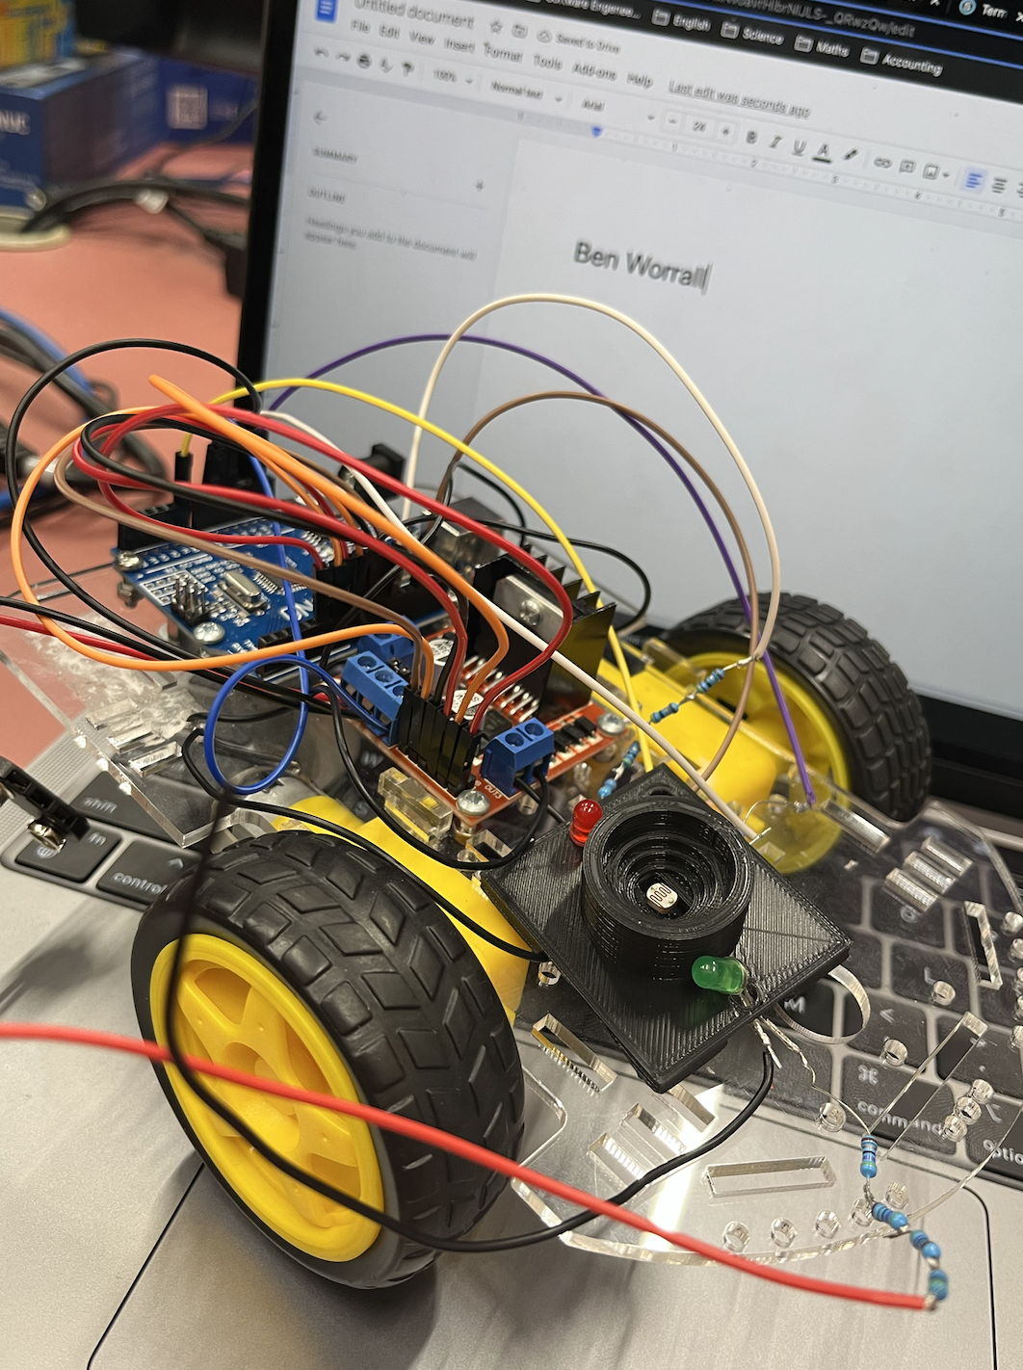

Program and Test
This is the code for the LDR and LEDs That have been added in this keystage. This code shows that he slots A0, 5 and 6, It shows when the LDR value is below 300 pin 5 is on, and when it is above 300, pun 6 turns on.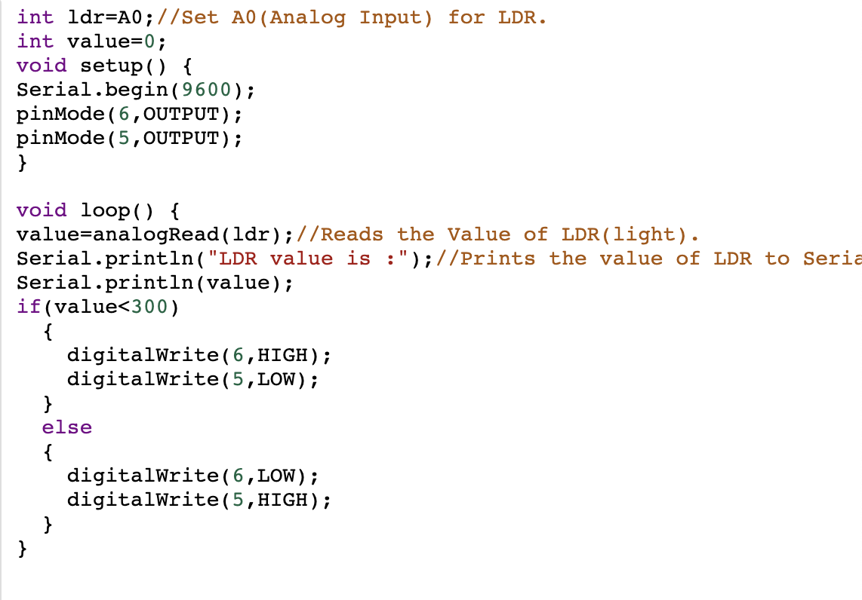
The way I tested this process was I printed two packages, One of them had a lot of material on the bottom that I was able to get off but It did not

Key stage 2 Reflection

Task List from initial planning

Task | Original Due Date | Reflections/Issues/Timing etc
Task | Description | Due date
Weight Sensor | I will add a weight sensor so that it can receive information and know when something of weight is put onto the machine | 2nd june - Completed 10 June
LED | I will add an LED onto the robot so that it can let the client know when something of weight is put down on the robot | 3rd june - Completed 6 June
Case Design | I will design a Case for the robot. adding all visual features | 8 june - Completed 14 June
Programming | I will program these steps in with the initial movement making it show a light when a weight is placed on. | 10 june - Completed 18 June
Test | I will test everything, checking all parts and fixing any issues or problems with the robot or code. | 13 june - Completed 18 June

Key stage 2 Overall Reflection

This process went well, it took a bit longer than I first expected but I got back on track, I feel good about it and happy that it all works how it should. I think I am a little behind at the moment but I can catch up very fast. Some of the general issues where the housing for the LED and weights had an issue underneath, when it printed it filled in the bottom but I managed to chip it out and it is fully functional now. A few of the positives is that now it can move and sense when there is weight due to the packaging. One of the negatives is that It took longer than expected.

I might make it only have 1 LED and code it to change when the weight is placed but for now it works so I won’t change anything.

Key stage 3:Distance Sensing
This key stage is all about distance sensing, I will add a sensor to the front of my robot so that it can protect itself from running into objects while completing the task for the client. I will know that I have successfully completed this key stage when the robot can wait until a package is added on top of it, move off and then if something is placed in front of it it stops.
Task | Description | Due date
Distance Sensor | In this task I will be wiring the Distance sensor to the robot. | 20 June
Programming | In this task I will be programming the distance sensor. | 22 June
Testing | In this task I'm testing the program and the distance sensor | 22 June
Case Design | In this task I am making a case design on Fusion360 | 22 June
Testing | In this task I am testing everything together. | 23 June

Design
I am going to put the distance sensor at the front of the robot and lead the cables through a gap in the chassis, this is to just keep the cables out of the line following the sensor when that is added. I used a caliper to make sure the hole was big enough before I soldered the wires onto the sensor and board.
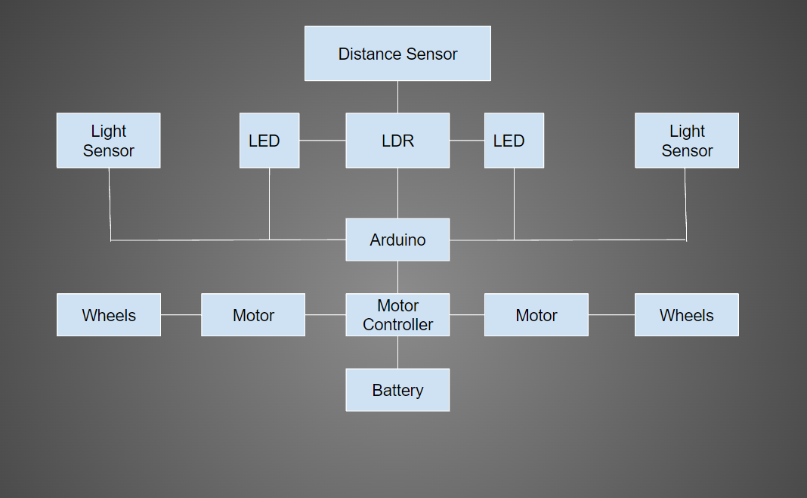
This is the diagram that shows how it is all connected, It is different from the last key stage because it now has the addition of a distance sensor on the top, this connects to the LDR and onto the arduino, making turn off when there is a object in front of it
Component Description
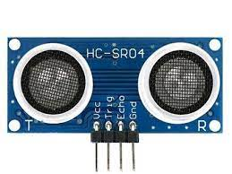
Distance Sensor: A distance sensor, senses the distance between it and the object in front of it through an output current in waveforms. It hits the object and bounces back into the receiver.

Construction
This section went extremely well, I had no issues and the sensor went on smoothly, I had to cut the end of a few other cables and add a different ending (male to female) this was because I chose 4 identical cables because they where the only ones available at this time. (photos attached)
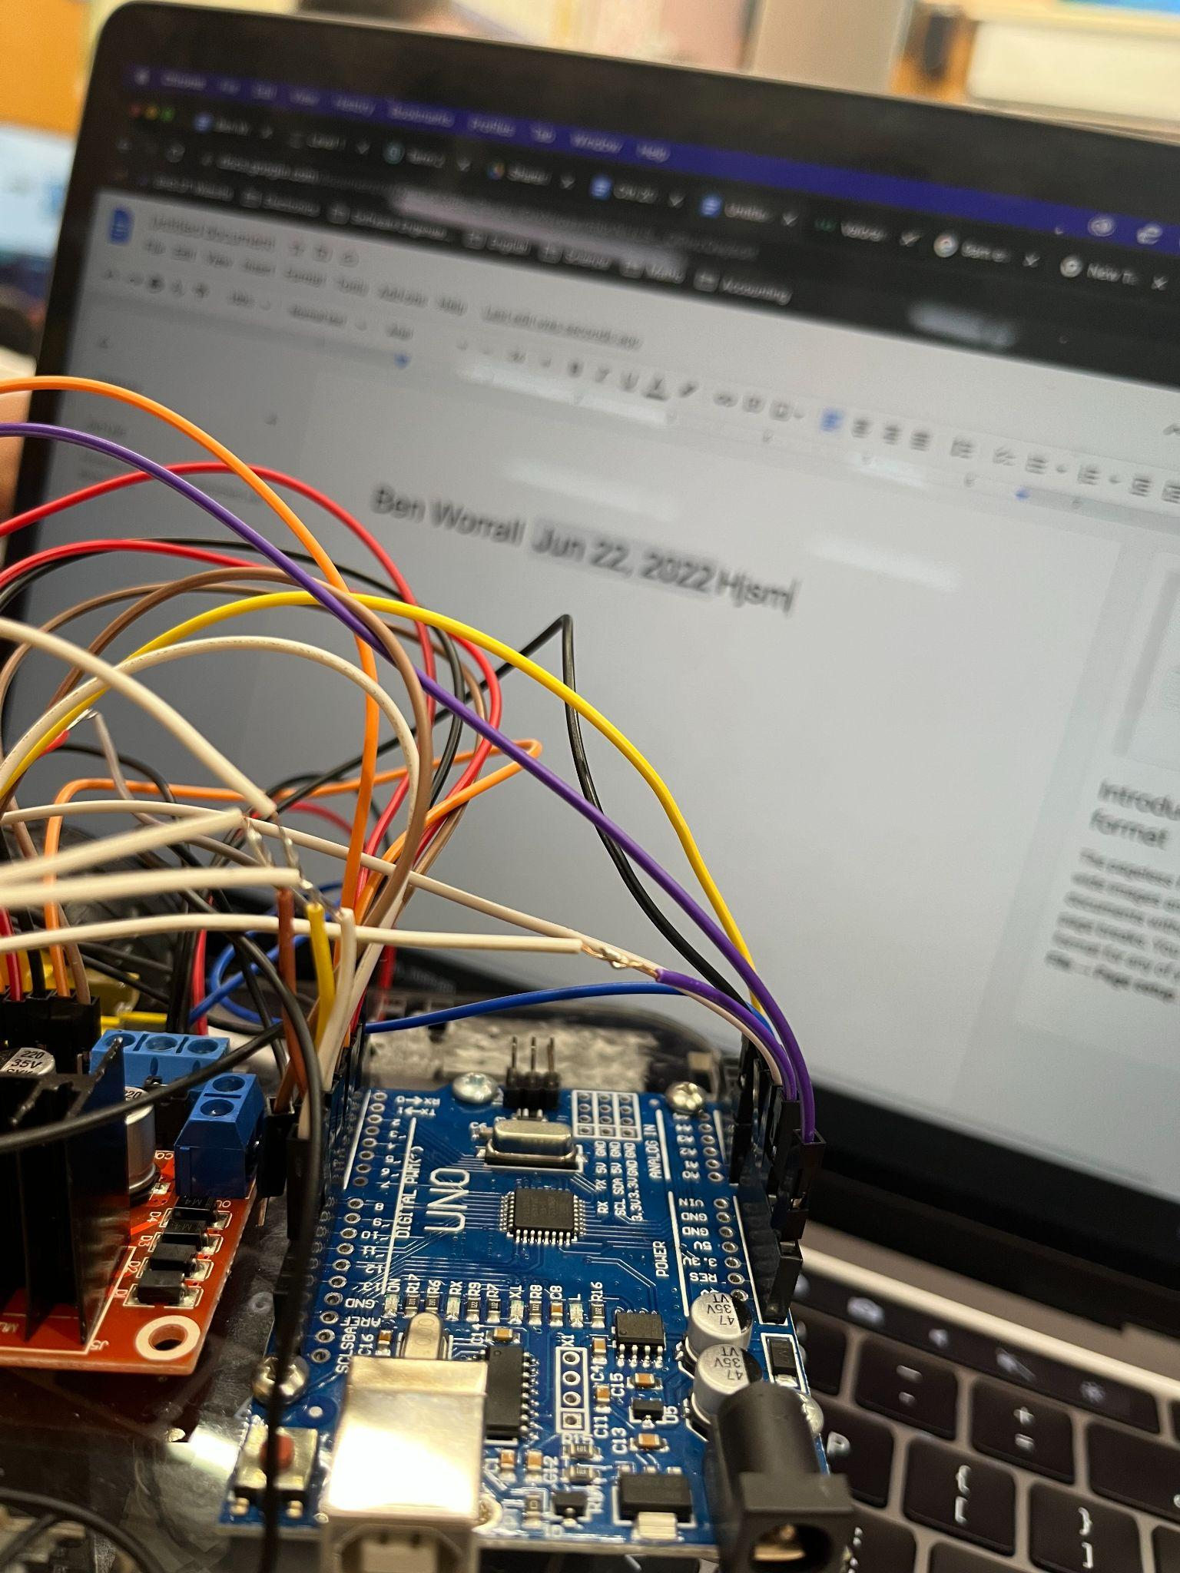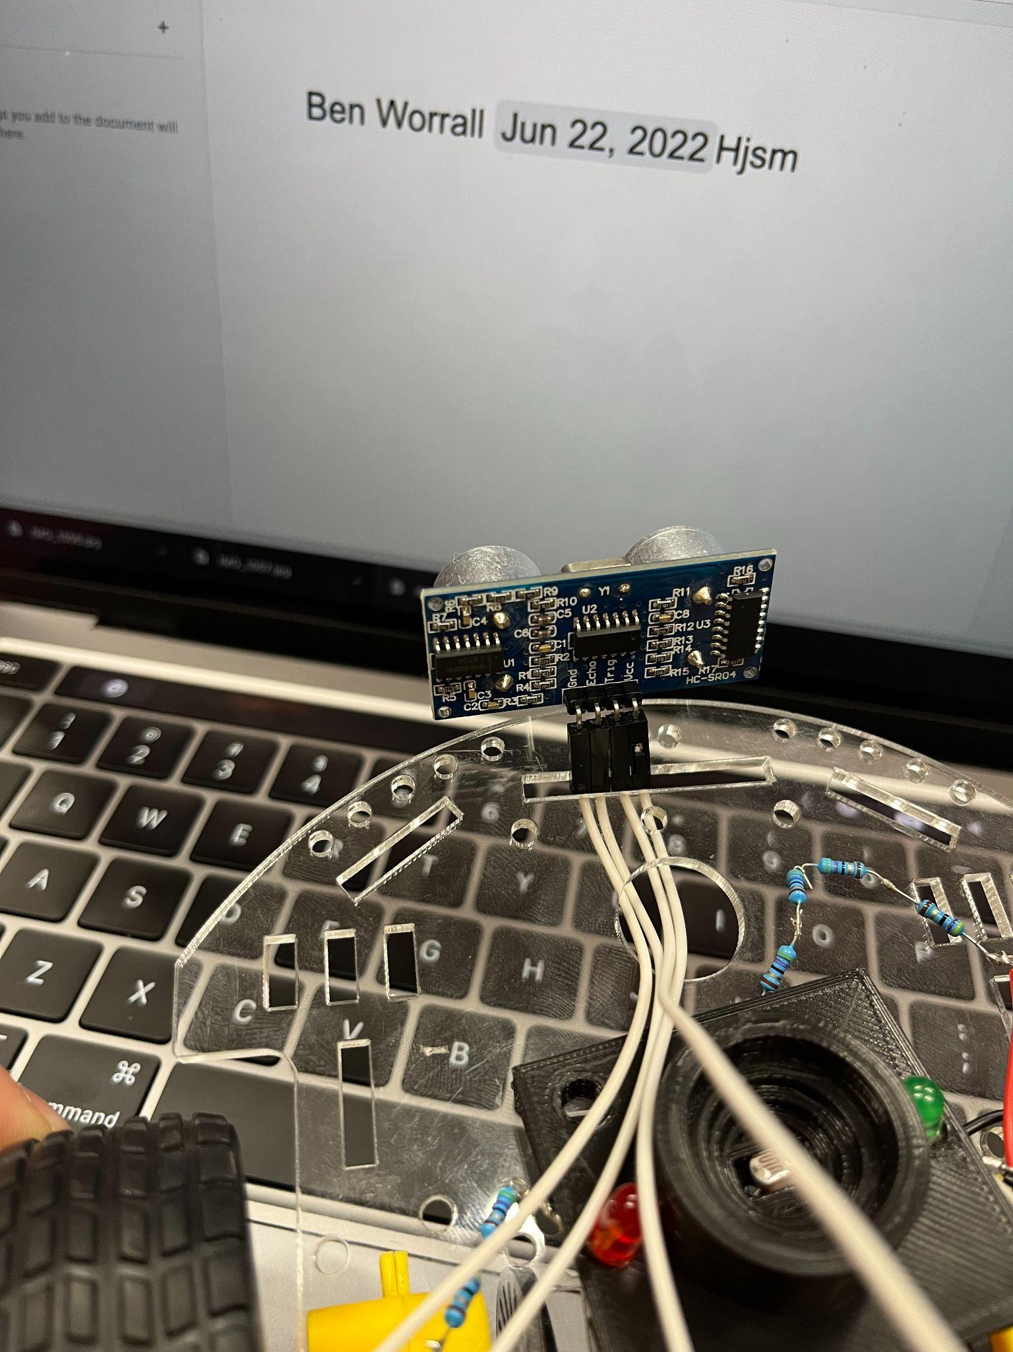

Program and Test
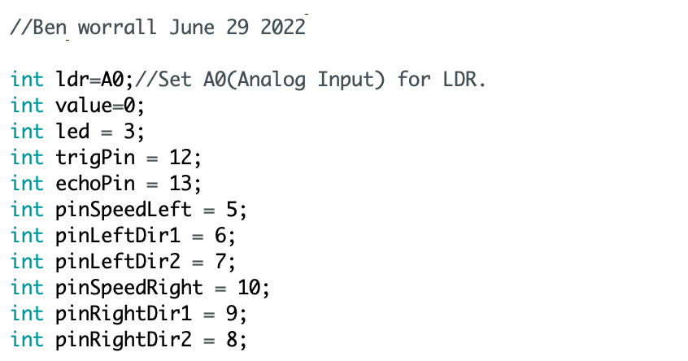
Attached is final program that was added onto the robot along with an explanation of what they mean.
This is the variable declaration, it shows all the pin slots and their variables.

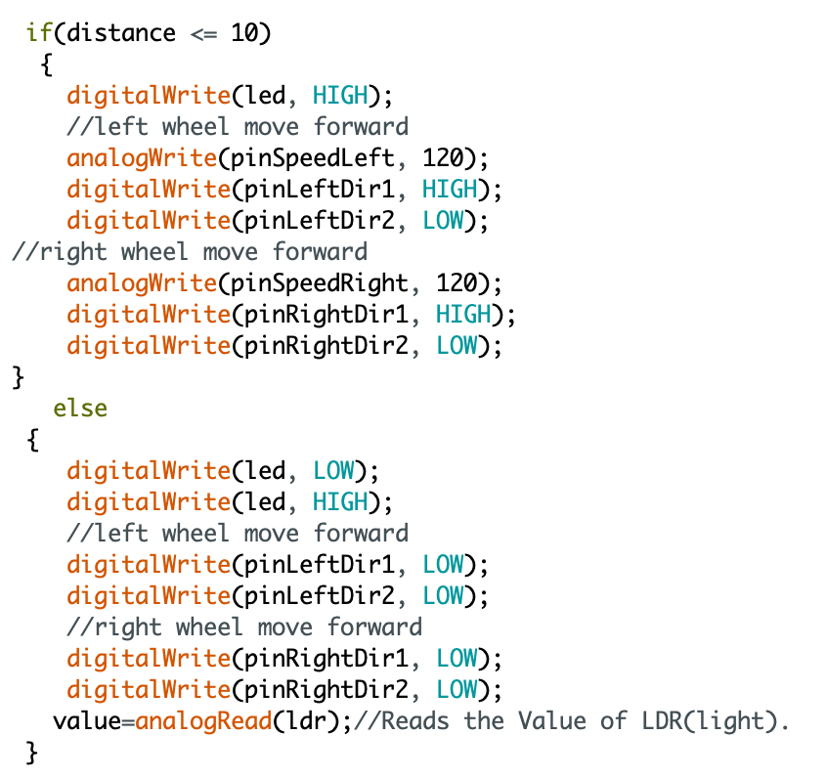
This is the distance sensing code, if something is in front of the distance sensor it will stop, if not it will just keep going.

This code combined with the package handling code makes the robot run. I haven't had any issues with it.
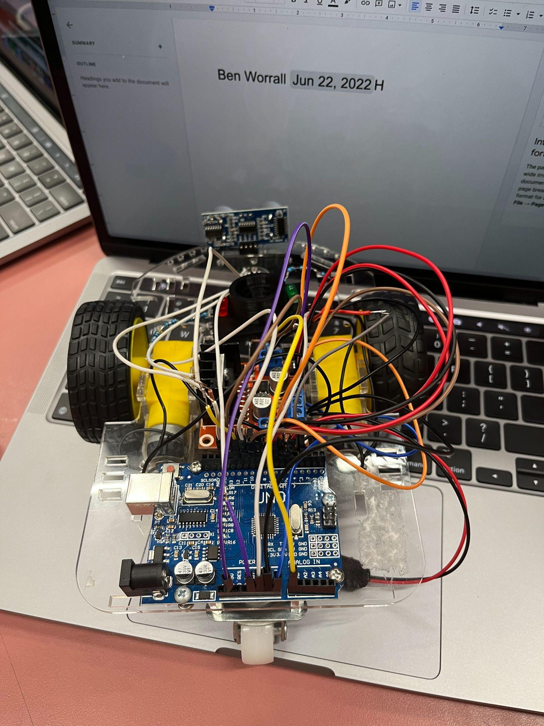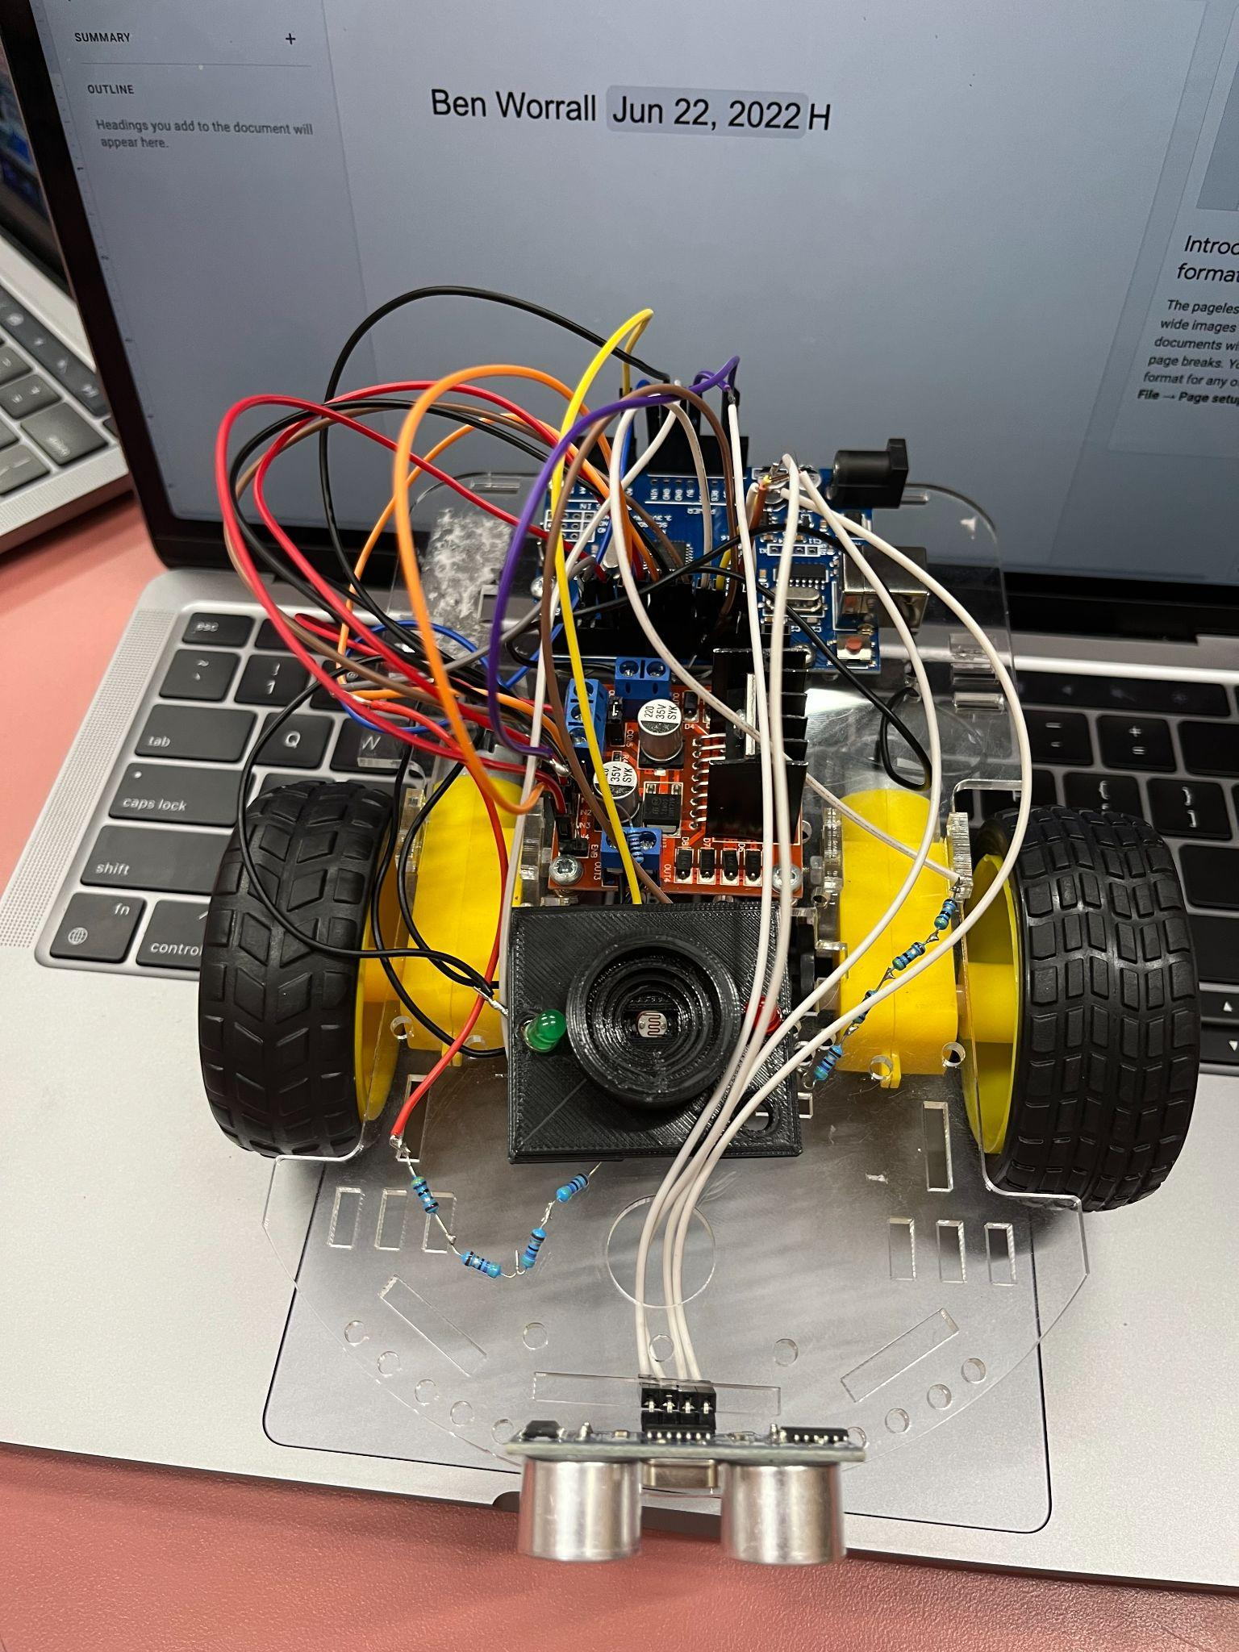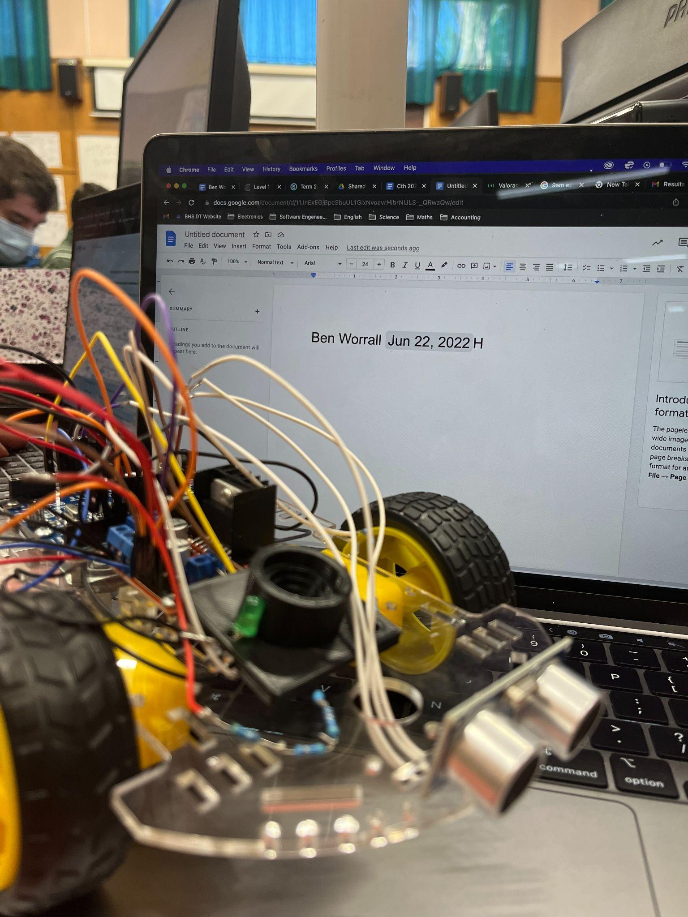
1 2 3
In photo 1 it shows a top down view of the robot, the wires are all plugged in and the distance sensor is placed at the front of the robot for best effect.
In photo 2 it show that the robot from the front with the wires from the distance sensor being routed underneath the robot to make room for the package detecting system,
In photo 3 it shows the package handing stage is behind the distance sensor and the sensor is mounted to the front of the robot.

Reflection

Task List from initial planning

Task | Original Due Date | Reflections/Issues/Timing etc
Distance Sensor | 20 June | Completed this 21 June, finished the last keystage a day late so I had to push it back, it was fitted perfectly and all the cables worked
Programming | 22 June | Completed this June 22, Went well and had to troubleshoot a few things with the motors but I quickly fixed it
Testing | 22 June | completed june 23 a day late because programming took a little bit extra time than expected. It all worked well but the wheelses spun the wrong way, changed it and it is perfectly fine now. Working perfectly.

Key stage 3 Overall Reflection
My progress so far is still a little bit behind, I have caught up a lot since the last key stage and am on track to finish ontime. I am feeling good about this key stage as it has gone smoothly. I had a few issues with the motor spinning the wrong way around and there not being enough cables so I had to solder the cables differently which ended up fine. I fixed the motors by changing the code. Some of the positives are that I have learned a lot more about the code, and how the robot works/functions, another positive is that I have caught up with the progress I lost in the week that I was sick. One of the negatives is that I am still a little bit behind and that the cables don’t look as good as they could but I will fix it up once I have finished the whole project if I have time.

Yes, I would make changes to the cables that I got, I had to solder different cables together to make the connections work.

Final Key Stage
This is the task list for the final keys tage, I was unable to complete key stage 4 due to time but I would send this robot to the client as a prototype and add the line following system afterwards. I completed the first key stage ontime and the 2nd two a bit late due to absences, overall I am very happy with how this prototype turned out. If I was to add the line following sensor I would add it to the front of the robot underneath the distance sensor 5mm off the ground for the best effect. Here are some photos of the final robot.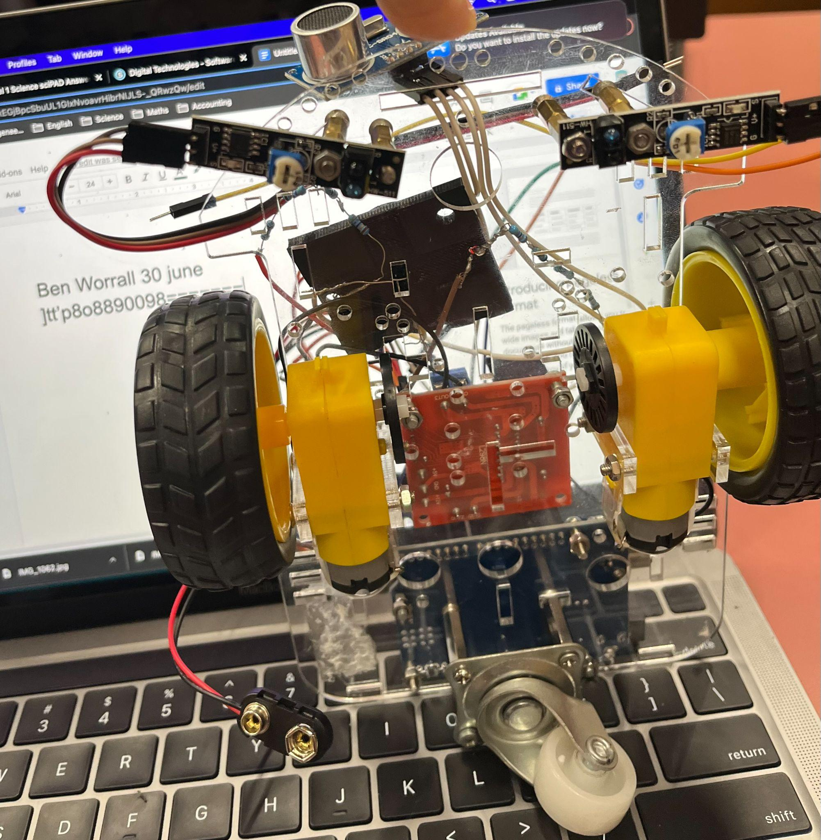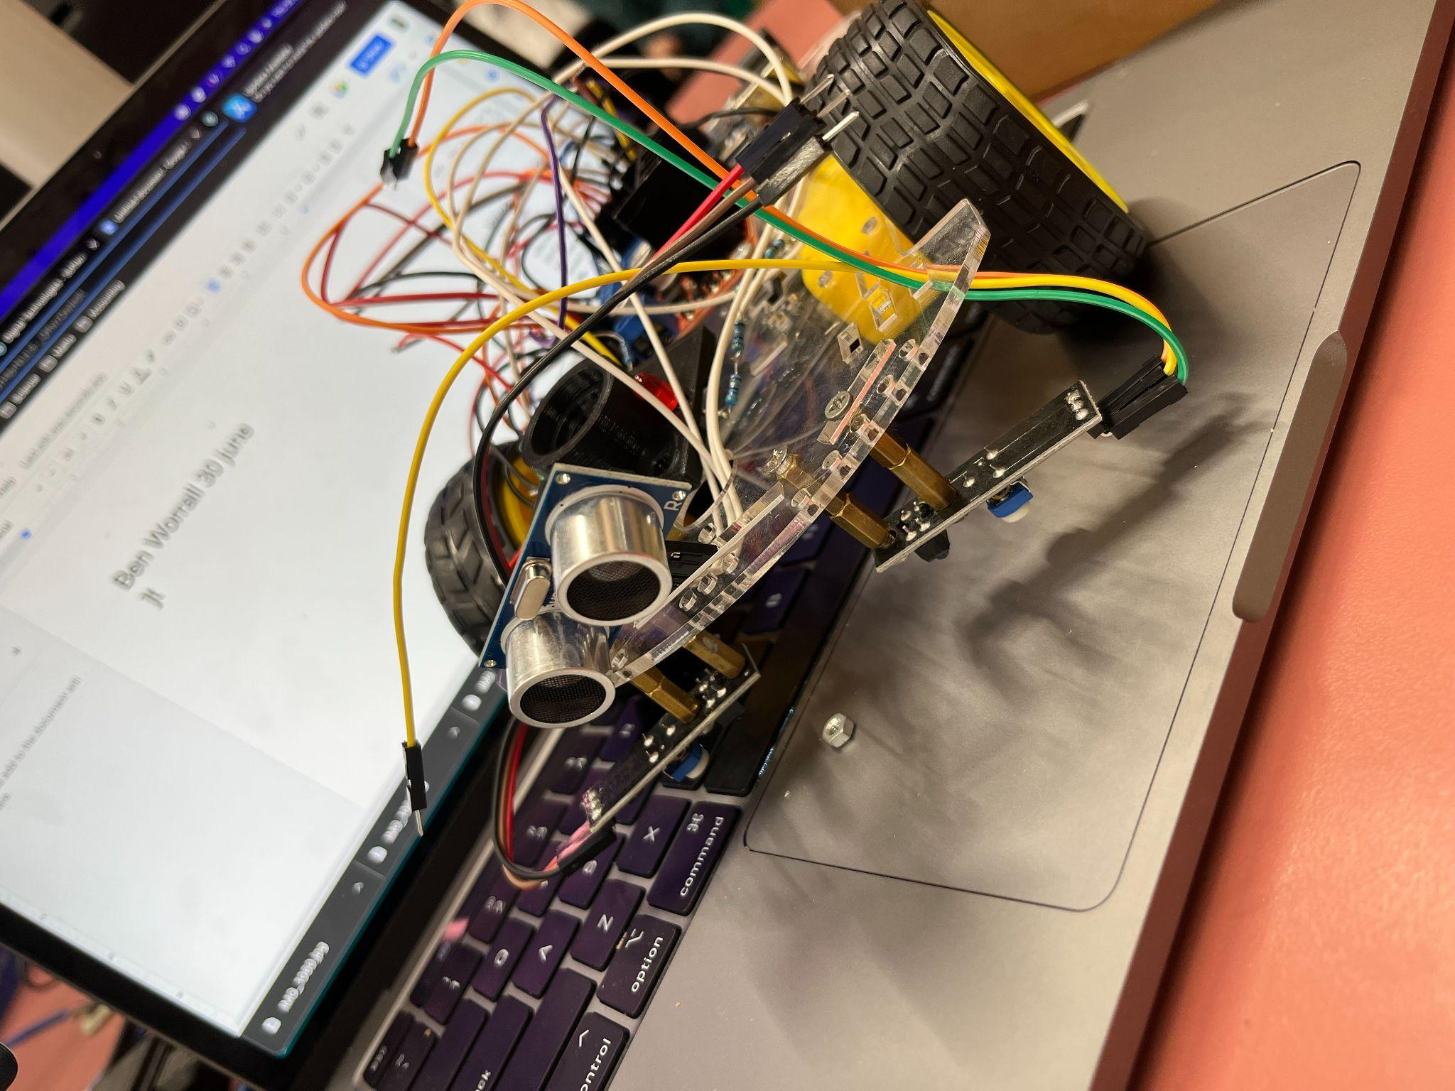

Task list

Task | Description | Due date | Tick when complete
Movement | In this key stage I had to get the motors working, making sure they move forward, backwards and can turn 360 degrees, I will know I have done this when i test it and the code I put in makes it go forward backwards and spin a full roation | 17 May 2022
Package Handling | In this key stage I had to create a housing for the LDR to sit so that it could carry the packages that where put onto the robot, this will have to link in with movement so when a package is placed onto the robot, it has to hold it securely and cover the LDR so that it functions properly. I will know I have completed this when I put my code in the robot stays still, then moves off when a package is placed on top. | 27 May 2022
Distance Sensing | In this key stage I have to link a distance sensor in with the past two key stages, making it safe so that it doesn't crash itself into a wall or get hit by passing objects. I will need to add a distance sensor and make sure that everything is working by testing it. I will know I have completed this when I place a package on the robot, and it moves off but when an object comes in front of it, it comes to a safe stop | 23 June
Line following | In this key stage I have to add a sensor that is 5mm above the ground, and code it to follow a line that is in front of it, this key stage involves taking all of the previous key stages and applying them into this to be able to send off to the client | 4 July 2022 | I did not complete this due to time, I would send the current robot as a prototype and continue with line following.
Submission | Documentation and Robot | 4pm, Monday 4 July 2022
f

